|  |  |  |  |
| --- | --- | --- | --- |
| **Fr. Conceicao Rodrigues College of Engineering**  **Department of Computer Engineering** | | | |
| **Student’s Roll No** | **9603** | **Students Name** | **Zane Falcao** |
| **Date of Performance** |  | **SE Computer – Div** | **A** |

**Aim:** Study Paging

**Lab Outcome:**

**CSL403.4:** Implement various memory management techniques and evaluate their performances.

**Problem Statements:**

Implement various page replacement policies

**(a)First In First Out (b)Least Recently Used**

1. Find the number of Page hits, Page Miss, Page hit ratio, Page Miss ratio.

2. Compare the results of both algorithms for a page reference string.

|  |  |  |  |
| --- | --- | --- | --- |
| **On time Submission(2)** | **Knowledge of Topic(4)** | **Implementation and Demonstraion(4)** | **Total (10)** |
|  |  |  |  |
| **Signature of Faculty** |  | **Date of Submission** |  |

#include <stdio.h>

int main()

{

int frame[100],pages[100],n,m,i,j,flag,hit=0,miss=0;

printf(“\nFirst In First Out”);

printf("Enter number of frames: ");

scanf("%d",&n);

printf("Enter number of pages: ");

scanf("%d",&m);

printf("Enter page reference string: ");

for (i=0;i<m;i++)

scanf("%d",&pages[i]);

for (i=0;i<n;i++)

frame[i]=-1;

j=0;

for(i=0;i<m;i++){

flag=0;

for(j=0;j<n;j++){

if(frame[j]==pages[i]){

flag=1;

hit++;

break;

}

}

if(flag==0) {

frame[miss%n]=pages[i];

miss++;

}

printf("Page reference %d:",pages[i]);

for (j=0;j<n;j++){

if (frame[j]==-1)

printf("- ");

else

printf("%d",frame[j]);

}

printf("\n");

}

float hit_ratio=(float)hit/m;

float miss_ratio=(float) miss/m;

printf("Number of page hits: %d\n",hit);

printf("Number of page misses: %d\n",miss);

printf("Page hit ratio: %f\n",hit_ratio);

printf("Page miss ratio: %f\n",miss_ratio);

return 0;

}

.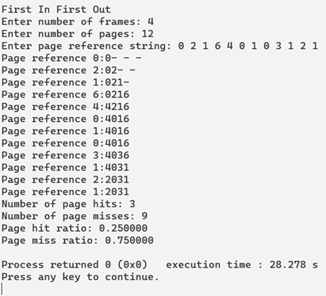

#include <stdio.h>

int main()

{

int m, n, position, k, l,a = 0, b = 0, page_fault = 0, page_hit = 0;

int total_frames, total_pages;

printf("\nLeast Recently Used\n");

printf("Enter the number of frames: ");

scanf("%d", &total_frames);

int frames[total_frames];

int temp[total_frames];

printf("Enter the number of pages: ");

scanf("%d", &total_pages);

int pages[total_pages];

printf("Enter the page numbers:\n");

for (n = 0; n < total_pages; n++) {

scanf("%d", &pages[n]);

}

for (m = 0; m < total_frames; m++) {

frames[m] = -1;

}

for (n = 0; n < total_pages; n++) {

printf("%d: ", pages[n]);

a = 0, b = 0;

for (m = 0; m < total_frames; m++) {

if (frames[m] == pages[n]) {

a = 1;

b = 1;

page_hit++;

break;

}

}

if (a == 0) {

for (m = 0; m < total_frames; m++) {

if (frames[m] == -1) {

frames[m] = pages[n];

b = 1;

page_fault++;

break;

}

}

}

if (b == 0) {

for (m = 0; m < total_frames; m++) {

temp[m] = 0;

}

for (k = n - 1, l = 1; l <= total_frames - 1; l++, k--) {

for (m = 0; m < total_frames; m++) {

if (frames[m] == pages[k]) {

temp[m] = 1;

}

}

}

for (m = 0; m < total_frames; m++) {

if (temp[m] == 0)

position = m;

}

frames[position] = pages[n];

page_fault++;

}

for (m = 0; m < total_frames; m++) {

printf("%d\t", frames[m]);

}

printf("\n");

}

printf("\nTotal Number of Page Faults:\t%d\n", page_fault);

printf("Total Number of Page Hits:\t%d\n", page_hit);

printf("Page Hit Ratio:\t\t%.2f%%\n", ((float) page_hit / total_pages) * 100);

printf("Page Miss Ratio:\t%.2f%%\n", ((float) page_fault / total_pages) * 100);

return 0;

}

