**SAVINDU**

**MANAHARA**

*Student*

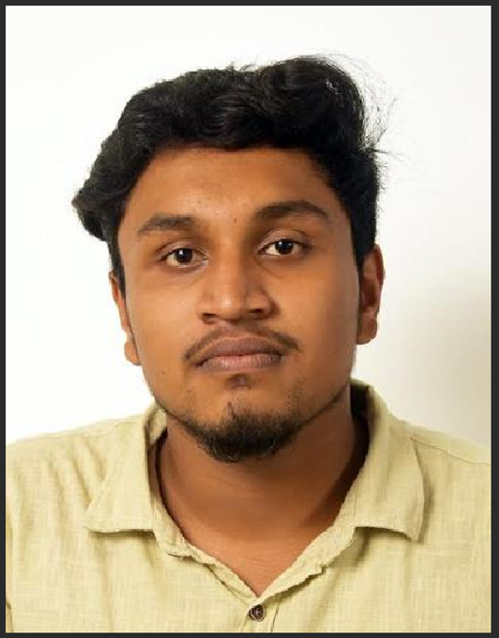

I’m After A/L student. Currently I doing Software Engineering higher diploma in ICBT Campus. I consider myself a responsible and orderly person.

**PERSONAL DETAILS**

* Name – Koku Hennadige Savindu Manahara Abeysooriya.
* Birth – 2003.04.27
* NIC – 200311800738
* Civil Status – Single

**CONTACT ME**

**e-mail :** <savindu147@gmail.com>

**Mobile No.:** 077-2892789

**Current Address:** 20/A, Tuduwamulla, Ambalangoda.

**Permanent Address:** 281/1, Aloka MW, Pannegamuwa, Weerawila.

**COMPUTER SKILLS**

* Text Processor.
* Spredsheed.
* Office Software.
* Programming Languages (C++, Java,Python,HTML,Css,JavaScript).
* Database Management (SQL).

**OTHER QUALIFICATIONS**

* **Higher Diploma in Computing & Software Engineering (CMU)**

**(Partly Completed – Undergraduate)**

**PROFILE**

**EDUCATIONAL BACKGROUND**

* **G.C.E.O/L 2019 (H/Debarawewa Central College)**
* **G.C.E. A/L 2022 (2023) –Technology Stream**
* **Higher Diploma in Computing & Software Engineering (CMU)(Partly Completed – Undergraduate)**

**CERTIFICATES**

* **Web Design for Beginners (University of Moratuwa)**
* **UI/UX app design with figma (Udemy)**
* **Web design for Beginners (Udemy)**
* **Python for Beginners (University of Moratuwa)**
* **Front-End Web Development (University of Moratuwa)**
* **SQL and Relational Databases (IBM)**
* **IT for Business Success (HP life)**
* **ARTIFICIAL INTELLIGENCE (ACCENTURE)**

**PROJECTS**

* **Image to Text Converter (Javascript,HTML,CSS)**
* **Calculator (HTML, CSS, and JavaScript)**
* **The Gallery Café Interactive Website(HTML,Javascript,CSS,Php,Mysql)**
* **Automate stock management(Java)**

**LANGUAGES KNOWLEDGE**

* Sinhala (mother tongue)
* English