Game Design Document

Fill up the following document

1. Write the title of your project.

Trap Adventure.

1. What is the goal of the game?

To be free from the dangerous monsters crawling through the forest.

1. Write a brief story of your game.

There is a man who is stranded on an island. The island is filled with monsters. The goal is to Get out of that island asap or he will be eaten alive.

1. Which are the playing characters of this game?

* Playing characters are the ones who respond to the user based on the input from the user.
* Cars, monkeys, dinos, wizards, etc., are the playing characters in the game.

|  |  |  |
| --- | --- | --- |
| Number | Character Name | What can this character do? |
| 1 | man | He can walk left and right and jump |
| 2 | monster | He dies |
| 3 |  |  |
| 4 |  |  |
| 5 |  |  |
| 6 |  |  |
| 7 |  |  |
| 8 |  |  |

1. Which are the Non-Playing Characters of this game?

* Non-Playing characters are the ones that don't have an action or behavior when the user interacts with the game.
* Hurdles, stones, bananas, coins, etc., are non-playing characters in the game.

|  |  |  |
| --- | --- | --- |
| Number | Character Name | What can this character do? |
| 1 | laser | It will kill the monster |
| 2 |  |  |
| 3 |  |  |
| 4 |  |  |
| 5 |  |  |
| 6 |  |  |
| 7 |  |  |
| 8 |  |  |

Draw your imagination of this game. What does this game look like?

* Draw the game either on your computer or on paper.
* Add images of the game scenes to show each of the playing and non-playing characters at least once.

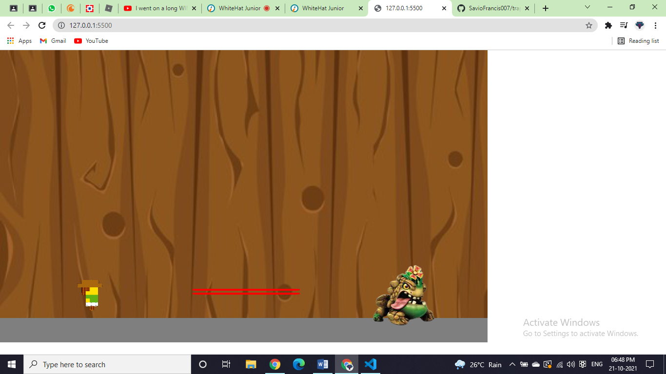

How do you plan to make your game engaging?

It is a simple game .