**The Correlation Between Acceleration of Particles Within a Canopy and the Drag Force Exhibited by the Buildings in the Canopy – Alexey Shapovalov**

Drag is a central element in flow analysis, for example, the calculation of drag within an urban canopy is a widely researched subject. Recently, a new technique was developed to follow the trajectories of specific particles within the canopy. Using this technique, data was measured from an urban canopy model inside a wind tunnel. From the collected data, a potential connection between the acceleration of the wind particles and the drag force exhibited by buildings was investigated. This was done by firstly calculating the Reynolds Stresses using the velocities of the particles. Then, using the data about the Reynolds Stresses the drag was inferred. Alongside that, the acceleration of the particles was calculated at different heights. The drag calculated from the Reynolds Stresses behaved as expected, starting with a sharp decent and afterwards slowly increasing as height increases (See figure 1). The acceleration measurements behaved similarly, excluding a small drop near the edge of the canopy. Despite the similarities in behavior, the connection wasn’t clear enough and it appears that at the very least no linear relationship exists between the two values. Even without a simple connection, the scale of the Reynolds Stresses was the same as the acceleration, and more research on the matter is encouraged.

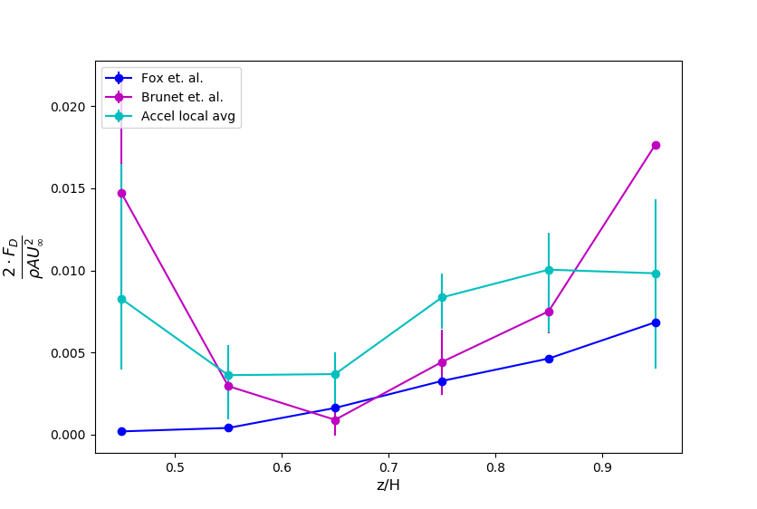

**Figure 1 – The drag coefficient in relation to the height when the velocity above the canopy is 4 m/s.** The graph displays the drag coefficient by height, where H = 100mm. The blue line represents calculations using the drag coefficient of an infinitely thin plate, the purple line represents the drag inferred using the Reynolds Stresses, and the cyan line represents the drag calculated with the accelerations. The error bars presented in the graph are a lower and upper bound on the possible value of the point on the graph. Said values were calculated by splitting the data into 10 different groups of data and calculating the average for these groups. The lowest and highest averages were used as the range of possible values for the real average.