📄 Assignment: DevOps Flask Portfolio Application Deployment

👨‍💻 Submitted By
Name: Kalyan
Role: DevOps Engineer (Trainee)

📌 Objective
To design, containerize, and deploy a 2-tier web application using DevOps practices.
The application uses Flask (backend) and MySQL (database), deployed on AWS EC2 with Docker and Nginx.

🏗️ Project Description
This project demonstrates a complete DevOps lifecycle:
- Development of a Flask web application
- Integration with MySQL database
- Containerization using Docker
- Deployment on AWS EC2
- Reverse proxy setup using Nginx

🧰 Tools & Technologies Used
- Programming Language: Python (Flask)
- Database: MySQL
- Containerization: Docker, Docker Compose
- Cloud Platform: AWS EC2
- Web Server: Nginx
- Version Control: Git & GitHub

⚙️ Implementation Steps

1️⃣ Application Development
- Created a Flask application (app.py)
- Configured MySQL connection using environment variables
- Implemented:
  - Message submission feature
  - Data storage in MySQL
  - Dynamic display of messages 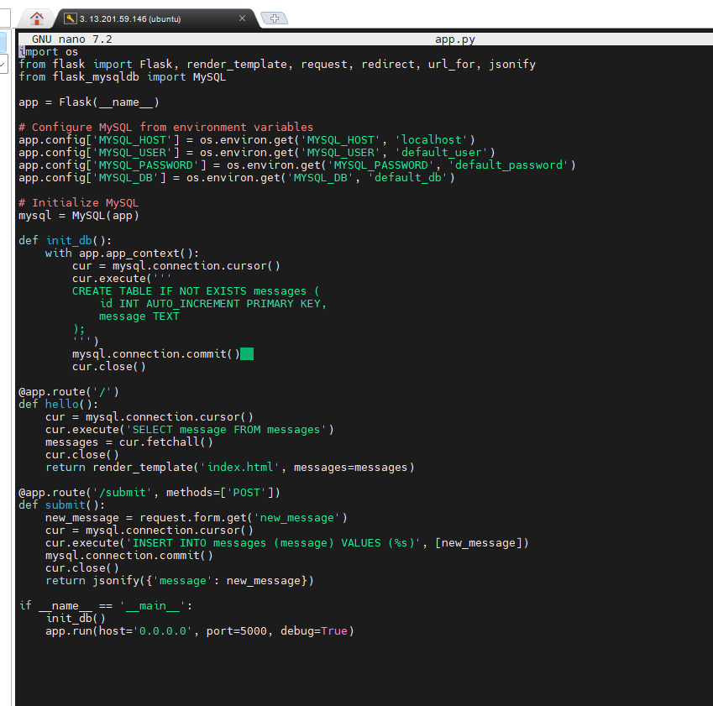

2️⃣ Containerization
- Created a Dockerfile to containerize the Flask app
- Defined dependencies in requirements.txt
- Used docker-compose.yml to:
  - Run Flask container
  - Run MySQL container
  - Establish network between services 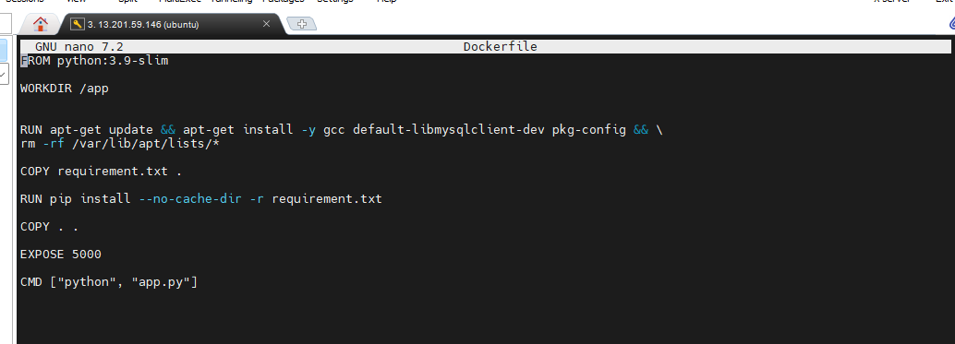

3️⃣ AWS Deployment
- Launched an EC2 instance (Ubuntu 22.04)
- Installed Docker, Docker Compose, and Nginx
- Cloned project from GitHub
- Built and ran containers using:
docker compose up -d --build 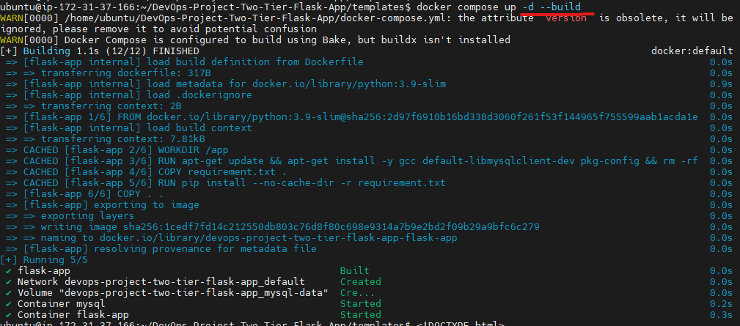

4️⃣ Nginx Configuration
- Configured Nginx as a reverse proxy
- Routed traffic from port 80 → Flask app (port 5000)
server {
listen 80;

location / {
proxy_pass http://EC2 IP:5000;
}
}

5️⃣ Application Access
- Accessed application via:
  - EC2 Public IP
  - Browser interface
- Verified:
  - Message submission
  - Database storage
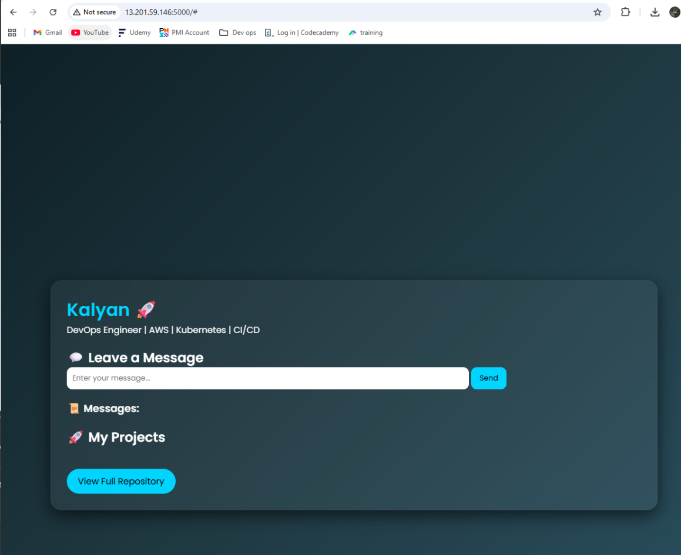
  - Data retrieval

🏛️ Architecture Diagram (AWS Deployment)
┌────────────────────┐
│ User │
│ (Browser) │
└─────────┬──────────┘
│
▼
┌────────────────────┐
│ AWS EC2 Server │
│ (Ubuntu Instance) │
└─────────┬──────────┘
│
┌──────────────────┼──────────────────┐
▼ ▼ ▼
┌────────────┐ ┌──────────────┐ ┌────────────┐
│ Nginx │ → │ Flask App │ → │ MySQL DB │
│ (Port 80) │ │ (Port 5000) │ │ (Port 3306)│
└────────────┘ └──────────────┘ └────────────┘

✨ Features Implemented
- 💬 User message submission
- 🗄️ Persistent data storage in MySQL
- 📜 Dynamic message display
- 🐳 Fully Dockerized setup
- ☁️ Cloud deployment on AWS
- 🔁 Container restart resilience

⚠️ Challenges Faced & Solutions
Challenge | Solution
MySQL connection errors | Fixed environment variables and DB name
Container startup timing issue | Added delay before DB initialization
Port accessibility issues | Configured AWS Security Group
Data persistence issues | Used Docker volumes

📊 Outcome
- Successfully deployed a 2-tier production-style application
- Achieved seamless integration between Flask and MySQL
- Implemented DevOps best practices including containerization and cloud deployment

🚀 Future Enhancements
- Implement CI/CD pipeline (Jenkins/GitHub Actions)
- Add HTTPS using SSL (Certbot)
- Migrate database to AWS RDS
- Deploy on Kubernetes (EKS)
- Add authentication system

🔗 GitHub Repository
https://github.com/Saviperr/devops-flask-portfolio-app

✅ Conclusion
This project demonstrates the practical implementation of DevOps concepts including containerization, cloud deployment, and service integration. It provides a strong foundation for building scalable and production-ready applications.

