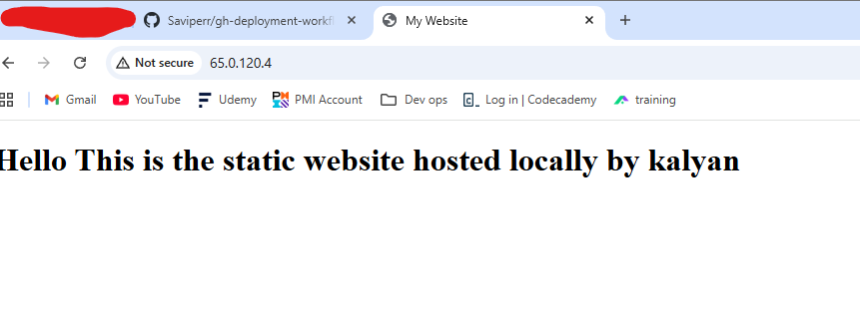🚀 Static Website Deployment using Nginx and Rsync

📌 Project Overview
This project demonstrates how to deploy a static website to a remote Linux server using Nginx and rsync. It covers basic DevOps concepts such as server setup, SSH access, web server configuration, and file synchronization.

🧰 Tools & Technologies Used
- Linux (Ubuntu Server)
- NGINX
- SSH
- rsync
- HTML, CSS

⚙️ Steps Performed

1. Server Setup
- Created a remote Linux server using a cloud provider
- Used Ubuntu 22.04 as the operating system

2. SSH Connection
Connected to the server using SSH:
ssh -i my-key.pem ubuntu@65.0.120.4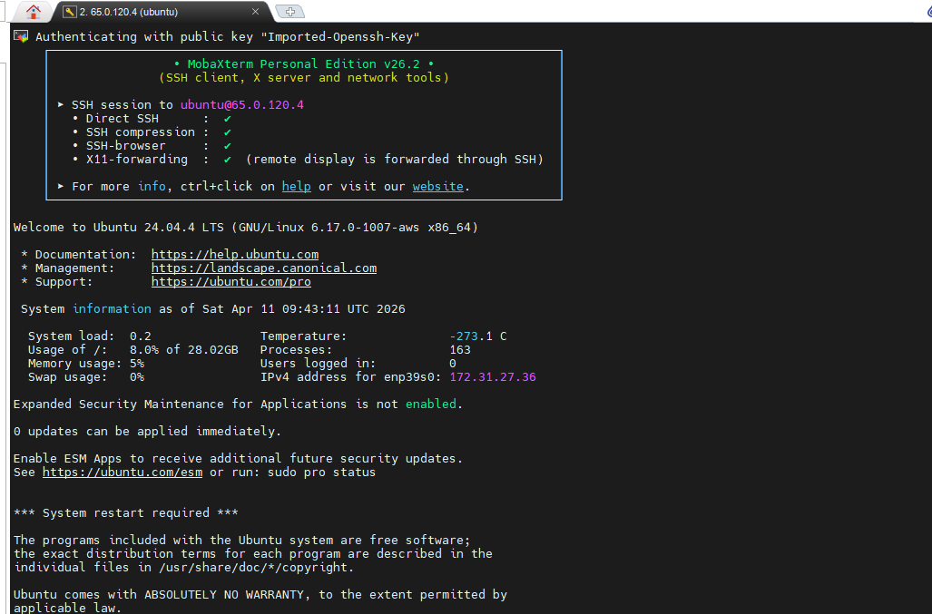

3. Installed Nginx
Updated packages and installed Nginx:
sudo apt update
sudo apt install nginx -y
Started and enabled Nginx:
sudo systemctl start nginx
sudo systemctl enable nginx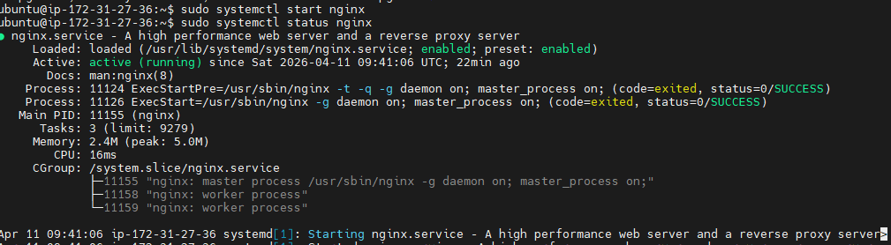

4. Configured Web Server
- Default web directory used: /var/www/html
- Removed default file and added custom website:
cd /var/www/html
sudo rm index.nginx-debian.html
sudo nano index.html
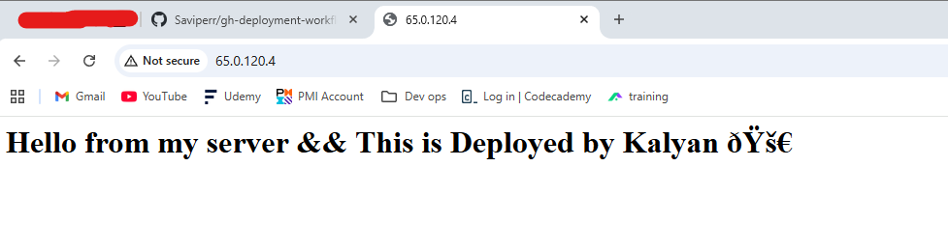

5. Created Static Website
A simple website was created using HTML and CSS files locally.

6. Deployed Using Rsync
Used rsync to sync local files with the server:
rsync -avz -e "ssh -i my-key.pem" . ubuntu@65.0.120.4:/var/www/html/

7. Deployment Script
Created a script deploy.sh to automate deployment:
#!/bin/bash

SERVER_IP="65.0.120.4"
KEY="my-key.pem"
REMOTE_DIR="/var/www/html"

echo "Deploying website..."

rsync -avz -e "ssh -i $KEY" . ubuntu@$SERVER_IP:$REMOTE_DIR

echo "Deployment completed!"

8. Accessing the Website
The website is accessible at:
http://65.0.120.4

🎯 Learning Outcomes
- Learned how to set up a Linux server
- Understood SSH authentication using key pairs
- Installed and configured Nginx web server
- Deployed static websites manually
- Used rsync for efficient file synchronization
- Gained basic understanding of deployment workflows

🚀 Conclusion
This project provided hands-on experience in deploying a static website using real-world tools. It helped in understanding the fundamentals of web hosting and deployment automation.

📄 License
This project is for educational purposes.

