Steps - E2E Agentic AI workflow
Step 1: Install node JS
Step 2: Install npm : If you find the error in screenshot, use commands in screenshot to lift the restriction.
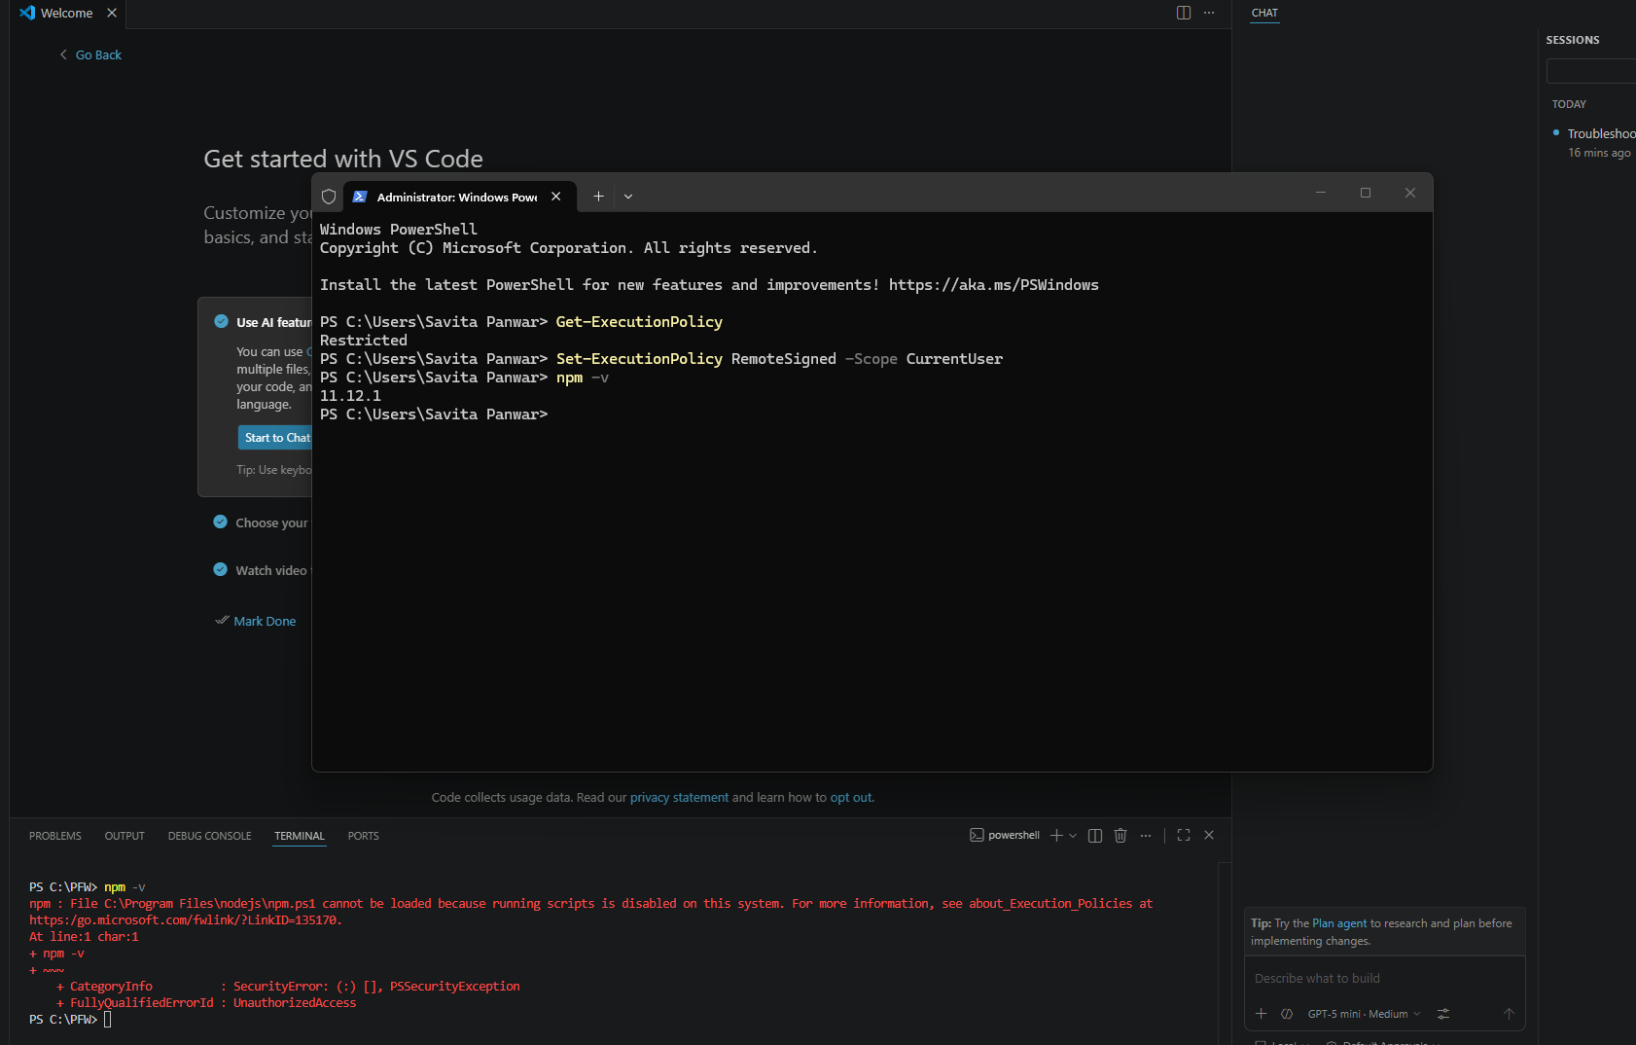

Step 3: Install playwright
Step 4: Install Playwright MCP server
- microsoft/playwright-mcp: Playwright MCP server
Step 5: Install playwright test agents
- npx playwright init-agents --loop=vscode
Step 6: Install Playwright MCP server :
- github/github-mcp-server: GitHub's official MCP Server
- Make sure : github and github copilot chat is installed
- Any issue , istall & restart VS code
Step 7 : Write US
- US with proper details and AC : Acceptance criteria
Step 8 : Write Prompt file to Run the Agentic AI workflow E2E
Step 9: Install git if not already installed
- Git - Install for Windows
Step 10: Run the E2E QA workflow using the generated prompt file.

Note : Steps are abstract , any further information you can get if you are stuck or feel free to message me.

