LAB EQUIPMENT MANAGEMENT SYSTEM

FOR

DECODE GENOMICS AND RESEARCH CENTER
Submitted by:

Nischal Joshi

TU Registration No.: 7-2-939-62-2019

TU Roll No.: 10091/19

Orchid International College

A Summer Project Submitted to

Faculty of Management, Tribhuvan University
In partial fulfilment of the requirements for the degree of
Bachelor of Information Management

Kathmandu, Nepal
July, 2023

STUDENT DECLARATION

This is to certify that I have completed the Summer Project entitled “Lab Equipment Management" under the guidance of “Mr. Dhiraj Kumar Jha” in partial fulfilment of the requirements for the degree of Bachelor of Information Management at Faculty of Management, Tribhuvan University. This is my original work and I have not submitted it earlier elsewhere.

Date: July 2023
Name: Nischal Joshi
Signature:

CERTIFICATE FROM THE SUPERVISOR

This is to certify that the summer project entitled a “Lab Equipment Management System” is an academic work done by "Nischal Joshi (10091/19)” submitted in the partial fulfilment of the requirement for the degree of Bachelor of Information Management at Faculty of Management, Tribhuvan University under my guidance and supervision. To the best of my knowledge, the information presented by him in the summer project report has not been submitted earlier.

…………………………….
Signature of the Supervisor
Name: Er. Dhiraj Kumar Jha
Designation: Project Coordinator
Date: July,2023

EXECUTIVE SUMMARY

The main objective of this project is to make an online platform for DGRC to sell its lab equipment and track some records.

Lab Equipment Management System contains two modules. One module is designed for the customer that contain a login screen. The customer has to register himself/herself before logging in to the web application (ordering the equipment). After logging in, the customers can choose the category, order the equipment’s and make the payment. The second module is the admin module that is designed on the website. The admin can manage the categories, view payments and manage the products details.
The above mentioned web based system is designed according to object oriented Analysis and design techniques and UML (Unified modeling language) is used to model the system. While the system is a web based solution PHP has been used for building up the logic of the system. HTML, CSS, Java script, and Bootstrap is used to model interface. MYSQL has been used at the back end for the database handling

ACKNOWLEDGEMENTS

This summer project report has been prepared for the fulfilment of the requirement for the degree of Bachelor in Information Management (BIM) under the faculty of Management Tribhuvan University.
It has been a great opportunity to learn and gather practical knowledge due to the University for including such a task in the curriculum of BIM. The environment of Orchid International College has been supportive in all stages of this project. Er. Dhiraj Kumar Jha, project coordinator has been supportive and inspirational to grow and develop the project. I would like to acknowledge Decode Genomics & Research Center for providing the required information in completion of this project. As a whole, the direct and indirect help of all the people was valuable for preparation of this project report. The outcome is the result of their support and encouragement.

LIST OF ABBREVIATIONS

Admin Administration
BIM Bachelor in Information Management
DGRC DECODE GENOMICS & RESEARCH CENTER
ER Entity-Relationship
JS JavaScript
LEMS Lab equipment management system
UC Use-Case
UI User Interface
UML Unified Modeling Language

TABLE OF CONTENTS

STUDENT DECLARATION ii
CERTIFICATE FROM THE SUPERVISOR iii
EXECUTIVE SUMMARY iv
ACKNOWLEDGEMENTS v
LIST OF ABBREVIATIONS vi
LIST OF FIGURES ix
LIST OF TABLES x
CHAPTER I – INTRODUCTION 1
1.1 Background of Study 1
1.2 Introduction of the Organization 1
1.3 Current Situation of the Organization 1
1.4 Problem Statement of the report 1
1.5 Objectives of the Study 2
1.6 Literature Review 2
1.7 Methodology 3
1.7.1 Data and Information 3
1.7.2 Project Framework 4
1.7.3 Tools Used 4
1.7.4 Technique of the project report 5
1.7.4.1 Problem analysis 5
1.7.4.2 Feasibility analysis 5
1.7.4.3 Technical feasibility 5
1.7.4.4 Operational feasibility 5
1.7.4.5 Schedule feasibility 5
CHAPTER II - TASK AND ACTIVITIES PERFORMED 7
2.1 Analysis of tasks 7
2.2 Problem and issue 7
2.3 Analysis of Possible Solution 7
2.3.1 Requirement Analysis 7
2.3.2 Functional Requirements 7
2.3.3 Non-Functional Requirement 11
2.3.4 Software Requirements: 12
2.3.5 Hardware Requirements: 12
2.3.6 Entity Relationship Diagram 13
2.3.7 Relational Model 14
2.3.8 Activity Diagram 15
2.3.9 Testing 20
2.4 Findings 22
3.1 Discussion 23
3.2 Conclusion 23
3.3 Future Enhancements 23
REFERENCES 24
APPENDICES 25

LIST OF FIGURES

Figure 1: Waterfall Model……………………………………………………………….4
Figure 2: Use Case diagram of Lab Equipment Management System…………………..8
Figure 3: Entity Relationship Diagram…………………………………………………13
Figure 4: Relational Model……………………………………………………………..14
Figure 5:Manage Category……………………………………………………………..15
Figure 6:View Product…………………………………………………………………16
Figure 7: Manage Product…………………………………………….......................... 16
Figure 8:Order Product…………………………………………………………………17
Figure 9:Make Payment………………………………………………………………...18
Figure 10:Cancel Order………………………………….………….…………………..19

LIST OF TABLES

Table 1: Project Schedul………….…………………...…………………………………6
Table 2: Manage Product……………………………..…………...………………….….9
Table 3: Manage Category………………………….....…………………………………9
Table 4: View Product…………………………………….………………..…………..10
Table 5: Order Product…………………………………….………………….………..10
Table 6: Make Payment……………………………….….…………………………….10
Table 7: Software Requirement……………………….….…………………………….12
Table 8: Hardware Requirement………………………….……………………………12

CHAPTER I – INTRODUCTION

Background of Study
For the customer to make the appropriate purchase payment, the system will create an online web application. The goal of this project was to create an online application that would allow customers to purchase/buy lab equipment. Customers can purchase/buy based on the product category.

Introduction of the Organization

Decode Genomics and Research Center Pvt. Ltd is a Molecular Diagnostic Laboratory providing molecular diagnostic services. It is located in Bagbazar, Kathmandu. It was established in 2015.

Current Situation of the Organization
In the current situation, DGRC works in a traditional way and they want to explore their business in e-commerce field as well.

Problem Statement of the report
DGRC Pvt. Ltd is mainly focused on Molecular Diagnostics services and selling lab equipment’s but the problem faced by the lab is they don’t have any online medium for selling their lab equipment’s and DGRC is missing out on customer by not entering on online medium. The way DGRC sell their lab products in traditional way and old method of record keeping is which can be considered as a problem for the lab.
The project will help the customer to purchase the equipment’s through online medium which helps customers to know about the details, availability and unavailability of the product. The customer now can directly buy the lab equipment from their remote place and won’t need to physically visit the lab and buy the equipment. The record keeping of the lab will be more organized as the details of each customer and product will be digitalized. This project will help DGRC to make their online business grow and help them understand the e-commerce side of the business.

Objectives of the Study
The system aims to help the customer to purchase the product online through the internet and track sales record and manage the products.
The main objectives of the study are given as follows:
● To build a web based application that manage DGRC.
● To sell and manage the product through online
● To keep customer record
● To gather more customer

1.6 Literature Review
The main objective of this study is to explore the growing demand for online marketplaces that connect buyers and sellers of laboratory equipment. The review emphasizes the benefits of such websites, including enhanced access to a wide range of instruments, cost-effectiveness, and improved resource utilization. The emergence of online platforms facilitating the buying and selling of laboratory equipment has transformed the way scientific instruments are acquired and utilized. This literature review delves into the significance of these websites in the research community and explores the benefits they offer to both buyers and sellers. The review also examines their impact on lab efficiency, cost-effectiveness, and sustainable resource management. Online lab equipment trading platforms provide researchers and institutions with convenient access to a wide array of laboratory instruments. This accessibility streamlines the procurement process and offers a diverse selection of equipment, enabling users to find the most suitable options for their specific needs. Such websites promote cost-effective equipment transactions by facilitating direct interactions between buyers and sellers. Eliminating intermediaries often leads to competitive pricing and cost savings for both parties, making essential lab equipment more affordable.
The literature supports the importance and advantages of online lab equipment trading platforms. These websites offer convenience, cost-effectiveness, and sustainability while fostering collaboration and research efficiency.

Methodology

The methodical and organized process that software development teams use to plan, create, test, and deliver software products or applications is referred to as methodology. It describes the procedures, standards, and principles that programmers and other project participants must adhere to in order to finish the software development project successfully and quickly. To build a system for DGRC different methodologies and procedures have been followed.

1.7.1 Data and Information

Information was gathered primarily through the primary data collection method. The Director of DGRC was given information on the organizational visit, and the director gave favorable feedback when asked about the project-related questions.

1.7.2 Project Framework

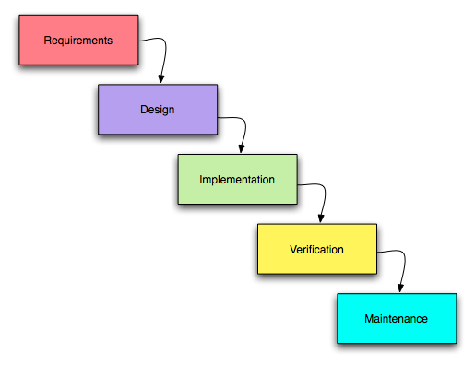

Figure 1: Waterfall Model

The reason behind considering this methodology is as follows:
- Prior to design, each phase and necessity is specified.
- Simpler to comprehend and apply.
- No requirements for development or execution that are unclear.
- It is predictable and has distinct milestones.

1.7.3 Tools Used
Database: MySQL
Language: HTML, CSS, JS,PHP
Server: XAMPP
Text editor: Visual Studio Code

1.7.4 Technique of the project report

1.7.4.1 Problem analysis

The main problem of DGRC is that they haven’t explored the online side of business and it can be a drawback to emerging business. The internet aspect is missing and it can be a major issue for the business.

1.7.4.2 Feasibility analysis

The analysis of the project has led to the conclusion that the project is feasible with time and cost. The tools used for development are almost Open Source and involve less cost and maintenance

1.7.4.3 Technical feasibility

The technical analysis will require you to thoroughly assess the proposed technical solution. Technical feasibility evaluates whether the proposed web-based application can be developed using the available technology stack and resources. Visual Studio Code will be used to develop the project.

1.7.4.4 Operational feasibility
It assesses whether the e-commerce website can be effectively integrated and operated without significant disruption or obstacles.

1.7.4.5 Schedule feasibility
The analysis of this project has led to the conclusion that the project is feasible with time as it can be completed with the given time frame including all the criteria and the features.

Table 1: Project Schedule

Task |  | Duration
Project Planning | 1 week
Research Study | 2 week
Collecting Information | 2 weeks
Coding and Design | 4 weeks
Unit Testing | 3 weeks
Deployment | 1 weeks

CHAPTER II - TASK AND ACTIVITIES PERFORMED

2.1 Analysis of tasks

Before analyzing the task, organization was visited to collect the requirements. After the requirement collection the major problem was identified and a procedure was carried out to build the working framework. The analysis of major problem was helpful in drawing out the conclusion and solving the issue. The newly developed system helps to solve the problem that is being faced by DGRC.

2.2 Problem and issue

After the brief analysis of the task and requirement. We found out the root problem that the Lab was facing. The organization haven’t explored the online side of business and that is making them lack behind.

2.3 Analysis of Possible Solution

2.3.1 Requirement Analysis

The main objectives of requirement analysis are to identify and evaluate the requirement of the proposed system. It helps to know about user requirements, system requirements, functional requirements, and non- functional requirements for LEMS of DGRC. The primary goal of requirement analysis is to establish a clear and complete understanding of what the software should accomplish before proceeding with its design and development.

2.3.2 Functional Requirements

These requirements are typically described in a detailed and unambiguous manner to guide the development process. Functional requirements focus on what the system should do and how it should respond to various inputs and actions. They are essential for determining the core features and functionalities of the software system. Functional requirements should be measurable, meaning that they can be tested to ensure they are met. A functional requirement is a description of the service that the software must offer. It describes a software system or its components. A function is nothing but inputs to the software system, its behavior, and outputs. It describes the functions of a system and its components. The LEMS for Decode Genomics And Research Center shall contain the admin who could be able to manage the product and its different categories. Functional requirements can be briefly described with the help of Use Case Diagram which is shown below:
2.3.2.1 Use Case Diagram
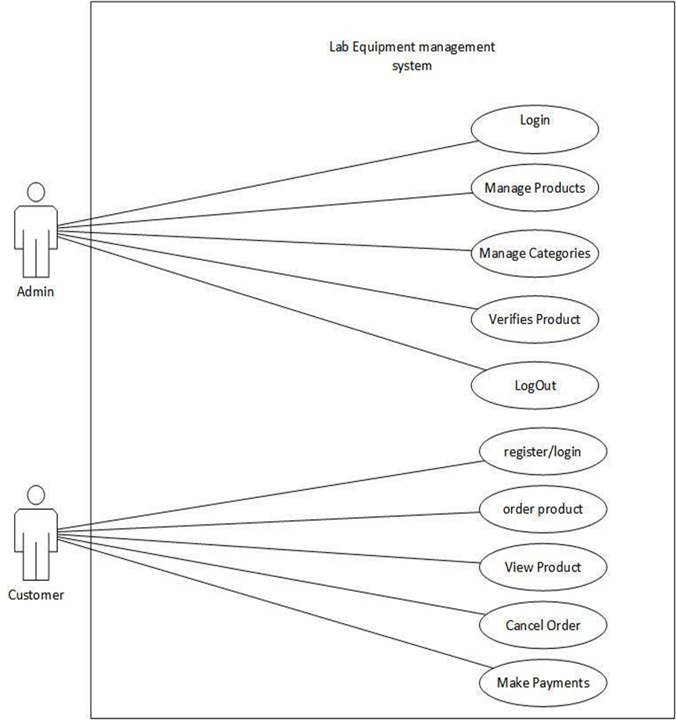

Figure 2: Use Case Diagram of Lab Equipment Management System

Table 2: Manage Product

USE-CASE IDENTIFIER | UC-1: MANAGE PRODUCT
Primary Actor | Admin
Secondary Actor | None
Description | The admin can add, view, update, and delete the product.
Pre-condition | The admin have to be logged in to modify the product
Post-condition | The database is updated and product is modified.
Failure-scenario | The database is not updated

Table 3: Manage categories
USE-CASE IDENTIFIER | UC-2: MANAGE CATEGORIES
Primary Actor | Admin
Secondary Actor | None
Description | The admin can Insert and View categories
Pre-condition | The admin have to be logged in to insert the categories
Post-condition | The database is updated categories are stored.
Failure-scenario | The database is not updated

Table 4: View product

USE-CASE IDENTIFIER | UC-3:
Primary Actor | Customer
Secondary Actor | None
Description | Customer can view the product so that they can place the product for order
Pre-condition | Customer need to visit the website to be able to view the product
Post-condition | Customer will be able to place the order
Failure-scenario | The product details can be mismatched

Table 5: Order Product

USE-CASE IDENTIFIER | UC-4:
Primary Actor | Customer
Secondary Actor | None
Description | Customer can order the desired product
Pre-condition | Customer must be logged in to the system
Post-condition | Database is updated with new order
Failure-scenario | Difficulties in order placing due to lack of product in stock

Table 6: Make Payment
USE-CASE IDENTIFIER | UC-5:
Primary Actor | Customer
Secondary Actor | None
Description | Customer can make payment after placing the order.
Pre-condition | Customer must be logged in to the system
Post-condition | The database will be updated with the payment information
Failure-scenario | Failure in payment due to technical error

2.3.3 Non-Functional Requirement
Non-Functional Requirement describes a software system's quality aspect. Based on non-functional criteria that are essential to the software system's success, such as responsiveness, usability, security, portability, and others, they evaluate the software system. With the aid of all the non-functional requirements, DGRC is able to determine the true strengths and weaknesses of the system.
The non-functional requirements for the project are as follows:
● Security
The system implementation was done in PHP Programming language which has its own security system. The authorities are provided according to the roles. Different methods are used to insure the security aspect of DGRC’s LEMS.
● Safety
The project does not have any direct physical harm to the users. The project is safe to use as it gives data confidentiality, availability and authorization to all of its users in the DGRC.
● Backup
The database may get crashed at any certain time due to operating system failure so it is required to take the database backup for DGRC.
● Performance
The system is expected to perform effectively and efficiently. It should be able to provide fast and optimal performance in a cost-effective way.

2.3.4 Software Requirements:

Table 7: Software Requirement
IDE | Visual Studio Code
Design | Figma
Diagrams | draw.io, Microsoft Visio
Server | XAMPP, MySQLServer
Browser | Google Chrome, Mozilla Firefox, Edge

2.3.5 Hardware Requirements:

Table 8: Hardware Requirement
Operating System | Windows 10
Processor | 2.13 Ghz
RAM | 8 GB
Disk Space | 5 GB minimum
Device | PC, Laptop, Android Device

2.3.6 Entity Relationship Diagram

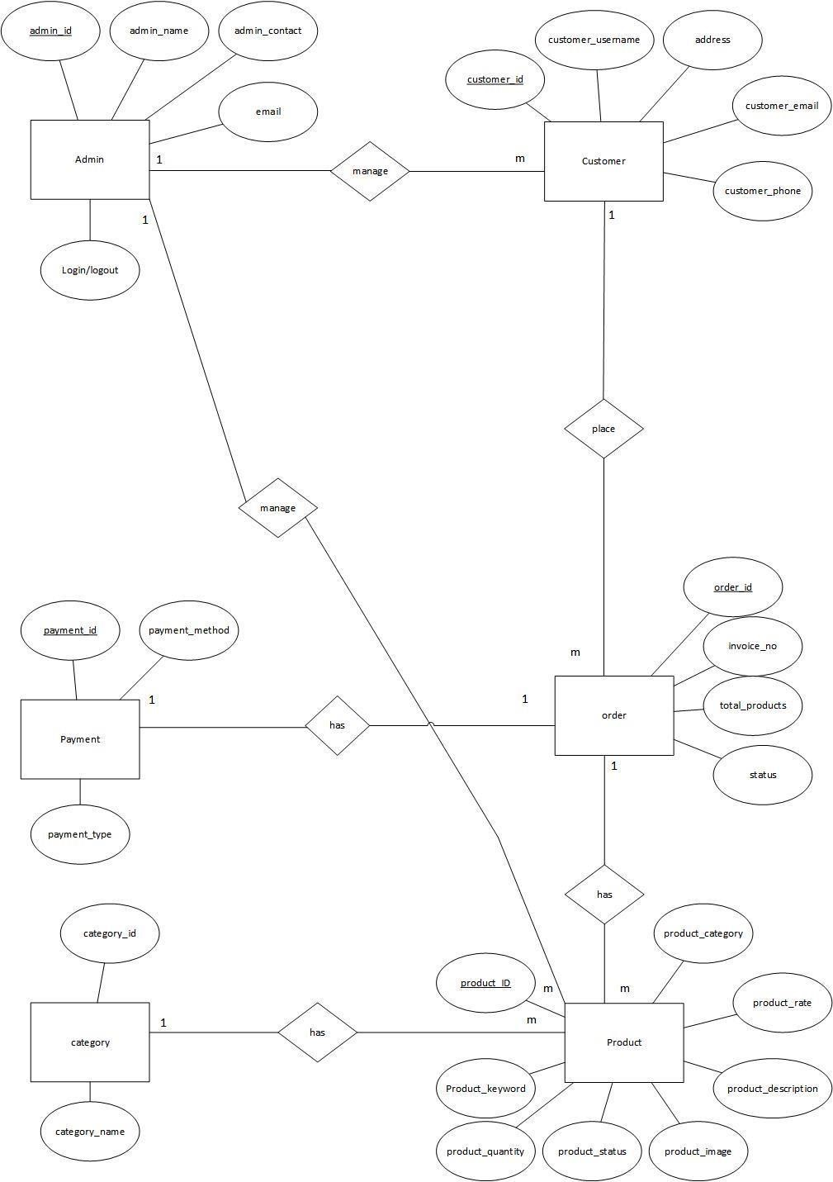

Figure 3: Entity Relationship Diagram
Relationship
Admin has relationship of one to many with customer. Customer has one to many relationship with the order. Order has one to many relationship with product. Product has many to one relationship with category.

2.3.7 Relational Model

Relational Model is conceptual basis of relational database (Somerville, 1. 2011). It is a UML diagram that shows a static view of a system. Relational Model is described in the figure which is shown below.
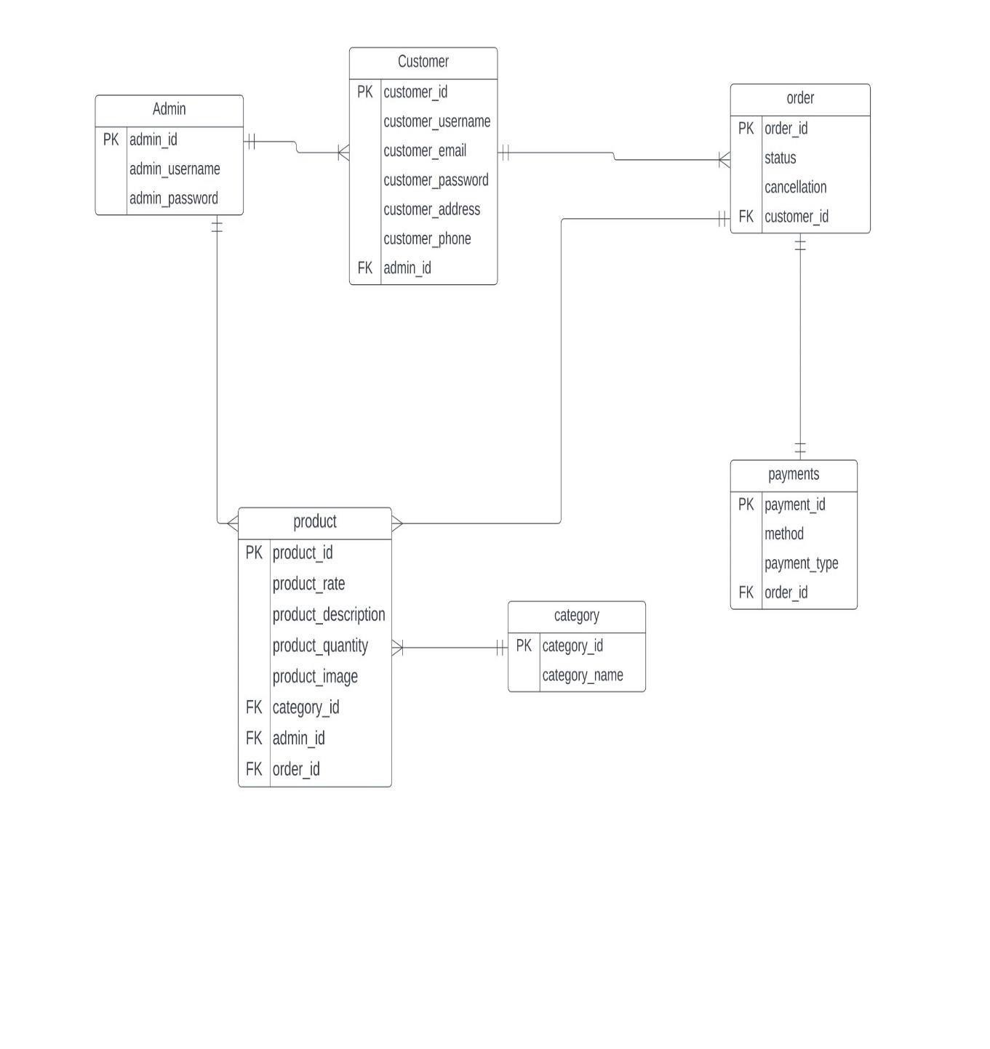

Figure 4: Relational model of DGRC’s LEMS

2.3.8 Activity Diagram

- Manage Category

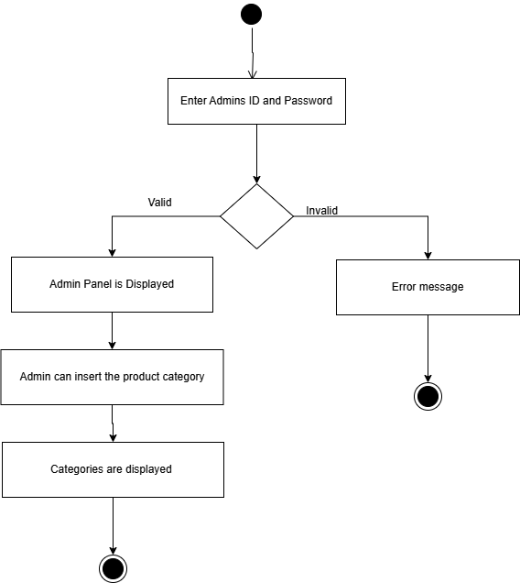

Figure 5: Manage Category

The activity diagram includes four steps. First the admin enters their ID and Password. If the password is matched then Admin panel is displayed and Admin can insert the product category and after that the categories are displayed. If the ID and Password doesn’t match then a error message is displayed.

- View Product
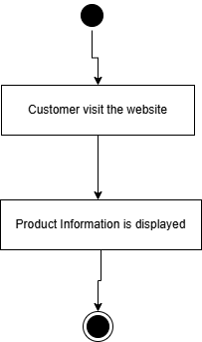

Figure 6: View Products

It includes only two steps and it’s mainly concern with the customer viewing the product since the product can be viewed without having logged into the system.

- Manage Product
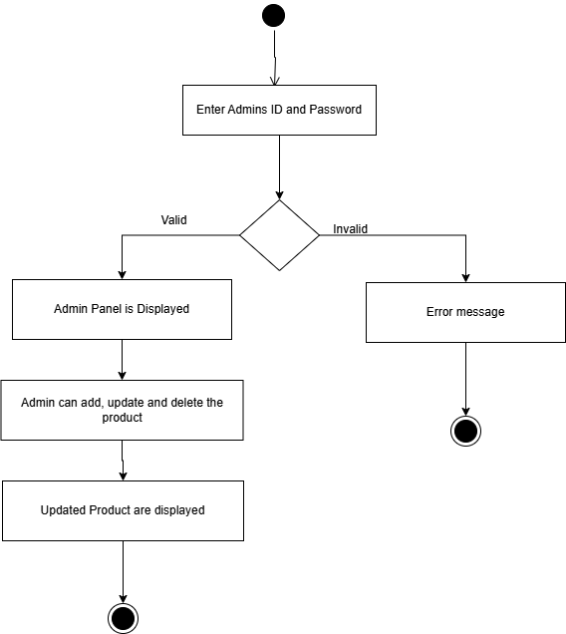

Figure 7: Manage Product

It includes four steps and the admin enters its ID and Password. After that admin panel is displayed if the credentials are verified. Admin can add, update & delete the product and updated product is displayed.

- Order Product

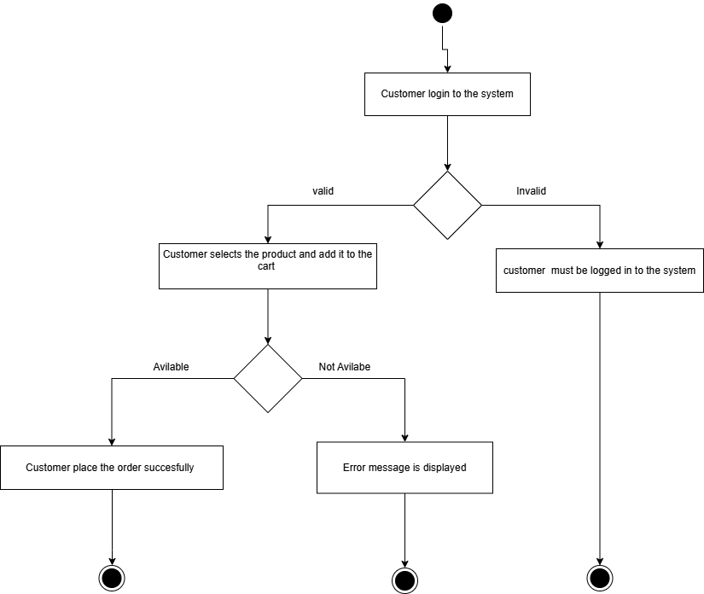

Figure 2: Order product

The activity diagram for "Order Product" starts with entering the customer’s login and if the customer credential is valid the customer can select the product and add it to the cart.
And after adding the product if the product is available order is placed successfully otherwise an error message is displayed.

- Make Payment

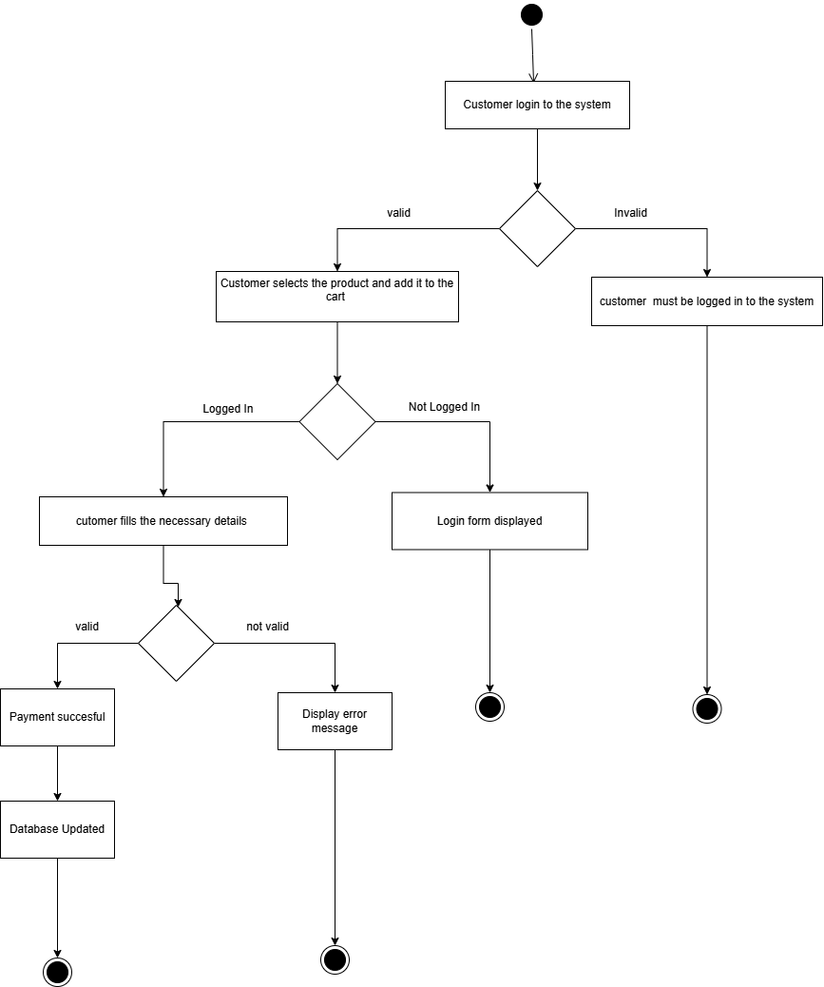

Figure 3: Make Payment

The "Make Payment" activity diagram encompasses the process of validating a customer credentials and if the login info are valid then customer can pay for the selected product. If customer is not logged in to the system then login form is displayed and if the login info is valid then customer fills the necessary details and if the details are valid then payment is considered to be successful and database is updated if not error message is displayed.

- Cancel Order

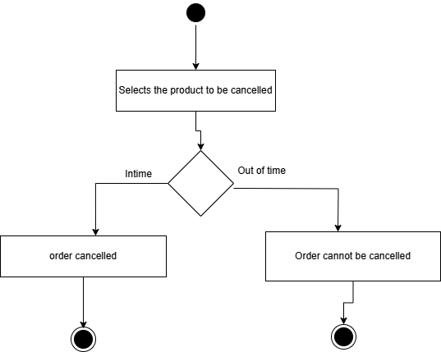

Figure 4: Cancel Order

The "Make Payment" activity diagram encompasses the process of validating a customer to cancel the product in case of cancellation.

2.3.9 Testing

In testing, the different inputs were tested as input to GUI forms which can is shown below with the help of table as well as figure:
Testing Table for Admin Login:
Unit effected | Test input data | Actual result | Expected result | Remarks
Admin Login | Username=admin2  Password=admin2 | Error: “Login error message is displayed” | Logged in | Fail

Testing table for registering a new user:
Unit effected | Test input data | Actual result | Expected result | Remarks
New user  Registration | Username=  Email=  Password=12  3  Phone=9821 634040  Address= ktm | Field username is empty  Field email is empty | Field username is empty  Field email is empty | Pass

Testing table for inserting a new category:
Unit effected | Test input data | Actual result | Expected result | Remarks
Inserting new category | Category name=’Blood pressure measurement’ | Category inserted | New Category should be updated | Pass

2.4 Findings
After analyzing about the organization, It was known that if organization uses the same traditional approaches to record about products, orders , payments and customer then it would increase the cost of products which directly impacts market today and customers may be distracted. If DGRC uses the application for the business purpose then it would be easier to meet the current demand and supply of the customer and thus the company would be able to meet its goal comfortably.

CHAPTER III – DISCUSSION AND CONCLUSION

3.1 Discussion
The aim of this project was to research and develop a web-based application for “DECODE GENOMICS AND RESEARCH CENTER” to increase their sales and make an online presence. The project covers the problem that was identified during the organization visit and the solution to the problem was solved by developing software. The system will help for the every necessary activity to be done and for the working in the systematic way. The development is assumed to be very helpful for the organization.

3.2 Conclusion
The development is able to fulfill the requirement of the organization by reducing the gap between the customer and the organization. After the collection of requirements we were able to build a web based application that allows the buying of lab equipment’s online. The system was successfully completed in time as per the objectives .The system is expected to fulfil all the requirements and prove to be beneficial for DGRC. Testing had been performed upon the system, its unit to ensure the normal behavior of the system. The waterfall model used in this system is helpful to check in every phase after each coding.

3.3 Future Enhancements
The purpose of this project is to enable the purchase of lab supplies online. The system was developed effectively, and it is being kept up to date with the resources available.

REFERENCES
Best Lab Equipment management system Overview:
https://www.labcompare.com/General-Laboratory-Equipment/6063-Lab-Management-Software/

Sommerville, I. (2011). Software Engineering ninth edition. Pearson Education Inc. https://pdfs.semanticscholar.org/b50d/1a39b9b65912268ae0e65a64bad87c1ad184.pdf https://www.wikiwand.com/en/Hea

Adam. (n.d.). PHP. Retrieved from https://assets.ctfassets.net/nkydfjx48olf/5qFMF3mvitLMahX67i7iOb/028229996c13cbc27a0538f055a41b46/php_cookbook.pdf

Stack Overfow. (n.d.). Retrieved from Stack Overfow: Stack Overfow

W3 Schools. (n.d.). Retrieved from W3 Schools: https://assets.ctfassets.net/nkydfjx48olf/5qFMF3mvitLMahX67i7iOb/028229996c13cbc27a0538f055a41b46/php_cookbook.pdf

APPENDICES

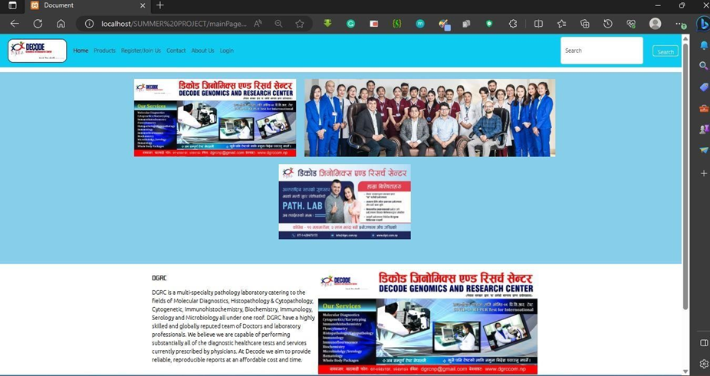

Home Page

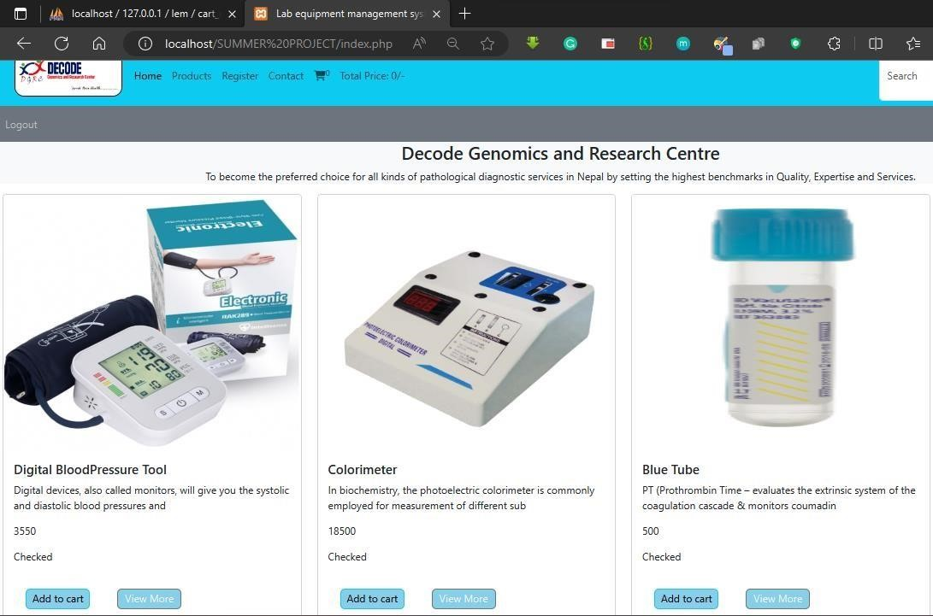

Product View
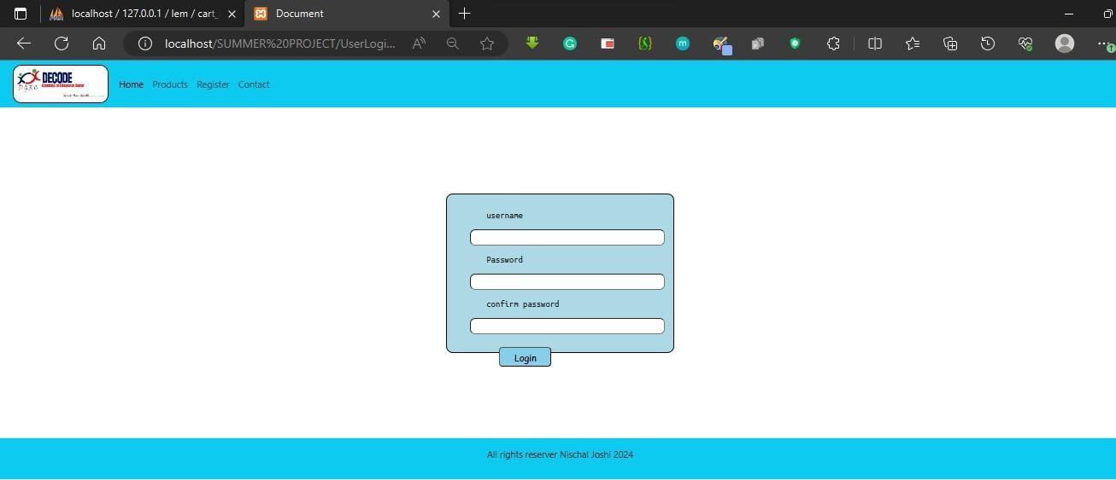

User Login

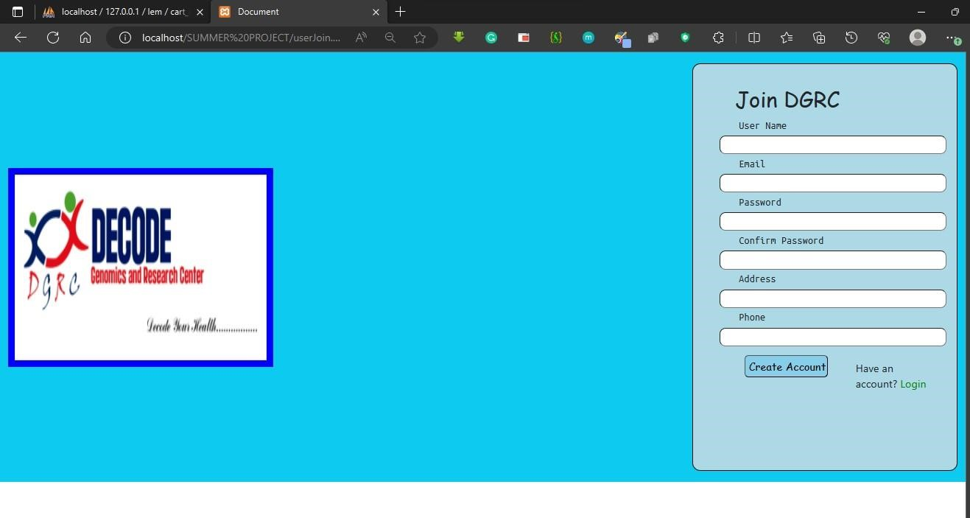

User Register
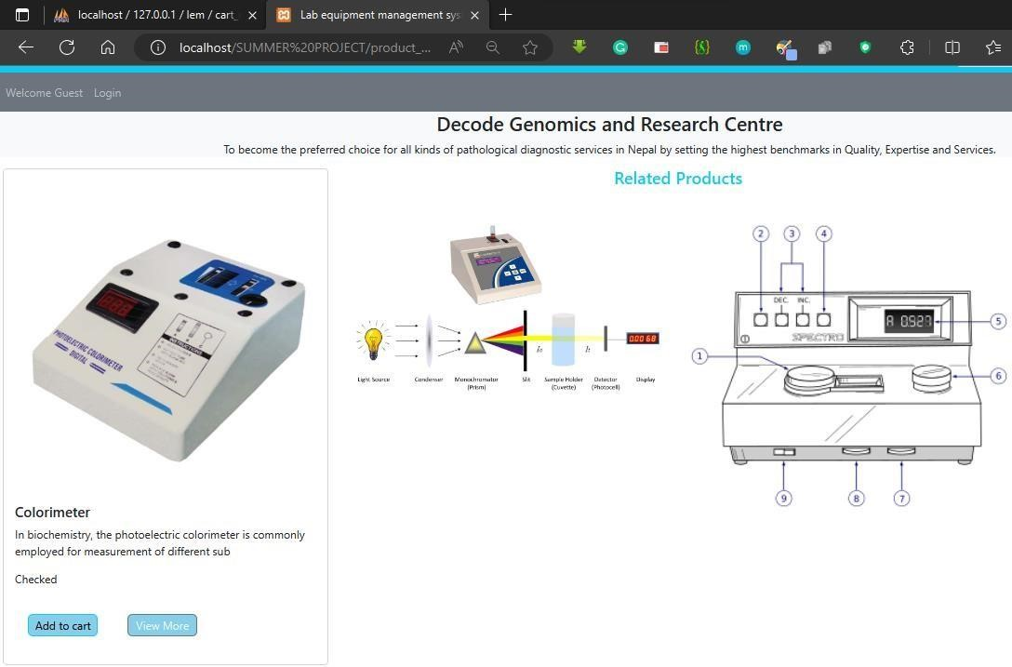

View Product Details

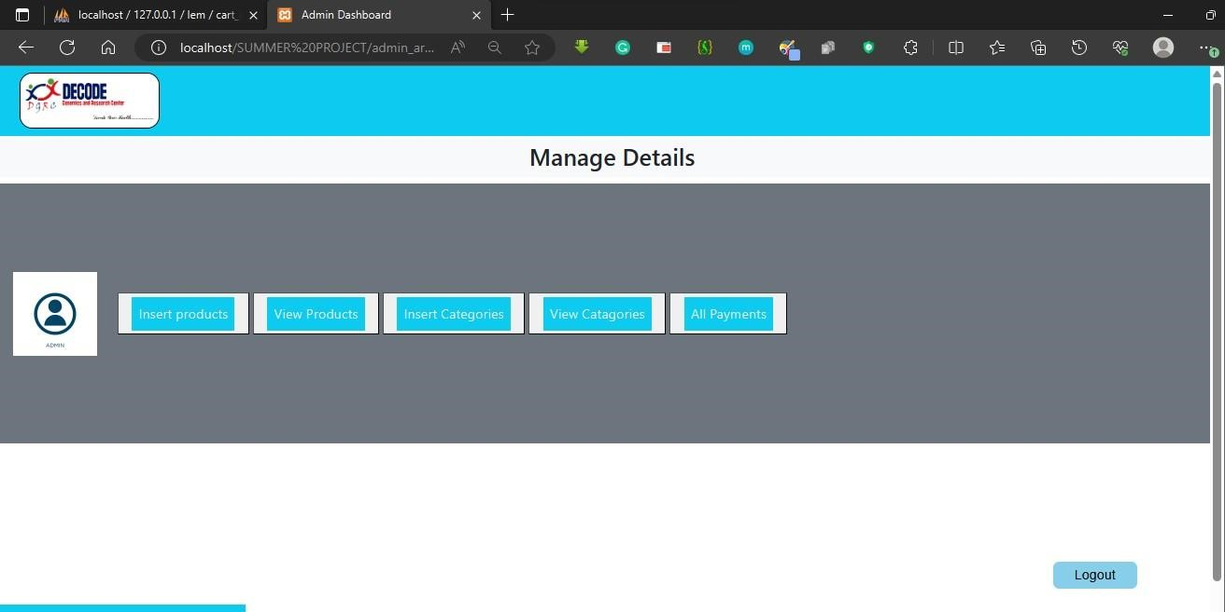

Admin Panel

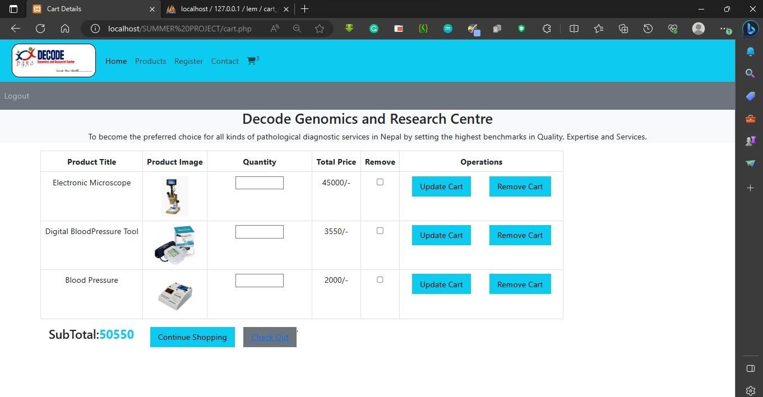

Add to Cart
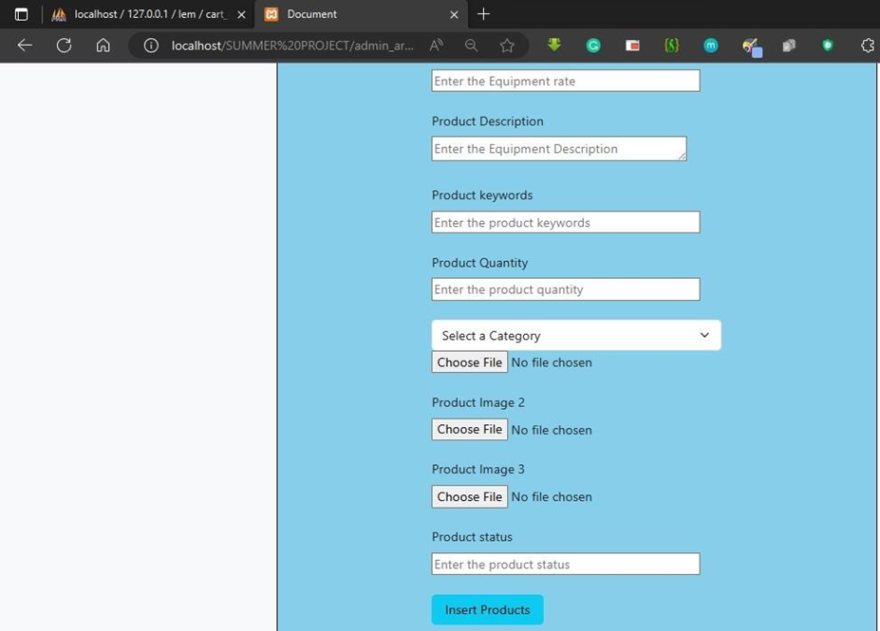

Insert Product

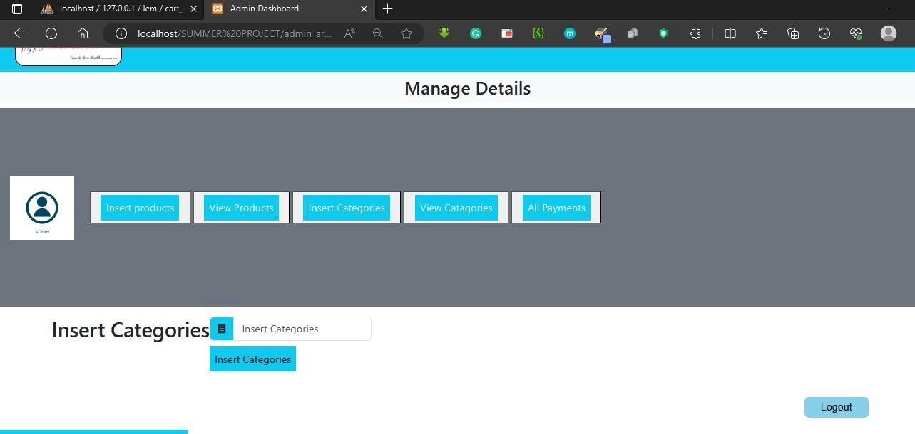

Insert Category

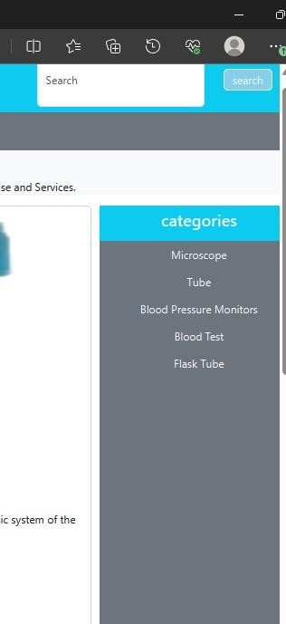

View Inserted categories

