MINOR PROJECT

STACK PRICE PREDICTION

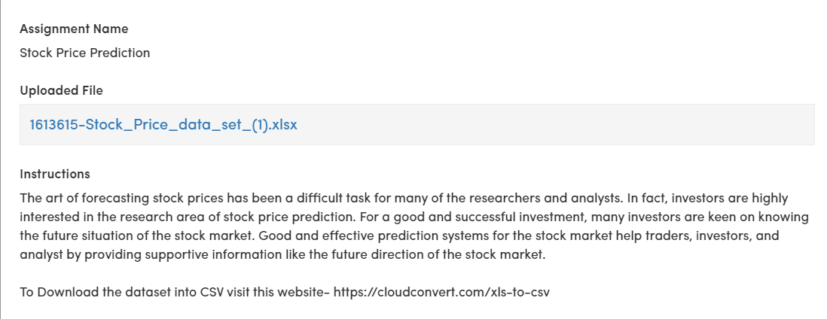

CODING:

import pandas as pd

import numpy as np

import matplotlib.pyplot as plt

from sklearn.model_selection import train_test_split

from sklearn.linear_model import LinearRegression

from sklearn.metrics import mean_squared_error, r2_score

file_path = "Stock_Price.csv"

df = pd.read_excel(file_path)

print(df.head())

# Assuming the dataset has columns like 'Date', 'Open', 'High', 'Low', 'Close', 'Volume'

print("Missing values:")

print(df.isnull().sum())

df['Date'] = pd.to_datetime(df['Date'])

df.sort_values('Date', inplace=True)

df.set_index('Date', inplace=True)

df['DayofWeek'] = df.index.dayofweek

features = ['Open', 'High', 'Low', 'Volume', 'DayofWeek']

target = ['Close']

X = df[features]

y = df[target]

X_train, X_test, y_train, y_test = train_test_split(X, y, test_size=0.2, random_state=42)

model = LinearRegression()

model.fit(X_train, y_train)

y_pred = model.predict(X_test)

mse = mean_squared_error(y_test, y_pred)

r2 = r2_score(y_test, y_pred)

print("Mean Squared Error:", mse)

print("R-squared:", r2)

plt.figure(figsize=(12, 6))

plt.plot(df.index[-len(y_test):], y_test, label='Actual Prices', color='blue')

plt.plot(df.index[-len(y_test):], y_pred, label='Predicted Prices', color='red')

plt.xlabel("Date")

plt.ylabel("Stock Price")

plt.title("Actual vs. Predicted Stock Prices")

plt.legend()

plt.show()