**DAY 9**

**CLASS EXERCISE 1**

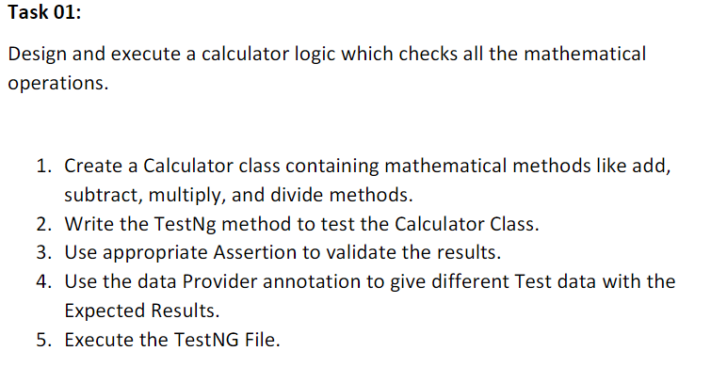

**CODE:**

package day9;

import org.testng.annotations.Test;

import org.testng.annotations.DataProvider;

public class ex1 {

@Test(dataProvider = "dp",priority=2)

public void add(Integer n1, Integer n2) {

System.out.println("add:"+n1+n2);

}

@Test(dataProvider = "dp",priority=1)

public void sub(Integer n1,Integer n2) {

System.out.println("sub"+(n1-n2));

}

@Test(dataProvider = "dp",priority=3)

public void mul(Integer n1,Integer n2) {

System.out.println("mul:"+(n1*n2));

}

@Test(dataProvider ="dp",priority=4)

public void div(Integer n1,Integer n2) {

System.out.println("div:"+(n1/n2));

}

@DataProvider

public Object[][] dp() {

return new Object[][] {

new Object[] { 30, 20 },

new Object[] { 34, 20 },

};

}

}

**OUTPUT:**

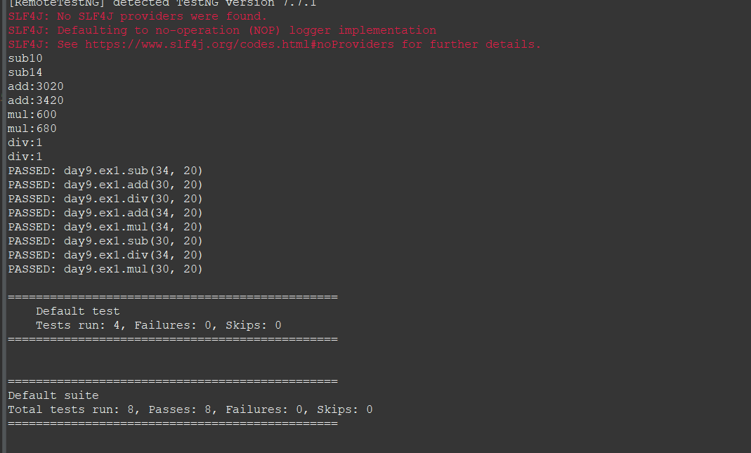

**CLASS EXERCISE 2**

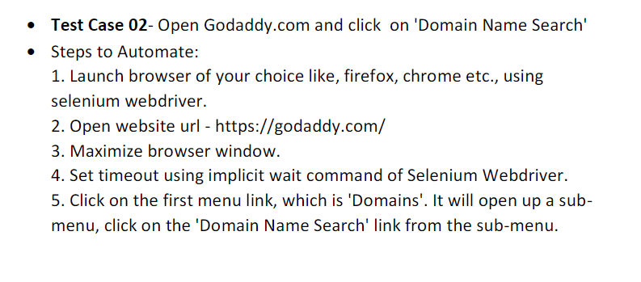

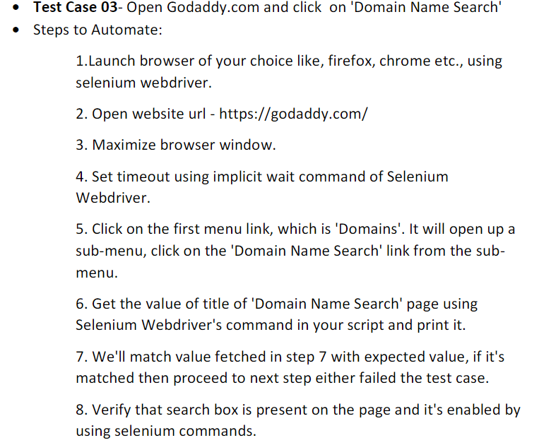

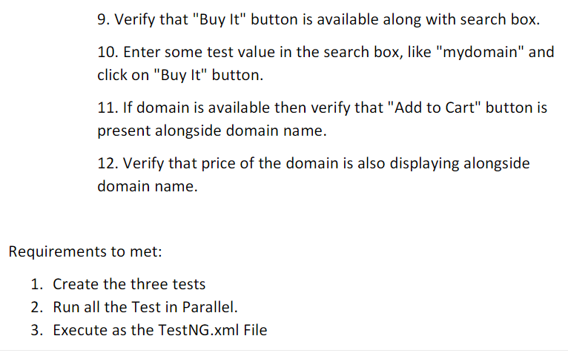

**CODE:**

package day9;

import org.testng.annotations.Test;

import io.github.bonigarcia.wdm.WebDriverManager;

import org.openqa.selenium.By;

import org.openqa.selenium.WebDriver;

import org.openqa.selenium.chrome.ChromeDriver;

import org.openqa.selenium.chrome.ChromeOptions;

import org.testng.Assert;

public class ex2 {

WebDriver driver;

*@Test*(groups="SmokeTest")

public void validate() {

ChromeOptions co = new ChromeOptions();

co.addArguments("--remote-allows-origins=*");

WebDriverManager.*chromedriver*().setup();

driver = new ChromeDriver(co);

driver.get("https://www.godaddy.com/");

driver.manage().window().maximize();

String actualTitle = driver.getTitle();

String expectedTitle = "Domain Names, Websites, Hosting & Online Marketing Tools - GoDaddy IN";

Assert.*assertEquals*(actualTitle, expectedTitle);

String actualUrl = driver.getCurrentUrl();

String expectedUrl = "https://www.godaddy.com/en-in";

Assert.*assertEquals*(actualUrl, expectedUrl);

}

*@Test*(groups="RegressionTestCase")

public void search() throws InterruptedException

{

ChromeOptions co = new ChromeOptions();

co.addArguments("--remote-allows-origins=*");

WebDriverManager.*chromedriver*().setup();

driver = new ChromeDriver(co);

driver.get("https://www.godaddy.com/");

driver.manage().window().maximize();

// driver.manage().timeouts().implicitlyWait(10, TimeUnit.SECONDS);//??? why stopped ....don't wait for exact 10 seconds..if next element loaded it breaks

Thread.*sleep*(3000);

driver.findElement(By.*xpath*("/html/body/header/div/section/div/div[1]/nav/div[2]/div[1]/ul/li[1]/button")).click();

Thread.*sleep*(3000);

driver.findElement(By.*linkText*("Domain Name Search")).click();;

}

*@Test*(groups="RegressionTestCase")

public void case3() throws InterruptedException

{

ChromeOptions co = new ChromeOptions();

co.addArguments("--remote-allows-origins=*");

WebDriverManager.*chromedriver*().setup();

driver = new ChromeDriver(co);

driver.get("https://www.godaddy.com/");

driver.manage().window().maximize();

Thread.*sleep*(3000);

driver.findElement(By.*xpath*("/html/body/header/div/section/div/div[1]/nav/div[2]/div[1]/ul/li[1]/button")).click();

Thread.*sleep*(3000);

driver.findElement(By.*linkText*("Domain Name Search")).click();

Thread.*sleep*(3000);

String title = driver.getTitle();

System.*out*.println(title);

Assert.*assertEquals*(title, "GoDaddy Domain Search - Buy and Register Available Domain Names");

Thread.*sleep*(5000);

boolean isSearchBoxPresent = driver.findElement(By.*name*("searchText")).isDisplayed();

Assert.*assertEquals*(isSearchBoxPresent, true);

}

}

Output:

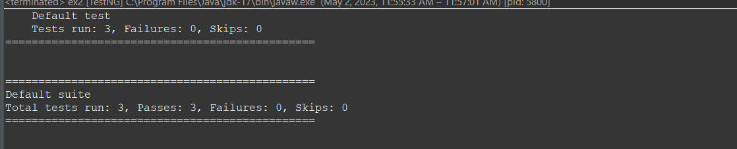

**CLASS EXERCISE 4**

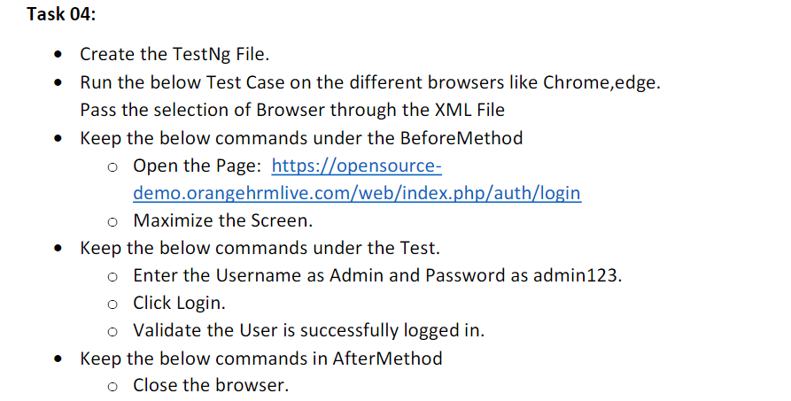

**CODE:**

package day9;

import org.testng.annotations.Test;

import io.github.bonigarcia.wdm.WebDriverManager;

import org.testng.annotations.BeforeMethod;

import org.testng.annotations.Parameters;

import org.openqa.selenium.By;

import org.openqa.selenium.WebDriver;

import org.openqa.selenium.chrome.ChromeDriver;

import org.openqa.selenium.chrome.ChromeOptions;

import org.openqa.selenium.edge.EdgeDriver;

import org.openqa.selenium.edge.EdgeOptions;

import org.testng.Assert;

import org.testng.annotations.AfterMethod;

public class ex4 {

WebDriver driver;

*@Test*

public void f() throws InterruptedException {

Thread.*sleep*(3000);

driver.findElement(By.*xpath*("/html/body/div/div[1]/div/div[1]/div/div[2]/div[2]/form/div[1]/div/div[2]/input")).sendKeys("Admin");

driver.findElement(By.*xpath*("/html/body/div/div[1]/div/div[1]/div/div[2]/div[2]/form/div[2]/div/div[2]/input")).sendKeys("admin123");

driver.findElement(By.*xpath*("/html/body/div/div[1]/div/div[1]/div/div[2]/div[2]/form/div[3]/button")).click();

Thread.*sleep*(3000);

String str=driver.findElement(By.*xpath*("/html/body/div/div[1]/div[1]/header/div[1]/div[1]/span/h6")).getText();

Assert.*assertEquals*(str, "Dashboard");

}

*@Parameters*({"browser"})

*@BeforeMethod*

public void beforeMethod(String browser) {

if(browser.equals("chrome")) {

ChromeOptions co = new ChromeOptions();

co.addArguments("--remote-allow-orginis=*");

WebDriverManager.*chromedriver*().setup();

driver = new ChromeDriver();

driver.get("https://opensource-demo.orangehrmlive.com/web/index.php/auth/login");

driver.manage().window().maximize();

}

else if(browser.equals("edge")) {

EdgeOptions co = new EdgeOptions();

co.addArguments("--remote-allow-orginis=*");

WebDriverManager.*edgedriver*().setup();

driver = new EdgeDriver();

driver.get("https://opensource-demo.orangehrmlive.com/web/index.php/auth/login");

driver.manage().window().maximize();

}

}

*@AfterMethod*

public void afterMethod() {

driver.close();

}

}

TestNG.XML

<?xml version="1.0" encoding="UTF-8"?>

<!DOCTYPE suite SYSTEM "https://testng.org/testng-1.0.dtd">

<suite name="Suite" parallel="false">

<test name="Test">

<parameter name="browser" value="chrome"></parameter>

<classes>

<class name="day9.ex4"/>

</classes>

</test> <!-- Test -->

</suite> <!-- Suite -->

**OUTPUT:**

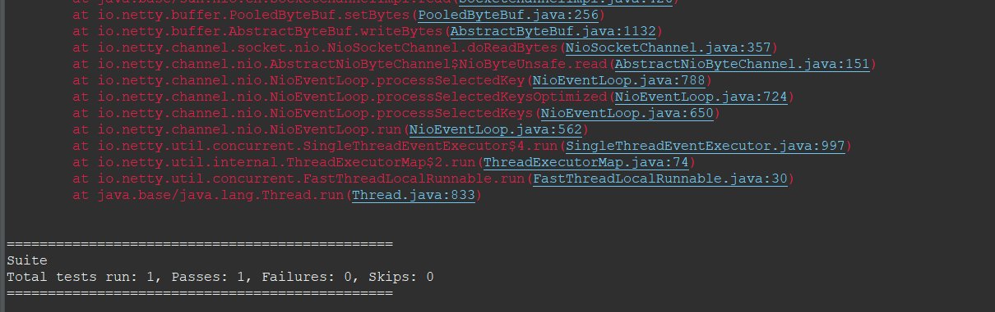

**CLASS EXERCISE 5**

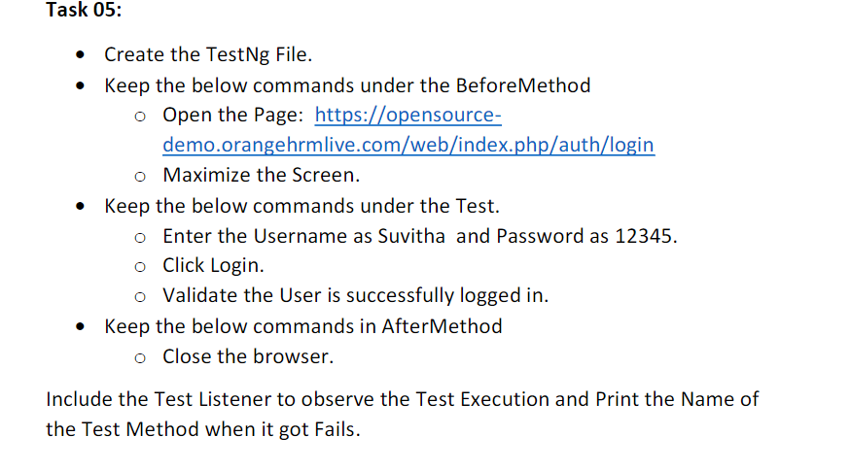

**CODE:**

package day9;

import org.testng.annotations.Test;

import io.github.bonigarcia.wdm.WebDriverManager;

import org.testng.annotations.BeforeMethod;

import org.openqa.selenium.By;

import org.openqa.selenium.WebDriver;

import org.openqa.selenium.chrome.ChromeDriver;

import org.openqa.selenium.chrome.ChromeOptions;

import org.testng.Assert;

import org.testng.annotations.AfterMethod;

public class ex5 {

WebDriver driver;

*@Test*

public void f() throws InterruptedException {

Thread.*sleep*(3000);

driver.findElement(By.*xpath*("/html/body/div/div[1]/div/div[1]/div/div[2]/div[2]/form/div[1]/div/div[2]/input")).sendKeys("Suvitha");

driver.findElement(By.*xpath*("/html/body/div/div[1]/div/div[1]/div/div[2]/div[2]/form/div[2]/div/div[2]/input")).sendKeys("12345");

driver.findElement(By.*xpath*("/html/body/div/div[1]/div/div[1]/div/div[2]/div[2]/form/div[3]/button")).click();

Thread.*sleep*(3000);

String str=driver.findElement(By.*xpath*("/html/body/div/div[1]/div[1]/header/div[1]/div[1]/span/h6")).getText();

Assert.*assertEquals*(str, "Dashboard");

}

*@BeforeMethod*

public void beforeMethod() {

ChromeOptions co = new ChromeOptions();

co.addArguments("--remote-allow-orginis=*");

WebDriverManager.*chromedriver*().setup();

driver = new ChromeDriver();

driver.get("https://opensource-demo.orangehrmlive.com/web/index.php/auth/login");

driver.manage().window().maximize();

}

*@AfterMethod*

public void afterMethod() {

driver.close();

}

}

**LISTENER**

package day9;

import org.testng.ITestContext;

import org.testng.ITestListener;

import org.testng.ITestResult;

public class listener implements ITestListener{

public static void main(String[] args) {

// **TODO** Auto-generated method stub

}

public void onTestStart(ITestResult result) {

// **TODO** Auto-generated method stub

System.***out***.println("Test started"+result.getName());

}

public void onTestSuccess(ITestResult result) {

// **TODO** Auto-generated method stub

System.***out***.println("Test succeed"+result.getName());

}

public void onTestFailure(ITestResult result) {

// **TODO** Auto-generated method stub

System.***out***.println("Test Failed"+result.getName());

}

public void onTestSkipped(ITestResult result) {

// **TODO** Auto-generated method stub

System.***out***.println("Test skipped"+result.getName());

}

public void onTestFailedButWithinSuccessPercentage(ITestResult result) {

// **TODO** Auto-generated method stub

System.***out***.println("Test Failed with success percentage"+result.getName());

}

public void onTestFailedWithTimeout(ITestResult result) {

// **TODO** Auto-generated method stub

System.***out***.println("Test Failed with Timeout"+result.getName());

}

public void onStart(ITestContext context) {

// **TODO** Auto-generated method stub

System.***out***.println("Test onstart");

}

public void onFinish(ITestContext context) {

// **TODO** Auto-generated method stub

System.***out***.println("Test onFinish");

}

}

**TestNG**

<?xml version="1.0" encoding="UTF-8"?>

<!DOCTYPE suite SYSTEM "https://testng.org/testng-1.0.dtd">

<suite name="Suite">

<listeners>

<listener class-name="day9.listener"></listener>

</listeners>

<test thread-count="1" name="Test">

<parameter name="browser" value="chrome"></parameter>

<classes>

<class name="day9.ex5"/>

</classes>

</test> <!-- Test -->

</suite> <!-- Suite -->

**OUTPUT:**

