**Unveiling marketing insights**

INTRODUCTION :

Marketing insight integrates personal and professional experiences with precisely gathered and analyzed data. You can’t accomplish anything worthwhile if you don’t know what you should do with the data you already have.

It is essential to monitor the effectiveness of a marketing campaign at every stage of its development. By doing this, you’ll be able to create better campaigns in the future based on what you see, and you’ll be able to track the success of these campaigns through insights.

OVER VIEW :

Marketing insights are all about understanding your customers – who they are, what they like, what they don't, what they're looking for, and how well your marketing efforts are communicating that you can help them find it.

PURPOSE:

The goal of a market Insight is to bring understanding and clarity through the conveyance of fresh perspectives. Further ,market insight shouldn't be confused with consumer insight -market insight address not individuals, but professionals In a field directly impacted by innovation.

PROBLEM DEFINITION AND DESIGN THINKING:

Market problems are your target market's stated or silent problems. This could refer to existing inefficiencies, awkward workflows or non-optimal solutions. The key to finding a market problem is to listen for frustrations, or “if only” statements, that arise during interviews.Design thinking is a systemic, intuitive, customer-focused problem-solving approach that organizations can use to respond to rapidly changing environments and to create maximum impact.

EMPATHY MAP:

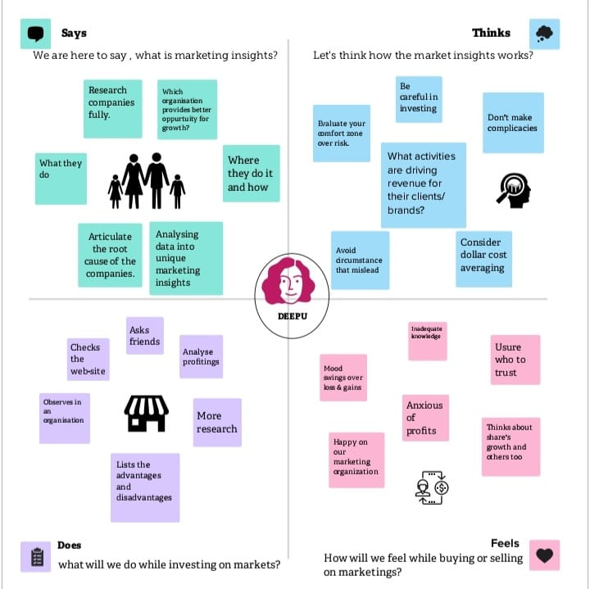

BRAINSTROMING:

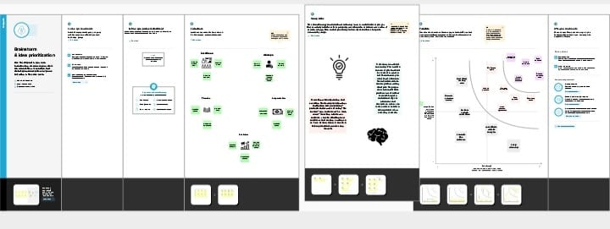

RESULT:

marketing insights translate big data into meaningful information that you can use to inform decisions and drive better results, as noted by Mediatool.

STORY 1:

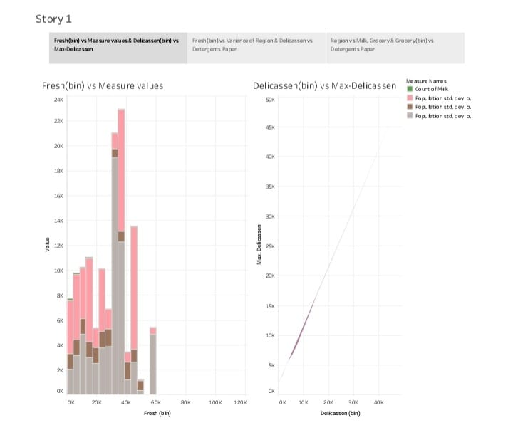

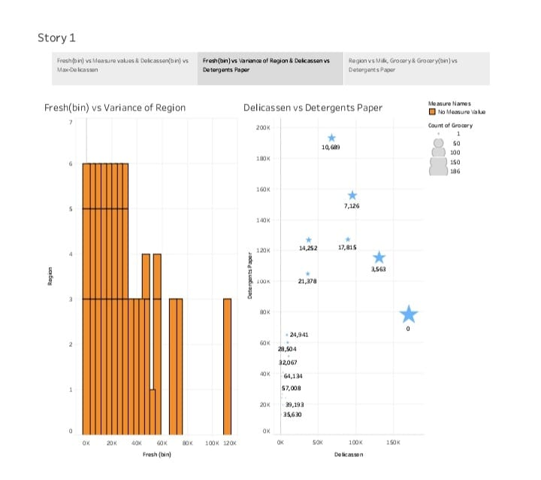

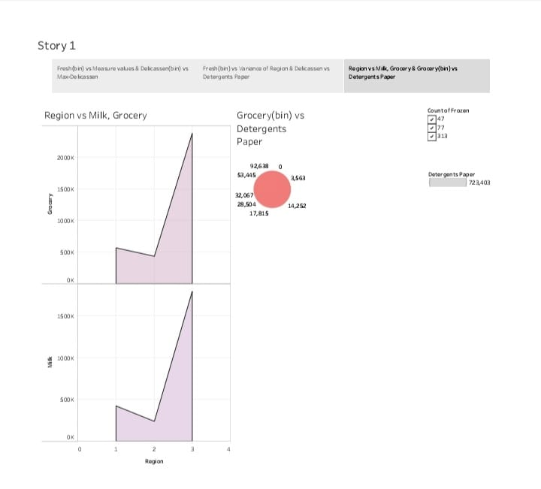

STORY 2:

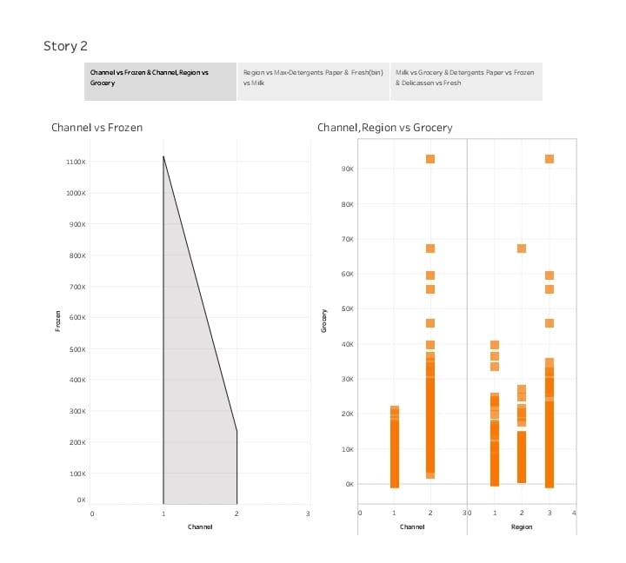

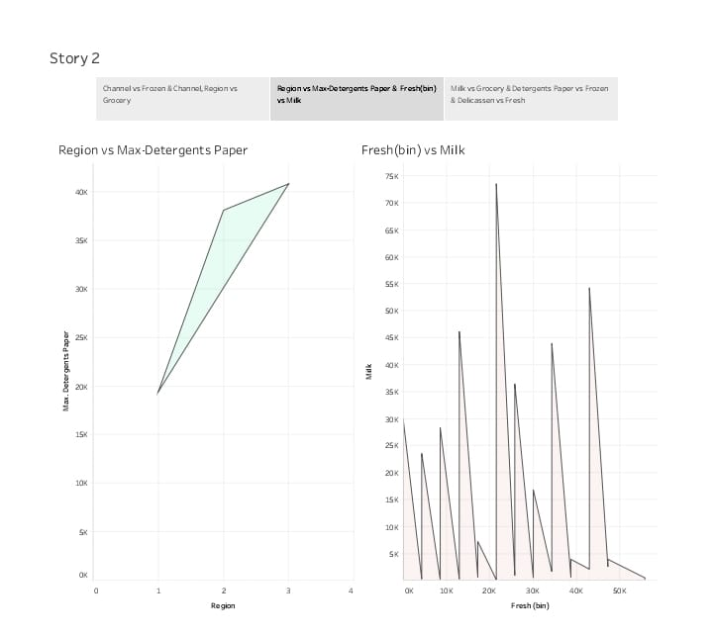

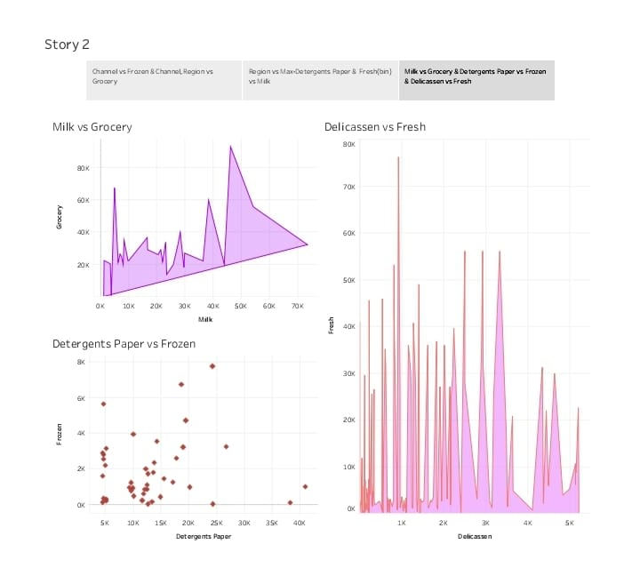

ADVANTAGES:

* Promotes Your Business to a Target Audience. ...
* Helps You Understand Your Customers.

DISADVANTAGES:

* Costs of Marketing.
* Time and Effort May Not Yield a Return.

APPLICATION:

marketing is applied when communicating the value of a company's product to potential customers. This value communication seeks to justify the price of the product. Customers satisfied with the features and benefits are more likely to purchase the product.

CONCLUSION:

Marketing plays a very important role in every organisation as ir enhance the efficiency and effectiveness of working of the comany.

FUTURE SCOPE:

Future market insight has an overall rating of 2.7 out of 5, based on over 227 review left anonymous by employee. 34% of employees would recommend working at Future market insights to a friend and 29% have a posi Outlook for the business.

APPENDIX:

The purpose of the appendix is to provide supporting documentation or evidence for key component in your business plan . While you may include charts in graph in the body of your your plan,these should be summary project ,while the fully detailed charts and tables would be found in th appendix.