**Project Document**

**Title: Streamlining Ticket Assignment for Efficient Support Operations**

**1. Introduction**

The objective of this initiative is to implement an automated system for ticket routing at ABC Corporation, aimed at improving operational efficiency by accurately assigning support tickets to the appropriate teams.  
This solution will:

* Reduce delays in issue resolution
* Enhance customer satisfaction
* Optimize resource utilization within the support department

**2. System Setup and Configuration**

**2.1 Create Users**

Steps to create users in ServiceNow:

1. Open ServiceNow
2. Navigate to All → Users under *System Security*
3. Click New
4. Fill in required details
5. Click Submit
6. Repeat to create additional users

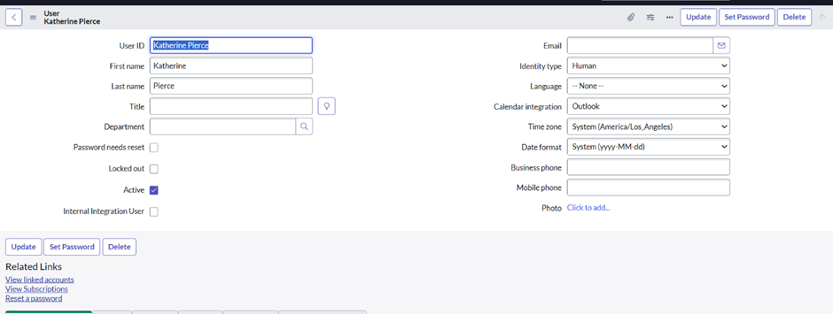

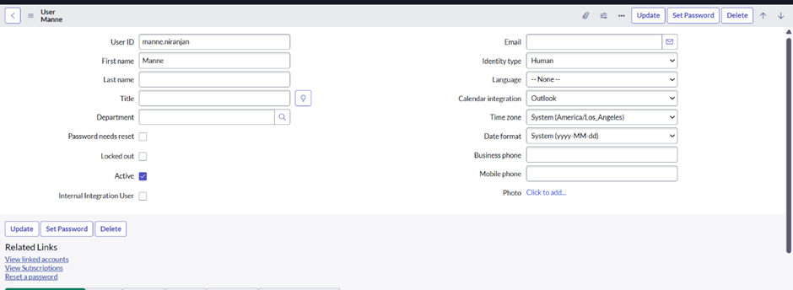

**2.2 Create Groups**

1. Open ServiceNow
2. Navigate to All → Groups under *System Security*
3. Click New
4. Fill in required details
5. Click Submit
6. Repeat to create additional groups

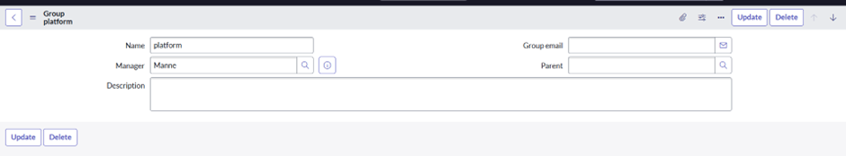

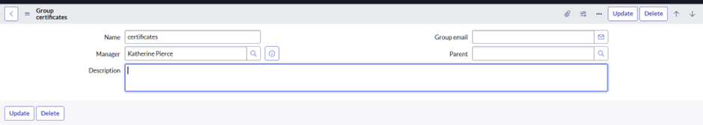

**2.3 Create Roles**

1. Open ServiceNow
2. Navigate to All → Roles under *System Security*
3. Click New
4. Provide role details
5. Click Submit
6. Repeat for additional roles

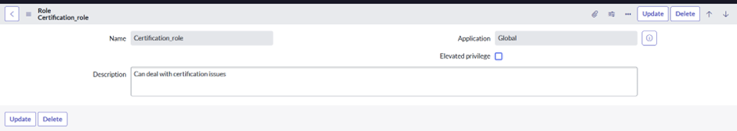

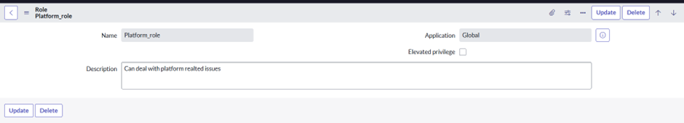

**2.4 Create Table**

1. Open ServiceNow
2. Navigate to All → Tables under *System Definition*
3. Click New
4. Enter:
   * Label: Operations Related
   * Check: *Create module* & *Create mobile module*
   * Menu name: Operations Related
   * Define columns as needed
5. Click Submit

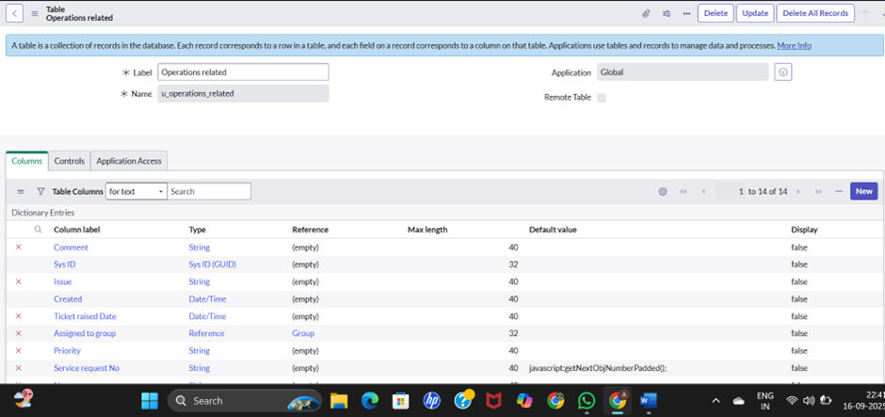

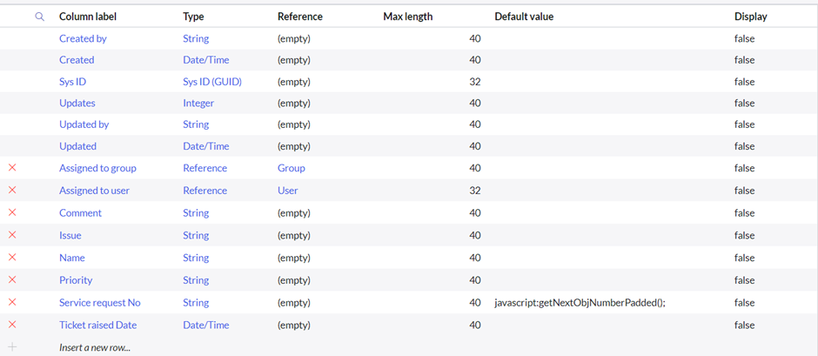

**2.5 Create Choices for Issue Field**

Choices configured:

* Unable to login to platform
* 404 error
* Regarding certificates
* Regarding user expired

**3. Role and Group Assignments**

**3.1 Assign Roles & Users to Certificate Group**

* Add Katherine Pierce as group member
* Assign Certification_role

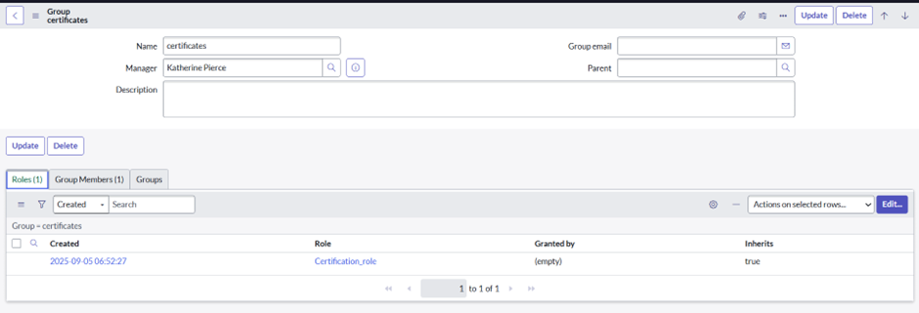

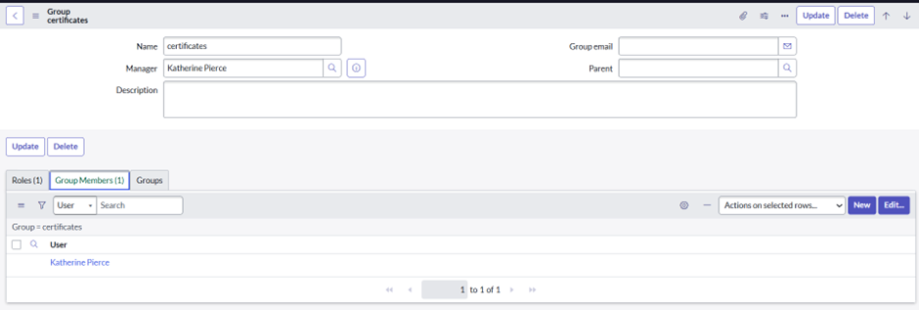

**3.2 Assign Roles & Users to Platform Group**

* Add Manne Niranjan as group member
* Assign Platform_role

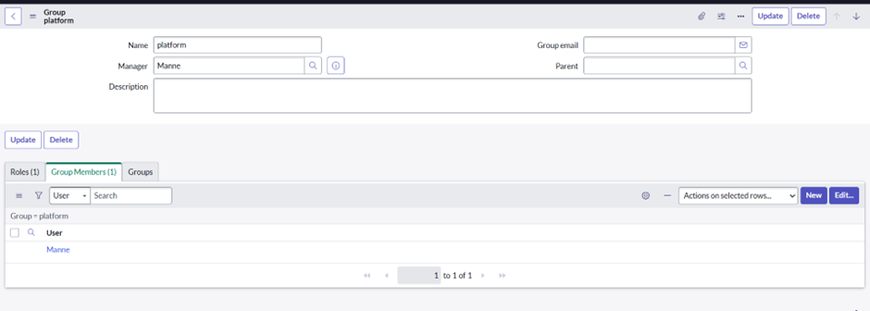

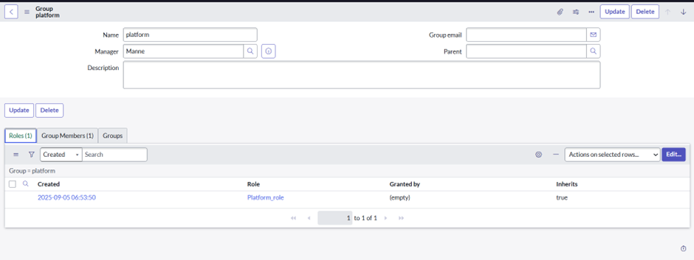

**3.3 Assign Role to Table**

1. Navigate to the Operations Related table
2. Update *Application Access* with required roles:
   * Platform_role
   * Certification_role
3. Configure for both *Read* and *Write* operations

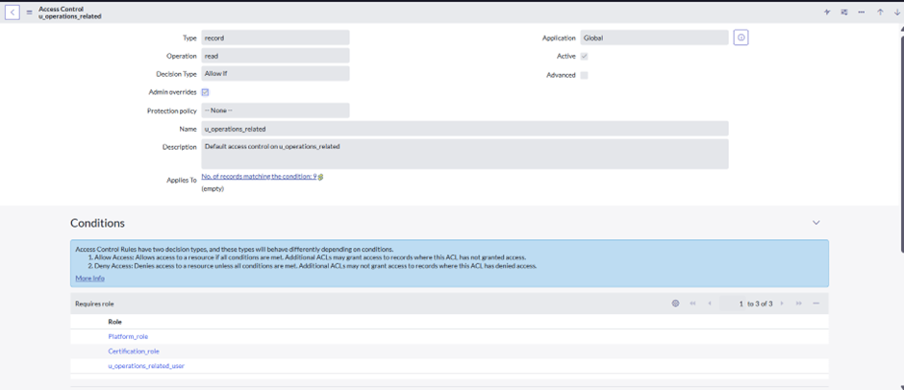

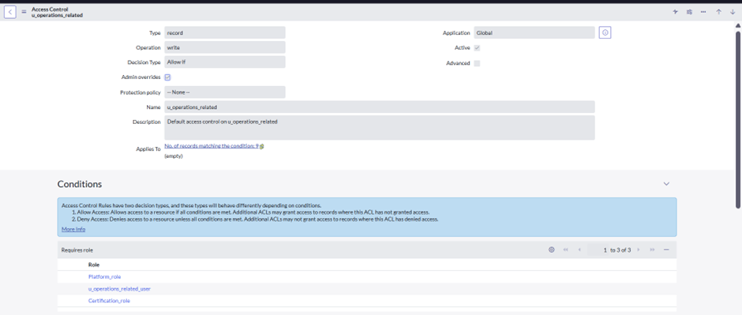

**4. Access Control (ACL) Creation**

1. Navigate to All → ACL under *System Security*
2. Click New
3. Configure ACL with admin role under *Requires Role*
4. Create 4 ACL entries for specific fields as required

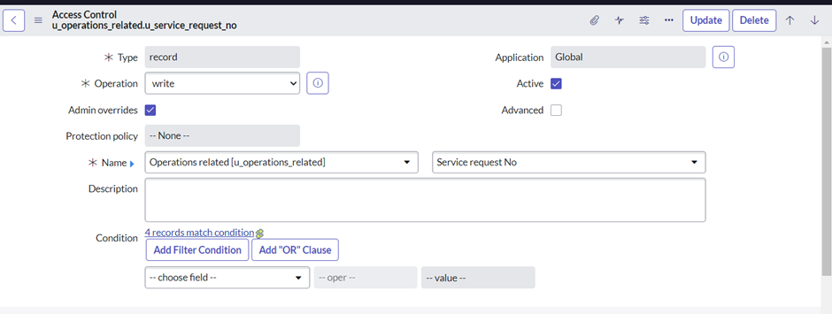

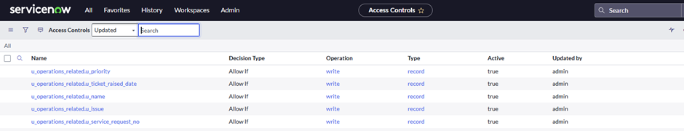

**5. Flow Automation**

**5.1 Flow for Certificate Group**

* Flow Name: Regarding Certificate
* Trigger: Create or update record in *Operations Related* table
* Condition: Issue = "Regarding Certificates"
* Action: Update record → Assign to group = Certificates

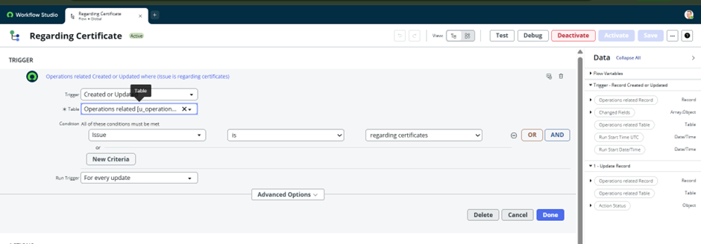

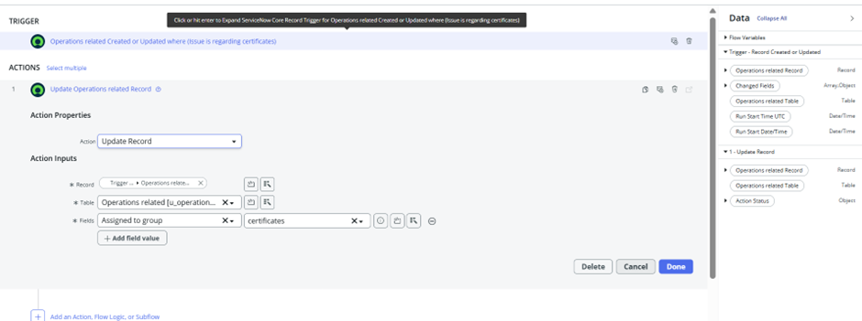

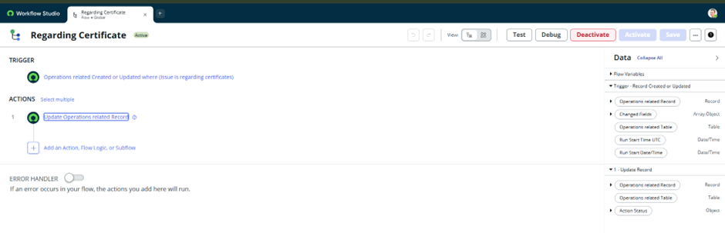

**5.2 Flow for Platform Group**

* Flow Name: Regarding Platform
* Trigger: Create or update record in *Operations Related* table
* Conditions:
  + Issue = Unable to login to platform
  + Issue = 404 Error
  + Issue = User expired
* Action: Update record → Assign to group = Platform

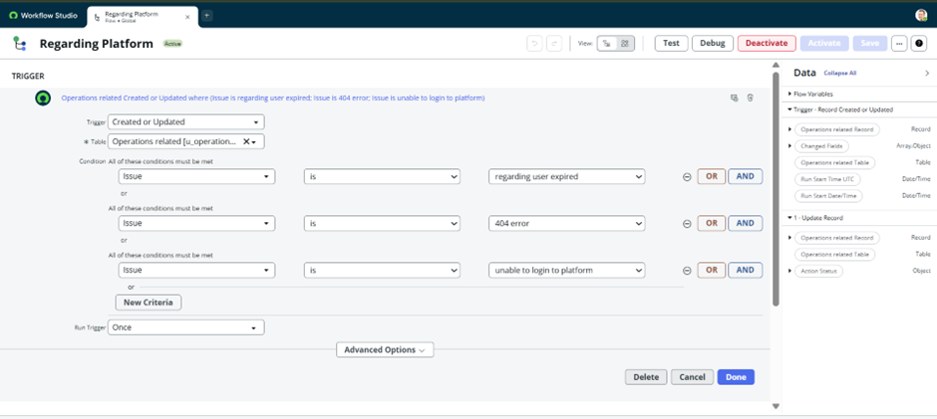

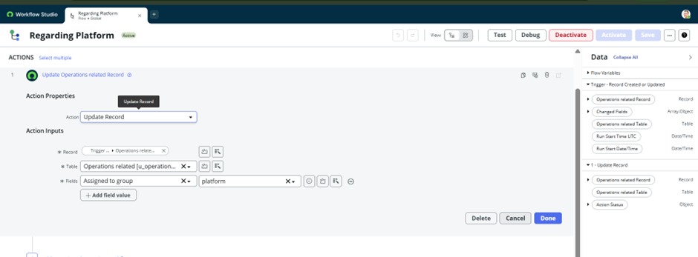

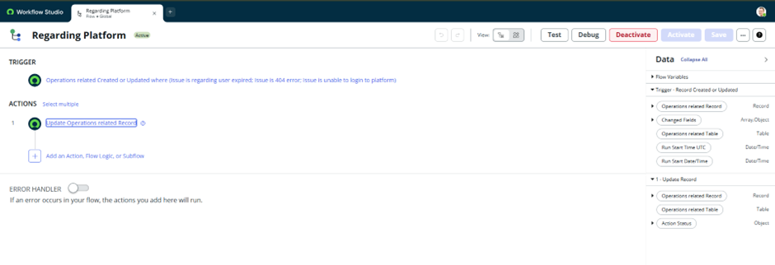

**6. Final Outcome**

The automated system ensures that tickets are dynamically assigned to the correct groups (Certificates or Platform) based on the issue field. This results in:

* Faster issue resolution
* Improved customer experience
* Optimized use of support resources

