**Phase 6: User Interface Development**

**Goal:**  
Provide a functional Salesforce Lightning UI for Agents and Managers to manage Customers, SIM activations/cancellations, and Service Requests efficiently, with only essential features.

**1. Lightning App**

**Purpose:** Central workspace for Agents and Managers.

**Steps:**

1. Setup → **App Builder → Apps → New Lightning App**
2. Enter Details:
   * Name: **Telecom Service Hub**
   * Description: Telecom CRM for Customer & SIM Request Management
   * Logo & Theme (optional)
3. Navigation: **Standard Navigation**
4. Add Tabs:
   * **Customers (Customer__c)**
   * **Service Requests (Service_Request__c)**
   * **Plans (Plan__c)**
5. Assign App to **Agent** and **Manager** profiles
6. Click **Finish → Save**

**Impact:** Users have a single workspace with quick access to main objects.

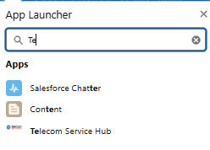



**2. Tabs**

**Purpose:** Quick access to main objects.

**Steps:**

* Ensure **Custom Object Tabs** exist for Customer__c and Service_Request__c
* Use existing tab for Plan__c

**Impact:** Objects are accessible from the app navigation.

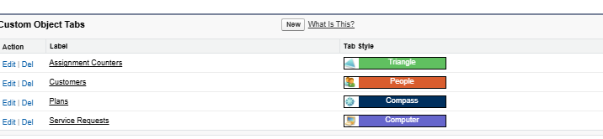

**3. Record Pages**

**Purpose:** Customize layout for clarity and efficiency.

**Steps:**

1. Setup → **Object Manager → Customer / Service_Request__c → Lightning Record Page**
2. Add Components:
   * **Highlights Panel**: Key fields like Status, Plan, Priority
   * **Related Lists**: Service Requests per Customer
3. Assign Lightning Page to **Agent** and **Manager** profiles
4. Save & Activate

**Impact:** Shows important information clearly for workflow efficiency.

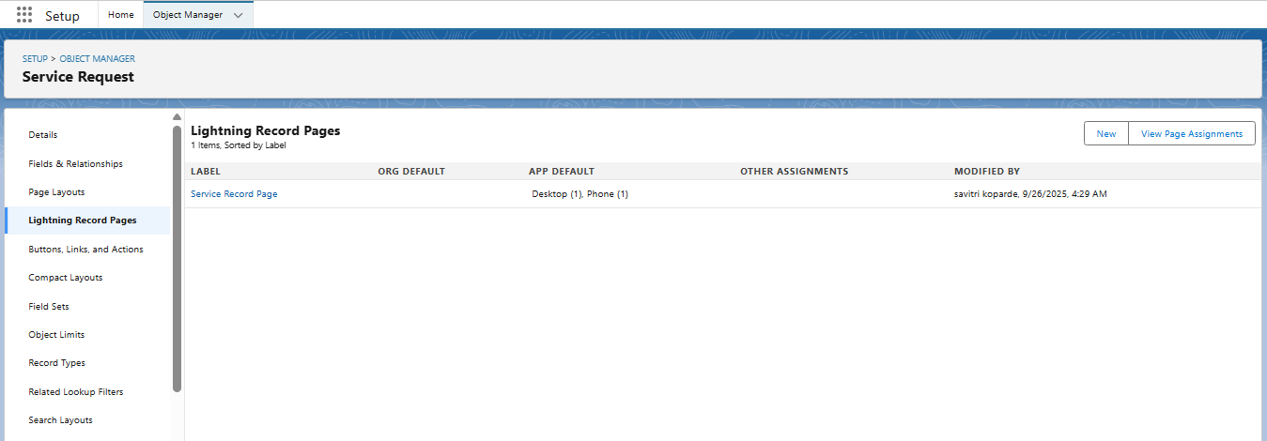

Structure:

