1. Download java 11+ version from: <https://www.oracle.com/technetwork/java/javase/downloads/jdk11-downloads-5066655.html>
2. Install it on your PC and remember the path where you installed it.
3. Download and install Google Chrome: <https://www.google.com/intl/en_ALL/chrome/>
4. Unzip Traiding bot.
5. Open file config.txt
6. Write your apikey, login, password

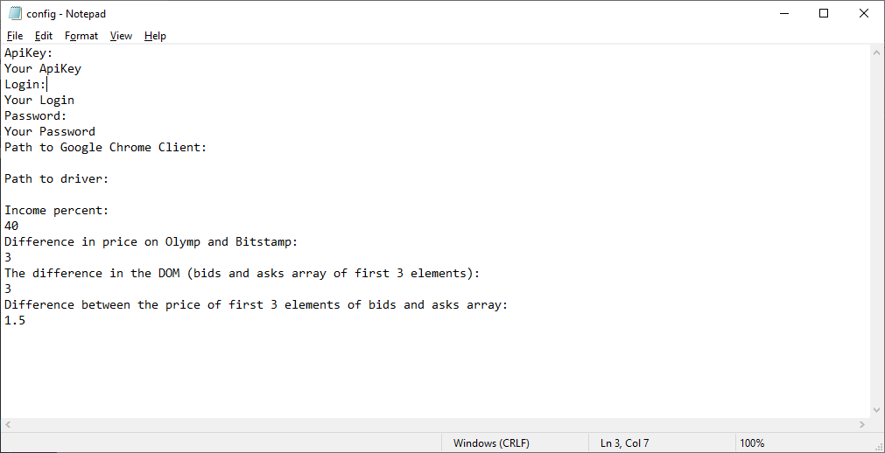

1. Then you need to enter path to your Google Chrome client directory

Tutorial: <https://www.howtogeek.com/255653/how-to-find-your-chrome-profile-folder-on-windows-mac-and-linux/>

Example: C:\Users\Tom\AppData\Local\Google\Chrome\User Data\Default

1. Next enter path to driver, it will be in the directory where you unzip Bot.

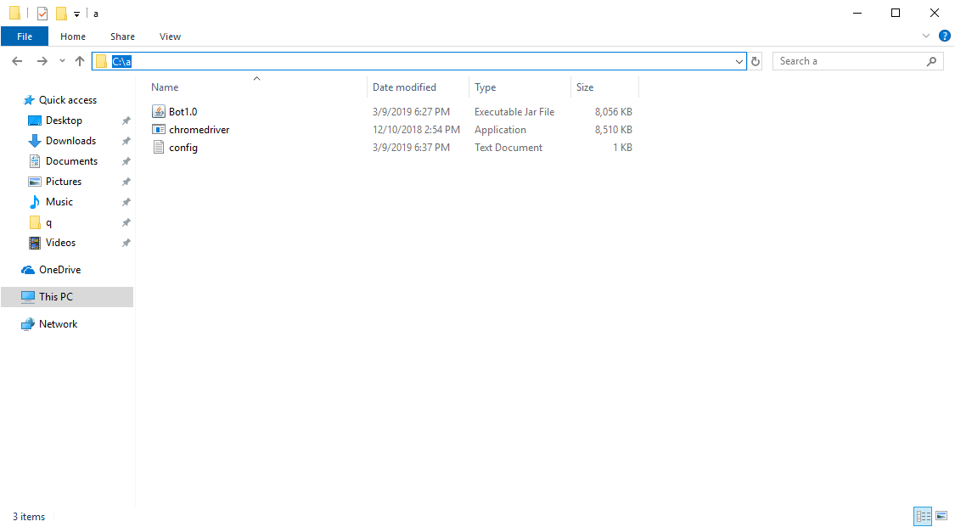

Example: C:\a\chromedriver.exe

1. Open command window (write cmd in windows search)
2. Enter this command:

"C:\Program Files\Java\jdk-11.0.2\bin\java.exe" -jar d:\a\Bot1.0.jar d:\a\config.txt

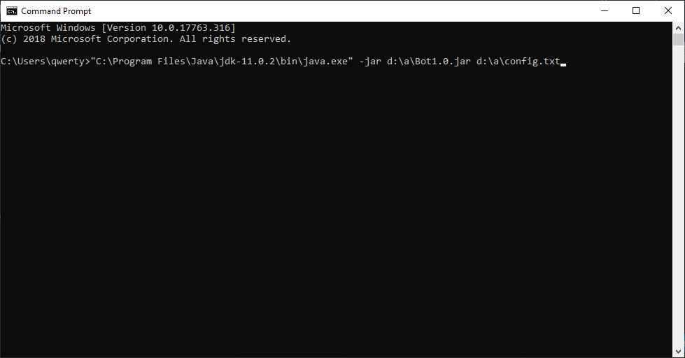

Path to unzipped bot and config.txt file.

Look step 4.

Path to installed java.   
 Look step 1.

1. If everything was right, you will see this:

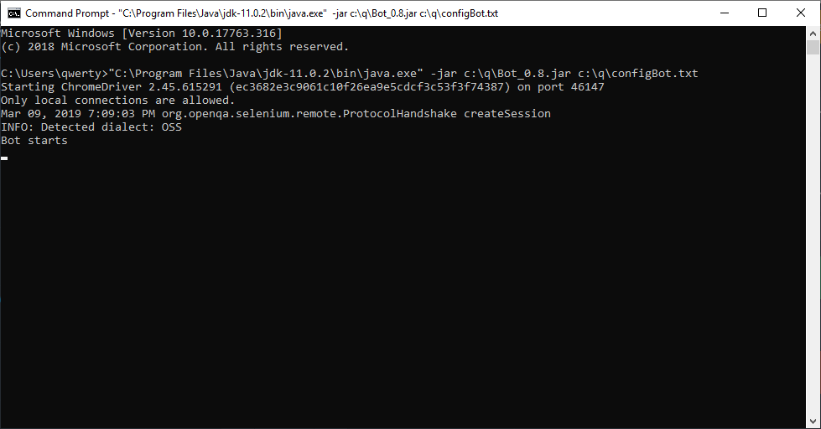

If you have any questions you can write to our support team: <https://t.me/OlympTradeBotSupport>