**Aim**: Commands in Impala

**impala-shell**

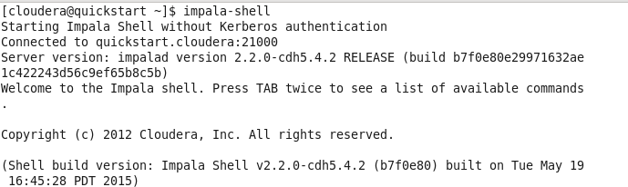

**select version();**

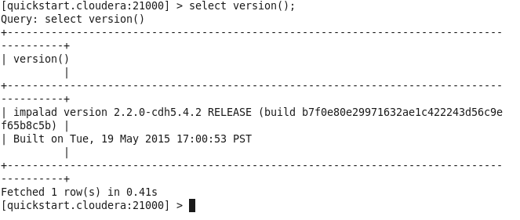

***Show databases:****This command will list existing databases in Impala*.

**show databases;**

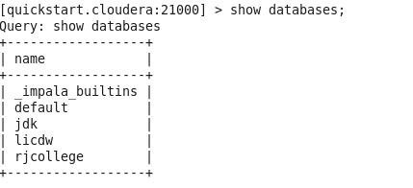

**select current_database();**

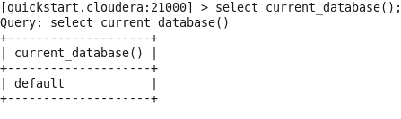  
  
**show tables**;

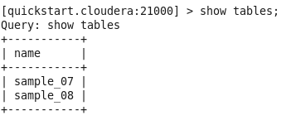  
  
**show tables in jdk;**



**show tables like 'sample*';**  
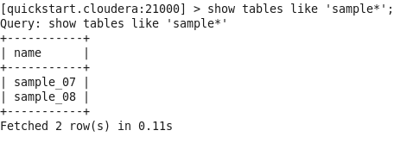

***Create a database:****This command is used to create a database.*

***Syntax:*** *create database <database_name>*

**create database RJ;**

  
  
**show databases;**

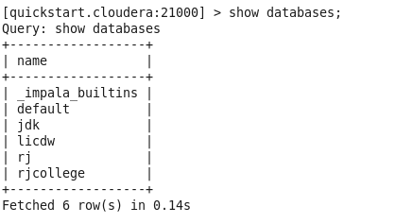

**use RJ;**  


***Create table:****This command is used to create tables.*

***Syntax:*** *create table <table_name>(field_name1 data_type, field_name2 data_type);*  
**create table t1 (x int);**  
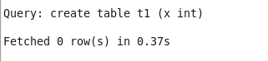

**Show tables is used to view all the tables in current database**

**show tables;**

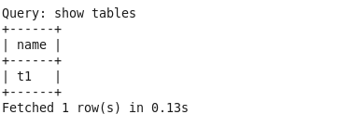  
  
**select current_database();**

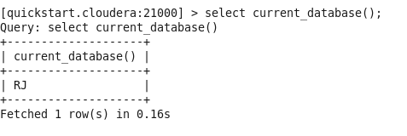

***Insert:****This command is used to insert records in either overwrite or append records in tables.*

***Syntax:*** *Insert into <database_name>.<table_name> values(field_value1,* field_value2)  
**insert into t1 values (1),(3),(2),(4);**

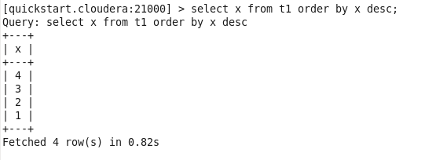

**Order by : This is used to sort the data**

**select x from t1 order by x desc;**

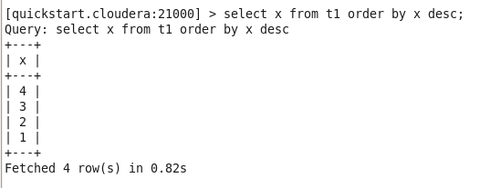

***Aggregate functions*:**

**select min(x), max(x), sum(x), avg(x) from t1;**

