INTRODUCTION

The objective of the project was to create innovative and interactive Tableau dashboards that focus on potential commodities, countries, year, trade amount and quantity.
The dataset provided contained 59090 observations of 10 variables.

Country or Area | There were three countries – Australia, Canada, and the USA
Year | The Year variable ranged from 1988 to 2016
Comm Code | The commodity code was unique for each commodity. Example: 10111 for Horses, live pure bred
Commodity | The commodity variable contained various trade commodities that belonged to each of the 12 categories.
Flow | This indicates flow of trade. They are Export, Import, Re-Import, and Re-Export.
Trade Usd | The trade value in US Dollars
Weight | The total weight of the traded commodity in Kgs
Quantity Name | Quantity name of the traded commodity
Quantity | The total quantity of the traded commodity
Category | There were 12 unique categories in the data.

ANALYSIS
OBJECTIVE 1
To find the market size from the given dataset based on quantity

What is market size?
Market size refers to the total amount of sales, revenue, or demand for a specific product, service, or category within a particular market. It is usually measured in terms of the volume or value of goods or services sold or the number of customers or users who purchase them. Market size is an essential metric for businesses and investors who want to assess the potential growth and profitability of a market or industry. It can also provide insights into the competition, pricing, and customer preferences within a market.

Requirements:
So, to make an analysis of the market size, I have renamed the field ‘Trade Usd’ to ‘Trade in USD’ to get a better understanding of the field name.
I have then dropped the fields ‘Flow’ and ‘Year’ in the filters section. After dropping them in the section we get a pop-up for ‘Flow’ it gives me options to choose from ‘Export’, ‘Import’, ‘Re-export’, ‘Re-import’. Similarly we get a pop-up for ‘Year’ and we make the choice of year.
Then we drop the Quantity on the size for representation of the market size, Country on text to give text name. For a colourful look I have dropped the Trade in USD on the colour mark.
Finally, added caption and title name to the sheet.

A few observations for the dataset analysis:
1) From 1988 to 2016, the USA has been the largest exporter, importer, and re-exporter of commodities. Whereas Canada has been the largest re-importer of commodities.
2) The USA has never re-imported commodities throughout these years.

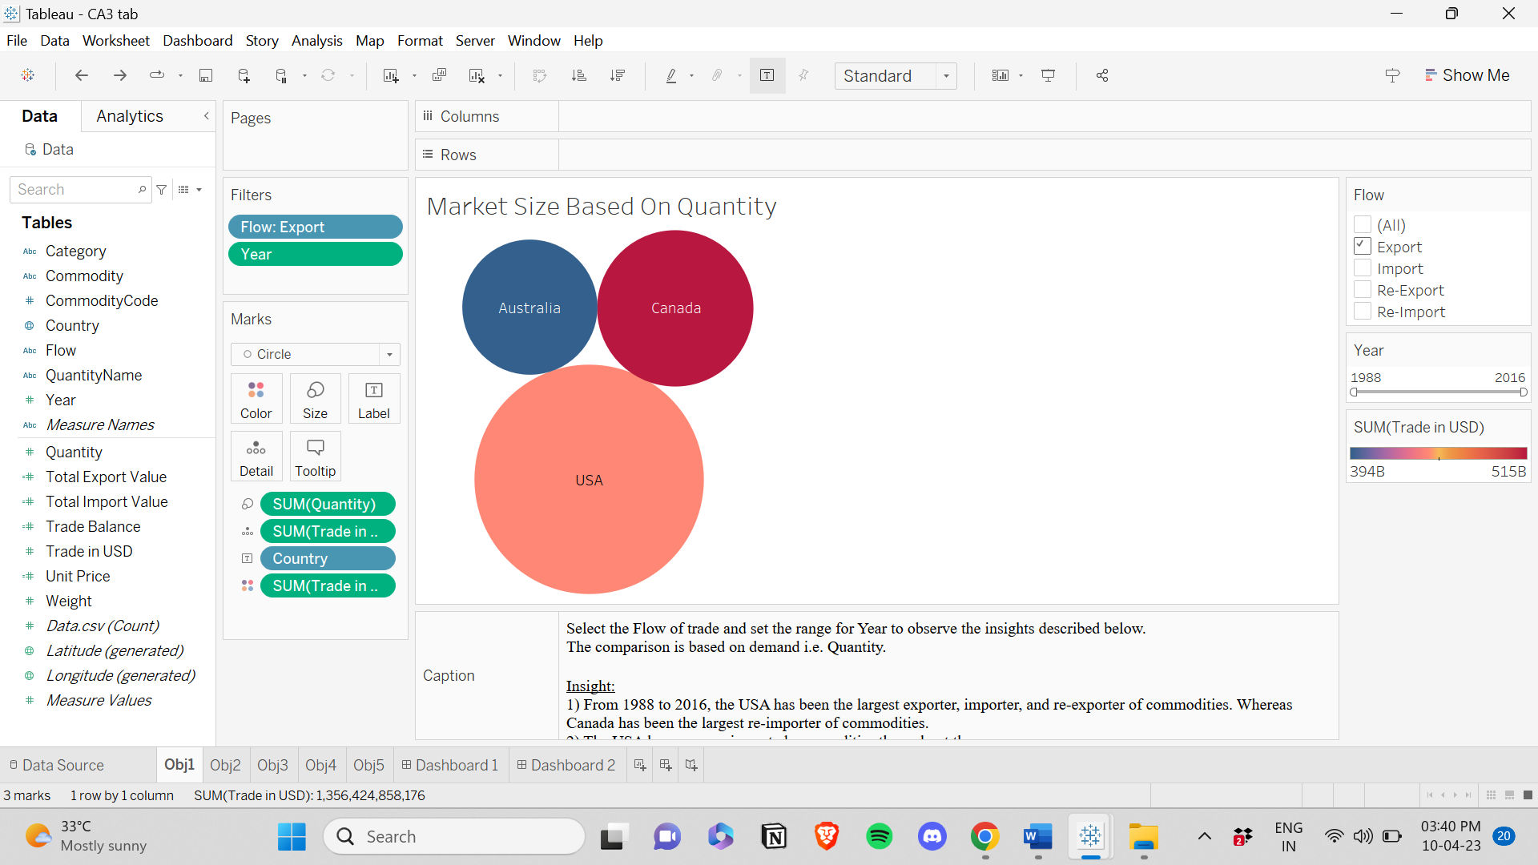

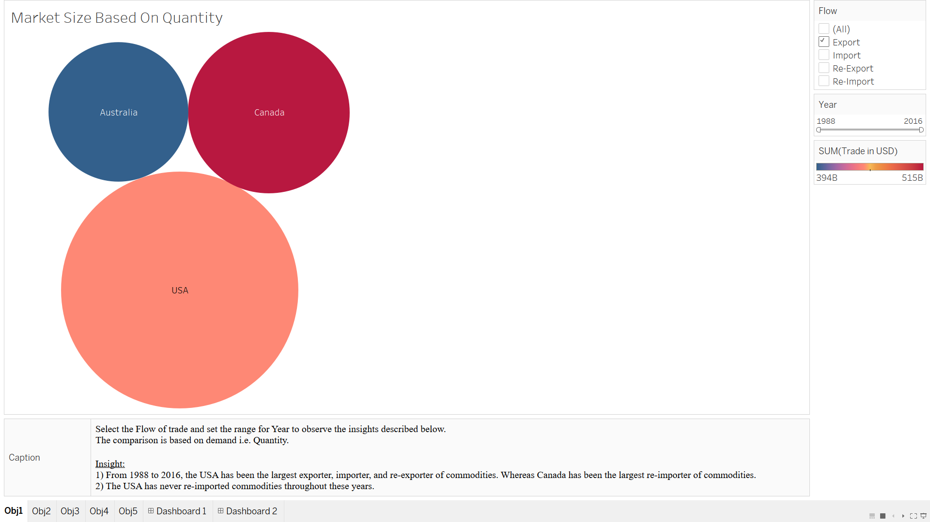
OBJECTIVE 2 :
To analyze the trade market (import, export, re-export, re-import)

What is trade market?
The term "trade market" typically refers to a marketplace where various goods and services are bought and sold between buyers and sellers. This can include physical marketplaces such as traditional brick-and-mortar stores, as well as online marketplaces like Amazon, eBay etc.

The trade market plays a crucial role in the economy as it allows for the exchange of goods and services between producers and consumers, which helps to allocate resources efficiently and spur economic growth. In addition, the trade market can also provide opportunities for investors to trade securities such as stocks, bonds, and currencies, which can be bought and sold on stock exchanges and foreign exchange markets.

Requirements:
To analyze the trade market, I first dropped the field ‘Year’ and ‘Quantity’ in columns and rows respectively. Then I applied ‘Flow’ to filters and this time choose, ‘Export’ to show the analysis of export data of the trade market between the three countries. To add colour definition I added the country field on the colour marks. Finally added caption and title to the sheet

To list a few observations from the visualization :
The data collected from 1988 to 2016 indicates:
1) Australia hasn't re-exported commodities since the year 2000.
2) Canada began re-exporting commodities from the year 2000.
3) In the year 2016, Canada was the largest re-exporter of commodities.
4) The USA has been dominant in export, import and re-export of commodities from 1988 to 2016.
5) The USA has never re-imported commodities.

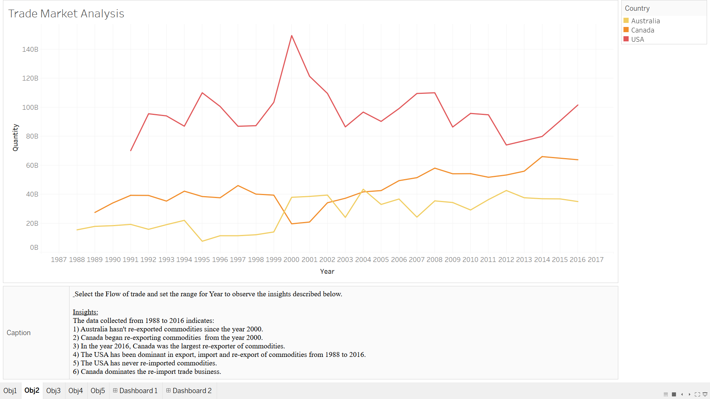
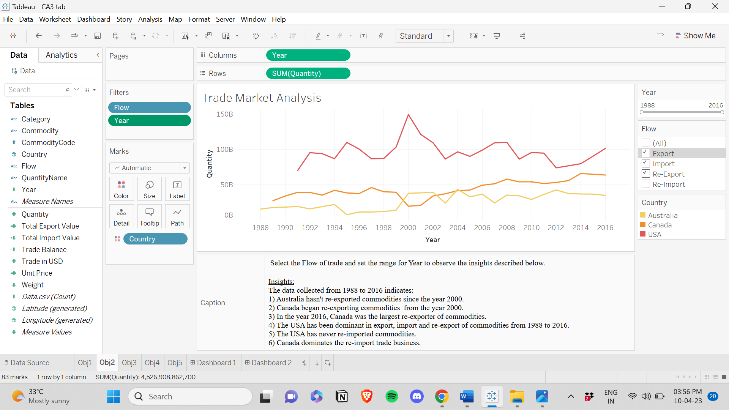

OBJECTIVE 3 :
To find the trade value

What is trade value?
Trade value refers to the worth or price of goods or services that are exchanged in a trade or transaction. It can be calculated in various ways, such as based on the market demand and supply, production costs, quality of the goods or services, and competition. The trade value of a product or service can also be influenced by economic factors such as inflation, interest rates, and currency exchange rates. Understanding trade value is important for businesses, governments, and individuals involved in trade as it helps them make informed decisions about buying and selling goods and services.

Requirements:
For this objective to fulfil, I dropped the flow and filtered it based on import for representation, where we can select from various other options as well. I then dropped Year and Trade in USD in filers as well. The representation for this objective was symbols map.

OBSERVATIONS:

The map displays the selected country and its total trade value based on the selected trade flow - export, import, re-export, or re-import.
The Flow filter for the USA will not show Re-import, as there is no re-import activity in the country from the given data. Similarly, Australia will not show Re-export, as the re-export activity in Australia stopped since 1999.

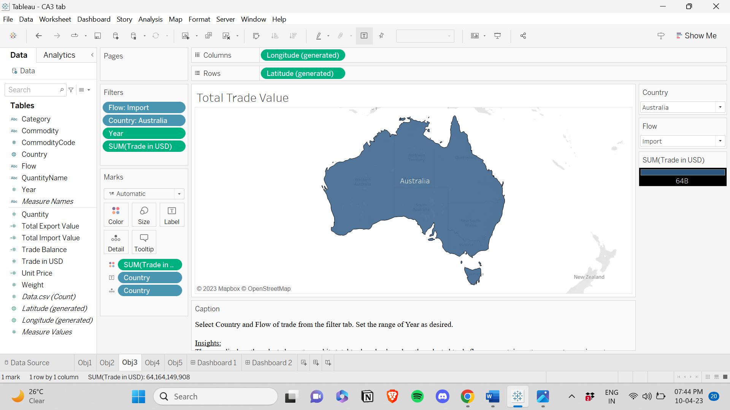
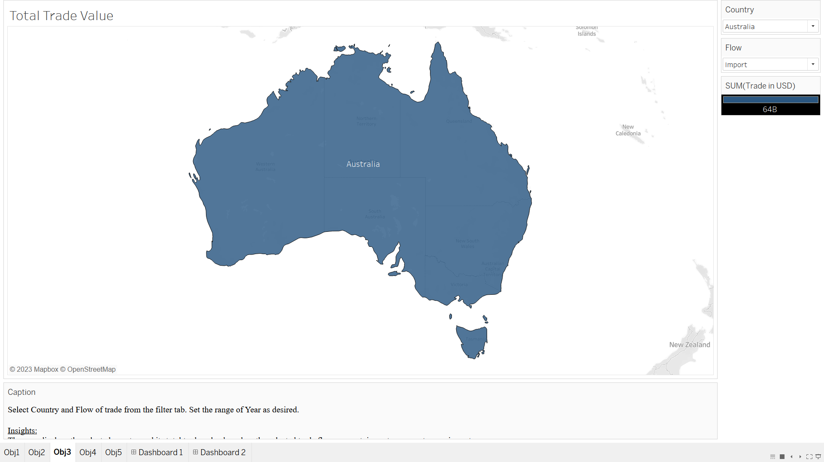

OBJECTIVE 4 :
Comparing the category, country wise and quantity

Requirements:
For this objective I have dropped the Flow in the filters section and the chosen Import for demo purpose. I have then dropped Country , Category and Year in the filters. As for the columns I have dropped Quantity field and in the rows I have dropped Country and Category to make the respective visualization

A few observations from the analysis:
There are 12 categories in the given data. Each category has a list commodity.
Per the country and the flow of trade, we can observe the ranking of categories based on demand i.e., Quantity. Example: When we select Australia and Export from the filter tabs, we can observe the top categories.
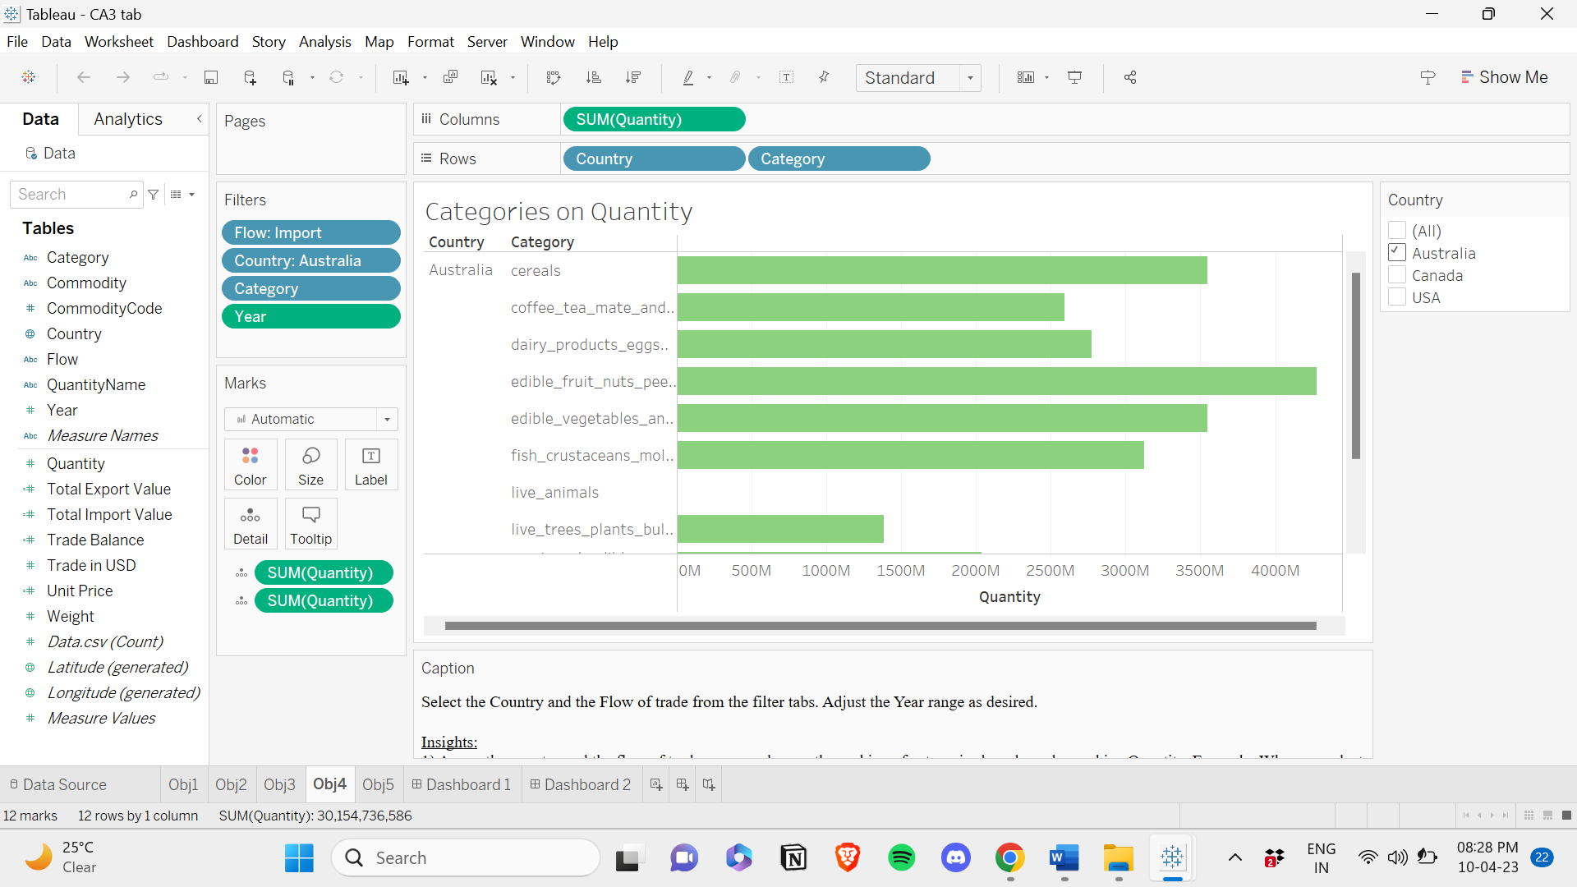
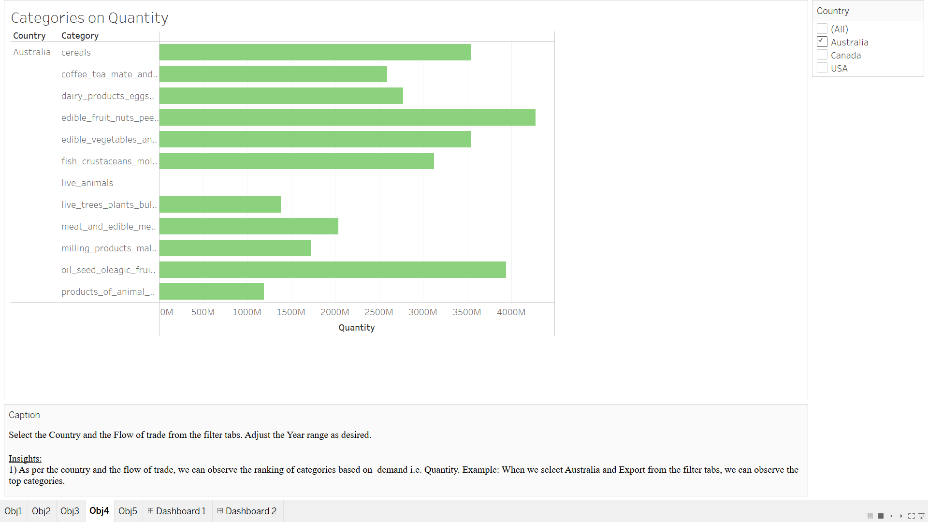

OBJECTIVE 5 :
Before getting started for doing this objective, I have made 2 calculated fields:
Total Import Value and Total Export Value.

The formula used for Total Import Value is:
IF ([Flow] = 'Import') THEN
[Trade in USD] END

The formula used for Total Export Value is:
IF ([Flow] = 'Export') THEN
[Trade in USD] END

For this objective to be complete I have dropped the flow selecting all the option in the filers section. Then I have dropped Country as we need to compare the categories country wise, for this example I have chosen Australia. Then I have dropped Year and Measure Names in the filters section.
Next to make a comparison I have dropped the Year into the Column and Total Import Value, Total Export Value and Trade Balance into the rows.

Observation:
The Trade balance has been calculated by subtracting the total import value from the total export value. It measures the country's net income earned on international assets. If the Trade Balance is positive, then it is called Trade Surplus, while a negative value is called Trade Deficit.
The Trade Balance has been positive for the three countries throughout the years 1988 - 2016, indicating Trade Surplus.
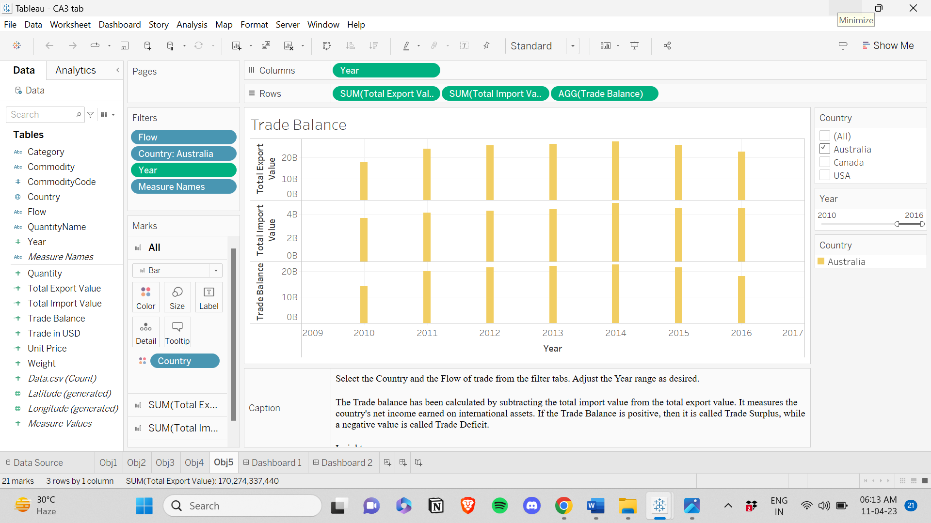
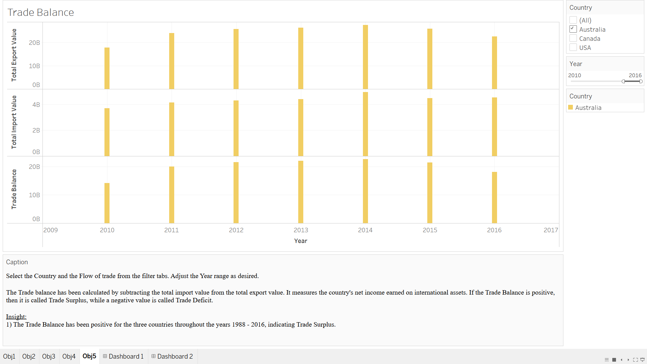

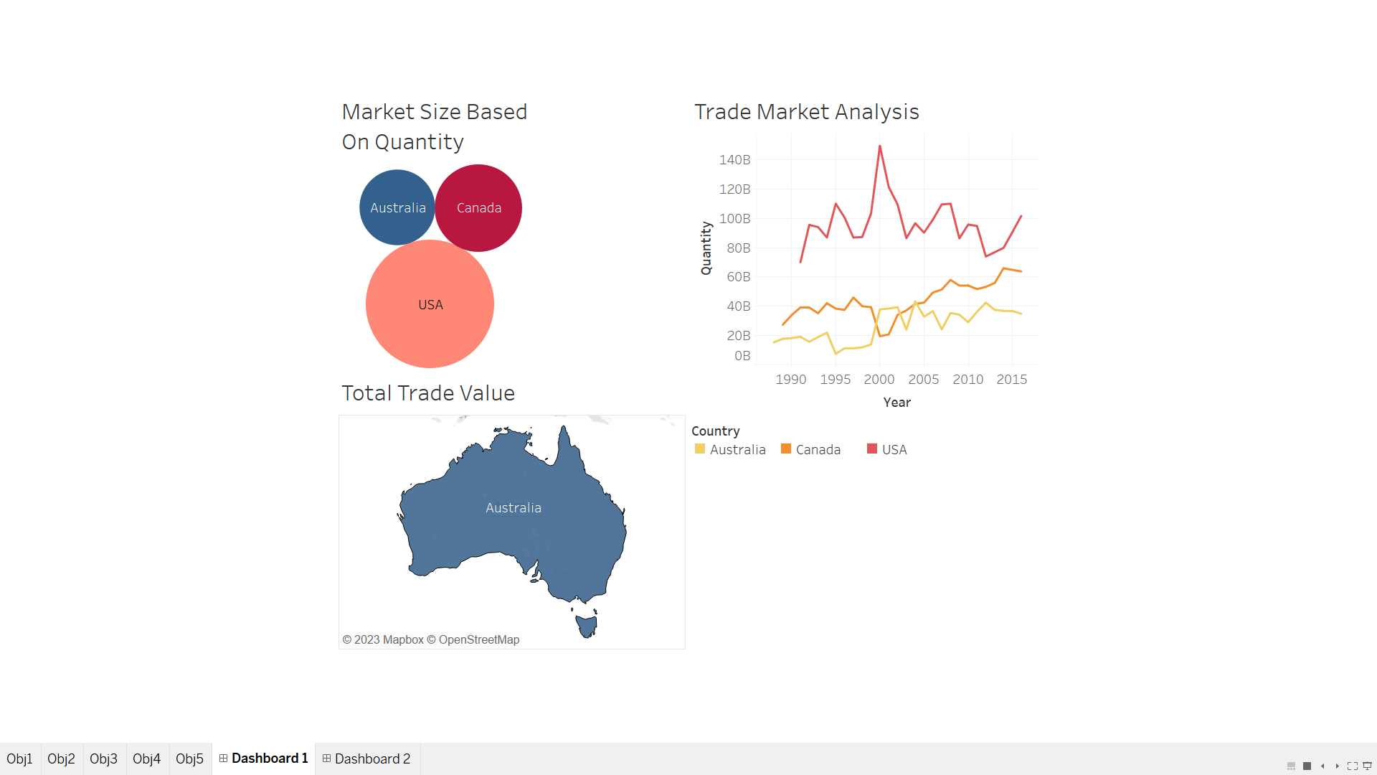
DASHBOARDS:
