# Project 2 Report

## Sarah Wallis, Dustin Evans

## 10/13/2024

## Experiment Description

Experiments were conducted with a value of 1,000,000 for N (the range of numbers for Collatz computations) and values in the range [1,8] for T (the number of threads), both with and without thread locking. The experiments were conducted on Sarah’s personal machine which has one CPU with eight cores along with 32gb of memory. The environment used was Ubuntu under WSL.

## Stopping Time Results

## Measured Time Results

Ten subsequent tests were conducted for each set of parameters, and the following results for measured processing time were obtained.

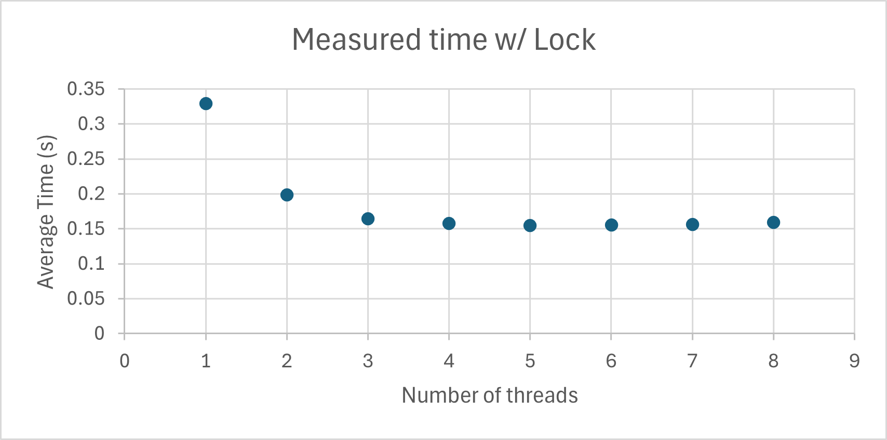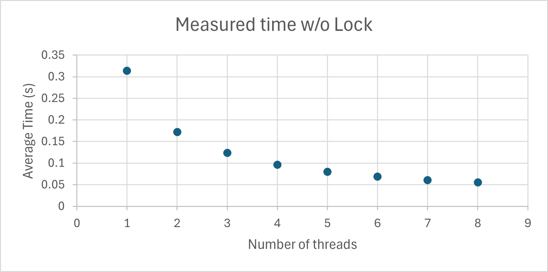

## Analysis

## From the results of the data, it can be concluded that—within the given range of parameters with thread locking active—the runtime performance improves greatly at first but faces diminishing returns as more threads are added. In contrast, without thread locking, adding more threads results in more shallow diminishing returns and thus allows for greater performance over time, though one must first discount the consequential errors introduced due to race conditions.

## Conclusions

It can be concluded that, given the value of N at 1,000,000, the ideal parameters for this experiment are ~4 threads with locking in place, as beyond four threads the performance improvements are negligible to non-existent. Adding multiple threads clearly enhances performance to a point, and the histogram results remain accurate when the thread locking mechanism is in place. It can thus be stated that multithreading can greatly improve performance if utilized properly.