База даних для зберігання інформації про музичні твори.

Схема бази даних:

Створення бази даних great_music:

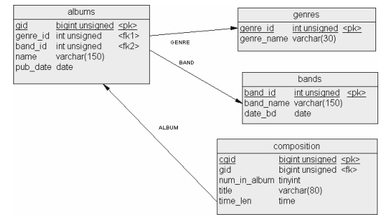

CREATE DATABASE great_music;

Створення таблиць:

CREATE TABLE genres ( genre_id int unsigned AUTO_INCREMENT PRIMERY KEY, genre_name varchar(30));

CREATE TABLE bands ( band_id int unsigned AUTO_INCREMENT PRIMERY KEY, band_name varchar(150), date_bd date);

CREATE TABLE albums ( alb_id bigint unsigned AUTO_INCREMENT PRIMERY KEY, genre_id int unsigned, band_id int unsigned, name varchar(150), pub_date date, FOREIGN KEY (genre_id) REFERENCES genres (genre_id), FOREIGN KEY (band_id) REFERENCES bands (band_id) );

CREATE TABLE compositions ( c_id bigint unsigned AUTO_INCREMENT PRIMERY KEY, alb_id bigint unsigned, num_in_album tinyint, title varchar(80), time_len time, FOREIGN KEY (alb_id) REFERENCES albums (alb_id));

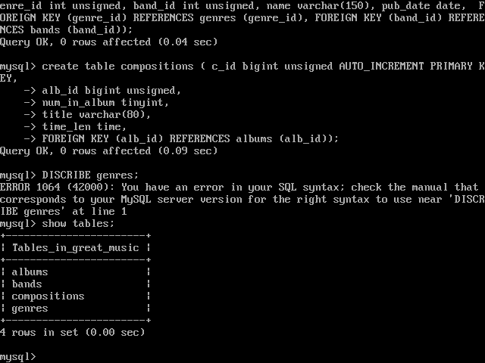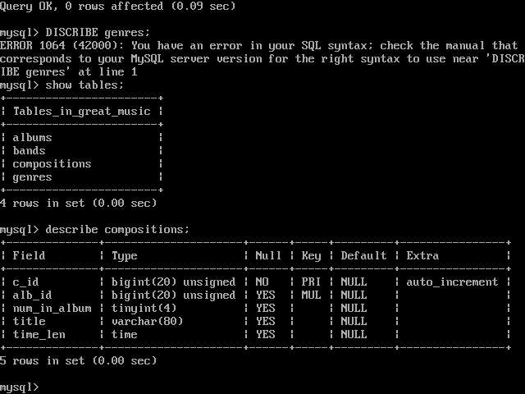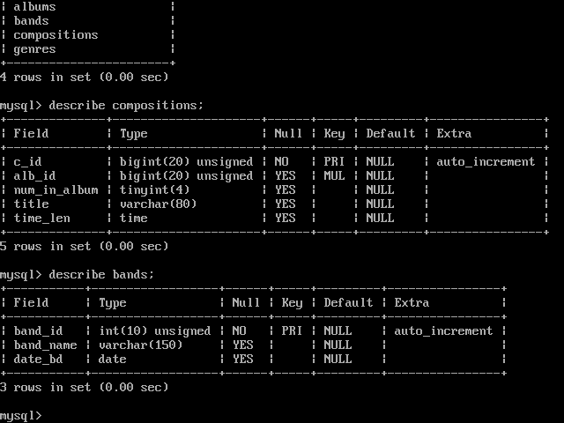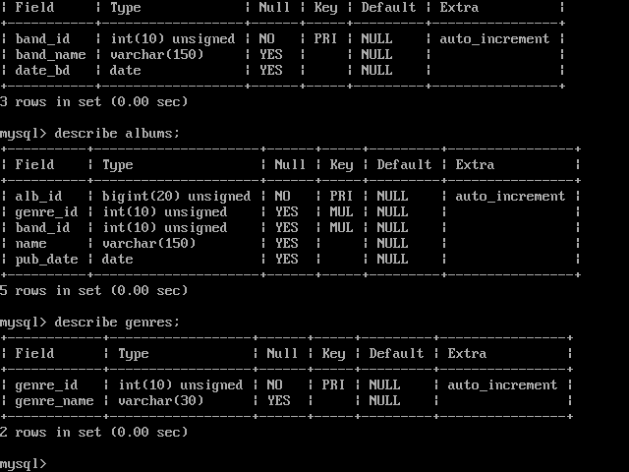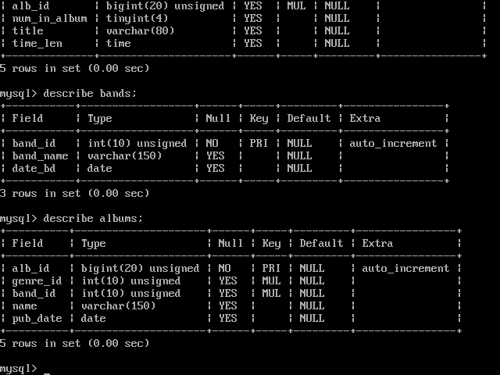

Внесення даних у таблиці бази даних:

INSERT INTO bands (band_name, date_bd) values

(‘Metallica’, ‘1981-05-25’),

(‘Dream Theater’, ‘1985-10-13’),

(‘Scorpions’, ‘1965-08-17’),

(‘Helloween’, ‘1984-03-25’),

(‘Manowar’, ‘1980-05-15’),

(‘Guns N Roses’, ‘1985-10-15’),

(‘Avenged Sevenfold’, ‘1999-01-12’);

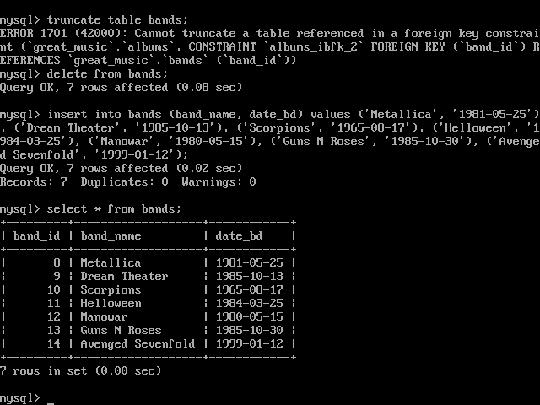

INSERT INTO geners (genre_name) values

(‘Progresive Metal’),

(‘Heavy Metal’),

(‘Power Metal’),

(‘Hard Rock’);

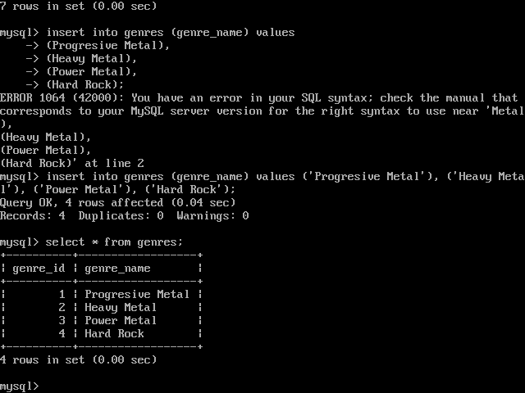

INSERT INTO albums (genre_id, band_id, name, pub_date) values

(‘2’, ‘8’, ‘Master Of Puppets’, ‘1986-05-12’),

(‘2’, ‘8’, ‘…And Justice for All ’, ‘1988-04-11’),

(‘1’, ‘9’, ‘Images And Words’, ‘1992-07-20’),

(‘1’, ‘9’, ‘Systematic Chaos’, ‘2007-10-03’),

(‘4’, ‘10’, ‘Moment Of Glory’, ‘2000-04-24’),

(‘4’, ‘10’, ‘Eye II Eye’, ‘1999-09-01’),

(‘3’, ‘11’, ‘7 Sinners’, ‘2010-02-09’),

(‘3’, ‘12’, ‘Kings of Metal’, ‘1988-10-10’),

(‘2’, ‘13’, ‘Chinese Democracy’, ‘2008-12-30’),

(‘4’, ‘14’, ‘Heil To the King’, ‘2013-04-28’);

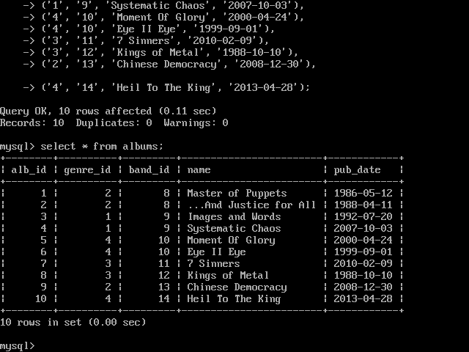

INSERT INTO compotisions (alb_id, num_in_album, title, time_len) values

(‘1’, ‘2’, ‘Master Of Puppets’, ’00:08:35’),

(‘2’, ‘4’, ‘One’, ’00:07:24’),

(‘3’, ‘1’, ‘Pull Me Under’, ’00:08:14’),

(‘4’, ‘2’, ‘Forsaken’, ’00:05:35’),

(‘5’, ‘3’, ‘Send Me An Angel’, ’00:06:19’),

(‘6’, ‘9’, ‘Yellow Buttefly’, ’00:05:44’),

(‘7’, ‘5’, ‘World Of Fantasy’, ’00:05:15’),

(‘8’, ‘2’, ‘Kings Of Metal’, ’00:03:45’),

(‘9’, ‘13’, ‘This I Love’, ’00:05:34’),

(‘10’, ‘5’, ‘Requiem’, ’00:04:33’);

