
Fast API ဘံ import ထားတာကနေ အောက်က ဟာတွေပါ import
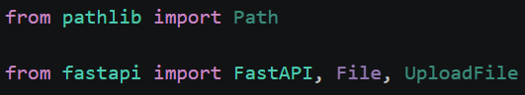
@app.post("/files/upload")
async def upload_file(file: UploadFile = File(...)):

file_path = STORAGE_DIR / file.filename

with file_path.open("wb") as buffer:
while chunk := await file.read(1024 * 1024):
buffer.write(chunk)

await file.close()

return {
"filename": file.filename,
"message": "File uploaded successfully"
}

The above code allow us to upload photos from wifi

