**NAAYA AAYAM MULTI-DISCIPLINARY INSTITUTE**

**(NAMI), NEPAL**

**THE UNIVERSITY OF NORTHAMPTON**

**UK**

**BSc Computing**

**CSY 1018 Web Development**

**Assignment 1**

**By: Shasanka Acharya**

**UN ID: 16418524**

Contents

Introduction ................................................................................................................................................ 3

Getting Started............................................................................................................................................ 3

My Designs .................................................................................................................................................. 4

Wireframes. .............................................................................................................................................. 4

Icons and image that I created .................................................................................................................. 11

Good practices. ......................................................................................................................................... 13

HTML/CSS Validation tests. ....................................................................................................................... 15

My website during the development phase.............................................................................................. 16

Final appearance of my page .................................................................................................................... 17

Mobile/Responsive views ......................................................................................................................... 20

Conclusion ................................................................................................................................................. 23

References ................................................................................................................................................ 24

**Introduction**

This report describes the development process of a simple portfolio website designed by me. The main purpose of this report is to display the originality of my codes and my designs. It took approximately a month to finish my website and this report will discuss the development of my website over the period of a month.

My Github account containing my pages: <https://sawzank.github.io/csy1018-assign1/>

**Getting Started**

Designing a portfolio website was something new to me. To get a clear visual on what a portfolio website is and how it is designed correctly, I searched for some portfolio websites online. After carefully going through some of the websites, I got an idea about the designs and how a portfolio website should look like. During my first week, I came up with a design which later saw many changes. The portfolio websites that I looked to get inspiration and ideas from were:

* <https://joel.sh/about>
* <http://kennguyen.wixsite.com/test>
* <http://kaitbos.com/>

**My Designs**

**Wireframes**

**Wireframe of homepage:**

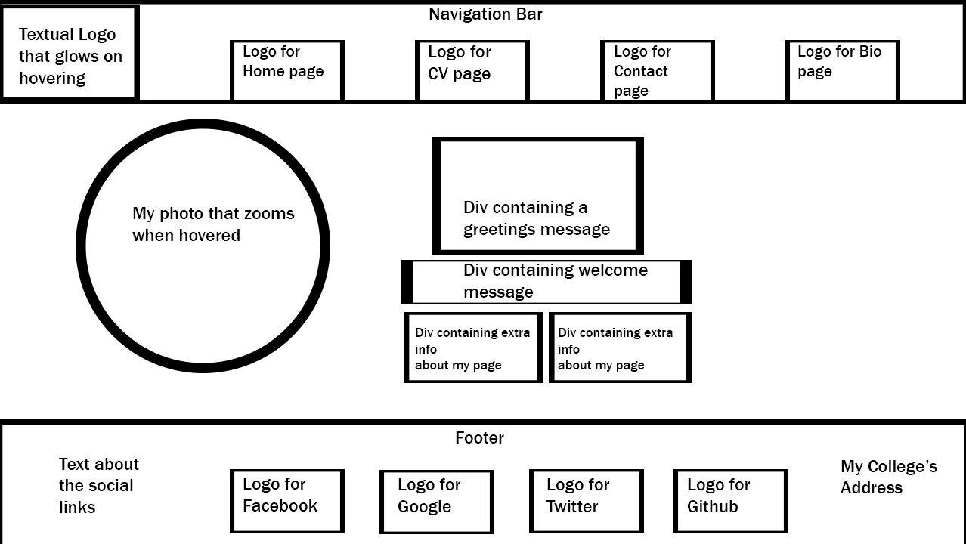

**Wireframe of CV page:**

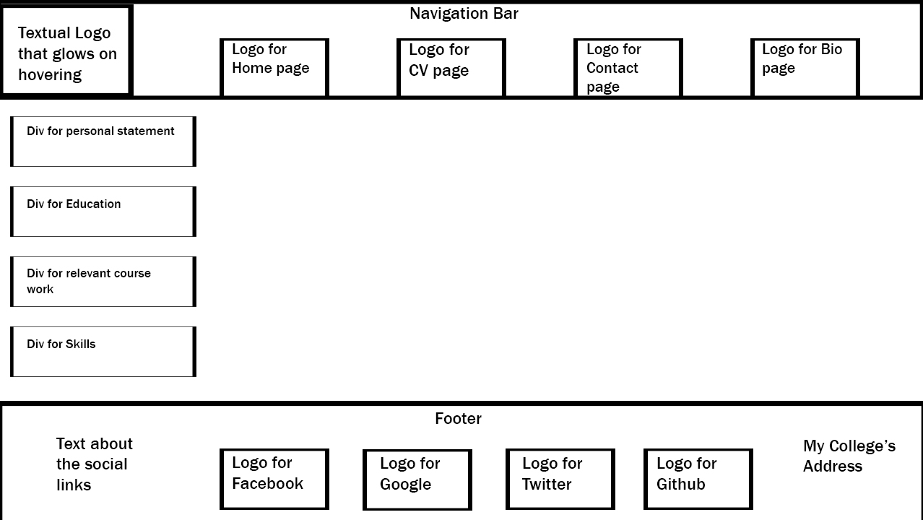

**Wireframe of Contact page:**

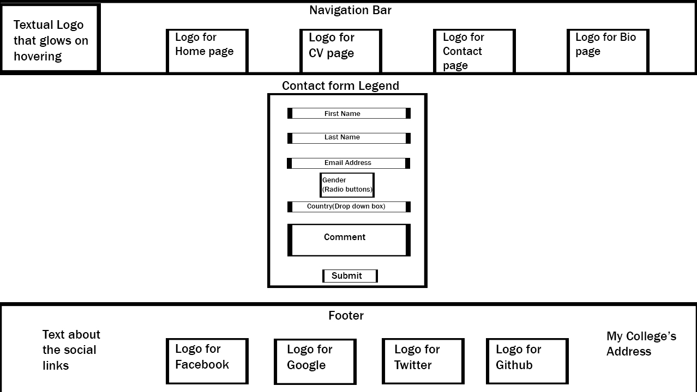

**Wireframe of Bio page:**

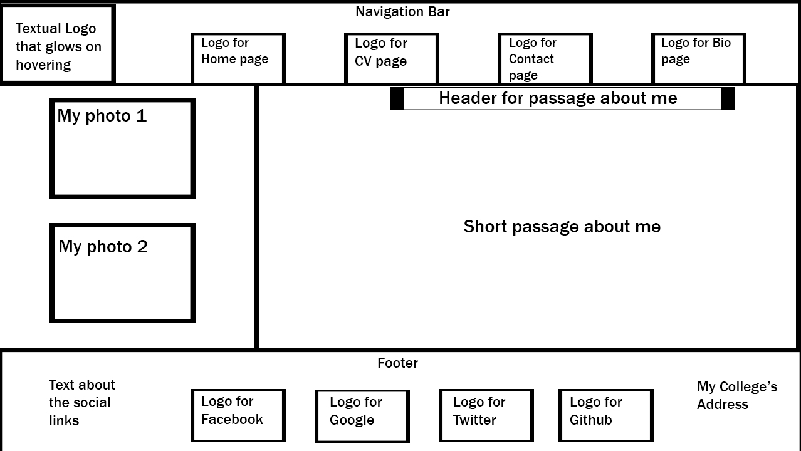

All of my wireframes have the same header and footer. The only thing different is the body portion.

**Mobile wireframes:**

**Homepage:**

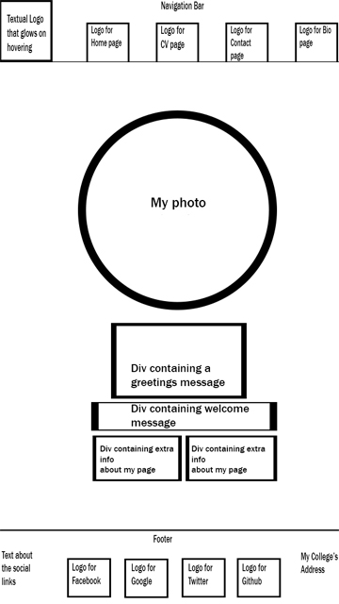

**CV:**

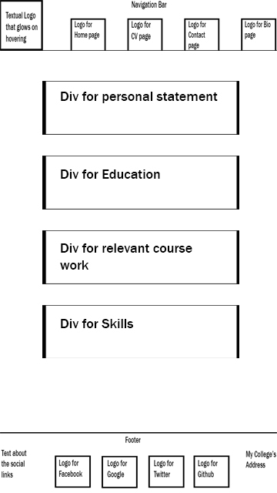

**Contact:**

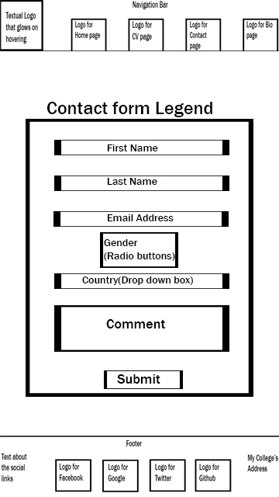

**Bio:**

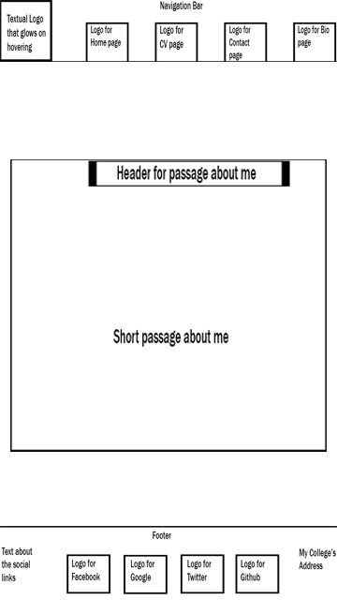

**Icons and images that I have created:**

For my website, I designed the icons for the navigation bar and the background image for the body myself. I used Photo shop to create them.

The icons and the image that I have created along with the screenshots of them being created are presented below:

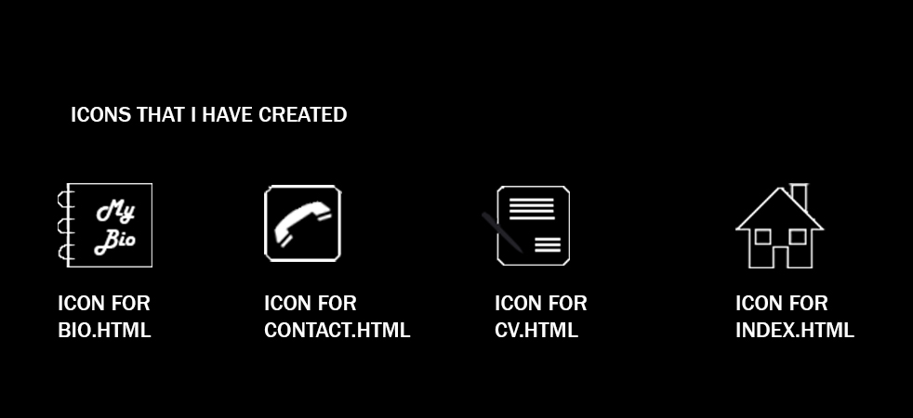

**Icons being created:**

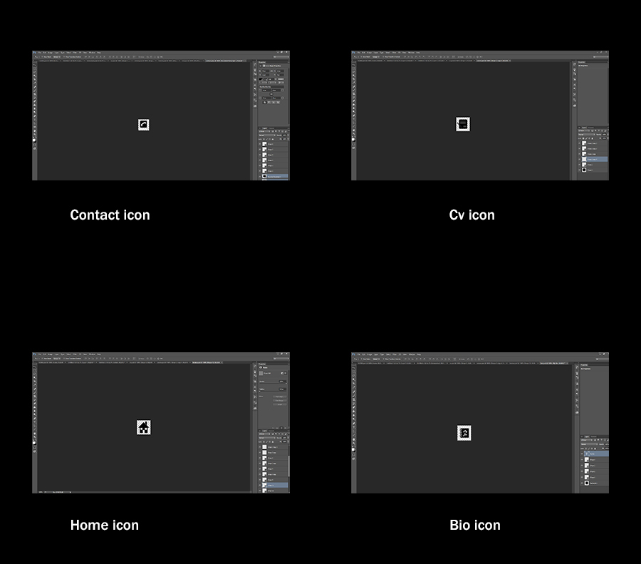

**Background image that I have created:**



**Background image being created:**

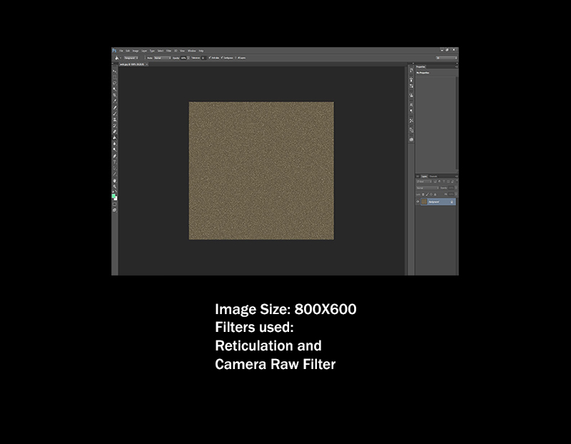

**Good practices**

During the designing phase of my webpage, I considered the following points to make my webpage good:

Use of Icons for navigation:

To make my website look more visually pleasing, I used icons in the navigation bar. These icons are like metaphors that tell the user what happens when user clicks on them. The icons that I have used clearly give the user an idea on what they will do after being clicked.

Image optimization:

Since images with larger size load slower, all of my images have been optimized. This enables less usage of data over a network. The optimization was achieved by decreasing the resolution.

Appearance of the website:

After going through some of the portfolio websites, I wanted to make something as similar to what I had seen and yet I wanted it to be unique and different too. The visuals of their websites made me want to explore more. I wanted to create a similar experience for someone visiting my website. For this, I decided to go with a dark but vibrant theme. Also, I wanted my website to have a simple design. Even though my web pages have very few items, all of the items have been made to look visually attractive and keep the visitors from leaving my website.

Loading speed:

When it comes to the loading speed of a website, the faster the loading speed, the better is the website. I checked the speed of my webpage from Pingdom.com, an online tool for checking the loading speed. These were the results I obtained from my test:

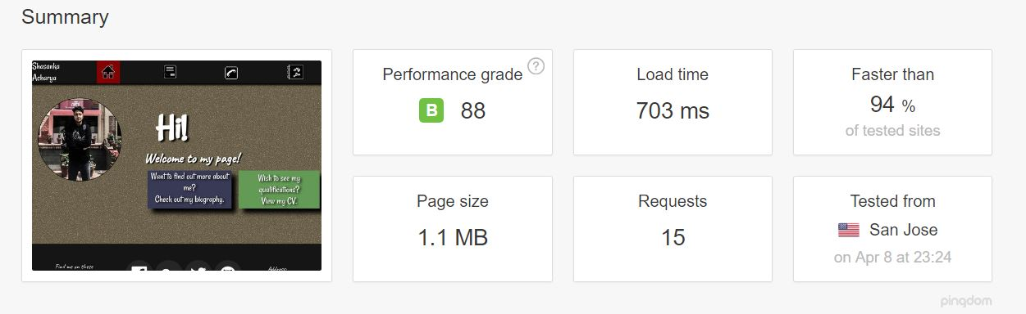

My website is faster than 94% of the websites tested, which is great considering the high quality image and icons used on my homepage. Still, there is room for improvement and a lot of things can be made better to improve the speed of my website.

**HTML/CSS Validation tests:**

The validation tests produced no errors for my pages.

HTML Validation:

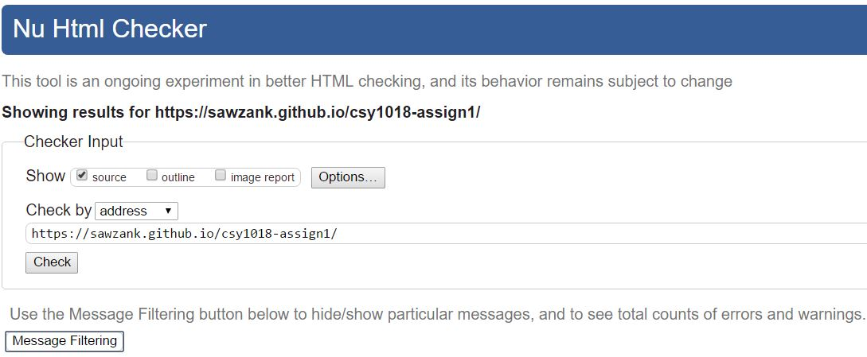

CSS validation:

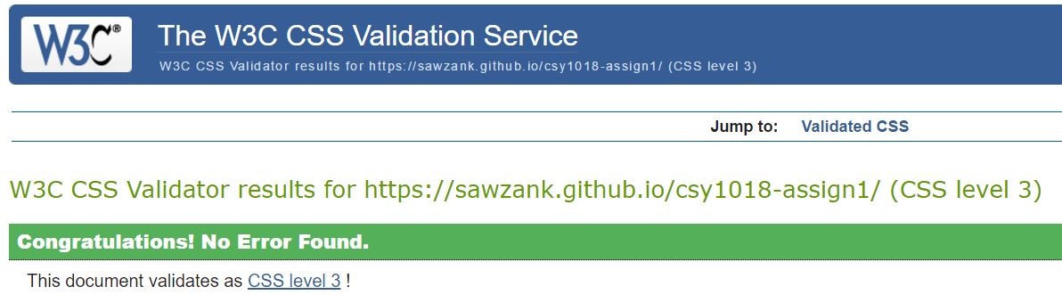

**My website during the development phases:**

First stage of development:

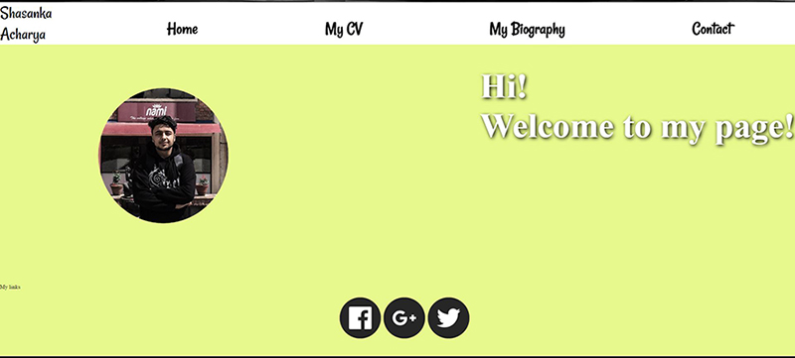

This is the first actual appearance of my complete home page. At that time, I was considering to go with this shade of light green colour for my background. This design saw many changes over the course of a month.

Second stage of development:

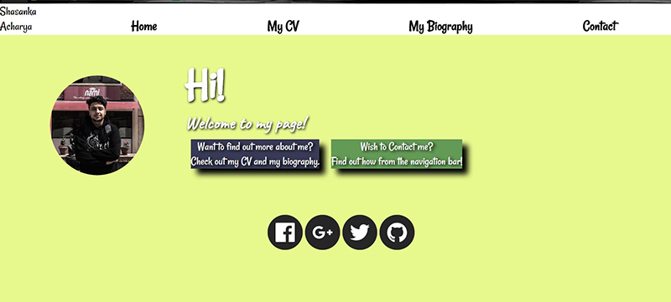

During this stage, I made changes to the font and added two new div accompanying the welcome message besides my picture.

**Final appearance of my page:**

After all the changes my page saw, this is what my website looks like now:

Home page:

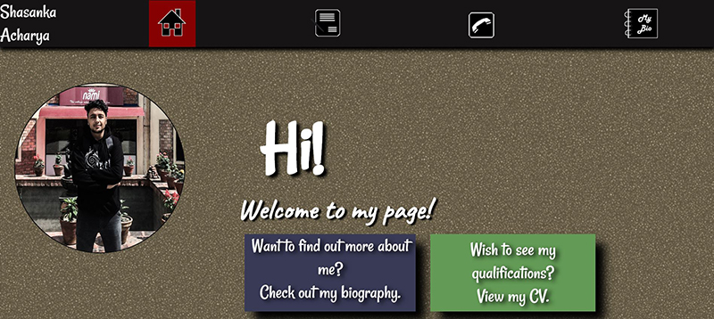

CV page:

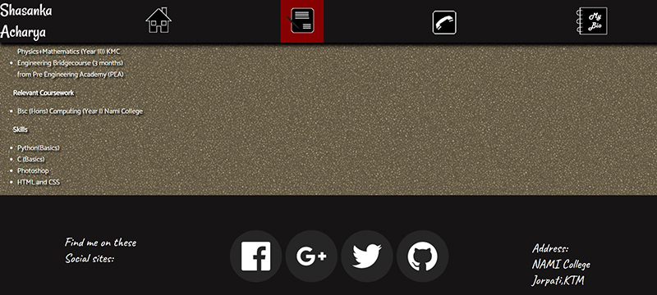

Contact page (zoomed out):

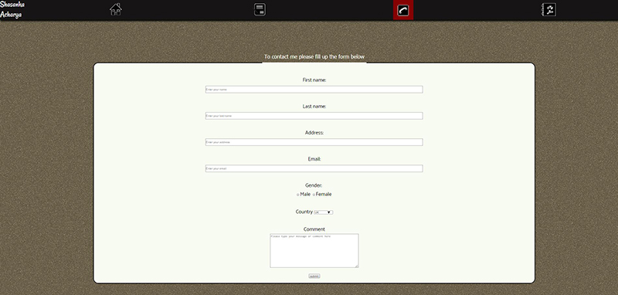

Bio page:

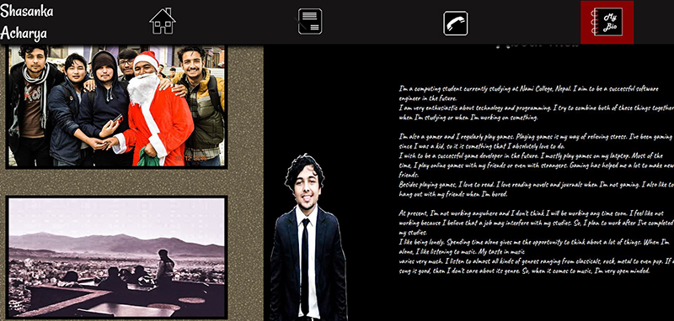

My website saw some drastic changes before reaching to its final form. Almost everything from the header, footer and the body were changed. In the end I opted for this design because it looked visually pleasing.

**Mobile/responsive views:**

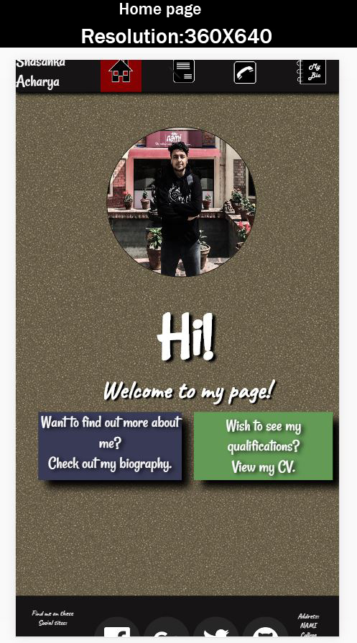

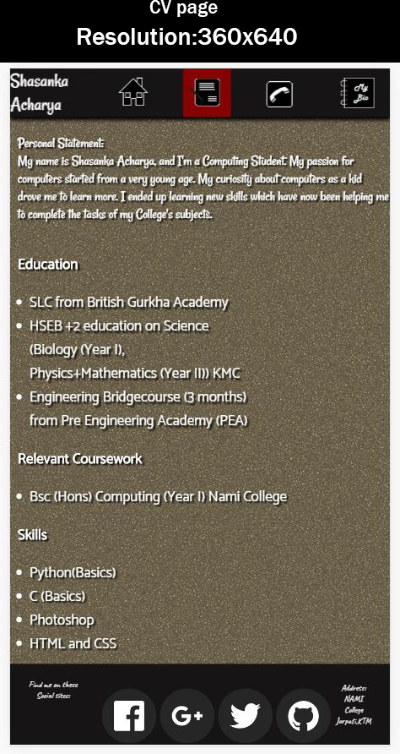

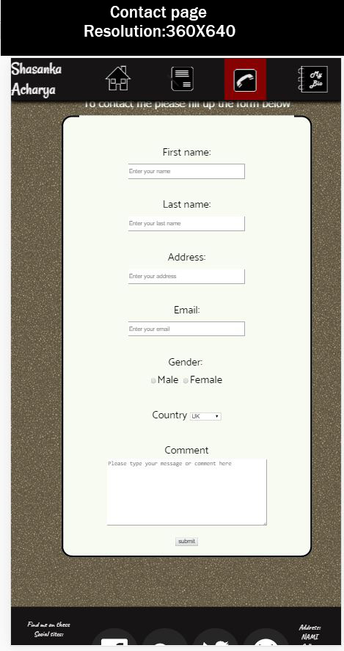

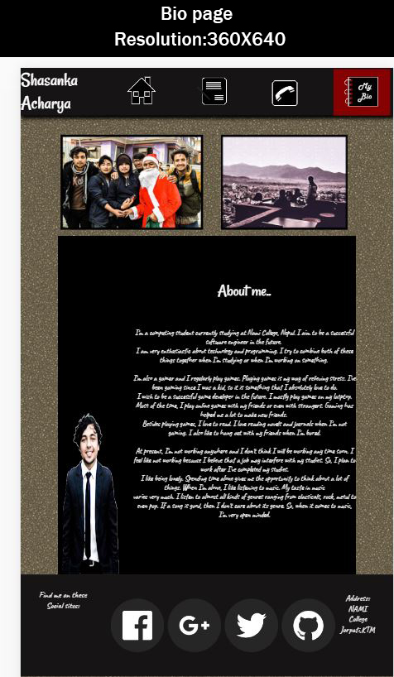

**Conclusion:**

After the completion of this assignment, I can now say that I know the basics of webpage designing. Prior to the assignment, I had no knowledge on HTML and CSS. This assignment also introduced me to some modern trends like responsiveness and materialistic designing, which can be applied to any field of the designing world.

**References:**

Vecteezy. 2017. *Free Social Media Icons - Download SVG, EPS & PNG*. [ONLINE] Available at: [https://www.vecteezy.com/vector-art/95039-free-social-media-icons#](https://www.vecteezy.com/vector-art/95039-free-social-media-icons). [Accessed 12 March 2017].

W3schools.com. 2017. *CSS Navigation Bar*. [ONLINE] Available at: <https://www.w3schools.com/css/css_navbar.asp>. [Accessed 26 March 2017].

Google Fonts. 2017. *Rancho.* [ONLINE] Available at: <https://fonts.google.com/specimen/Rancho>. [Accessed 12 March 2017].

Google Fonts. 2017. *Caveat.* [ONLINE] Available at: <https://fonts.google.com/specimen/Caveat>. [Accessed 13 March 2017].

Google Fonts. 2017. *Catamaran.* [ONLINE] Available at: <https://fonts.google.com/specimen/Catamaran>. [Accessed 5 April 2017].

Joel Stanford. 2017. *About Joel | joel.sh.* [ONLINE] Available at: <https://joel.sh/about>. [Accessed 12 March 2017].

test. 2017. *test*. [ONLINE] Available at: <http://kennguyen.wixsite.com/test>. [Accessed 12 March 2017].

Kait Bos. 2017. *Kait Bos | Toronto Freelance Graphic Designer*. [ONLINE] Available at: <http://kaitbos.com/>. [Accessed 12 March 2017].

The W3C CSS Validation Service. 2017. *The W3C CSS Validation Service*. [ONLINE] Available at: <https://jigsaw.w3.org/css-validator/>. [Accessed 08 April 2017].

The W3C Markup Validation Service. 2017. *The W3C Markup Validation Service*. [ONLINE] Available at: <https://validator.w3.org/>. [Accessed 08 April 2017].

Website speed test. 2017. *Website speed test*. [ONLINE] Available at: <https://tools.pingdom.com/>. [Accessed 08 April 2017].