Final Project Report

Clothes Management System



Project Supervisor
Asadullah

Submitted By

F25PROJECTF080

Sawaira Mumtaz BC220408093

Software Projects & Research Section,
Department of Computer Sciences,
Virtual University of Pakistan


CERTIFICATE

This is to certify that Sawaira Mumtaz BC220408093 have worked on and completed their Software Project at Software & Research Projects Section, Department of Computer Sciences, Virtual University of Pakistan in partial fulfillment of the requirement for the degree of BS in Computer Sciences under my guidance and supervision.

In our opinion, it is satisfactory and up to the mark and therefore fulfills the requirements of BS in Computer Sciences.

Supervisor / Internal Examiner

Asadullah
Supervisor,
Software Projects & Research Section,
Department of Computer Sciences
Virtual University of Pakistan

___________________
(Signature)

External Examiner/Subject Specialist
<<External Supervisor Name>>

___________________
(Signature)

Accepted By:

_____________
(For office use)

EXORDIUM

In the name of Allah, the Compassionate, the Merciful.

Praise be to Allah, Lord of Creation,
The Compassionate, the Merciful,
King of Judgment-day!

You alone we worship, and to You alone we pray for help,
Guide us to the straight path

The path of those who You have favored,

Not of those who have incurred Your wrath,
Nor of those who have gone astray.

DEDICATION

I dedicate this Clothes Management System project to my family and teachers, whose constant support, patience, and encouragement helped me stay focused and keep improving. Their belief in my abilities gave me the confidence to turn my ideas into a working system. I also dedicate this work to my own determination and growth, as it reflects the effort, learning, and discipline I developed throughout this journey. May this project be a small step toward greater achievements in the future.

ACKNOWLEDGEMENT

I would like to express my sincere gratitude to my teachers and mentors for their valuable guidance, support, and encouragement throughout the development of this Clothes Management System project. Their insights and feedback played an important role in improving my understanding and skills. I am also thankful to my family for their continuous motivation and patience during this journey. Finally, I appreciate my own efforts and consistency that helped me complete this project successfully, as it reflects my learning, dedication, and growth.
PREFACE

This project, Clothes Management System, has been developed as part of my learning journey to understand and apply programming concepts in a practical way. The main purpose of this system is to manage clothing inventory efficiently, including item management, transactions, and report generation. Through this project, I aimed to improve my skills in database handling, user interface design, and problem solving. This work reflects both theoretical knowledge and practical implementation, and it serves as a foundation for building more advanced and efficient systems in the future.
TABLE OF CONTENTS

CHAPTER 1: Gathering & Analyzing Info

1.1 INTRODUCTION 10
1.2 PURPOSE 10
1.3 SCOPE 10
1.4 DEFINITIONS, ACRONYMS AND ABBREVIATIONS 11
1.5 PROJECT REQUIREMENTS 12
1.5.1 FUNCTIONAL REQUIREMENTS 12
FUNCTIONAL REQUIREMENTS: 12
1.5.2 NON-FUNCTIONAL REQUIREMENTS 13
1.6 USE CASES AND USAGE SCENARIOS 15
1.6.1 USE CASE DIAGRAMS 15
1.6.2 USAGE SCENARIOS 15
1.7 DEVELOPMENT METHODOLOGY 24
1.7.1 CHOSEN METHODOLOGY 24
1.7.2 REASONS FOR CHOSEN METHODOLOGY 29
1.7.3 WORK PLAN (GANTT CHART) 30
1.7.4 PROJECT SCHEDULE (SUBMISSION CALENDAR) 30

CHAPTER 2: DESIGNING THE PROJECT

2.1 INTRODUCTION 33
2.2 PURPOSE 33
2.3 SCOPE 33
2.4 DEFINITIONS, ACRONYMS AND ABBREVIATIONS 34

2.5 ARCHITECTURAL REPRESENTATION (ARCHITECTURE DIAGRAM) 35
2.6 DYNAMIC MODEL: SEQUENCE DIAGRAMS 35
2.7 OBJECT MODEL/LOGICAL MODEL: CLASS DIAGRAM 45
2.8 DATABASE MODEL (DATABASE DIAGRAM) 46
2.9 GRAPHICAL USER INTERFACES 46

CHAPTER 3 Development Plan

3.1 Development plan (Architecture Diagram)……………………………49

CHAPTER 1
Gathering & Analyzing Info

Introduction

The Clothes Management System is a desktop-based application designed to

streamline the management of clothing inventory. Its core objective is to store,

organize, and manage detailed information about clothing items efficiently. The

application categorizes inventory by target groups (Men, Women, Kids) and

seasons (Summer, Winter), allowing for fast, structured searches. This

categorization helps users quickly retrieve item specifications, including pricing

and availability, enhancing customer service

Purpose
The purpose of this write-up is to outline the design, functionality, and technical
implementation of the Clothes Management System, a desktop application built
with Python and Tkinter. It serves as a detailed guide for understanding how the
system streamlines clothing inventory management for shop owners or
administrators, allowing them to efficiently store, organize, and track ite
ms, sales, purchases, and stock levels. The document explains key features such
as user authentication, item management, dynamic stock updates, and
automated report generation, while also specifying the technical tools, libraries,
and development guidelines to ensure accurate, consistent, and user-friendly
operation. Essentially, it provides a clear roadmap for building, using, and
maintaining the system effectively.

SCOPE
The scope of the Clothes Management System covers the complete digital m

management of clothing inventory for retail shops, enabling administrators to

register users, authenticate access, and maintain full control over clothing items,
stock updates, sales, purchases, and reporting. The system supports structured

categorization of items by target group and season, provides fast item search,

automates profit and stock calculations, and generates daily, weekly, monthly,

and yearly reports. It is designed as a desktop application using Python and

Tinker, offering a simple interface for non-technical sales staff while ensuring

accurate, real time inventory handling and reliable recordkeeping for business

owners

definitions, acronyms and abbreviations

Definitions
- Clothing Item: Any apparel product in the inventory, categorized by type, target group, and season.
- Inventory Management: The process of tracking, organizing, and controlling stock levels of clothing items.
- Admin: A user with full access to the system who can manage users, inventory, sales, and reports.
- User: A person who can access the system for specific tasks like searching items or viewing reports, depending on permissions.
- Report Generation: The process of creating detailed summaries of stock levels, sales, purchases, and profit over specific timeframes.
- Profit Calculation: The automated computation of profit based on the difference between selling price and purchase price of clothing items.

Acronyms
- GUI: Graphical User Interface a visual interface that allows users to interact with the system through menus, buttons, and forms.
- ID: Identification of a unique identifier assigned to each clothing item in the inventory.
- PC: Personal Computer the device on which the desktop application is installed.

Abbreviations
- Tkinter: Toolkit interface for Python used to build desktop GUIs.
- Python: A high-level programming language used to develop the system.
- DB: Database the structured storage where all inventory, sales, and user data is kept.

1.5 Project requirements

Functional Requirements

Functional Requirements:
Functional requirements describe what the system must do. They define the specific operations, tasks, and behaviors the system should perform to meet user needs. These requirements explain the core functions such as user registration, item management, sales handling, stock updates, searching, and report generation. In short, they outline the actions the system is expected to carry out.

User Registration and Authentication
  - The system must allow the admin to register new users by storing their credentials securely in the database. All users, including admins and sales staff, must be able to log in and log out using valid credentials. The system must validate usernames and passwords before granting access. Incorrect login attempts should display an error message and deny access.

Clothing Item Management
  - The admin must be able to add new clothing items by entering details such as name, category, season, purchase price, sale price, quantity, and unique item ID. The system must allow the admin to update item information when needed and delete items that are no longer available. Every modification should immediately reflect in the inventory database.

Item Search
  - The system must allow users and admins to search for clothing items using various filters such as item name, ID, category, season, or price. Search results should display all relevant details including availability, price, and stock count. The system must return accurate and fast results to support customer queries.

Sales Management
  - The system must record each sale made at the counter. Whenever an item is sold, the system should automatically reduce its stock quantity in the database. Users should be able to view the remaining quantity after each sale. The system must also prevent sales if an item is out of stock.

Purchase Management
  - The admin must be able to record purchases of new stock. Whenever new stock arrives, the system should add the purchased quantity to the existing inventory. The purchase process must update the database instantly to ensure accurate stock tracking.

Stock Updates
  - The system must dynamically update stock levels after each sale or purchase. Users must be able to view updated stock information at any time. Low stock items should be highlighted or indicated for restocking.

Report Generation
  - The admin must be able to generate report summaries for daily, weekly, monthly, and yearly sales and purchases. Reports should include total available stock, total sold items, total purchased items, and profit calculations. Reports must be printable and saved digitally for recordkeeping.

Automated Profit Calculation
  - The system must automatically calculate profit based on predefined purchase and sale prices stored in the database. Manual entry of profit values should not be allowed. Profit values must update instantly after every sale.

Centralized Data Management
  - All modules should use a single centralized database. Any data entered in one module must automatically update in all relevant modules without requiring repeated entry.

Non-Functional Requirements
Nonfunctional requirements describe how the system should perform its tasks. They define the quality standards, constraints, and attributes such as performance, security, usability, reliability, scalability, and maintainability. These requirements do not specify features but describe the conditions under which the system must operate to ensure a smooth and efficient user experience.

Performance Requirements
  - The system must respond quickly to user actions. Search results should appear within a few seconds. Stock updates and report generation should be processed without noticeable lag. The system must handle large inventories without slowing down.

Usability Requirements
  - The interface must be simple and easy to use for non technical staff. All buttons, menus, and input fields must be clearly labeled. The system must support keyboard and mouse navigation and provide clear error or confirmation messages.

Reliability Requirements
  - The system must run without crashes and must protect data against loss or corruption. All updates to the database must be reliable and consistent. System errors should not affect stored data.

Security Requirements
  - User credentials must be stored securely. Only authenticated users should access the application. Admin only functions must be protected so that normal users cannot modify sensitive data like clothing items, purchases, or user accounts.

Maintainability Requirements
  - The system should be easy to maintain, update, and debug. The codebase must follow a modular structure where inventory, sales, login, and reporting are clearly separated for easier modification.

Portability Requirements
  - The system must run on Windows based computers. It should not depend on external web based technologies. The system must be fully functional on desktops and laptops using Python and Tinker.

Scalability Requirements
  - The system should support growth in inventory size, users, and sales records without performance issues. Adding new categories or seasons should not require rewriting major parts of the system

1.6 use cases and usage scenarios
1.6.1 Use Case Diagrams
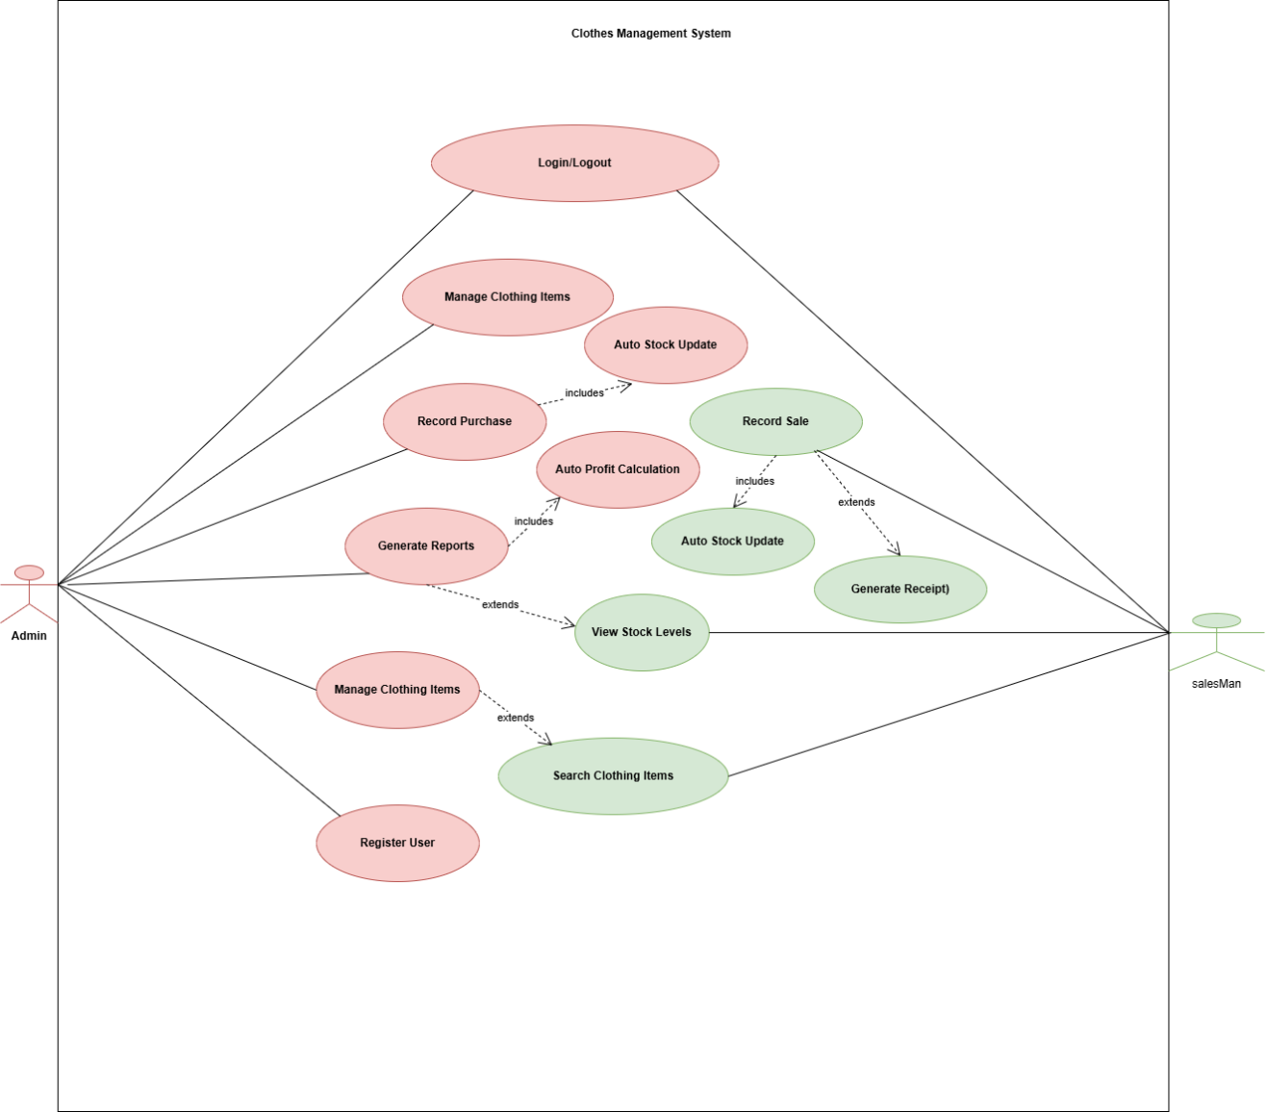

1.6.2 Usage Scenarios

Usage Scenario #1
Use Case title | Login / Logout
Use Case Id | UC-01
Actor | Admin ,salesman
Actions | 1. The actor enters username & password.  2. System validates credentials.  3. The system grants access.  4. Logout when the actor chooses to exit.
Description | Allows users to securely access or leave the system.
Alternative Paths | Invalid credentials → show error.
Pre-Conditions | Users must be registered in the system.
Post Conditions | Users are logged into their dashboard or logged out successfully.
Author | BC220408093
Exceptions | System unavailable; server error.

Usage Scenario #2

Use Case title | Manage Clothing Items
Use Case Id | UC-02
Actor | Admin
Actions | 1. Admin selects “Manage Clothing Items.”  2. Admin performs add/update/delete.  3. System updates database.
Description | Admin can add, edit, update, or delete clothing inventory.
Alternative Paths | Invalid data input; item already exists.
Pre-Conditions | Admin must be logged in.
Post Conditions | Updated inventory list.
Author | BC220408093
Exceptions | Database errors; missing required fields.

Usage Scenario #3
Use Case title | Record Purchase
Use Case Id | UC-03
Actor | Admin
Actions | 1. Admin chooses “Record Purchase.”  2. Adds purchase details.  3. System stores purchase.  4. System triggers Auto Stock Update.
Description | Admin records the purchase of new stock.
Alternative Paths | Incorrect purchase details.
Pre-Conditions | Items must exist in the catalog.
Post Conditions | Stock updated; purchase recorded.
Author | Bc220408093
Exceptions | Calculation or data input errors.

Usage Scenario #4
Use Case title | Auto Stock Update
Use Case Id | Uc-04
Actor | Admin
Actions | 1. Triggered by sale/purchase.  2. The system calculates new quantities.  3. Updates inventory.
Description | Automatically updates stock levels after sales or purchases.
Alternative Paths | None—fully automated.
Pre-Conditions | Stock items exist.
Post Conditions | Accurate stock level shown.
Author | Bc220408093
Exceptions | Negative stock error; corrupted quantity values.

Usage Scenario #05
Use Case title | Auto Profit Calculation
Use Case Id | UC-05
Actor | system
Actions | 1. Sale recorded.  2. The system reads cost & selling price.  3. Calculates profit.  4. Stores profit log
Description | Computes profit automatically after a sale.
Alternative Paths | Cost/selling price missing.
Pre-Conditions | Sale transactions must exist.
Post Conditions | Profit stored for reporting.
Author | Bc220408093
Exceptions | Calculation errors; missing item pricing.

Usage Scenario #06
Use Case title | Generate Reports
Use Case Id | Uc-06
Actor | Admin
Actions | 1. Admin selects report type.  2. The system fetches relevant data.  3. System displays/export report.
Description | Admin generates sales, stock, or profit reports.
Alternative Paths | No data available for report.
Pre-Conditions | Admin logged in; required data exists.
Post Conditions | Report generated.
Author | Bc220408093
Exceptions | File export failure; system timeout.

Usage Scenario #07
Use Case title | Register User
Use Case Id | UC-07
Actor | Admin
Actions | 1. Admin enters user details.  2. The system validates details.  3. New user created.
Description | Admin registers a new Salesman or Admin.
Alternative Paths | Username already taken; invalid data.
Pre-Conditions | Admin must be authenticated.
Post Conditions | The new user account is active.
Author | Bc220408093
Exceptions | Database error; missing fields.

Usage Scenario #08
Use Case title | View Stock Levels
Use Case Id | UC-08
Actor | Salesman, Admin
Actions | 1. The actor opens the stock module.  2. System shows updated stock list.
Description | No stock items available.
Alternative Paths | Users must be logged in.
Pre-Conditions | Stock levels displayed.
Post Conditions | Inventory retrieval failure.
Author | Bc220408093
Exceptions | Inventory retrieval failure.

Usage Scenario #09
Use Case title | Record Sale
Use Case Id | UC-09
Actor | salesman
Actions | 1. Salesman selects item & quantity.  2. Enter customer details.  3. System records sale.  4. Triggers Auto Stock Update and Generate Receipt.
Description | Salesman records a new sale transaction.
Alternative Paths | Item out of stock; invalid quantity.
Pre-Conditions | Sale stored; stock reduced.
Post Conditions | Stock must be available.
Author | Bc220408093
Exceptions | Stock error; payment issues.

1.7 Development Methodology

1.7.1 Chosen Methodology
The adopted methodology refers to the specific approach, framework, or set of techniques chosen to systematically conduct a project, study, or process. It includes the methods, strategies, and tools applied to achieve the objectives effectively and efficiently. This methodology outlines how the work will be carried out, ensuring clarity, consistency, and reproducibility of results.

- Spiral Methodology
- Waterfall Methodology

5.1. Spiral Model
The Spiral Model is a software development methodology that combines the iterative nature of prototyping with the systematic aspects of the Waterfall model, focusing particularly on risk management and gradual refinement of the system. It was introduced by Barry Boehm in 1986 to address the shortcomings of traditional models, especially in complex and large-scale projects where requirements are not fully understood upfront and may evolve over time.
Characteristics of the Spiral Model:
- Iterative Nature: The Spiral Model works through a series of iterations or “spirals,” where each cycle involves repeating the process of planning, risk analysis, engineering, and evaluation. Each spiral refines the project further, allowing for continuous improvement and adaptation as development progresses.
- Risk Management: One of the distinguishing features of the Spiral Model is its emphasis on risk assessment. Each cycle starts with identifying and analysing potential risks—whether they are technical, financial, or related to market changes. This helps in taking proactive steps to mitigate risks, ensuring that the project doesn’t derail midway. As new information emerges, risks are reassessed, making it suitable for complex systems.
- Phases in the Spiral Model: The Spiral Model consists of four main phases that repeat with each iteration:
  - Planning: Define objectives, constraints, and gather requirements.
  - Risk Analysis: Identify and evaluate potential risks, and decide on mitigation strategies.
  - Engineering: Develop the product or software, incorporating the feedback from the previous phase. This includes design, coding, and testing.
  - Evaluation: Review progress with stakeholders and adjust the plan for the next spiral based on feedback.

- Prototyping: Early prototypes of key features are created during the engineering phase. These prototypes are iteratively refined based on feedback, allowing for a deeper understanding of the requirements and the user’s expectations. This reduces the chances of building a system that doesn't meet the users' needs.
- Documentation and Feedback: While the Spiral Model is more flexible than rigid waterfall-like methodologies, it still involves thorough documentation and regular feedback. The evaluation phase involves gathering feedback from stakeholders and end-users, ensuring that the project is on the right track. This feedback loop ensures that the product evolves according to the actual needs rather than assumptions made at the beginning.
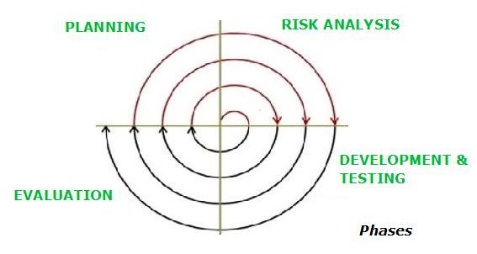
Figure 1. Spiral Model
The Spiral Model fits a clothes management project because it works in repeated cycles where each cycle includes planning risk analysis, building a small part of the system and reviewing it with users. This approach helps you start with basic features like adding clothes categories and storing images then expand into advanced functions like inventory reports search filters and user authentication. Each round lets you identify problems early, adjust the design and add improvements which makes the entire system more accurate and user friendly as it grows.

Water Fall Model:
The Waterfall Method is a traditional and linear project management and software development methodology. It emphasizes a sequential design process, where each phase must be completed before the next one begins. This structured approach is commonly used in projects where requirements are well-defined and unlikely to change significantly.
The Waterfall Method follows a linear and sequential process. Each phase flows down to the next, similar to a waterfall.
- Requirement Analysis:
  - Gather and document all customer requirements.
  - Outputs: Software requirement specifications (SRS), detailed business requirements.
- System Design:
  - Create a blueprint for the system's architecture and design.
  - Outputs: System and software design documents.
- Implementation (Coding):
  - Translate the designs into actual code.
  - Outputs: Executable code or software components.
- Testing:
  - Validate that the developed software meets the requirements and is free of defects.
  - Outputs: Test cases, bug reports, and a validated system.
- Deployment:
  - Deliver the finished product to the client or market.
  - Outputs: Installed and operational software.
- Maintenance:
  - Address post-deployment issues like bugs, updates, and new requirements.
  - Outputs: Updated software versions.

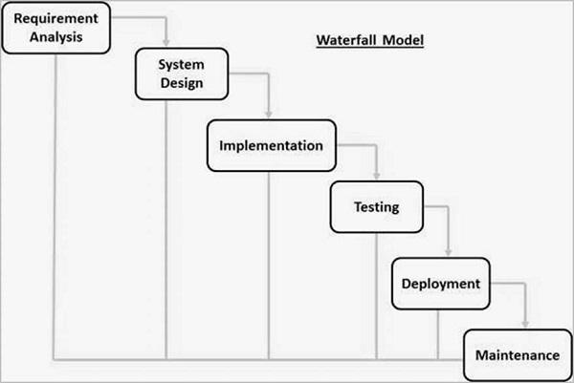
Figure 3. Water Fall Model
The Waterfall Model suits a clothes management system when all requirements are clear from the start because it follows a step by step flow from planning to design development testing and final deployment. In this approach you first document all features such as adding and viewing clothes items using image storage tracking categories and generating reports. After the requirements are fixed the design is created followed by coding the full system at once testing every module in the end and delivering the completed software. This model provides a structured and predictable path which works well when changes are not expected during development.
VU process model:

VU process model is a combination of both waterfall and spiral model which is also called hybrid approach of system development so in my project “algorithm encyclopedia” I choose this model. The idea behind this model is to get the benefits of both these models. Essentially, Water Fall Model is a framework for software development in which development proceeds sequentially through a series of phases, starting with system requirements analysis and leading up to product release and maintenance, whereas the key characteristics of spiral model is risk management at regular stages in the entire software development cycle. In the VU Process Model we will be working in phases to complete our given project. The reason to select this model is that this approach of system development maximizes the quality of the system and minimizes the disadvantages and risk. It is a linear model and easy to understand. This provides much facility to estimate project cost and provide better understanding to project developers. The VU process model is heavily dependent on risk analysis and evaluation in each phase.

VU process model consists of four phases:
1. Requirement
In this phase we work on functional requirements, non-functional requirements, use case diagrams and usage scenarios. In the usage scenario we explain each use case and actors.
2. Planning Phase:
In this phase different phases are completed to complete the project. Methodology is selected and an overall work plan is made.
3. Designing:
This phase consists of two design documents. In Design document we
will develop the Activity Diagram, Sequence diagrams, Collaboration Diagram, Architecture Design Diagram and DFD diagram. And Design document II we develop the Object model, Class diagram, interface design, database design, test cases, Deployment diagram and Component diagram
4. Development:
In this phase code has been written for implementation of the project.

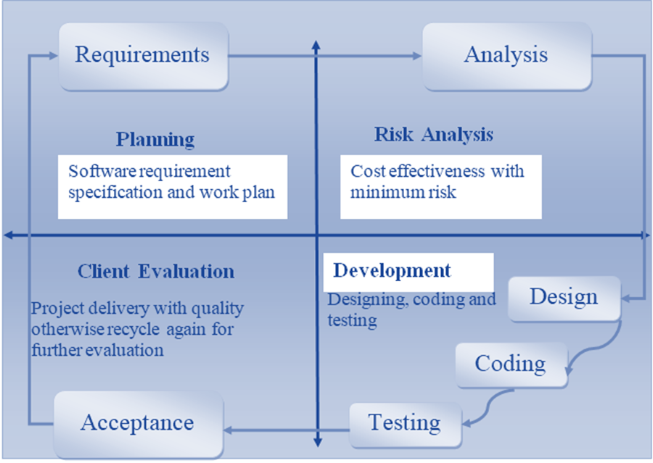
Figure.04 VU Model

1.7.2 Reasons for Chosen Methodology
I chose the VU model for my project. A reason for adopting this methodology is as under.
- First of all Virtual University of Pakistan guides us that you must select the VU Model for the project.
- The second reason is that only the VU Model fully fills all the requirements of my project.
VU Model is the combination of Waterfall and Spiral methodologies. One feature of waterfall methodology is the sequence of steps that we take in our methodology and one feature of spiral methodology is to go through previous steps. This feature is also included in our methodology.

1.7.3 Work Plan (Gantt Chart)
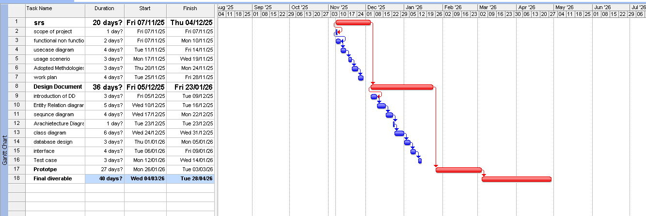

1.7.4 Project Schedule (Submission Calendar)

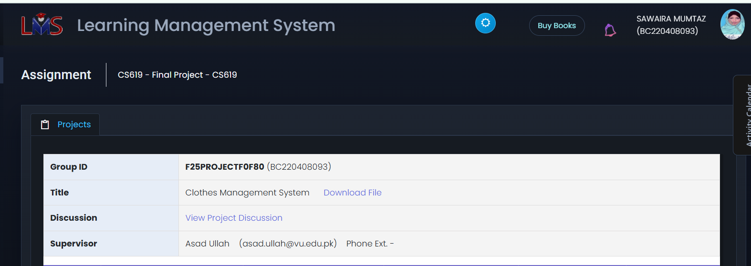

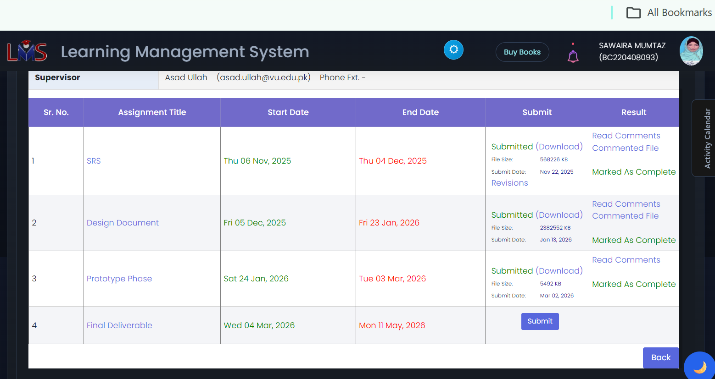

CHAPTER 2
Designing the Project

2.1 Introduction
This design document presents the structure and planned implementation of the Clothes Management System, a desktop application created to support shop owners and staff in managing clothing inventory, sales, purchases, and reporting. It provides a detailed overview of how the system will function, how its components will interact, and how the interface and data will be organized. The introduction sets the foundation for understanding the system goals, the technologies used, and the design decisions that guide the development process.

2.2 Purpose
The purpose of this design document is to translate system requirements into a clear technical blueprint that guides developers during implementation and supports consistency across all development activities. It helps ensure that the system is built according to user needs, adheres to specified requirements, reduces ambiguity, and minimizes risks by providing early insight into system structure. This document also serves as a reference for future updates, maintenance, and quality assurance activities.

2.3 Scope
The scope of this design document is to define the structure, components, and behavior of the Clothes Management System, detailing how each module will be built and interact within the application. It outlines the system architecture, user interface layout, data flow, database structure, functional modules, and the technologies required for implementation. This scope ensures that developers and stakeholders share a complete and consistent understanding of what will be designed, how it will work, and the boundaries of the system.

2.4 Definitions, Acronyms and Abbreviations
Acronyms
- GUI: Graphical User Interface a visual interface for interacting with the system.
- ID: Identification of a unique identifier assigned to each clothing item.
- PC: Personal Computer the platform on which the desktop application runs.
Abbreviations
- Tkinter: Python library for creating desktop GUIs.
- Python: Programming language used for system development.
- DB: Database storage system for all inventory, sales, and user information.

2.5 Architectural Representation (Architecture Diagram)
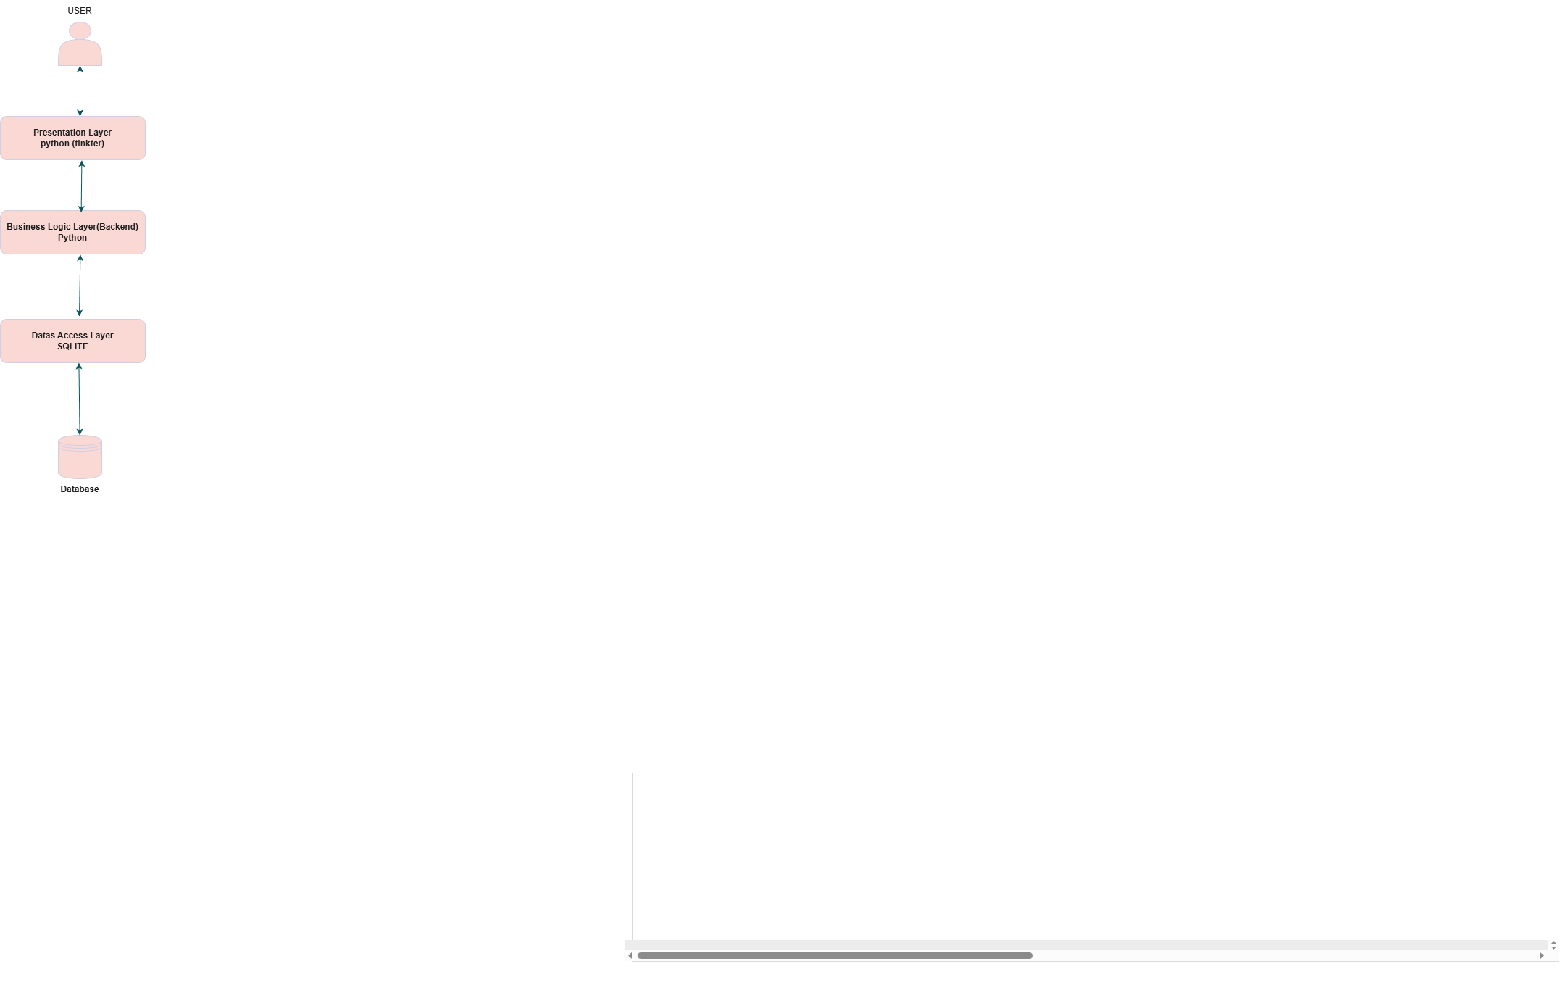

2.6 Dynamic Model: Sequence Diagrams

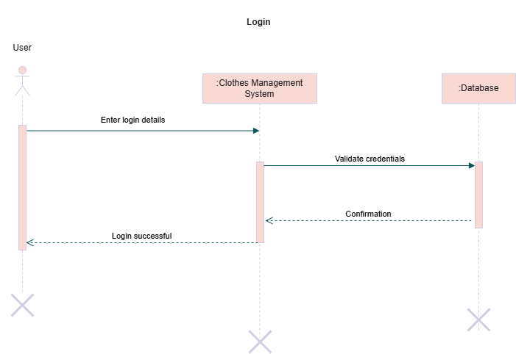

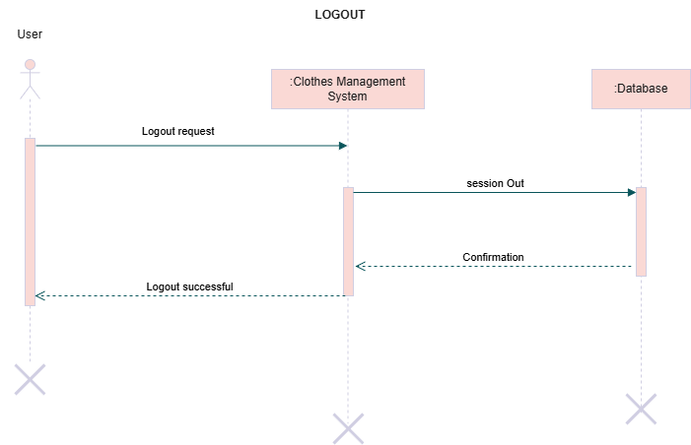

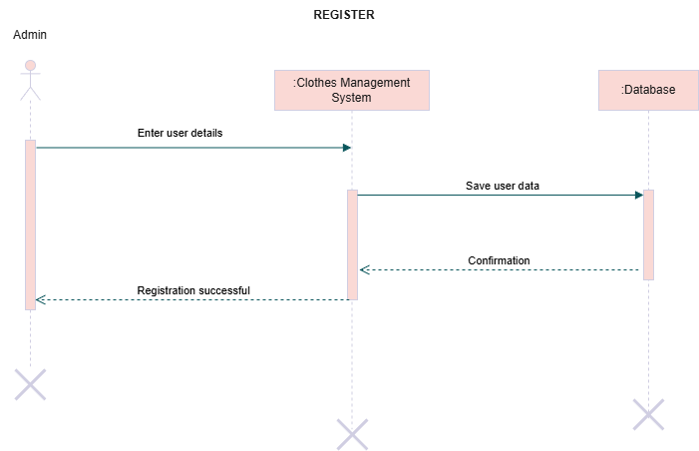

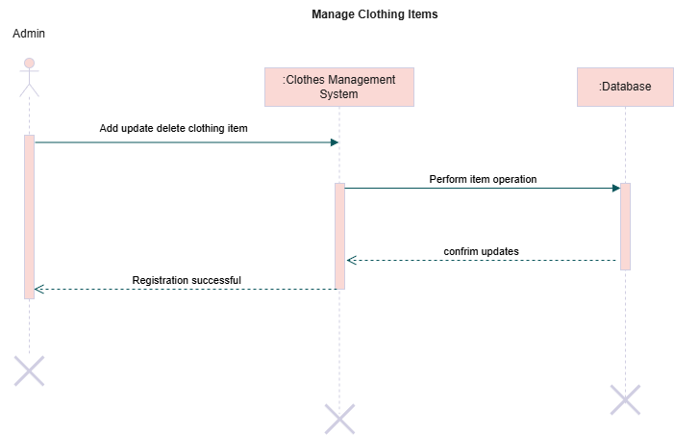

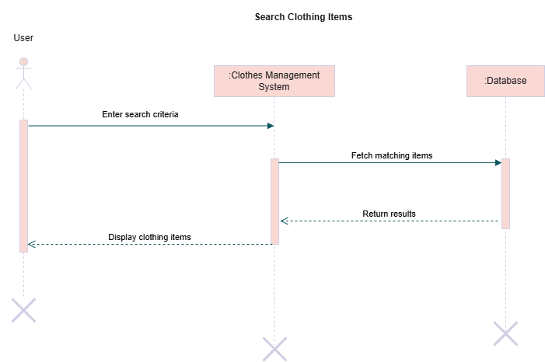

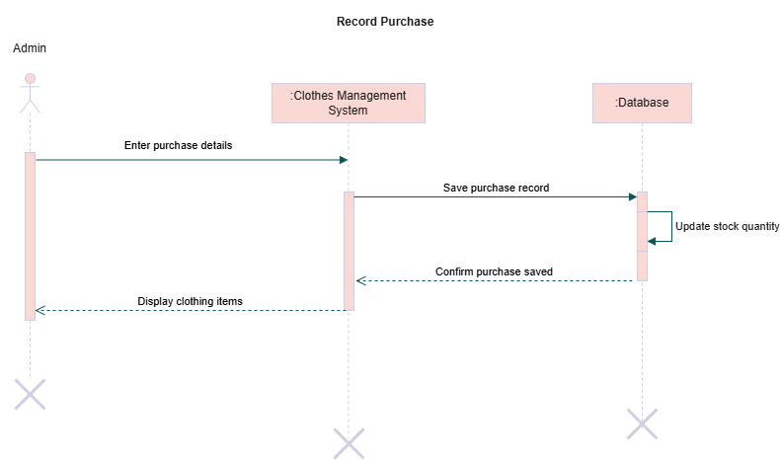

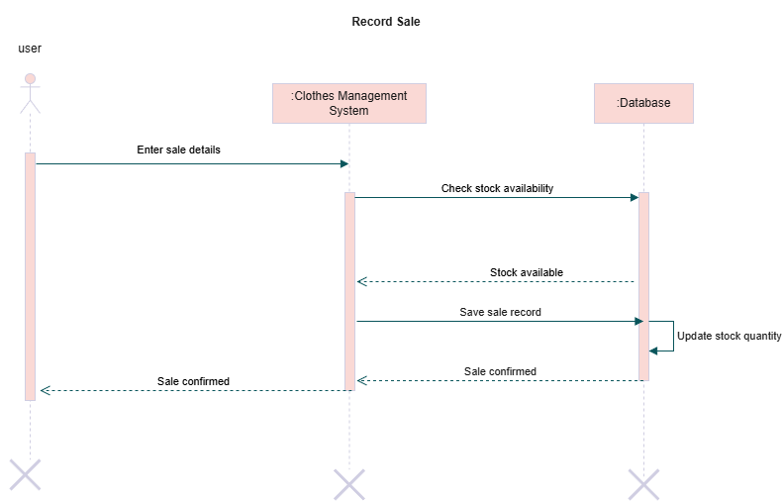
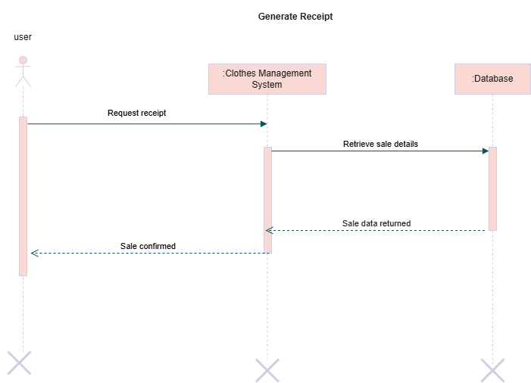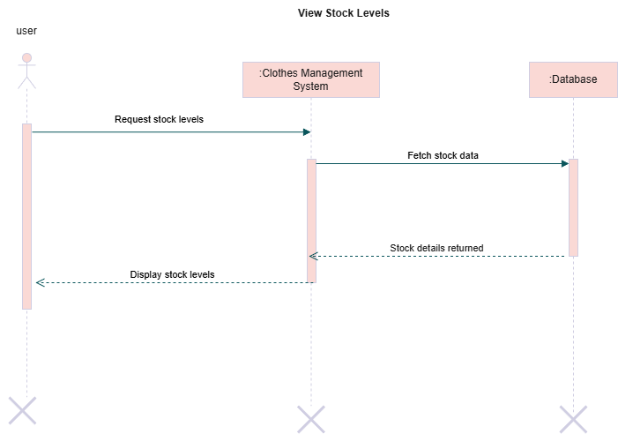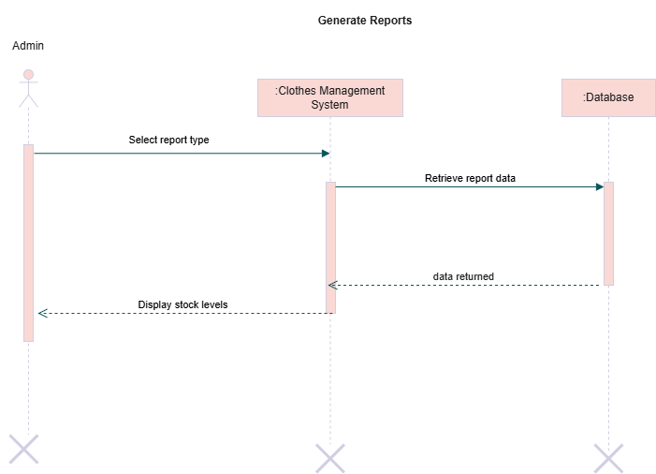

2.7 Object Model/Logical Model: Class Diagram
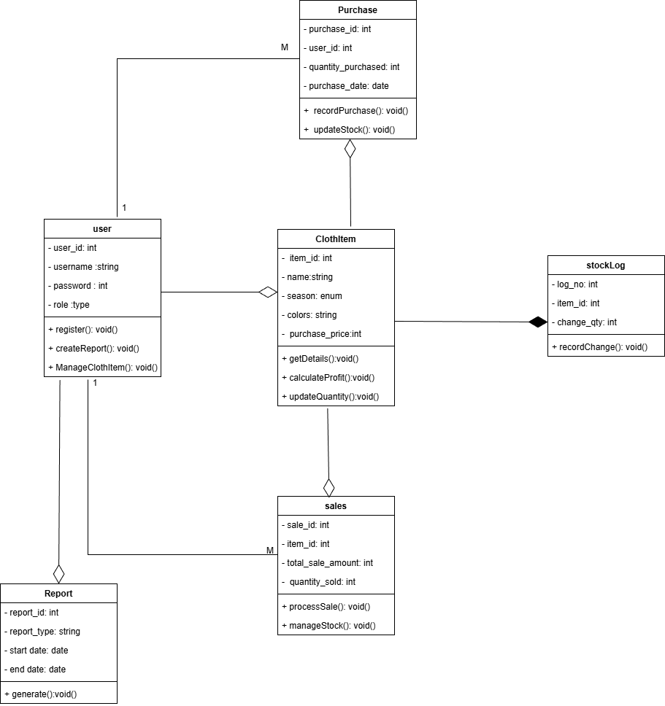

2.8 Database Model (Database Diagram)
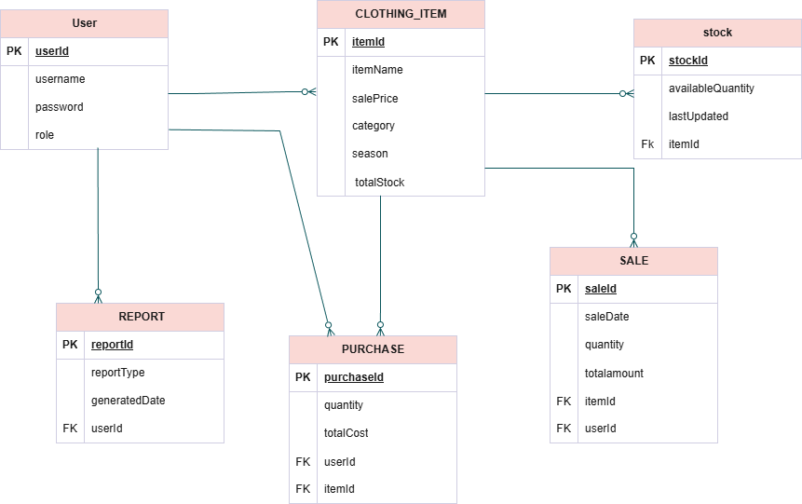

2.9 Graphical User Interfaces

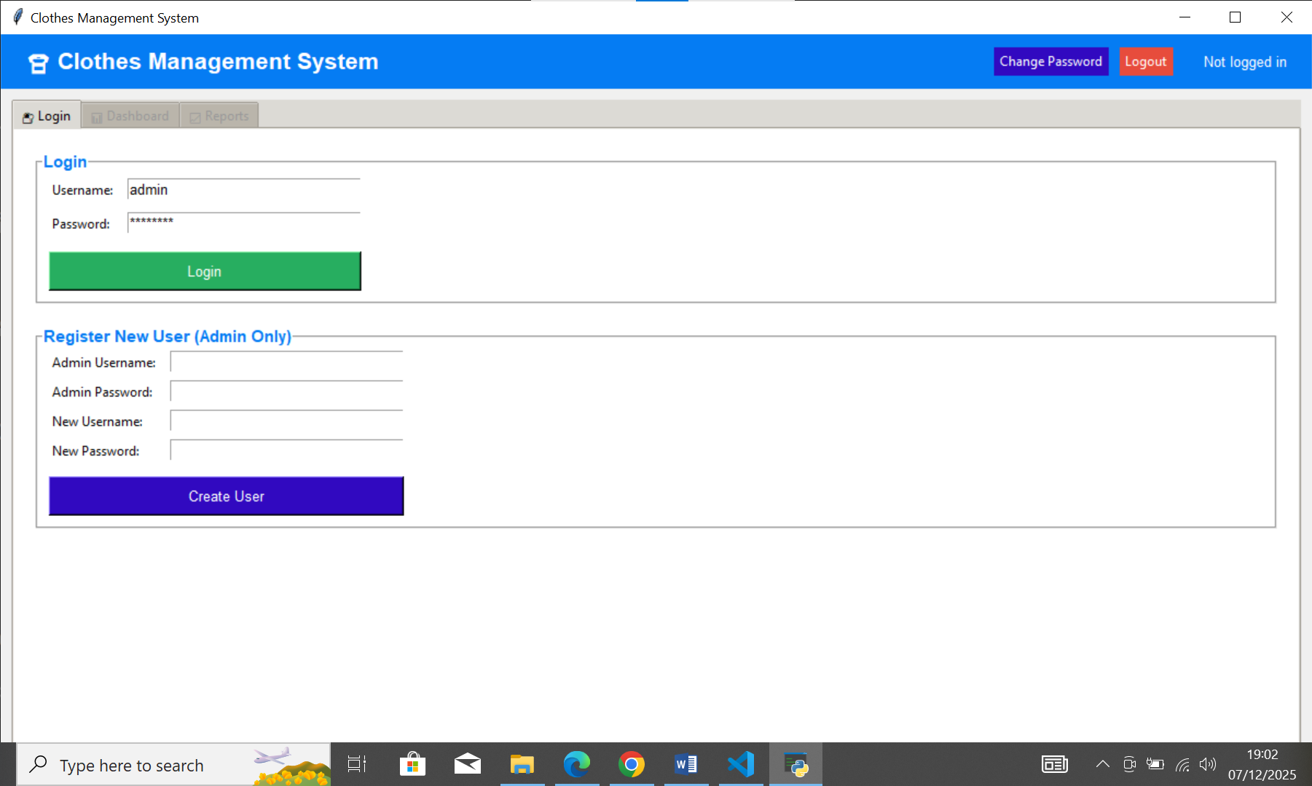

- Admin Dashboard:

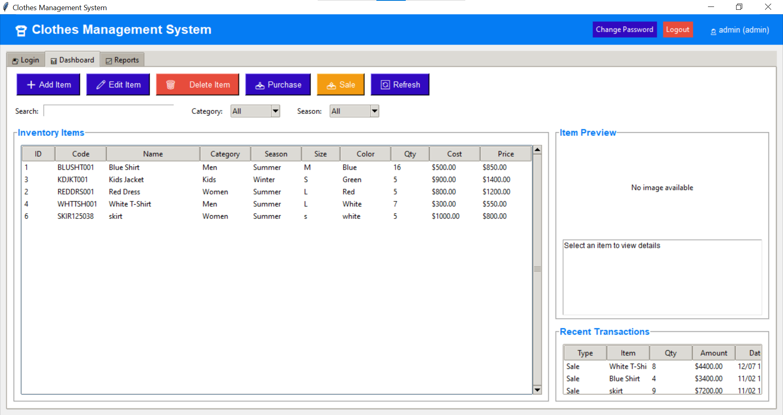

- Sales Man dashboard:

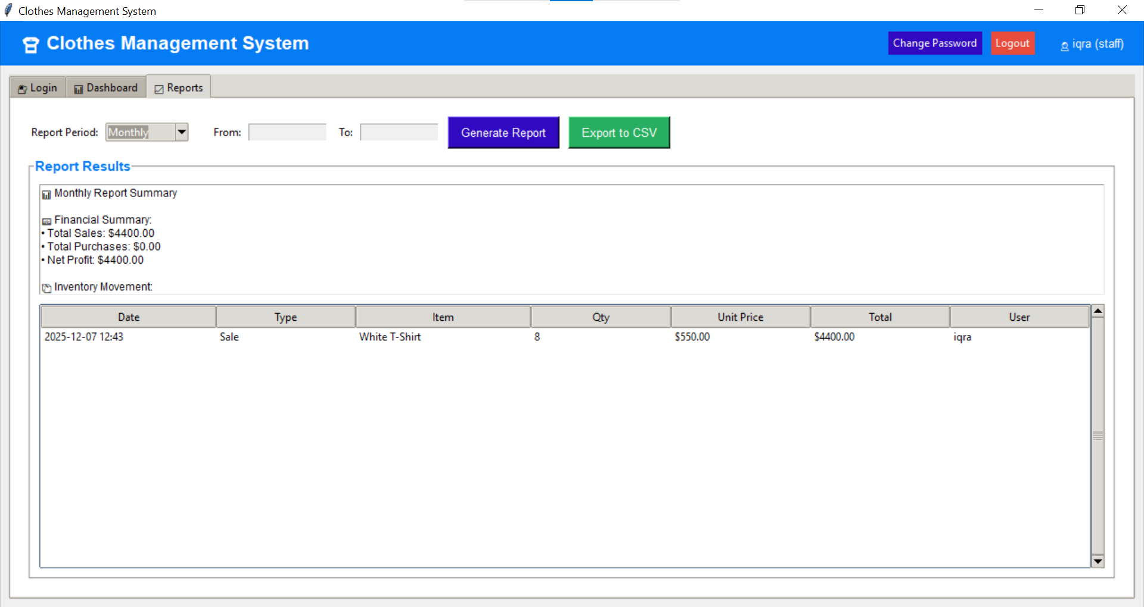

CHAPTER 3
Development

3.1 Development plan (Architecture Diagram)


REFERENCES:

- Google.com
- Udemy.com
- Greeksforgreeks
- Youtube
- Introduction to database management cs403

