Notes
- Only put one supplier on each requisition. Do not add multiple vendors in the same REQ.
- Keep tax exempt items such as chemical/biological reagents on their own REQ in workday as well (See below for more information on tax exemptions).

Workday
https://www.myworkday.com/asu/d/home.htmld
- Once on the homepage linked above, click “menu” at the top left of the screen
- Click “purchases”
- Click “create requisition”
- You should be the requester, the company should be Arizona State University, currency should be USD
- Requisition type will be “goods and services” unless the item you are ordering is a chemical; in this case, the requisition type will be chemical
- Delete automatic ship-to address and put in: 734 W Alameda Dr (ALMDBR) Tempe AZ 85282 (will auto-populate after typing 734 and press enter)
- Type WCPH into the building/room # section and select code DC7904_WCPH
- Add grant (GR) or program (PG) number and cost center (CC)
- Leave automatic additional worktags there and add WCPH 330 by typing in “Susanne” and scrolling through the options to find the one with WCPH 330 and double clicking that option
- Leave all other boxes blank and press OK
- Click connect to supplier website
- Click connect
- From here you can either click on the supplier from the list provided if you want to order from a specific supplier, or you can search the name or catalog # of the item you want to buy to view all the suppliers and prices
- Once on the product you wish to buy, add it to the cart
- When you click checkout it will take you back to the workday website, if you’d like to order multiple products from the same supplier, you can add more products. If not, go straight to “view cart details” and “send to workday” then “checkout”
- Spend category is usually “medical, laboratory and scientific accessories and supplies,” tax applicability is “taxable goods” unless the item is tax exempt (see below for information on tax exemptions), and tax code is “Tempe TPT/sales tax (8.1%)”
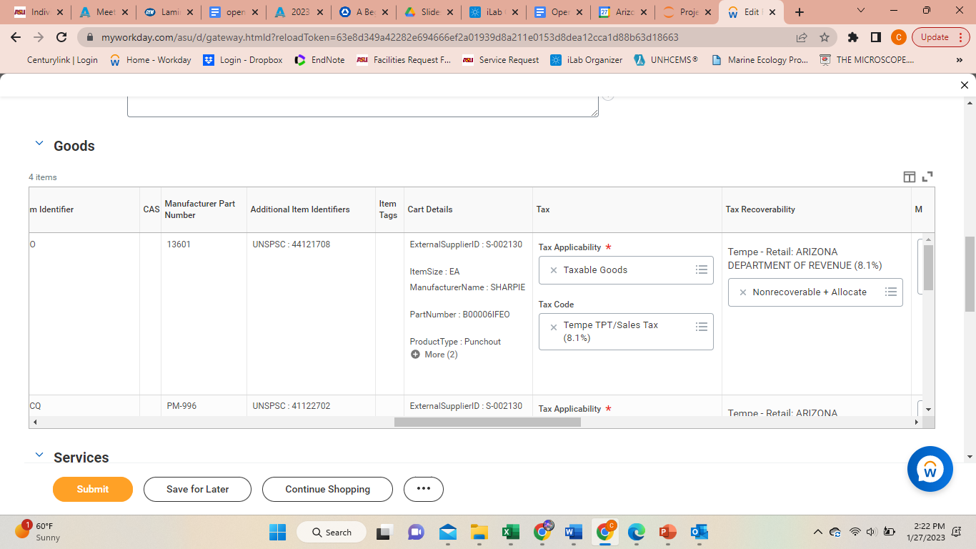
- Make sure “nonrecoverable + allocate” auto populates under tax recoverability
- Write in a reason for purchase in the memo section
  - Example reason for purchase of serological pipettes: used to collect samples from plankton culture experiments
- Scroll down and “save for later.”
- Make note of the REQ # in the maroon badge at the top of the page and total amount directly underneath the REQ# for later use. Export to excel using the first button on the top right of the goods line

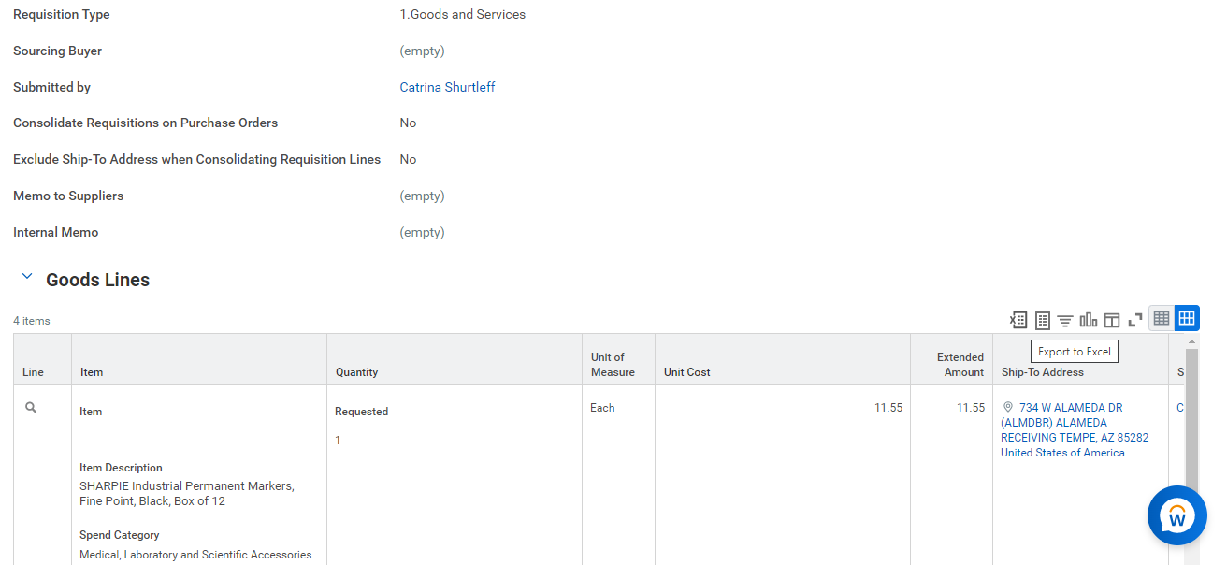
- Email the excel sheet to Susanne and ask for approval. You must have the total cost of the order and the grant/ program # stated in the email
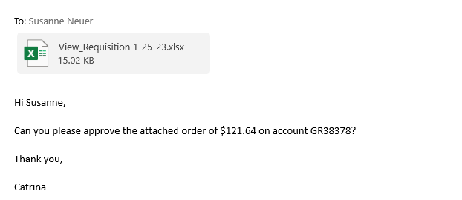
- Once Susanne has emailed back her approval, you will print to PDF and save the entire email exchange and log back into workday
- On workday, click “menu” and “purchases” and then “requisitions” under view
- Type in the REQ# to the requisition line and press OK
- Click “edit requisition” and then scroll down and attach the email exchange under attachments
- Click “submit”

Tax exemptions:
ASU is exempt from paying taxes on these types of items when used for “Research and Development”:
- Chemicals/Biologicals/Reagents that are used for “research and development” (note this does NOT include cleaning chemicals such as bleach for example)
- Capital and non-capital Equipment that is used in research and development. This is equipment over 5K in cost. Under 5K in cost is considered “non-capital equipment” and we are taxed if under 5K.
Lab supplies are not tax exempt- Just Chemicals/Biologicals/Reagents type of items.
Fill out tax exemption form with:
- Vendor name in box A
- What you are ordering and reason for ordering in box E
- Signature of the cost center manager and date that order is placed in box F
Then order in workday as described above but make sure to:
- Change the “Ship-To” address 551 E University Dr. (PSG chemical receiving) (will auto-populate after typing PSG and press enter)
- Type WCPH into the building/room # section and select code C1015_CEMS
- Choose “research and development” or “non-taxable” in the tax box column on each line
- Make sure you have coded the spend category to be a type of chemical or biological.
- Attach/upload completed exemption form to your order
- Check the box for external so ASU sends it to the vendor with your order.

Ordering from Suppliers not found on workday
After receiving a quote (for item) or invoice (for service) from the supplier, complete the following steps based on where the account you are ordering from is located
School of Ocean Futures /KE accounts (School accounts only, not College accounts): Account including but not limited to those with cost centers CC1220
You can view how-to instructions and access the required forms through the link below.
https://arizonastateu.sharepoint.com/sites/O365OKEDFinanceDPT/SitePages/Finance-Procurement-Form.aspx
Some specific notes:
- The finance partner is Susanne
- The shipping address is 734 W Alameda Dr. And make sure to note in the shipping details that the building code for delivery is DC_7904 WCPH. They do not explicitly ask you on the form and instead will send it to the building where the grant is located which may be a different location!
College of Global Futures accounts (not school accounts; see above): accounts including but not limited to those with cost centers CC1416
Submit a purchase request at the link below. See above for specific notes:
https://docs.google.com/forms/d/e/1FAIpQLScF66xtbZtJFM5j7MPOz5MPuyHq3p_UJrMMlExrY35jJkqZJA/viewform

Biodesign accounts: Account including but not limited to those with cost centers CC0014
You can view how-to instructions and access the required forms through the following link: https://arizonastateu.sharepoint.com/sites/O365OKEDFinanceDPT/Lists/Procurement%20Request/Finance.aspx
SOLS accounts:
- Fill out a Greensheet with your name and contact info as the preparer as well as the date
- Add the cost center and program/gift/grant #
- Write justification for your purchase. Include who will be using the purchased item and how the purchase will be of benefit to the user and ASU
- Fill in what building and room # the shipment or service will be sent to or was completed
- Provide the catalog # for the item you’re ordering, whether it is a chemical, quantity you are ordering, unit of order (each/box) item description, and pricing information – this information should all be on the quote/invoice provided by the supplier
- Email Susanne the filled-out form for account signature
- Send the completed form to: sols-business@asu.edu along with the invoice/quote

Once an item is received create a receipt!
- Log on to Workday
- Click “menu”
- Click “purchases”
- Click “create receipt”
- Enter the PO # (on packing slip) and click “OK”
- Click “fully received" check box
- Click “submit” if the entire order has been received or “save for later” if you are still waiting on other items
If you ever want to look at old receipts:
- Download the receipts shortcut
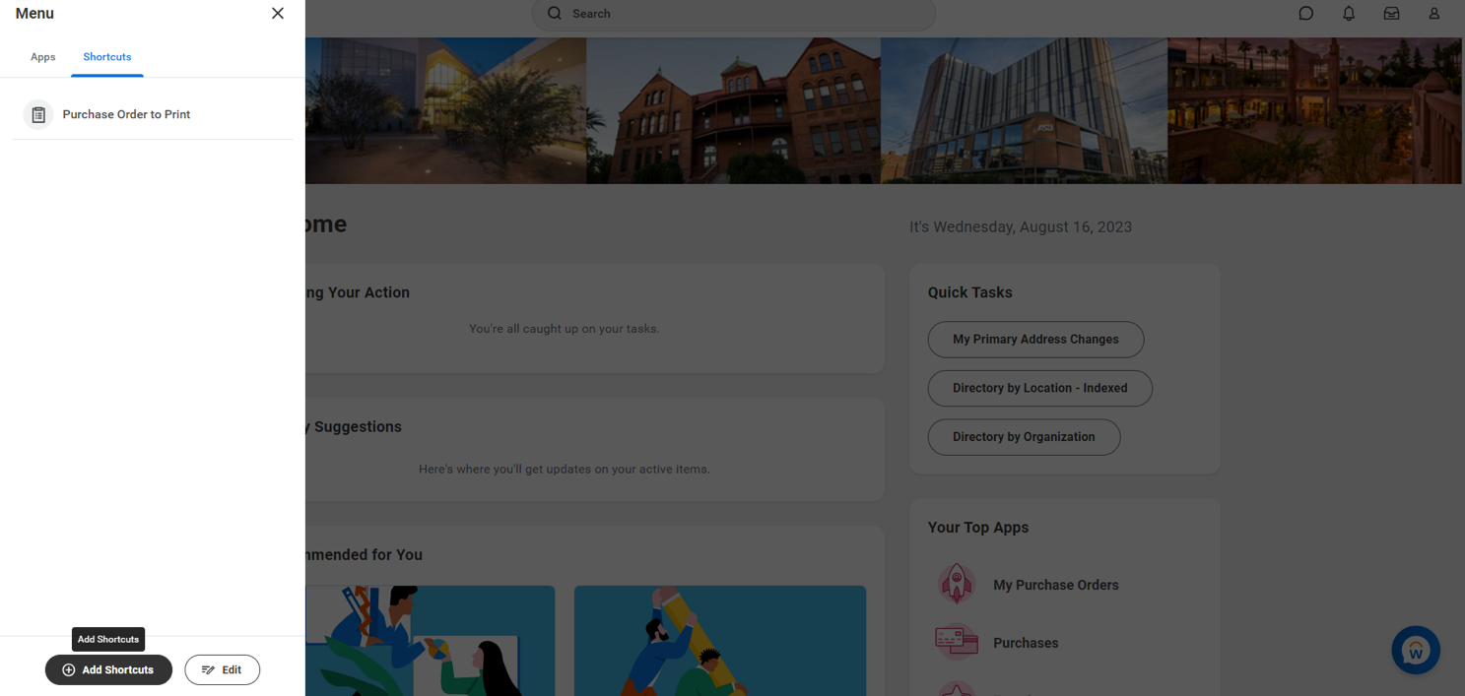
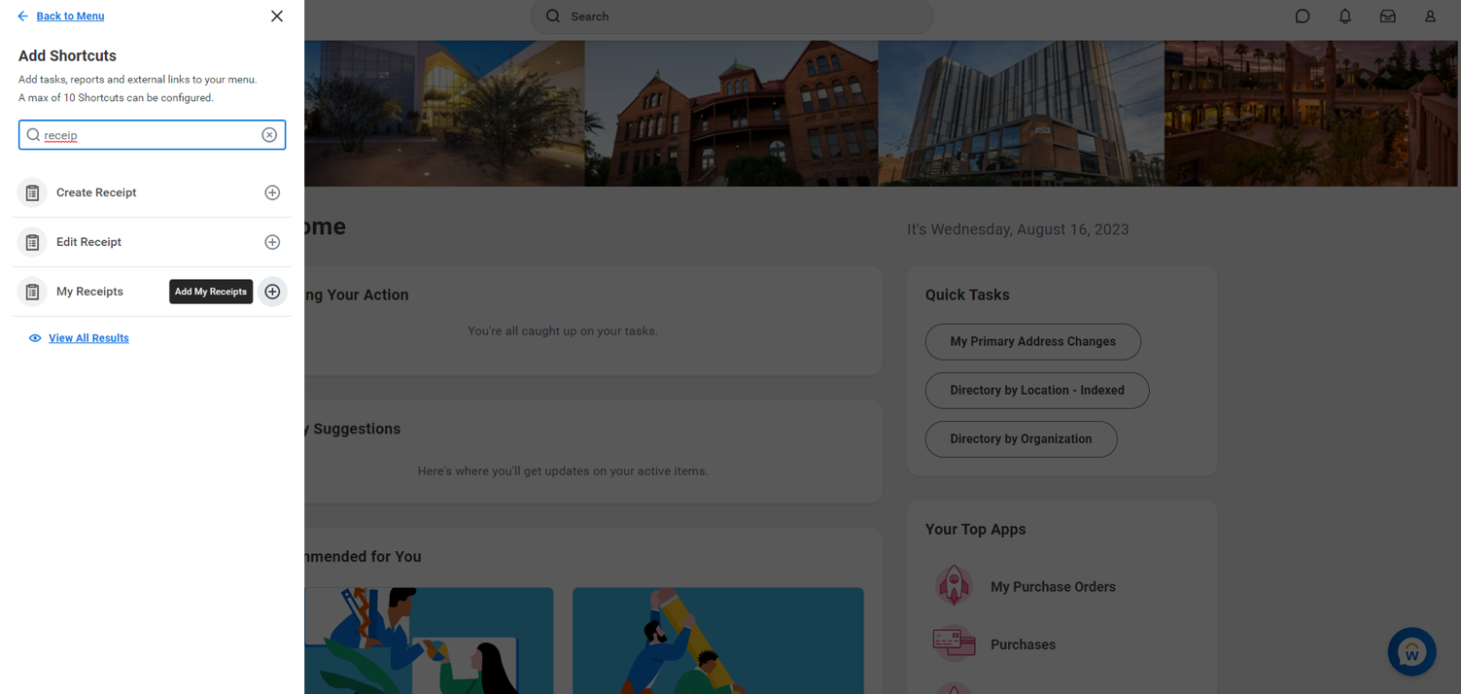
- Type in the PO #
- Click on the PO #
- Click on “balances”
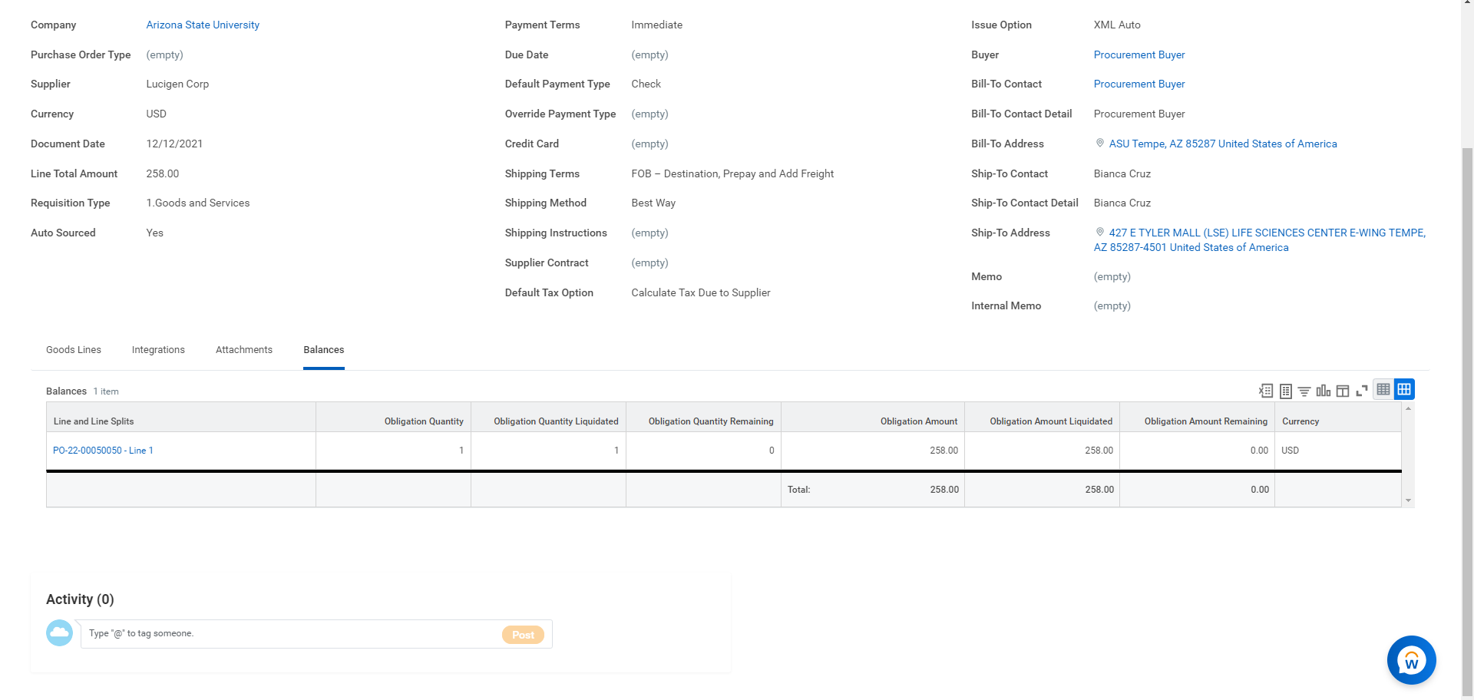
- Click on the PO #
- Click on “receipt”
