1.What are the two values of the Boolean data type? How do you write them?

The Boolean data type represents a logical value that can be either true or false. values are represented as keywords: **True** and **False** (note the capitalization)

2. What are the three different types of Boolean operators?

**- AND operator:** The AND operator returns true if both operands are true; otherwise, it returns false.

**- OR operator:** The OR operator returns true if at least one of the operands is true; it returns false only if both operands are false.

**- NOT operator:** The NOT operator is a unary operator that returns the opposite boolean value. If the operand is true, it returns false, and if the operand is false, it returns true.

3. Make a list of each Boolean operator's truth tables (i.e. every possible combination of Boolean values for the operator and what it evaluate ).

|  |  |  |  |  |  |  |  |  |  |
| --- | --- | --- | --- | --- | --- | --- | --- | --- | --- |
| AND | | Result |  | OR | | Result |  | NOR | Result |
| TRUE | TRUE | TRUE |  | TRUE | TRUE | TRUE |  | TRUE | FALSE |
| TRUE | FALSE | FALSE |  | TRUE | FALSE | TRUE |  | FALSE | TRUE |
| FALSE | TRUE | FALSE |  | FALSE | TRUE | TRUE |  |  |  |
| FALSE | FALSE | FALSE |  | FALSE | FALSE | FALSE |  |  |  |

4. What are the values of the following expressions?

(5 > 4) and (3 == 5)--False

not (5 > 4)--False

(5 > 4) or (3 == 5)-- True

not ((5 > 4) or (3 == 5))-- False

(True and True) and (True == False) --False

(not False) or (not True)—True

5. What are the six comparison operators?

|  |
| --- |
| **print(a == b)** |
| **print(a != b)** |
| **print(a > b)** |
| **print(a < b)** |
| **print(a >= b)** |
| **print(a <= b)** |

6. How do you tell the difference between the equal to and assignment operators? Describe a condition and when you would use one.

Equal to Operator (**==**): To check condition if it is True or False

Assignment Operator (**=**) to assign value to a variable like x=10

7. Identify the three blocks in this code:

spam = 0

if spam == 10:

print('eggs')

if spam > 5:

print('bacon')

else:

print('ham')

print('spam')

print('spam')

Block can be identified by indentation level

|  |  |  |  |
| --- | --- | --- | --- |
| Block1 | Block2 | Block3 | Block4 |
| spam = 0 | if spam == 10:  print('eggs') | if spam > 5:  print('bacon') else:  print('ham') | print('spam') print('spam') |

8. Write code that prints Hello if 1 is stored in spam, prints Howdy if 2 is stored in spam, and prints Greetings! if anything else is stored in spam.

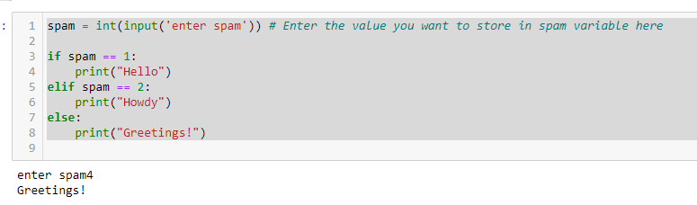

9.If your programme is stuck in an endless loop, what keys you’ll press?

**Need to terminate by pressing STOP button**

10. How can you tell the difference between break and continue?

1. break statement: - The break statement is used to exit or terminate the loop entirely.

2. continue statement: - The continue statement is used to skip the statements in the current iteration of the loop`

11. In a for loop, what is the difference between range(10), range(0, 10), and range(0, 10, 1)?

all three forms range(10), range(0, 10), and range(0, 10, 1) produce the same sequence of numbers from 0 to 9. The only difference is in how the range is specified, with the start value and step value being explicit in range(0, 10) and range(0, 10, 1), whereas they use default values in range(10)

12. Write a short program that prints the numbers 1 to 10 using a for loop. Then write an equivalent program that prints the numbers 1 to 10 using a while loop.



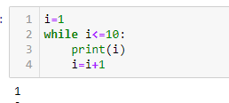

13. If you had a function named bacon() inside a module named spam, how would you call it after importing spam?

import spam

spam.bacon()

importing the module named "spam," you can call the function named "bacon()" using the dot notation.