1. Why are functions advantageous to have in your programs?

- The advantage of function in program is that we just have to call it and do not have to write whole code

2. When does the code in a function run: when it's specified or when it's called?

When it is called

1. What statement creates a function?

def()

1. What is the difference between a function and a function call?

1. How many global scopes are there in a Python program? How many local scopes?

In a Python program, there is only one global scope, which is the top-level scope of the program. The global scope is where variables and functions that are defined outside of any function or class reside. Variables and functions defined in the global scope are accessible throughout the entire program.

On the other hand, the number of local scopes in a Python program can vary depending on the number of functions and nested blocks of code. A local scope is created whenever a function is called or when a block of code is entered. Each function or block has its own local scope, which is separate from the global scope and any other local scopes.

1. What happens to variables in a local scope when the function call returns?

When a function call returns in Python, the variables defined within the function's local scope are erased from memory. They cannot be accessed or used outside of the function.

1. What is the concept of a return value? Is it possible to have a return value in an expression?

The concept of a return value refers to the value that is sent back by a function when it completes its execution. It allows the function to provide a result or data to the code that called it.

**And**

**Yes, the return value can use in an expression.**

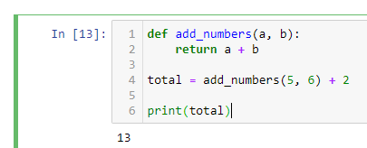

1. If a function does not have a return statement, what is the return value of a call to that function?

None type

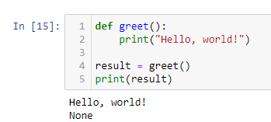

1. How do you make a function variable refer to the global variable?

By using **global** method, below example

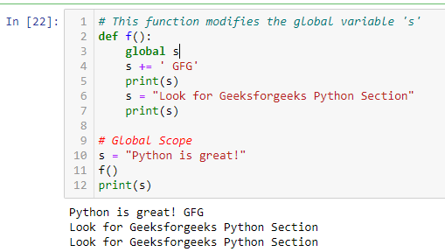

1. What is the data type of None?

In Python, None is a special object that represents the absence of a value or the lack of a specific data type.

1. What does the sentence import areallyourpetsnamederic do?

The sentence "import areallyourpetsnamederic" is not a valid or meaningful Python import statement. In Python, the import keyword is used to import modules or packages into your code, allowing you to access their functionality.

1. If you had a bacon() feature in a spam module, what would you call it after importing spam?

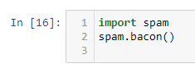

1. What can you do to save a programme from crashing if it encounters an error?

It can be done by Exception Handling with Try-Except:

14. What is the purpose of the try clause? What is the purpose of the except clause?

**Purpose of the try Clause:**

The try clause is used to enclose a block of code where exceptions might occur. Its purpose is to identify sections of code that may raise exceptions and allow for the handling of those exceptions.

**Purpose of the except Clause:**

The except clause is used to specify the actions or code to be executed when a specific exception occurs within the try block.

It allows you to catch and handle specific types of exceptions, providing an alternative flow of control when an exception is raised.