1. What does an empty dictionary's code look like?

{}

2. What is the value of a dictionary value with the key 'foo' and the value 42?

{foo:42}

1. What is the most significant distinction between a dictionary and a list?

List is collection of values

Where as Dictionary is collection of key and values

4. What happens if you try to access spam['foo'] if spam is {'bar': 100}?

It will give Key Error

5. If a dictionary is stored in spam, what is the difference between the expressions 'cat' in spam and 'cat' in spam.keys()?

‘cat’ in spam is basically, checking ‘cat in the whole dictionary

And ‘cat’ in spam.key is checking ‘cat’ in the **list of keys**

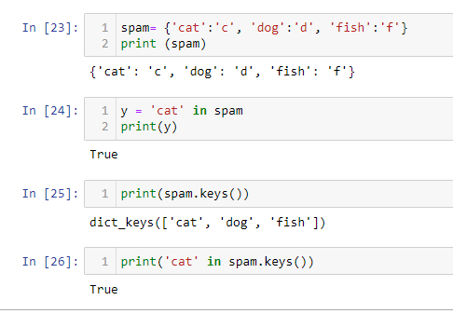

6. If a dictionary is stored in spam, what is the difference between the expressions 'cat' in spam and 'cat' in spam.values()?

Basically cat in spam.value() will check if ‘cat’ is list of dictionary values.

7. What is a shortcut for the following code?

if 'color' not in spam:

spam['color'] = 'black'

spam.setdefault('color', 'black')

8. How do you "pretty print" dictionary values using which module and function?

It can be done as below

import pprint # Module

pprint.pprint(my_dict) # function