Task #01: Lucid Chart
Name: Ms. Mitali Sawant
Challenge: Implementation of NEP 2020 in college
Stakeholder identified: College, funding agencies, faculty members, students, society

2 x 2 Power – Interest Matrix:
- Quadrant I: High Power – High Interest - Manage Closely - College
- Quadrant II: High Power – Low Interest - Keep Satisfied – Funding agencies
- Quadrant III: Low Power – High Interest - Keep Informed – Faculty members, students
- Quadrant IV: Low Power – Low Interest - Monitor – Society at large
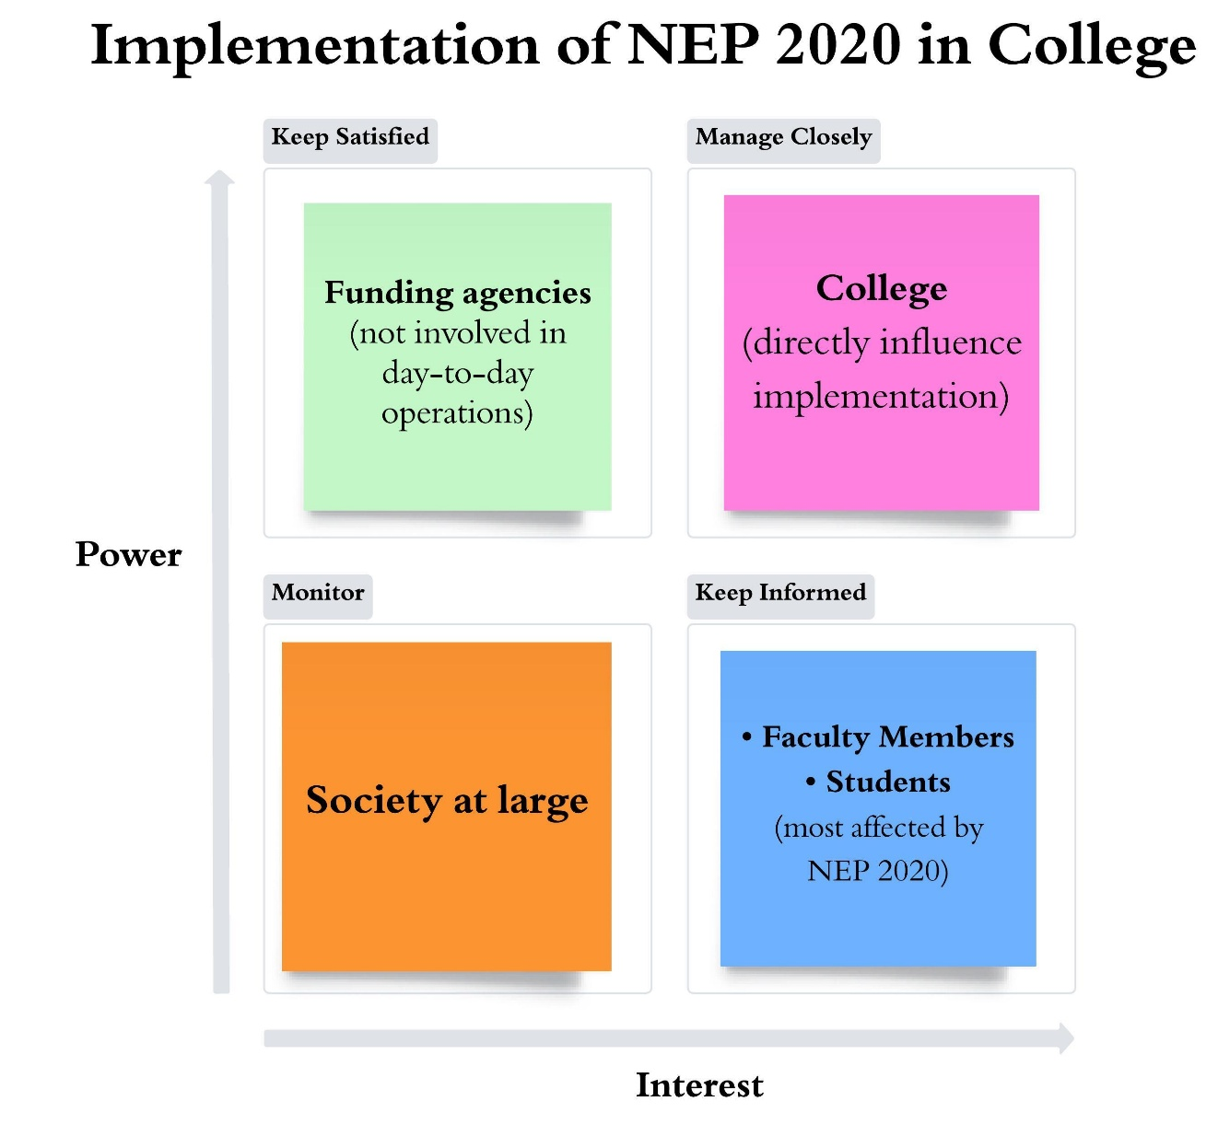

Task #03:
Applying Design Thinking as a Class Mentor for TYBA Economics Students (7 Stages)

Design Thinking is a student-centric, problem-solving framework that focuses on understanding learners’ needs and developing practical, innovative, and empathetic solutions. As a Class Mentor for TYBA Economics students, Design Thinking helps address academic challenges, career uncertainty, skill gaps, low engagement, and stress during the final year of graduation.
The 7-stage Design Thinking process ensures systematic mentoring by moving from understanding student problems to implementing and refining effective solutions.

Stage 1: Empathize
Explanation
The empathize stage focuses on deeply understanding students’ academic, emotional, and career-related concerns. As a mentor, this involves observing students, interacting informally, and listening without judgment.
Mentor Actions
- Conduct one-to-one mentoring sessions
- Use informal discussions, reflection journals, and feedback forms
- Observe classroom behavior, attendance, and participation patterns
- Understand socio-economic background, language barriers, and learning difficulties
Outcome
A clear understanding of:
- Exam anxiety and fear of final results
- Confusion regarding higher studies, competitive exams, or jobs
- Difficulty in understanding economic theories and quantitative papers
- Lack of confidence in communication and analytical skills

Stage 2: Define the Problem
Explanation
In this stage, the mentor clearly defines the core problems based on insights gained during empathy. Problems are framed in a student-centric manner rather than institutional assumptions.
Problem Statements (Examples)
- TYBA Economics students struggle to link theoretical concepts with real-world applications
- Students lack clarity about career paths after graduation
- Many students experience stress and low motivation during the final year
- There is inadequate exposure to practical skills required for employability
Outcome
Well-defined mentoring challenges that guide solution development.

Stage 3: Research
Explanation
Research strengthens the problem definition by gathering data and best practices from multiple sources.
Mentor Actions
- Review university syllabus and learning outcomes
- Analyze previous years’ results and internal assessment performance
- Consult senior faculty, alumni, and industry experts
- Study employability trends related to economics graduates
- Review NEP 2020 recommendations on skill-based education
Outcome
Evidence-based understanding of academic and career gaps among TYBA students.

Stage 4: Ideate
Explanation
The ideation stage involves generating multiple possible solutions without immediate judgment. Creativity and inclusiveness are encouraged.
Mentoring Ideas
- Weekly concept-clarification and doubt-solving sessions
- Career guidance workshops with alumni and experts
- Case-study-based teaching of economic theories
- Group discussions on current economic issues
- Basic training in data analysis, Excel, and report writing
- Peer mentoring and student presentation activities
Outcome
A wide range of mentoring strategies to address academic, emotional, and career needs.

Stage 5: Prototype
Explanation
Prototyping involves implementing selected ideas on a small scale to test their effectiveness.
Mentor Actions
- Start a monthly “Economics in Practice” session
- Conduct mock interviews and resume-building workshops
- Introduce short student-led seminars on syllabus topics
- Organize stress-management and time-management sessions
Outcome
Practical mentoring models that can be tested, observed, and refined.

Stage 6: Test
Explanation
The testing stage evaluates how students respond to the prototypes.
Mentor Actions
- Collect student feedback through surveys and discussions
- Observe improvement in attendance, participation, and confidence
- Track internal assessment performance and presentation skills
- Identify what works well and what needs improvement
Outcome
Validation of effective mentoring practices and identification of gaps.

Stage 7: Implement and Iterate
Explanation
This final stage focuses on full-scale implementation of successful strategies while continuously refining them based on feedback.
Mentor Actions
- Integrate successful activities into the annual mentoring plan
- Coordinate with faculty, placement cell, and career guidance units
- Maintain mentoring records for IQAC and NAAC documentation
- Modify mentoring strategies based on changing student needs
Outcome
A sustainable, student-centric mentoring framework that enhances:
- Academic performance
- Career readiness
- Emotional well-being
- Overall student satisfaction

Task #04:
UbD – Stage 1: Desired Results
Topic: Demand Analysis

1. Established Goals
Students will be able to:
- Understand the concept and meaning of demand in economics
- Analyze the law of demand and its underlying assumptions
- Examine the factors determining demand and changes in demand
- Interpret demand schedules and demand curves
- Apply demand analysis to real-life consumer behavior and market situations
- Develop analytical thinking using demand concepts for policy and business decisions

2. Understandings
Students will understand that:
- Demand represents not just desire but willingness and ability to pay at various prices
- The law of demand explains the inverse relationship between price and quantity demanded under normal conditions
- Demand is influenced by multiple factors beyond price, such as income, tastes, prices of related goods, and expectations
- Changes in price cause movement along the demand curve, whereas changes in other factors cause shifts in the demand curve
- Demand analysis helps explain real-world market phenomena like price changes, shortages, and consumer responses

3. Essential Questions
- What does demand mean in real economic terms?
- Why does quantity demanded generally fall when price rises?
- How do income and tastes influence consumer demand?
- What is the difference between a change in quantity demanded and a change in demand?
- How can demand analysis be used to understand everyday market behavior?
- Why is demand analysis important for economists, businesses, and policymakers?

4. Students Will Know (Knowledge Outcomes)
Students will know:
- Definition and meaning of demand
- Law of demand and its assumptions
- Demand schedule and demand curve
- Determinants of demand
- Difference between extension/contraction of demand and increase/decrease in demand
- Concept of individual and market demand
- Exceptions to the law of demand (introductory understanding)

5. Students Will Be Able to Do (Skill Outcomes)
Students will be able to:
- Explain demand concepts using appropriate economic terminology
- Draw and interpret demand curves and schedules
- Analyze changes in demand using graphical representation
- Apply demand theory to real-life examples and case studies
- Distinguish between movement along the curve and shift of the curve
- Critically analyze consumer behavior in different market situations

Task #05: Gap analysis

