Evidence Tampering Analysis Report

1. Introduction
This document provides a detailed overview of an image forensics system that performs in-depth analysis on images to detect anomalies and tampering. The system extracts metadata, computes visual features, conducts Error Level Analysis (ELA), and compares binary streams. The structured results are stored in timestamped directories to ensure clear organization.
2. Objectives
- Extract metadata (EXIF) from images.
- Perform feature extraction, including histograms, edge maps, and ORB descriptors.
- Conduct Error Level Analysis (ELA) to identify anomalies.
- Compare binary streams of images to detect modifications.
- Store outputs in uniquely timestamped directories.
- Generate structured reports in JSON and CSV formats.
3. Functional Modules
3.1 Metadata Extraction
Purpose: Extract EXIF metadata from images to obtain camera settings, timestamps, and GPS data.
Methodology:
- Uses the exifread library to process EXIF metadata.
- Metadata is stored in a JSON file.
- Error handling ensures missing or corrupted metadata is gracefully managed.
Output:
- JSON files containing extracted metadata.

3.2 Feature Extraction
Purpose: Extract essential visual features such as color histograms, edge maps, and ORB descriptors.
Methods Used:
- Color Histogram: Uses reduced 8-bin histogram granularity across RGB channels.
- Edge Detection: Sobel operator is applied to generate edge maps.
- ORB Features: Extracts Oriented FAST and Rotated BRIEF descriptors.
Output:
- Feature data stored in .npz format.
- Feature summary stored in JSON.
3.3 Error Level Analysis (ELA)
Purpose: Identify image manipulation by examining compression artifacts.
Steps:
- Compresses the original image at 90% quality.
- Computes differences between original and recompressed images.
- Enhances differences for better visualization.
Output:
- ELA images stored in uniquely named directories.
3.4 Binary Stream Comparison
Purpose: Detect image modifications by comparing binary data streams.
Process:
- Convert images to binary streams.
- Compute SHA-256 hash and perceptual hash (pHash) for comparison.
- Identify differences visually using pixel-wise subtraction.
Output:
- Difference images saved in a timestamped directory.
3.5 Report Generation
Purpose: Consolidate all extracted information into structured reports.
Report Contents:
- Metadata extraction results
- Feature summary statistics
- ELA results and flagged anomalies
- Binary stream comparison results
Output:
- JSON and CSV reports stored in structured directories.
4. Implementation Details
4.1 Libraries Used
- os - Directory management
- json - Metadata and report handling
- csv - CSV report generation
- cv2 (OpenCV) - Image processing
- numpy - Numerical operations
- PIL (Pillow) - Image manipulation
- exifread - Metadata extraction
- hashlib - Image hashing
- imagehash - Perceptual hashing
- argparse - Command-line interface
4.2 Directory Structure
Unlike previous versions, each analysis run now generates a timestamped directory, ensuring separation between different analyses.

4.3 Code Flow
- Extract Metadata
  - Input: Image file
  - Output: JSON metadata file
- Extract Features
  - Input: Image file
  - Output: Feature data (.npz) + JSON summary
- ELA Analysis
  - Input: Image file
  - Output: ELA image
- Binary Stream Comparison
  - Input: Image file
  - Output: Difference image
- Report Generation
  - Input: Analysis results
  - Output: JSON & CSV reports
5. Results and Outputs
Test Images Used:
- Original Image: images/image.jpeg
- Modified Image: images/image2.jpeg
Generated Outputs:
- Metadata: Extracted and saved as JSON.
- Features: Histograms, edge maps, and ORB descriptors saved as .npz.
- ELA Images: Generated and saved.
- Binary Comparison: Differences visualized and saved as .png.
- Final Report: Consolidated results saved as JSON & CSV.

Outputs:
Image:
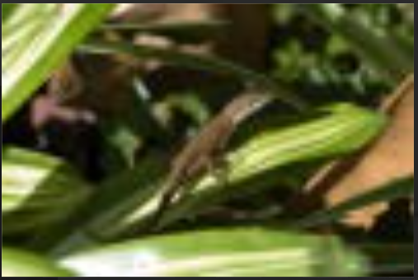

ELA of Image:
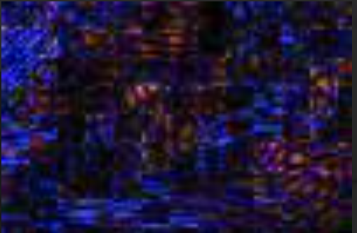
Image 2:

ELA od Image 2:
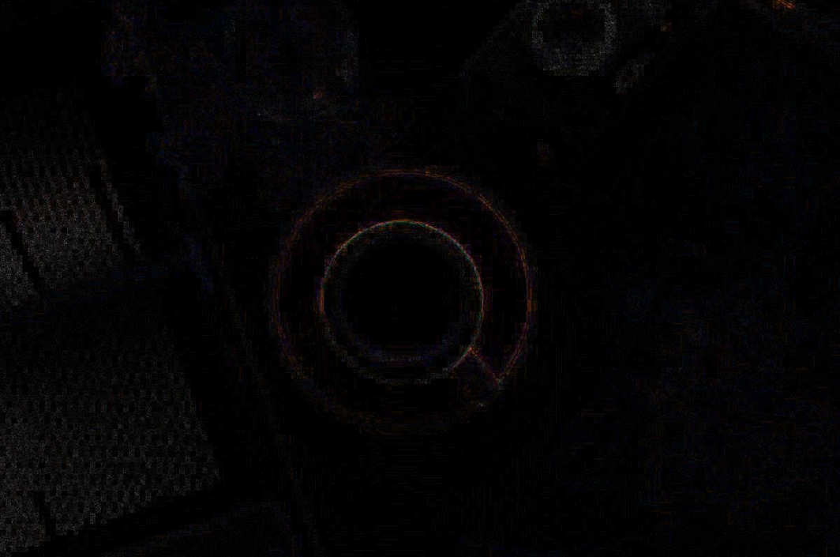

Automation output: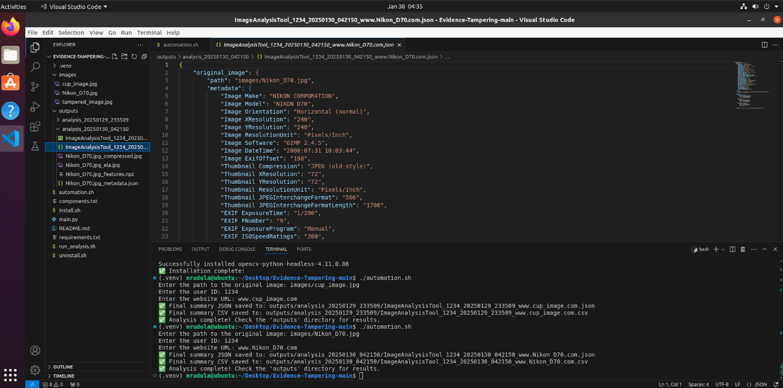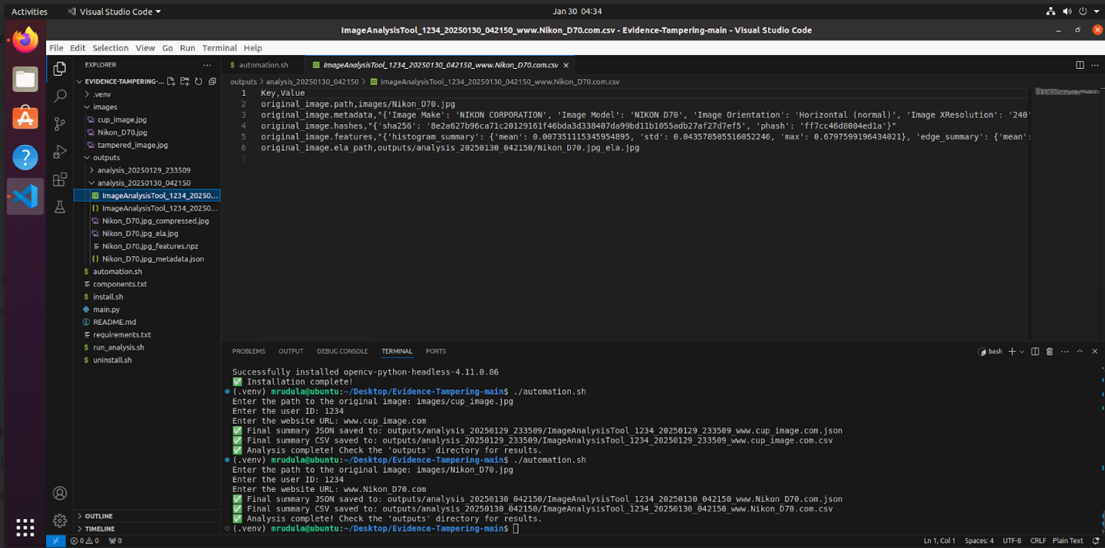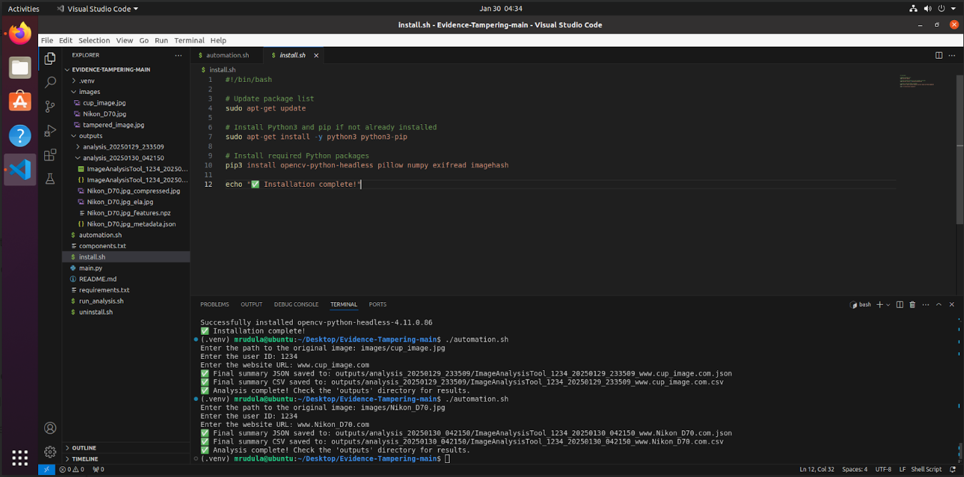
Code Explanation:
1. Import Required Modules
import os
import json
import csv
import cv2
import numpy as np
from PIL import Image, ImageChops
import exifread
import hashlib
import imagehash
from datetime import datetime
from urllib.parse import urlparse
import argparse

- os → Handles file and directory operations.
- json → Reads and writes JSON files.
- csv → Writes CSV files for structured output.
- cv2 → Uses OpenCV for image processing.
- numpy → Works with numerical arrays.
- PIL (Image, ImageChops) → Processes images.
- exifread → Extracts EXIF metadata from images.
- hashlib → Computes SHA-256 hashes.
- imagehash → Computes perceptual hashes (phash).
- datetime → Generates timestamps for filenames.
- urllib.parse → Extracts the domain name from a website URL.
- argparse → Parses command-line arguments.

2. Create Output Directories

def create_output_directories(tool_name, user_id, website_url):
base_output_dir = "outputs"
os.makedirs(base_output_dir, exist_ok=True)

- Creates a base directory called "outputs" if it doesn’t already exist.
timestamp = datetime.now().strftime("%Y%m%d_%H%M%S")
run_output_dir = os.path.join(base_output_dir, f"analysis_{timestamp}")
os.makedirs(run_output_dir, exist_ok=True)

- Generates a timestamp to organize results.
- Creates a new folder "analysis_YYYYMMDD_HHMMSS" inside "outputs".

parsed_url = urlparse(website_url)
domain = parsed_url.netloc or parsed_url.path

- Extracts the domain name from the website URL.
final_filename_json = f"{tool_name}_{user_id}_{timestamp}_{domain}.json"
final_filename_csv = f"{tool_name}_{user_id}_{timestamp}_{domain}.csv"
final_output_path_json = os.path.join(run_output_dir, final_filename_json)
final_output_path_csv = os.path.join(run_output_dir, final_filename_csv)

- Generates unique filenames for JSON and CSV reports.

return run_output_dir, final_output_path_json, final_output_path_csv

- Returns the output directory paths.

3. Extract Image Metadata
def extract_metadata(image_path, output_dir):
try:
with open(image_path, 'rb') as img_file:
tags = exifread.process_file(img_file, details=False)

- Opens the image in binary mode (rb).
- Reads EXIF metadata using exifread.

metadata = {tag: str(tags[tag]) for tag in tags if tag not in ("JPEGThumbnail", "TIFFThumbnail")}
- Converts metadata into a dictionary, excluding thumbnails.
metadata_filename = os.path.basename(image_path) + "_metadata.json"
metadata_path = os.path.join(output_dir, metadata_filename)
with open(metadata_path, 'w') as f:
json.dump(metadata, f, indent=4)

- Saves metadata to a JSON file.
return metadata
except Exception as e:
return {}

- Returns metadata or an empty dictionary if an error occurs.

4. Compute Image Hashes:
def compute_hashes(image_path):
try:
with open(image_path, "rb") as file:
sha256_hash = hashlib.sha256(file.read()).hexdigest()

- Computes the SHA-256 hash of the image.
image = Image.open(image_path)
phash = str(imagehash.phash(image))

- Computes the perceptual hash (phash) for detecting visual similarity.
return {"sha256": sha256_hash, "phash": phash}
except Exception as e:
return {"sha256": None, "phash": None}

- Returns hashes, or None if an error occurs.

5. Extract Image Features
def extract_features(image_path, output_dir):
try:
image = cv2.imread(image_path)
gray = cv2.cvtColor(image, cv2.COLOR_BGR2GRAY)

- Reads the image using OpenCV.
- Converts it to grayscale.
hist = cv2.calcHist([image], [0, 1, 2], None, [8, 8, 8], [0, 256] * 3)
hist = cv2.normalize(hist, hist).flatten()

- Computes color histogram for color distribution.
- Reduces histogram bins for efficiency.
hist_summary = {"mean": float(np.mean(hist)), "std": float(np.std(hist)), "max": float(np.max(hist))}

- Computes statistical summary of the histogram.
sobel_x = cv2.Sobel(gray, cv2.CV_64F, 1, 0, ksize=3)
sobel_y = cv2.Sobel(gray, cv2.CV_64F, 0, 1, ksize=3)
sobel_edges = cv2.magnitude(sobel_x, sobel_y)

- Computes edge maps using the Sobel operator.
edge_summary = {"mean": float(np.mean(sobel_edges)), "std": float(np.std(sobel_edges)), "max": float(np.max(sobel_edges))}

- Extracts edge statistics.
orb = cv2.ORB_create()
keypoints, descriptors = orb.detectAndCompute(image, None)

- Extracts ORB features (used for object detection).
descriptors_summary = None
if descriptors is not None:
descriptors_summary = {"mean": float(np.mean(descriptors)), "std": float(np.std(descriptors)), "max": float(np.max(descriptors))}

- Computes statistical summary of ORB descriptors.
features_filename = os.path.basename(image_path) + "_features.npz"
features_path = os.path.join(output_dir, features_filename)
np.savez(features_path, hist=hist, edges=sobel_edges, descriptors=descriptors)

- Saves extracted features to a .npz file.
return hist_summary, edge_summary, descriptors_summary
except Exception as e:
return None, None, None

- Returns extracted features, or None if an error occurs.

6. Perform Error Level Analysis (ELA)
def error_level_analysis(image_path, output_dir, quality=90):
try:
original = Image.open(image_path).convert('RGB')

- Opens the image and converts it to RGB.
compressed_path = os.path.join(output_dir, os.path.basename(image_path) + "_compressed.jpg")
ela_path = os.path.join(output_dir, os.path.basename(image_path) + "_ela.jpg")

original.save(compressed_path, 'JPEG', quality=quality)
compressed = Image.open(compressed_path)

- Saves a compressed version of the image.
ela_image = ImageChops.difference(original, compressed)
ela_image = ela_image.point(lambda p: p * 10) # Enhances differences
ela_image.save(ela_path)

return ela_path
except Exception as e:
return ""

- Computes the Error Level Analysis (ELA) image.

7. Save Summary in CSV Format
def save_summary_as_csv(summary, csv_path):
try:
with open(csv_path, mode='w', newline='') as f:
writer = csv.writer(f)
writer.writerow(["Key", "Value"])
for key, value in summary.items():
if isinstance(value, dict):
for sub_key, sub_value in value.items():
writer.writerow([f"{key}.{sub_key}", sub_value])
else:
writer.writerow([key, value])
except Exception as e:
pass

- Saves summary results in CSV format.

8. Conclusion
This system provides a structured and robust framework for image forensics. The modular design allows for extensibility, and the new timestamped directory structure ensures results remain well-organized. This tool is essential for forensic and cybersecurity applications, offering reliable detection of image manipulations.

