## EN813701

### Exercise 5 Comment Web Design

### **Problem 1 Commenting website that have bad designs (5 points)**

* Comment **at least three items** of **what you think the web should be improved based on web design best-practices**
* **Capture the part of the commented website and insert the captured image** in the document so that the explanation can be understood more clearly
  + For example, please don’t just say “bad colors” but should say
    - 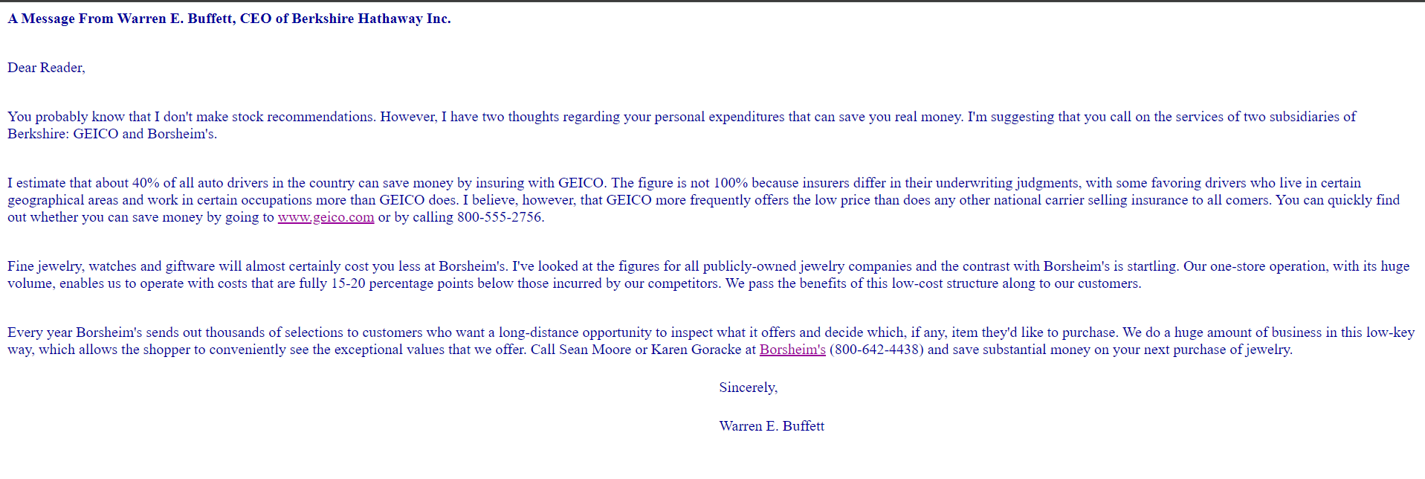The colors should be selected such that they are more well contrasted

**1. From the picture it can be seen that there are too many character to read effectively because of having the right number of characters.Each line is the key to reading the text.**

**Therefore, the length of each line should be reduced.**

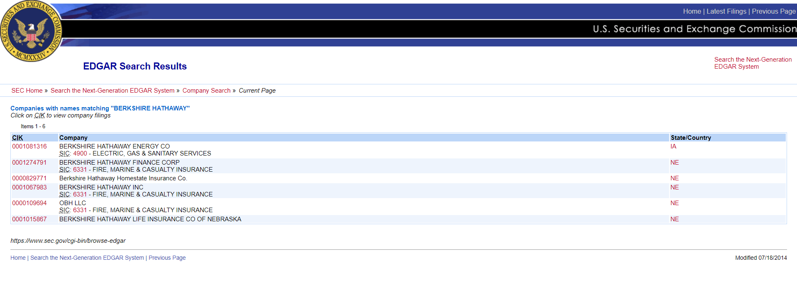

### 

### 

### 

**2.** **Each line is too close together..** **Should be separated more than this.**

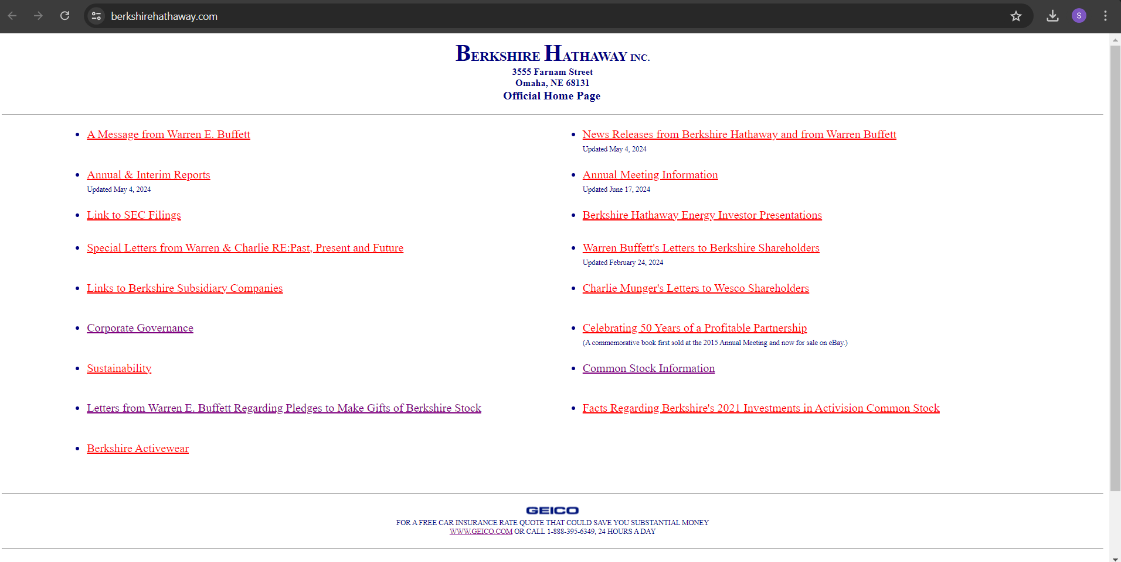

**3.** **Should add color to the website to make it look more attractive.**

### 

### How to submit the assignment

1. Place your web page solution in the folder **design** in **<yourname>-<yourid>-webapp-labs**
2. Add and commit the name of your document with the name as **<yourname>-<yourid>-improve-design** in the folder **design**
3. Push your files to your labs remoted repository at github.com
4. Submit the link at your labs remoted repository account in the assignment