## EN813701

### Exercise 5 Comment Web Design

### **Problem2 Learning from websites with good design (5 points)**

* Comment **at least three items** of **what you think the web has a good design based on web design best-practices**
* **Capture the part of the commented website and insert the captured image** in the document so that the explanation can be understood more clearly
  + For example, please don’t just say “good colors” but should say
    - The colors are well contrasted
    - The background color is well contrasted with the text color which makes the text difficult to read.

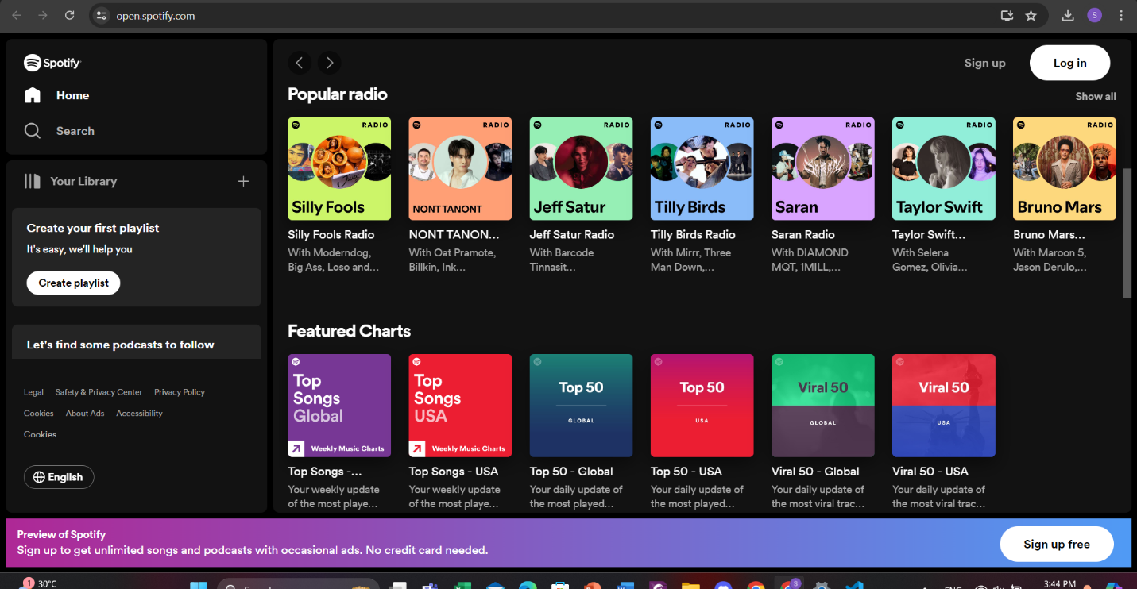

**1.** **The colors are well contrasted.The background color is well contrasted with the text color which makes the text easy to read.**

**2.** **There are convenient features such as Creating a playlist To listen only to what you want to listen Recommending songs if we don't know what to listen to**

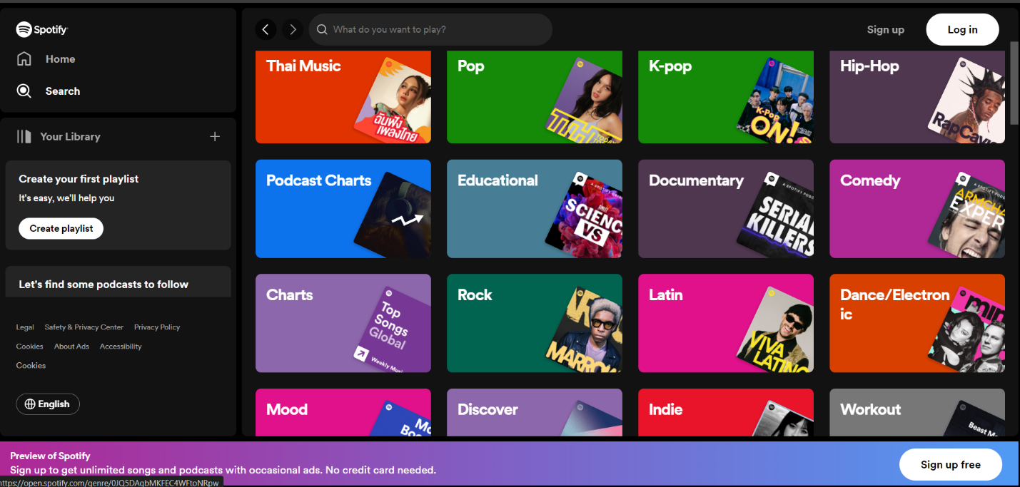

**3.** **Categorize various content well. Easily accessible, does not waste time**

### How to submit the assignment

1. Place your web page solution in the folder **design** in **<yourname>-<yourid>-webapp-labs**
2. Push the name of your document with the name as **<yourname>-<yourid>-learn-design** in the folder **design**
3. Commit your file to your labs remoted repository at github.com
4. Submit the link at your labs remoted repository account in the assignment