ABSTRACT
The Community Library Management System is a Java-based application designed to simplify and manage basic library activities. It provides a menu-driven interface that allows users to display available books, search for books, add new books, borrow books, and return borrowed books. The system keeps track of book IDs and available copies and also provides issue and return dates using Java’s Calendar class. It handles invalid book IDs and unavailable books while demonstrating important Java concepts such as arrays, methods, loops, switch-case, Scanner, and conditional statements.
Advantages
- Simple and easy-to-use interface.
- Makes book searching quick and convenient.
- Keeps track of available book copies.
- Supports borrowing and returning books.
- Reduces the need for manual record keeping.
- Provides issue and return dates automatically.
- Uses a menu-driven system for easy navigation.
- Demonstrates practical use of Java programming concepts.
Disadvantages
- Data is not permanently stored and may be lost when the program closes.
- Uses arrays, so the system has limited scalability.
- Does not include user login or authentication.
- Does not maintain detailed student/member records.
- No database connectivity is provided.
- Book information cannot be easily edited or deleted.
- Suitable mainly for a small-scale library.

IMPLEMENTATION
The Community Library Management System is implemented using Java with a menu-driven approach. The program stores book details such as book ID, book name, and available copies using arrays. Different methods are used to perform individual operations such as displaying books, searching for books, adding new books, borrowing books, and returning books. The Scanner class is used to accept input from the user, while loops and conditional statements control the program flow. The switch-case statement provides different options through the main menu. The Calendar class is used to generate the issue and return dates. The system also includes basic validation to handle invalid book IDs and books that are unavailable.
JAVA CODE
import java.util.Calendar;
import java.util.Scanner;
public class code {
static String[] books = {
"Java", "DSA", "Mathematics", "Computer Organization"
};
static int[] copies = {5, 3, 4, 2};
static int[] ids = {101, 102, 103, 104};
static void displayBooks(){
Scanner sc = new Scanner(System.in);
System.out.println("\nAvailable Books:");
for (String book : books) {
System.out.println(book);
}
}
static void searchBooks(){
Scanner sc = new Scanner(System.in);
System.out.print("Enter Book Name: ");
String name = sc.nextLine();
for (int i = 0; i < books.length; i++) {
if (books[i].equalsIgnoreCase(name)) {
System.out.println("Book Found!");
System.out.println("ID: " + ids[i]);
System.out.println("Copies: " + copies[i]);
return;
}
}
System.out.println("Book Not Found!");
}
static void Addbooks(){
Scanner sc = new Scanner(System.in);
System.out.println("Enter Name of the Book: ");
String book_a = sc.nextLine();
System.out.println("Author Name : ");
String author = sc.nextLine();
System.out.println("Number of Copies : ");
int copies = sc.nextInt();
System.out.println("Thankyou for adding these Books into our Collectionn!!!...");
}
static void BorrowBook(){
Scanner sc = new Scanner(System.in);
System.out.print("Enter Book ID: ");
int id = sc.nextInt();
Calendar cal = Calendar.getInstance();
for (int i = 0; i < ids.length; i++) {
if (ids[i] == id) {
if (copies[i] > 0) {
copies[i]--;
System.out.println("Book Borrowed Successfully!");
System.out.println("Issue Date : " +cal.get(Calendar.DATE) + "/" + (cal.get(Calendar.MONTH) + 1) + "/" + cal.get(Calendar.YEAR));
cal.add(Calendar.DATE,14);
System.out.println("Return Date : " +cal.get(Calendar.DATE) + "/" + (cal.get(Calendar.MONTH) + 1) + "/" + cal.get(Calendar.YEAR));
} else {
System.out.println("No Copies Available!");
}
return;
}
}
System.out.println("Invalid Book ID");
}
static void returnBook(){
Scanner sc = new Scanner(System.in);
System.out.print("Enter Book ID: ");
int id = sc.nextInt();
for (int i = 0; i < ids.length; i++) {
if (ids[i] == id) {
copies[i]++;
System.out.println("Book Returned Successfully!");
return;
}
}
System.out.println("Invalid Book ID");
}
public static void main(String[] args){
Scanner sc = new Scanner(System.in);
int choice;
do{
System.out.println("-------COMMUNITY LIBRARY SYSTEM-------");
System.out.println("1 . Display Books \n2 . Search \n3 . Add \n4 . Borrow \n5 . Return\n6 . Exit");
choice = sc.nextInt();
sc.nextLine();
switch(choice){
case 1:
displayBooks();
break;
case 2:
searchBooks();
break;
case 3:
Addbooks();
break;
case 4:
BorrowBook();
break;
case 5:
returnBook();
break;
case 6:
System.out.println("ThankYou For VISITING OUR LIBRARY");
break;
default:
System.out.println("Invalid Choice");
}
}while(choice !=6);
}
}
Screenshots
Interface
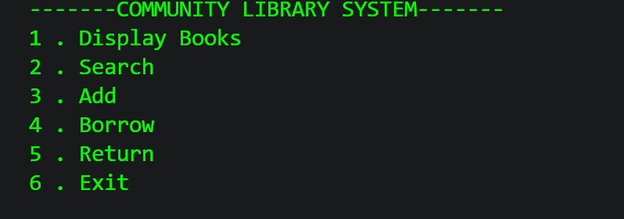
Display books
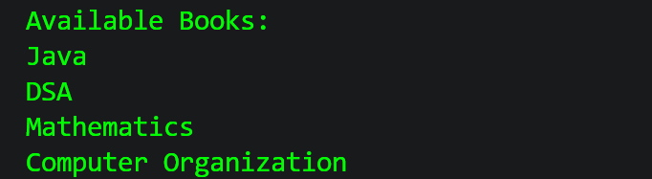
Search book
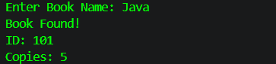
Add Book
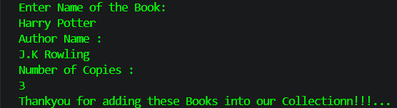

Borrow Book
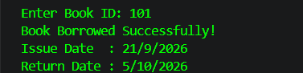
Return book


Conclusion
The Community Library Management System successfully demonstrates how Java can be used to develop a simple and interactive library application. The project provides essential features such as displaying books, searching for books, adding books, borrowing books, and returning books. It also keeps track of available copies and calculates issue and return dates. Through this project, basic Java concepts such as arrays, methods, loops, conditional statements, switch-case, Scanner, and Calendar were applied in a practical way. Overall, the project provides a simple foundation for managing library activities and can be further improved by adding permanent data storage, user authentication, and database connectivity.

