

**DEPARTMENT OF COMPUTER SCIENCE**

**SCHOOL OF ENGINEERING AND TECHNOLOGY**

**PONDICHERRY UNIVERSITY**

**PUDUCHERRY - 605014**

**AUG - DEC 2020**

**CSSC 512 Web Technologies**

**LAB SUBMISSION**

**Submitted By:**

**Sawon Bhattacharya**

**19370045**

**SCREENSHOTS**

1. **PERSONAL INFO**

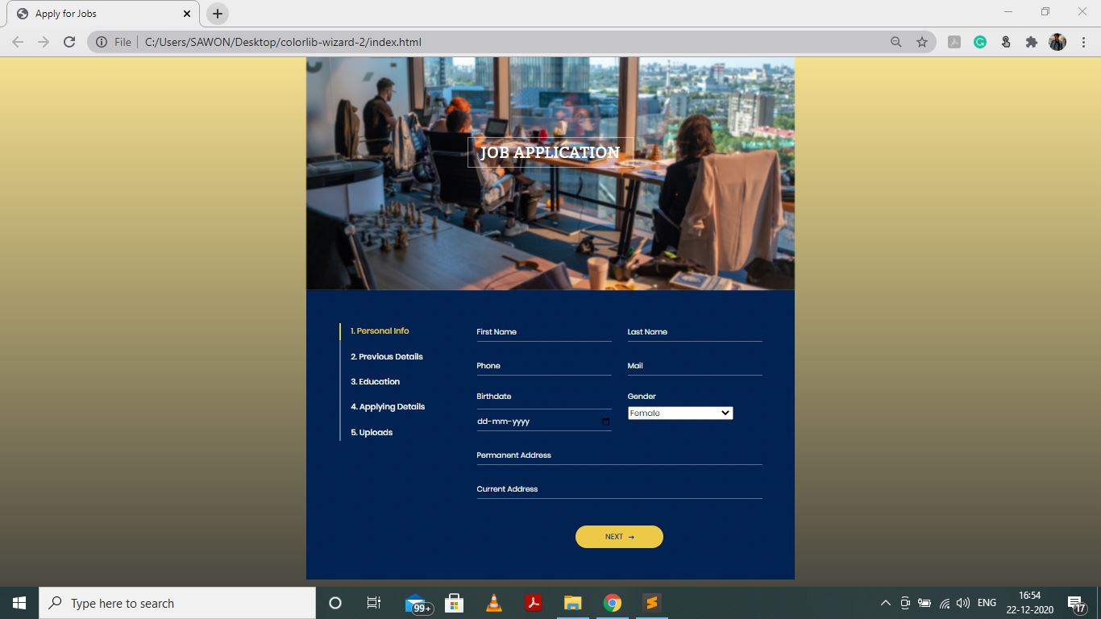

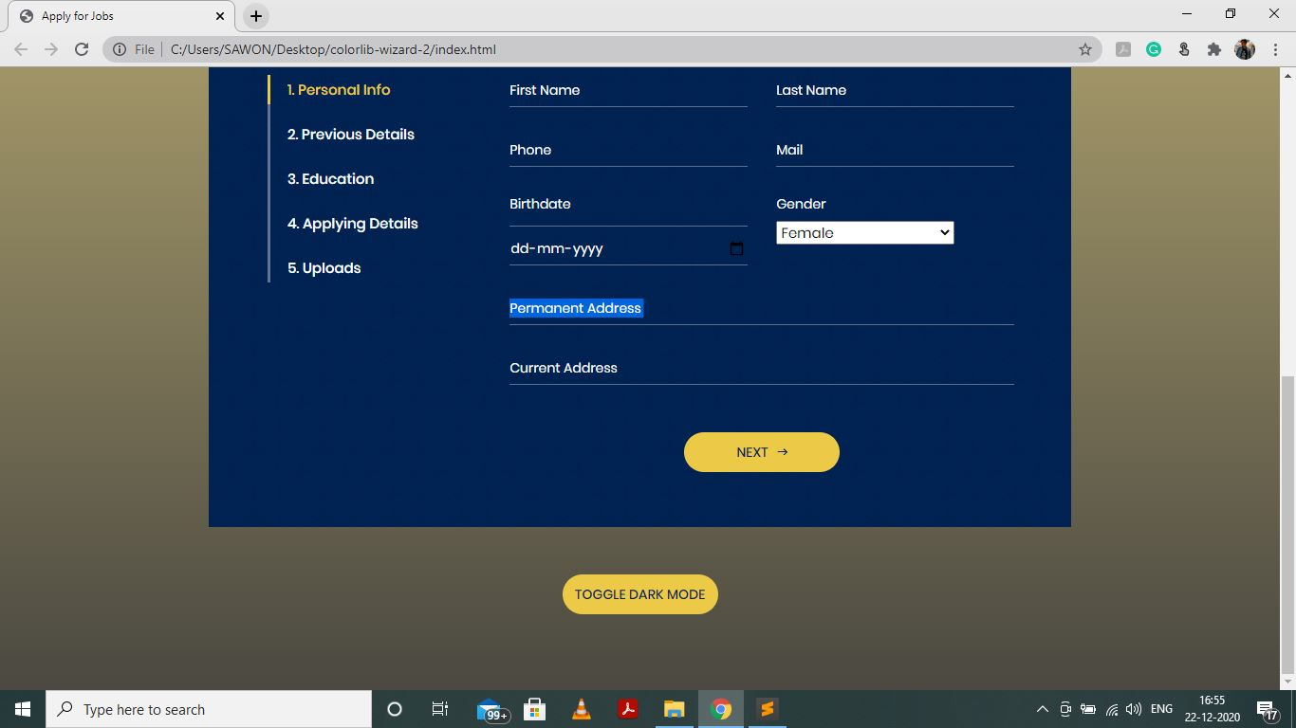

1. **PREVIOUS DETAILS**

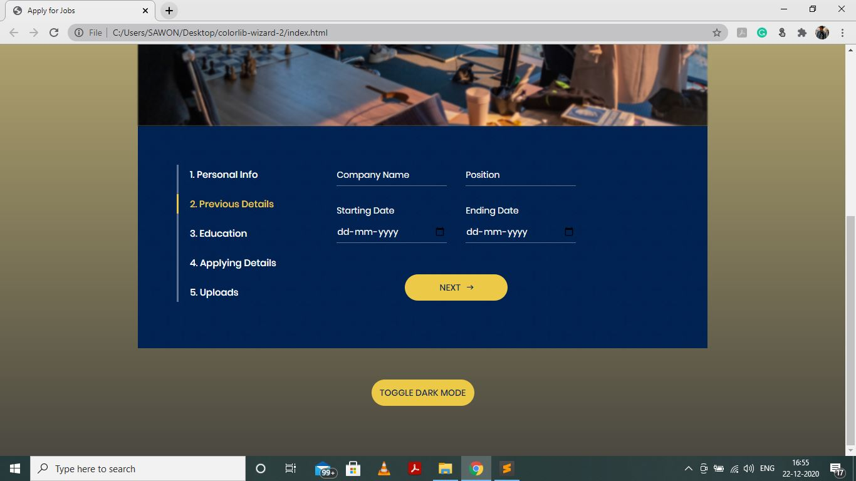

1. **EDUCATION**

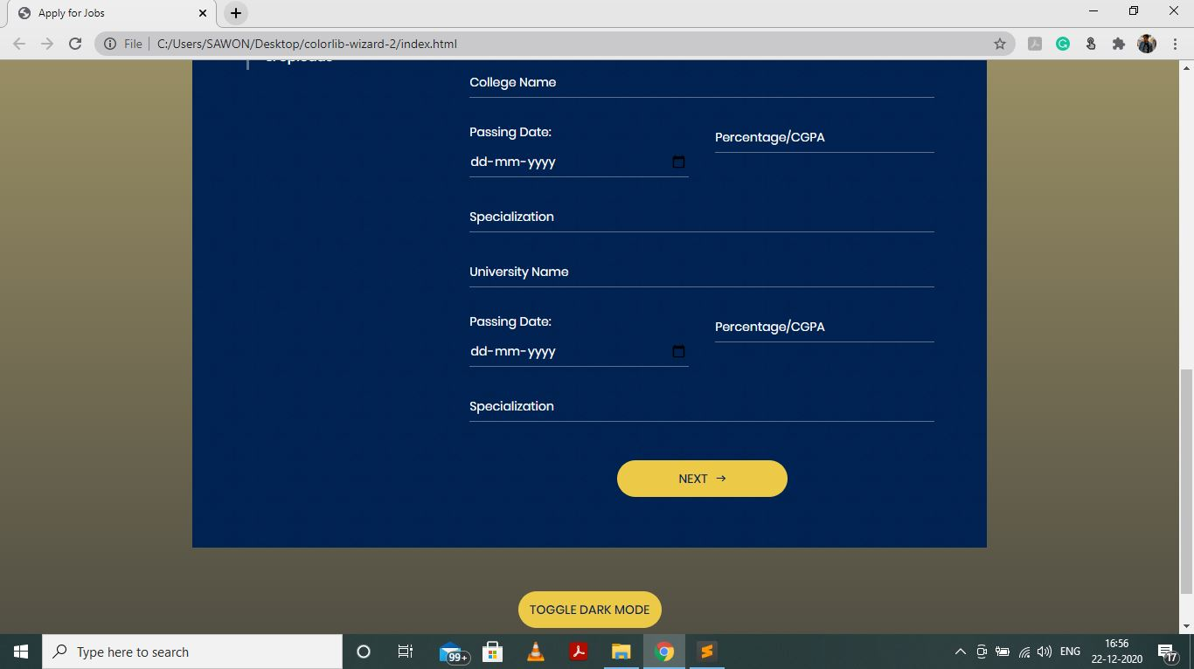

1. **APPLYING DETAILS**

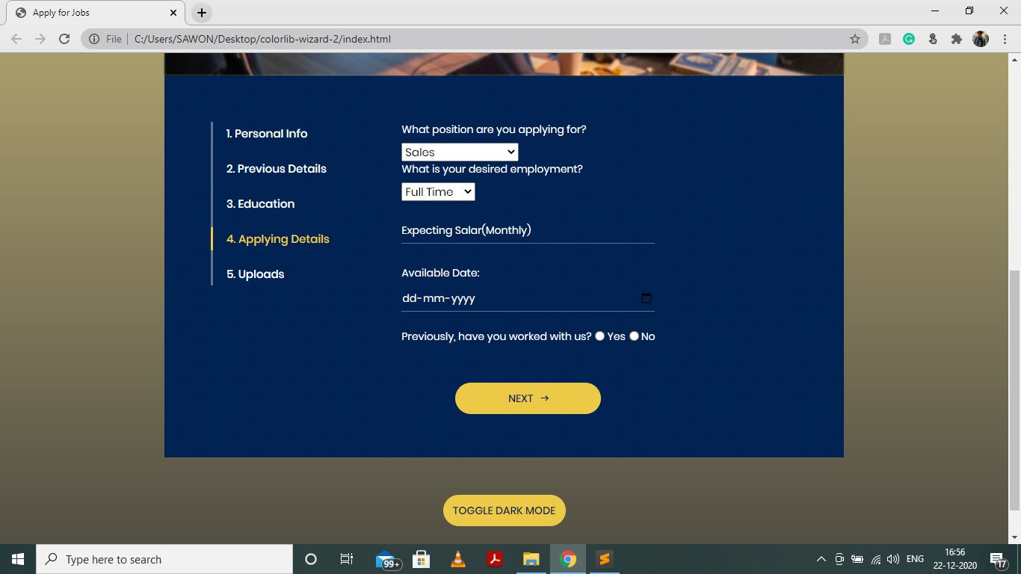

1. **UPLOADS** 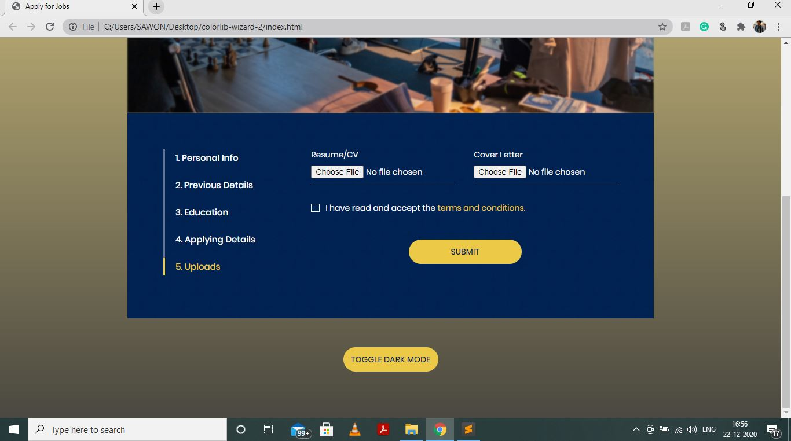
2. **NOTIFICATION TO FILL UP REQUIRED FIELD**

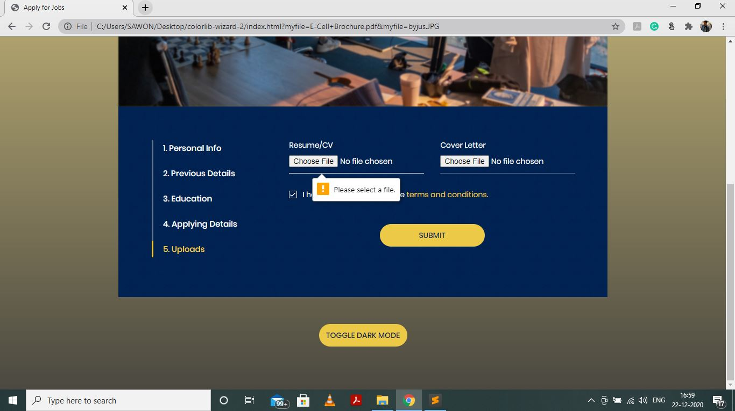

1. **SUBMISSION MESSAGE**

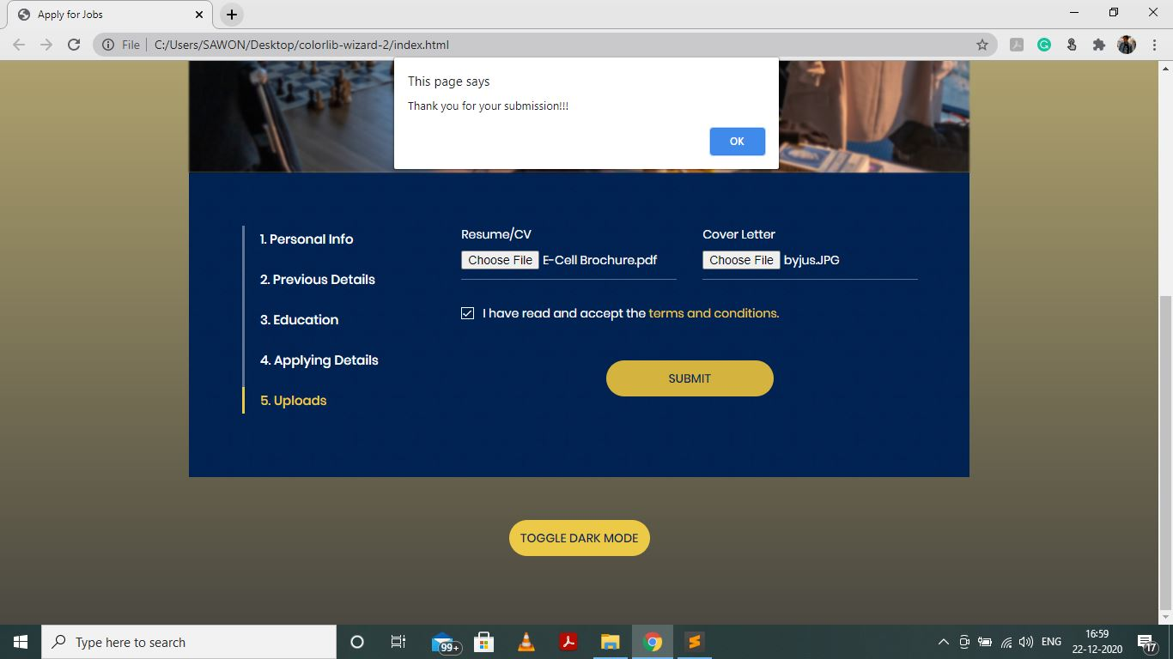

**HTML CODE**

<!DOCTYPE html>

<html>

    <head>

        <meta charset="utf-8">

        <title>Apply for Jobs</title>

        <meta name="viewport" content="width=device-width, initial-scale=1.0">

        <meta name="author" content="colorlib.com">

        <!-- LINEARICONS -->

        <link rel="stylesheet" href="fonts/linearicons/style.css">

        <!-- MATERIAL DESIGN ICONIC FONT -->

        <link rel="stylesheet" href="fonts/material-design-iconic-font/css/material-design-iconic-font.css">

        <!-- DATE-PICKER -->

        <link rel="stylesheet" href="vendor/date-picker/css/datepicker.min.css">

        <!-- STYLE CSS -->

        <link rel="stylesheet" href="css/style.css">

    </head>

    <body>

        <div id="dark" class="wrapper">

            <div class="inner">

                <div class="image-holder">

                    <img src="images/form-wizard.jpg" class="img-blur" alt="">

                    <h3>Job Application</h3>

                </div>

                <div id="wizard">

                    <!-- SECTION 1 -->

                    <h4>Personal Info</h4>

                    <section>

                        <form>

                        <div class="form-row">

                            <div class="form-holder">

                                <input type="text" class="form-control" placeholder="First Name" required>

                            </div>

                            <div class="form-holder">

                                <input type="text" class="form-control" placeholder="Last Name" required>

                            </div>

                        </div>

                        <div class="form-row">

                            <div class="form-holder">

                                <input type="text" class="form-control" placeholder="Phone" required>

                            </div>

                            <div class="form-holder">

                                <input type="text" class="form-control" placeholder="Mail" required>

                            </div>

                        </div>

                        <div class="form-row">

                            <div class="form-holder">

                                <label class="form-control">Birthdate</label>

                                <input type="date" class="form-control" placeholder="Birthdate" required>

                            </div>

                            <div class="form-holder">

                                     <label for="gen">Gender</label>

                                     <select id="gen" name="gen" class="clr">

                                        <option value="Female" class="clr">Female</option>

                                        <option value="Male" class="clr">Male</option>

                                        <option value="Others" class="clr">Others</option>

                                        <option value="Don't want to disclose" class="clr">Don't want to disclose</option>

                                     </select>

                            </div>

                        </div>

                        <div class="form-row">

                            <div class="form-holder w-100">

                                <input type="text" class="form-control" placeholder="Permanent Address" required>

                            </div>

                        </div>

                        <div class="form-row">

                            <div class="form-holder w-100">

                                <input type="text" class="form-control" placeholder="Current Address" required>

                            </div>

                        </div>

                        <button class="forward">Next

                            <i class="zmdi zmdi-long-arrow-right"></i>

                        </button>

                    </form>

                    </section>

                    <!-- SECTION 2 -->

                    <h4>Previous Details</h4>

                    <section class="section-style">

                         <form>

                            <div class="form-row">

                            <div class="form-holder">

                                <input type="text" class="form-control" placeholder="Company Name" required>

                            </div>

                            <div class="form-holder">

                                <input type="text" class="form-control" placeholder="Position" required>

                            </div>

                            </div>

                            <div class="form-row">

                            <div class="form-holder">

                                <label>Starting Date</label>

                                <input type="date" class="form-control" placeholder="Birthdate" required>

                            </div>

                            <div class="form-holder">

                                <label>Ending Date</label>

                                <input type="date" class="form-control" placeholder="Birthdate" required>

                            </div>

                        </div>

                            <button class="forward">Next

                                <i class="zmdi zmdi-long-arrow-right"></i>

                            </button>

                        </form>

                    </section>

                    <!-- SECTION 3 -->

                    <h4>Education</h4>

                    <section>

                        <form>

                        <div class="form-row">

                            <div class="form-holder w-100">

                                <input type="text" class="form-control" placeholder="10+2 School Name" required>

                            </div>

                        </div>

                        <div class="form-row">

                            <div class="form-holder">

                                <label>Passing Date:</label>

                                <input type="date" class="form-control" placeholder="Passing year" required>

                            </div>

                            <div class="form-holder">

                                <input type="number" class="form-control" placeholder="Percentage/CGPA" required>

                            </div>

                        </div>

                        <div class="form-row">

                            <div class="form-holder w-100">

                                <input type="text" class="form-control" placeholder="Specialization" required>

                            </div>

                        </div>

                        <div class="form-row">

                            <div class="form-holder w-100">

                                <input type="text" class="form-control" placeholder="College Name" required>

                            </div>

                        </div>

                        <div class="form-row">

                            <div class="form-holder">

                                <label>Passing Date:</label>

                                <input type="date" class="form-control" placeholder="Passing year" required>

                            </div>

                            <div class="form-holder">

                                <input type="number" class="form-control" placeholder="Percentage/CGPA" required>

                            </div>

                        </div>

                        <div class="form-row">

                            <div class="form-holder w-100">

                                <input type="text" class="form-control" placeholder="Specialization" required>

                            </div>

                        </div>

                        <div class="form-row">

                            <div class="form-holder w-100">

                                <input type="text" class="form-control" placeholder="University Name" required>

                            </div>

                        </div>

                        <div class="form-row">

                            <div class="form-holder">

                                <label>Passing Date:</label>

                                <input type="date" class="form-control" placeholder="Passing year" required>

                            </div>

                            <div class="form-holder">

                                <input type="number" class="form-control" placeholder="Percentage/CGPA" required>

                            </div>

                        </div>

                        <div class="form-row">

                            <div class="form-holder w-100">

                                <input type="text" class="form-control" placeholder="Specialization" required>

                            </div>

                        </div>

                        <button class="forward" style="width: 195px; margin-top: 44px;">Next

                            <i class="zmdi zmdi-long-arrow-right"></i>

                        </button>

                        </form>

                    </section>

                    <!-- SECTION 4 -->

                    <h4>Applying Details</h4>

                    <section class="section-style">

                        <form>

                        <section>

                        <div class="form-holder">

                                     <label for="gen">What position are you applying for?</label>

                                     <select id="gen" name="gen" class="clr">

                                        <option value="Sales" class="clr">Sales</option>

                                        <option value="IT" class="clr">IT</option>

                                        <option value="Marketing" class="clr">Marketing</option>

                                        <option value="R&D" class="clr">R&D</option>

                                        <option value="Customer Service" class="clr">Customer Service</option>

                                     </select>

                        </div>

                        <div class="form-holder">

                                     <label for="gen">What is your desired employment?</label>

                                     <select id="gen" name="gen" class="clr">

                                        <option value="Full Time" class="clr">Full Time</option>

                                        <option value="Part Time" class="clr">Part Time</option>

                                        <option value="Internship" class="clr">Internship</option>

                                     </select>

                        </div>

                        <br>

                        <div class="form-row">

                            <div class="form-holder w-100">

                                <input type="number" class="form-control" placeholder="Expecting Salar(Monthly)">

                            </div>

                        </div>

                        <div class="form-holder">

                                <label>Available Date:</label>

                                <input type="date" class="form-control" placeholder="Passing year" required>

                            </div>

                            <br>

                        <div class="form-row">

                            <label>Previously, have you worked with us?</label>

                            <input type="radio" id="Yes" name="gender" value="Yes">

                            <label for="Yes">Yes</label>

                            <input type="radio" id="No" name="gender" value="No">

                            <label for="No">No</label>

                        </div>

                        <button class="forward" style="width: 195px; margin-top: 44px;">Next

                            <i class="zmdi zmdi-long-arrow-right"></i>

                        </button>

                        </form>

                    </section>

                    </section>

                      <!-- SECTION 5 -->

                    <h4>Uploads</h4>

                    <section>

                        <form>

                        <div class="form-row">

                            <div class="form-holder">

                              <label for="myfile">Resume/CV</label>

                              <input type="file" id="myfile" name="myfile" class="form-control" placeholder="Resume/CV" required>

                            </div>

                            <div class="form-holder">

                                <label for="myfile">Cover Letter</label>

                                 <input type="file" id="myfile" name="myfile" class="form-control" placeholder="Cover Letter">

                            </div>

                        </div>

                        <div class="checkbox">

                            <label>

                                <input type="checkbox" required> I have read and accept the <a href="#">terms and conditions.</a>

                                <span class="checkmark"></span>

                            </label>

                        </div>

                        <button onclick="sub()" style="width: 195px; margin-top: 44px;">Submit

                        </button>

                        </form>

                    </section>

                </div>

                <button onclick="dark()">Toggle dark mode</button>

            </div>

        </div>

        <script src="js/jquery-3.3.1.min.js"></script>

        <!-- JQUERY STEP -->

        <script src="js/jquery.steps.js"></script>

        <!-- DATE-PICKER -->

        <script src="vendor/date-picker/js/datepicker.js"></script>

        <script src="vendor/date-picker/js/datepicker.en.js"></script>

        <script src="js/main.js"></script>

<!-- Template created and distributed by Colorlib -->

</body>

</html>

<script>

function sub() {

  alert("Thank you for your submission!!!")

}

</script>

<script>

function dark() {

   var element = document.getElementById("dark");

   element.classList.toggle("dark-mode");

}

</script>

**CSS CODE**

**(*NB: here css code has been reused)**

@font-face {

  font-family: "Poppins-Regular";

  src: url("../fonts/poppins/Poppins-Regular.ttf"); }

@font-face {

  font-family: "Poppins-Medium";

  src: url("../fonts/poppins/Poppins-Medium.ttf"); }

@font-face {

  font-family: "Bitter-Regular";

  src: url("../fonts/bitter/Bitter-Regular.ttf"); }

* {

  -webkit-box-sizing: border-box;

  -moz-box-sizing: border-box;

  box-sizing: border-box; }

.clr{

  color: black;

}

body {

  font-family: "Poppins-Regular";

  font-size: 15px;

  color: #fff;

  margin: 0; }

:focus {

  outline: none; }

textarea {

  resize: none; }

.img-blur{

  -webkit-filter: blur(1px);

  filter: blur(1px);

}

input, textarea, select, button {

  font-family: "Poppins-Regular";

  font-size: 15px;

  color: #fff; }

p, h1, h2, h3, h4, h5, h6, ul {

  margin: 0; }

ul {

  padding: 0;

  margin: 0;

  list-style: none; }

a {

  text-decoration: none; }

textarea {

  resize: none; }

img {

  max-width: 100%;

  vertical-align: middle; }

.wrapper {

  height: 100vh;

  background: #f9f6f1;

  display: flex;

  align-items: center;

  justify-content: center;

  overflow: hidden;

  background-image: linear-gradient(rgb(245, 224, 142), rgb(74, 72, 64));

  background-size: cover; }

.inner {

  width: 909px; }

.image-holder {

  position: relative; }

  .image-holder h3 {

    position: absolute;

    top: 50%;

    left: 50%;

    transform: translate(-50%, -50%); }

.dark-mode {

  background-image: linear-gradient(rgb(33, 32, 26), rgb(181, 170, 89));

  color: white;

}

h3 {

  font-family: "Bitter-Regular";

  font-size: 30px;

  color: #fff;

  text-transform: uppercase;

  padding: 9px 23px;

  border: 1px solid rgba(255, 255, 255, 0.5);

  font-weight: 400;

  letter-spacing: 0.3px; }

.wizard {

  background: url("../images/form-content-bg.png") repeat;

  padding: 62px 60px 58px 62px;

  display: flex; }

  .wizard .steps {

    width: 26.05%;

    margin-right: 68px; }

  .wizard .content {

    width: 73.95%; }

.steps ul {

  border-left: 3px solid rgba(242, 242, 242, 0.4); }

.steps li {

  margin-bottom: 16px;

  display: flex;

  align-items: center;

  height: 31px;

  position: relative; }

  .steps li a {

    color: #fff;

    font-family: "Poppins-Medium";

    font-size: 15px;

    padding-left: 18px; }

    .steps li a:before {

      content: "";

      width: 3px;

      height: 31px;

      position: absolute;

      left: -3px;

      top: 0; }

  .steps li.current a {

    color: #edc948; }

    .steps li.current a:before {

      background: #edc948; }

.content h4 {

  display: none; }

label {

  margin-bottom: 7px;

  display: block;

  font-size: 14px; }

.form-group .form-row {

  margin-bottom: 27px; }

.form-row {

  display: flex;

  margin-bottom: 29px; }

  .form-row.mb-21 {

    margin-bottom: 21px; }

  .form-row .form-holder, .form-row .select {

    width: 50%;

    margin-right: 30px; }

    .form-row .form-holder:last-child, .form-row .select:last-child {

      margin-right: 0; }

    .form-row .form-holder.w-100, .form-row .select.w-100 {

      width: 100%;

      margin-right: 0; }

    .form-row .form-holder.mr-20, .form-row .select.mr-20 {

      margin-right: 20px; }

  .form-row .select .form-holder {

    width: 100%;

    margin-right: 0; }

.form-holder {

  position: relative; }

  .form-holder span.lnr-chevron-down {

    position: absolute;

    bottom: 10px;

    right: 0;

    font-size: 10px; }

  .form-holder span.lnr-calendar-full {

    position: absolute;

    bottom: 12px;

    right: 0;

    font-size: 12px; }

  .form-holder span.placeholder {

    position: absolute;

    bottom: 8px;

    left: 0;

    font-size: 14px; }

.select {

  position: relative; }

  .select .select-control {

    height: 34px;

    border-bottom: 1px solid #5d718e;

    width: 100%;

    font-size: 14px;

    padding: 0;

    display: flex;

    align-items: center;

    cursor: pointer; }

  .select .dropdown {

    display: none;

    position: absolute;

    top: 100%;

    width: 100%;

    background: #fff;

    color: #999;

    z-index: 9;

    border: 1px solid #81acee; }

    .select .dropdown li {

      padding: 2px 10px; }

      .select .dropdown li:hover {

        background: #81acee;

        color: #fff; }

.form-control {

  background: none;

  height: 34px;

  border: none;

  border-bottom: 1px solid #5d718e;

  width: 100%;

  font-size: 14px;

  padding: 0; }

  .form-control.pl-85 {

    padding-left: 85px; }

  .form-control.pl-96 {

    padding-left: 96px; }

  .form-control::-webkit-input-placeholder {

    color: #fff; }

  .form-control::-moz-placeholder {

    color: #fff; }

  .form-control:-ms-input-placeholder {

    color: #fff; }

  .form-control:-moz-placeholder {

    color: #fff; }

  .form-control:focus {

    border-bottom: 1px solid #e6e6e6; }

textarea.form-control {

  padding: 6px 0; }

.option {

  color: #999;

  padding-left: 20px; }

select.form-control {

  -moz-appearance: none;

  -webkit-appearance: none;

  cursor: pointer;

  color: #fff; }

  select.form-control option[value=""][disabled] {

    display: none; }

select option {

  padding: 0 15px; }

.section-style {

  display: flex; }

  .section-style .board-wrapper {

    width: 50%;

    margin-right: 30px; }

  .section-style .form-wrapper, .section-style .pay-wrapper {

    width: 50%; }

.board-inner {

  background: #fff;

  color: #012353;

  font-size: 14px;

  padding: 22px 33px 13px 21px; }

  .board-inner div {

    margin-bottom: 8px; }

    .board-inner div:last-child {

      margin-bottom: 0; }

  .board-inner .board-item span {

    margin-left: 13px; }

  .board-inner .board-line {

    display: flex;

    justify-content: space-between; }

    .board-inner .board-line div {

      margin-bottom: 0; }

.bill {

  border: 1px solid #fff;

  padding: 18px 20px 11px 20px; }

  .bill .bill-item {

    display: flex;

    justify-content: space-between;

    margin-bottom: 7px; }

    .bill .bill-item .price {

      font-family: "Poppins-Medium";

      color: #edc948; }

    .bill .bill-item.people {

      justify-content: flex-start; }

      .bill .bill-item.people .bill-unit:first-child {

        margin-right: 28px; }

    .bill .bill-item.service {

      margin-top: 31px; }

    .bill .bill-item.vat {

      margin-bottom: 14px; }

    .bill .bill-item.total-price {

      margin-bottom: 21px; }

      .bill .bill-item.total-price .price {

        font-size: 17px; }

    .bill .bill-item.total {

      font-size: 12px;

      align-items: center; }

      .bill .bill-item.total span {

        display: block;

        margin-left: 0;

        font-size: 14px; }

      .bill .bill-item.total .price {

        font-size: 17px; }

  .bill .bill-unit span {

    margin-left: 2px; }

  .bill .bill-cell {

    padding-bottom: 7px;

    border-bottom: 1px solid #5d718e;

    margin-bottom: 15px; }

    .bill .bill-cell:last-child {

      margin-bottom: 0;

      padding-bottom: 0;

      border: none; }

button {

  padding: 0;

  border: none;

  display: flex;

  height: 42px;

  width: 164px;

  justify-content: center;

  align-items: center;

  background: #edc948;

  font-family: "Poppins-Medium";

  text-transform: uppercase;

  font-size: 14px;

  color: #012353;

  cursor: pointer;

  bottom: 56px;

  border-radius: 21px;

  font-weight: 500;

  margin: auto;

  margin-top: 50px;

  font-weight: 500; }

  button i {

    margin-left: 10px; }

  button:hover {

    background: #d4b43f; }

.checkbox {

  position: relative;

  padding-left: 25px; }

  .checkbox label {

    cursor: pointer; }

    .checkbox label a {

      color: #edc948; }

      .checkbox label a:hover {

        color: #d4b43f; }

  .checkbox input {

    position: absolute;

    opacity: 0;

    cursor: pointer; }

  .checkbox input:checked ~ .checkmark:after {

    display: block; }

.checkmark {

  position: absolute;

  top: 3px;

  left: 0;

  height: 14px;

  width: 15px;

  border: 1px solid #fff;

  font-family: Material-Design-Iconic-Font;

  font-size: 13px; }

  .checkmark:after {

    position: absolute;

    top: 0;

    left: 1px;

    display: none;

    content: '\f26b';

    color: #fff; }

.checkbox-circle {

  display: flex;

  justify-content: space-between;

  margin-bottom: 16px; }

  .checkbox-circle label {

    padding-left: 19px;

    cursor: pointer;

    font-size: 12px;

    display: inline-block;

    position: relative; }

  .checkbox-circle input {

    position: absolute;

    opacity: 0;

    cursor: pointer; }

  .checkbox-circle input:checked ~ .checkmark:after {

    display: block; }

  .checkbox-circle .checkmark {

    position: absolute;

    top: 3px;

    left: 0;

    height: 12px;

    width: 12px;

    border-radius: 50%;

    border: 1px solid #fff; }

    .checkbox-circle .checkmark:after {

      content: "";

      top: 3px;

      left: 3px;

      width: 4px;

      height: 4px;

      border-radius: 50%;

      background: #fff;

      position: absolute;

      display: none; }

  .section-style {

    flex-direction: column; }

    .section-style .board-wrapper {

      width: 100%;

      margin-right: 0;

      margin-bottom: 50px; }

    .section-style .form-wrapper, .section-style .pay-wrapper {

      width: 100%; }

  .form-row {

    display: block;

    margin-bottom: 0; }

    .form-row .form-holder {

      width: 100%;

      margin-right: 0; }

    .form-row .select {

      width: 100%;

      margin-right: 0; }

  .form-control, .select-control {

    margin-bottom: 29px; }

  .form-holder span.placeholder {

    bottom: 36px; }

  .form-holder span.lnr-chevron-down, .form-holder span.lnr-calendar-full {

    bottom: 39px; }

  .select span.lnr-chevron-down {

    bottom: 10px; }

  h3 {

    width: 90%;

    text-align: center; } }

**JS CODE**

$(function(){

    $("#wizard").steps({

        headerTag: "h4",

        bodyTag: "section",

        transitionEffect: "fade",

        enableAllSteps: true,

        enablePagination: false,

        transitionEffectSpeed: 500,

        labels: {

            current: ""

        }

    });

    // Custome Button Jquery Step

    $('.forward').click(function(){

        $("#wizard").steps('next');

    })

    // Date Picker

    var dp1 = $('#dp1').datepicker().data('datepicker');

    dp1.selectDate(new Date());

    var dp2 = $('#dp2').datepicker().data('datepicker');

    dp2.selectDate(new Date());

    var dp3 = $('#dp3').datepicker().data('datepicker');

    dp3.selectDate(new Date());

    var dp4 = $('#dp4').datepicker().data('datepicker');

    dp4.selectDate(new Date());

    // Select Dropdown

    $('html').click(function() {

        $('.select .dropdown').hide();

    });

    $('.select').click(function(event){

        event.stopPropagation();

    });

    $('.select .select-control').click(function(){

        $(this).parent().next().toggle();

    })

    $('.select .dropdown li').click(function(){

        $(this).parent().toggle();

        var text = $(this).attr('rel');

        $(this).parent().prev().find('div').text(text);

    })

})