Configure Okta SSO on your local development environment
steps to configure Okta SSO on your local development environment
- Go to okta.com
- Click on Try Okta (for free trials)
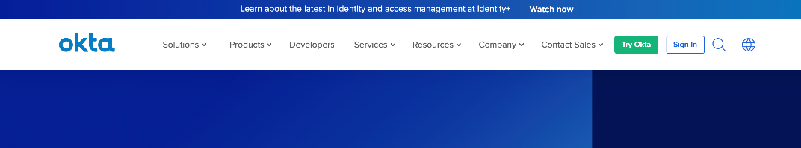
- Enter the signup information
- After entering the sign up information, Okta will send email with the newly created account credentials
- Login using the link sent in the email with the credentials provided
- After logging in, on the navbar, click on Applications
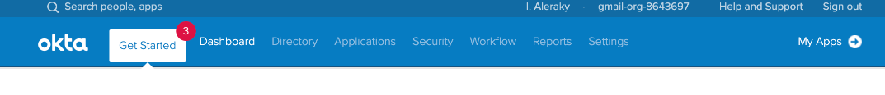
- On the top left corner, click Add Application
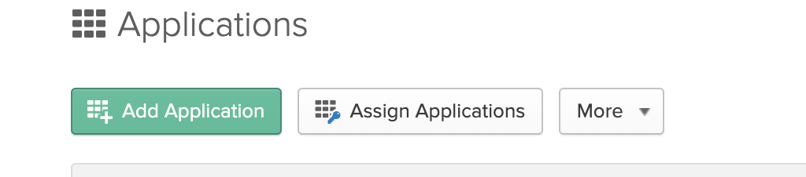
- On the top right corner, click Create New App
- from platform choose web and from Sign on method choose SAML 2.0
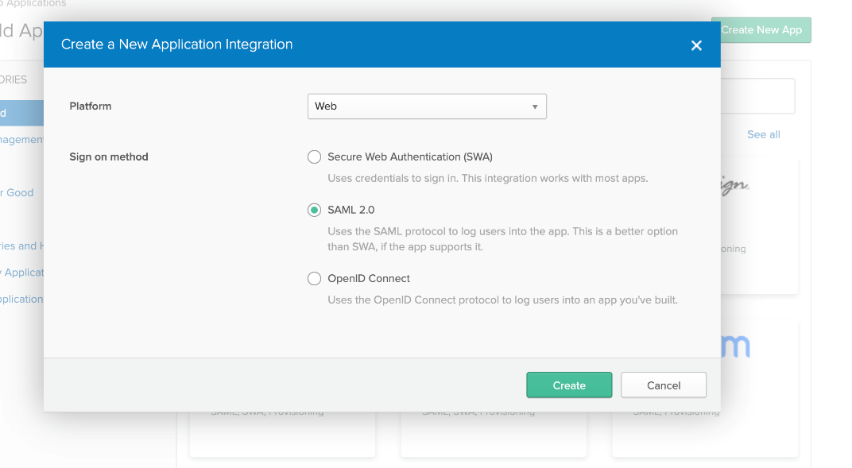
- click on Create
- enter the App name, then click next
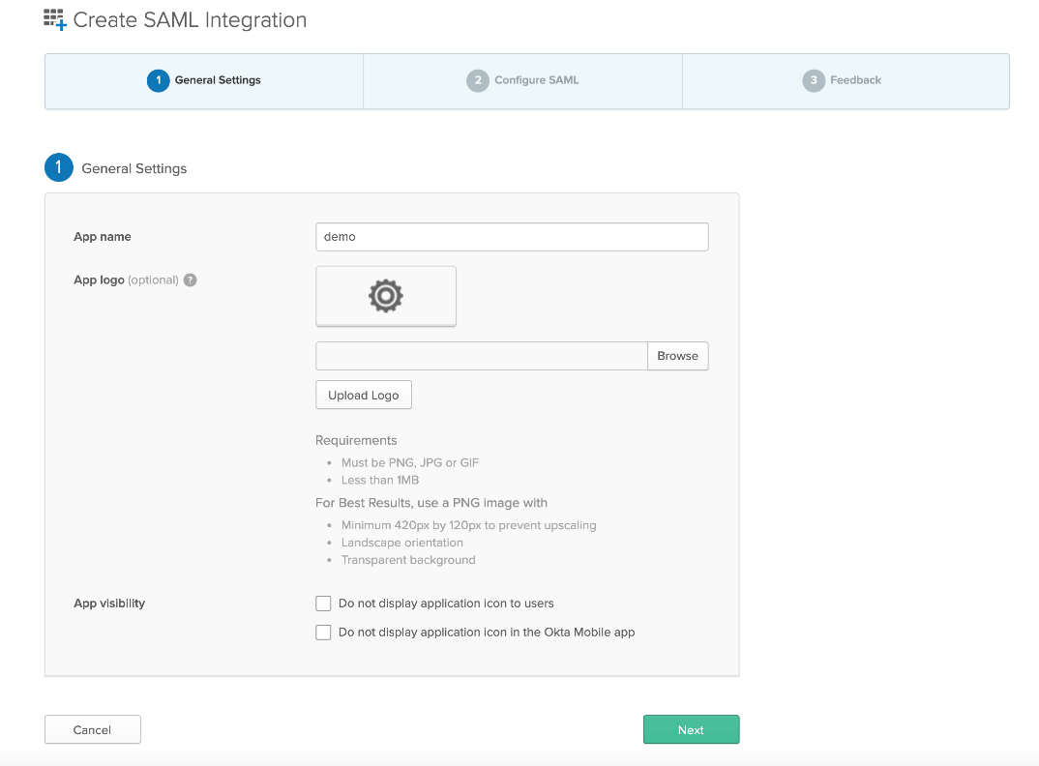
- in Single sign on URL, enter the URL of incorta that will redirect to okta which is <URL>/incorta/!<tenantName>/, example http://localhost:8080/incorta/!demo/
- Note: do not forget to add backslash “/“ at the end of the URL
- activate Use this for Recipient URL and Destination URL checkbutton
- in Audience URI (SP Entity ID) enter the same value of Single sign on URL like the following image.
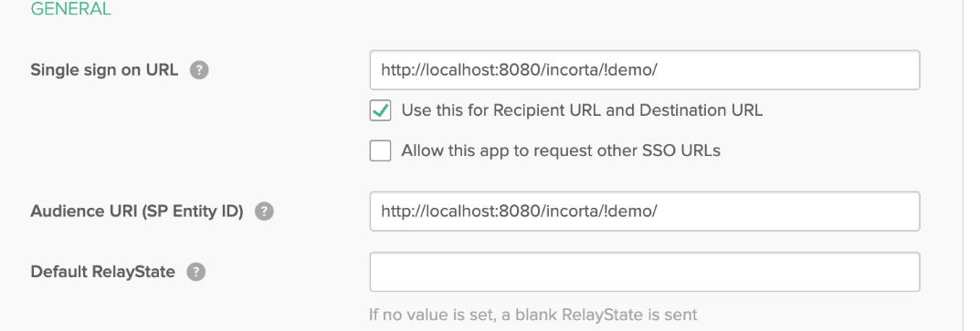
- add the user mapping from okta to Incorta, So in Name enter loginName and in Value enter user.email
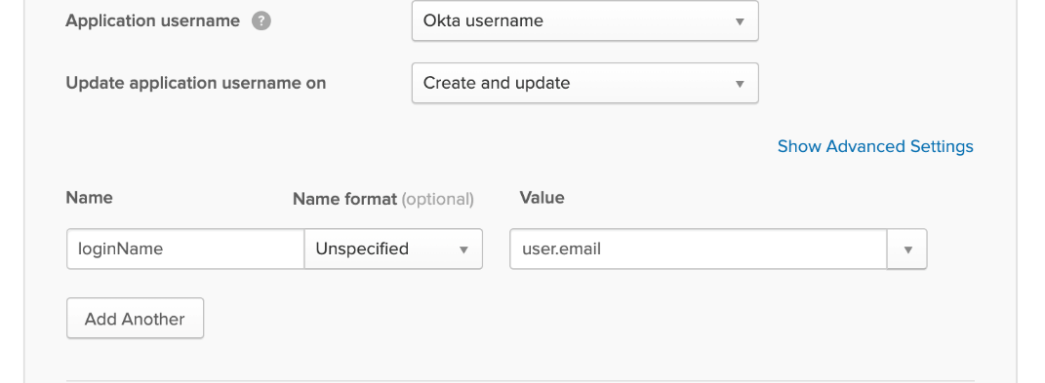
- check the information are like the following image then click next
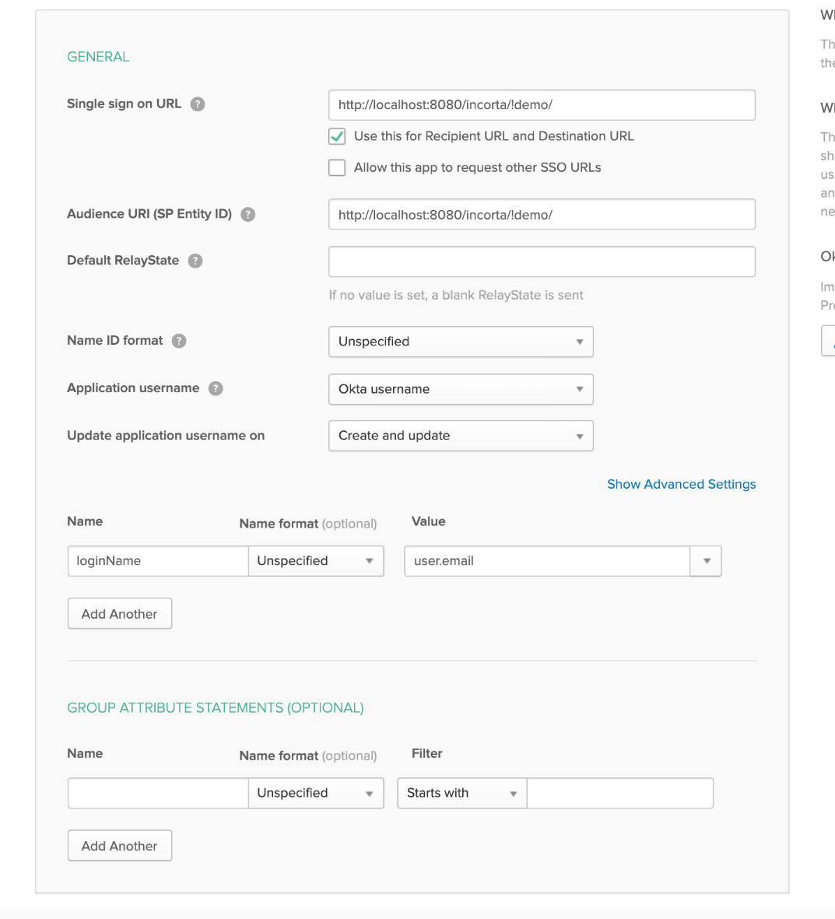
- choose I'm a software vendor. I'd like to integrate my app with Okta then click Finish
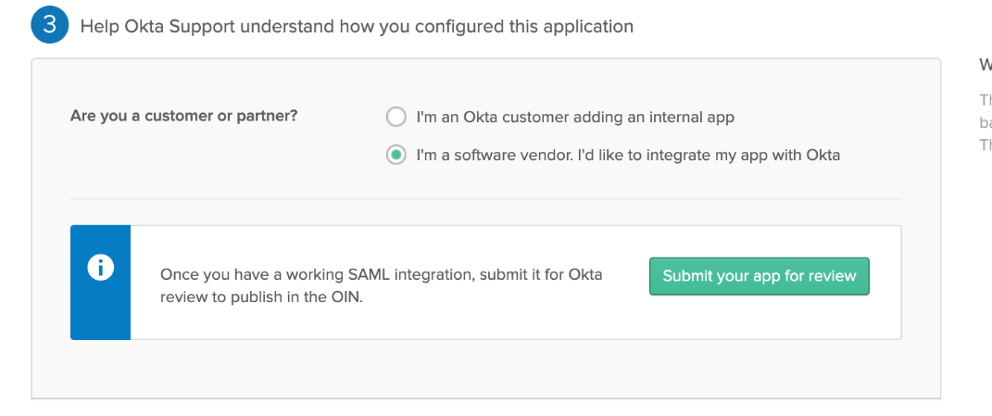
- in the Sign On tab, click on Identity Provider metadata, which will open a new tab in the browser containing XML
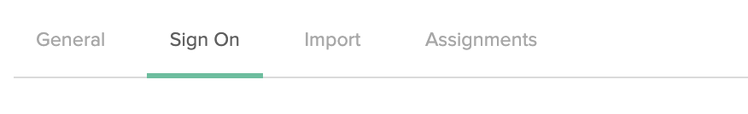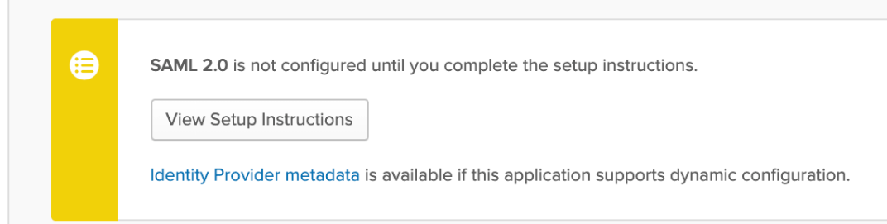
- right click on any free space and select save as, then click save to download the XML
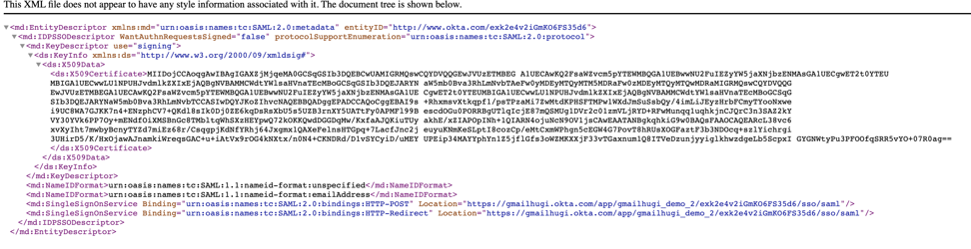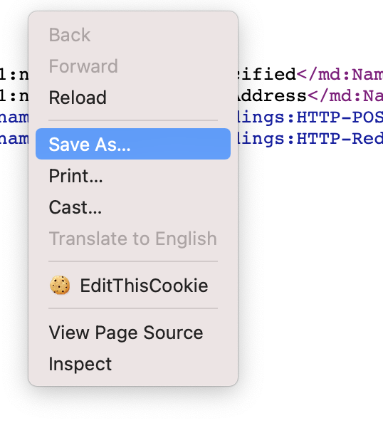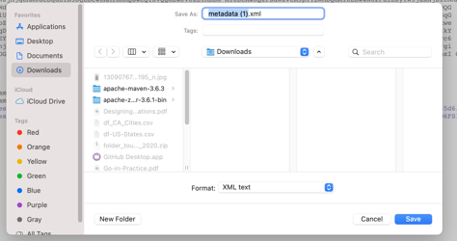
- go to the page of the application you created, then click on the Assignments tab
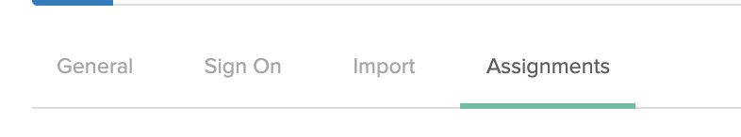
- click on Assign, then assign to people
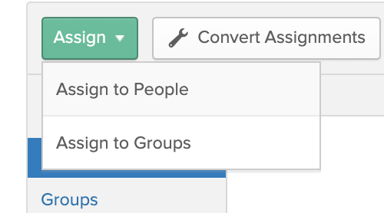
- choose the users assigned to this application by clicking assign
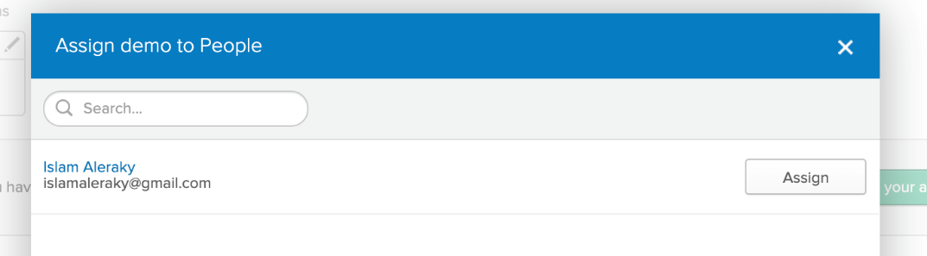
- click Save and Go Back, then click Done
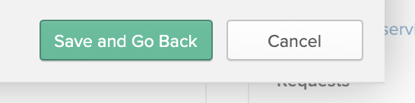
- Note: the user email in Okta should match the loginName in incorta
- enable SSO property for the tenant by setting the value of sso-login-enable key property (in incorta database table TENANT_CONFIG) that is related to the tenant used in okta to be true
- open eclipse and open the servers tab
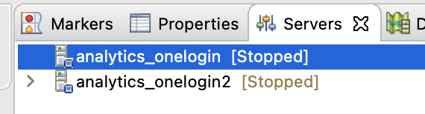
- right click on any empty space and choose new then choose server
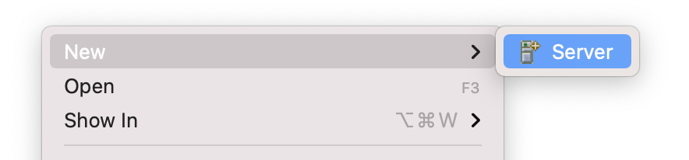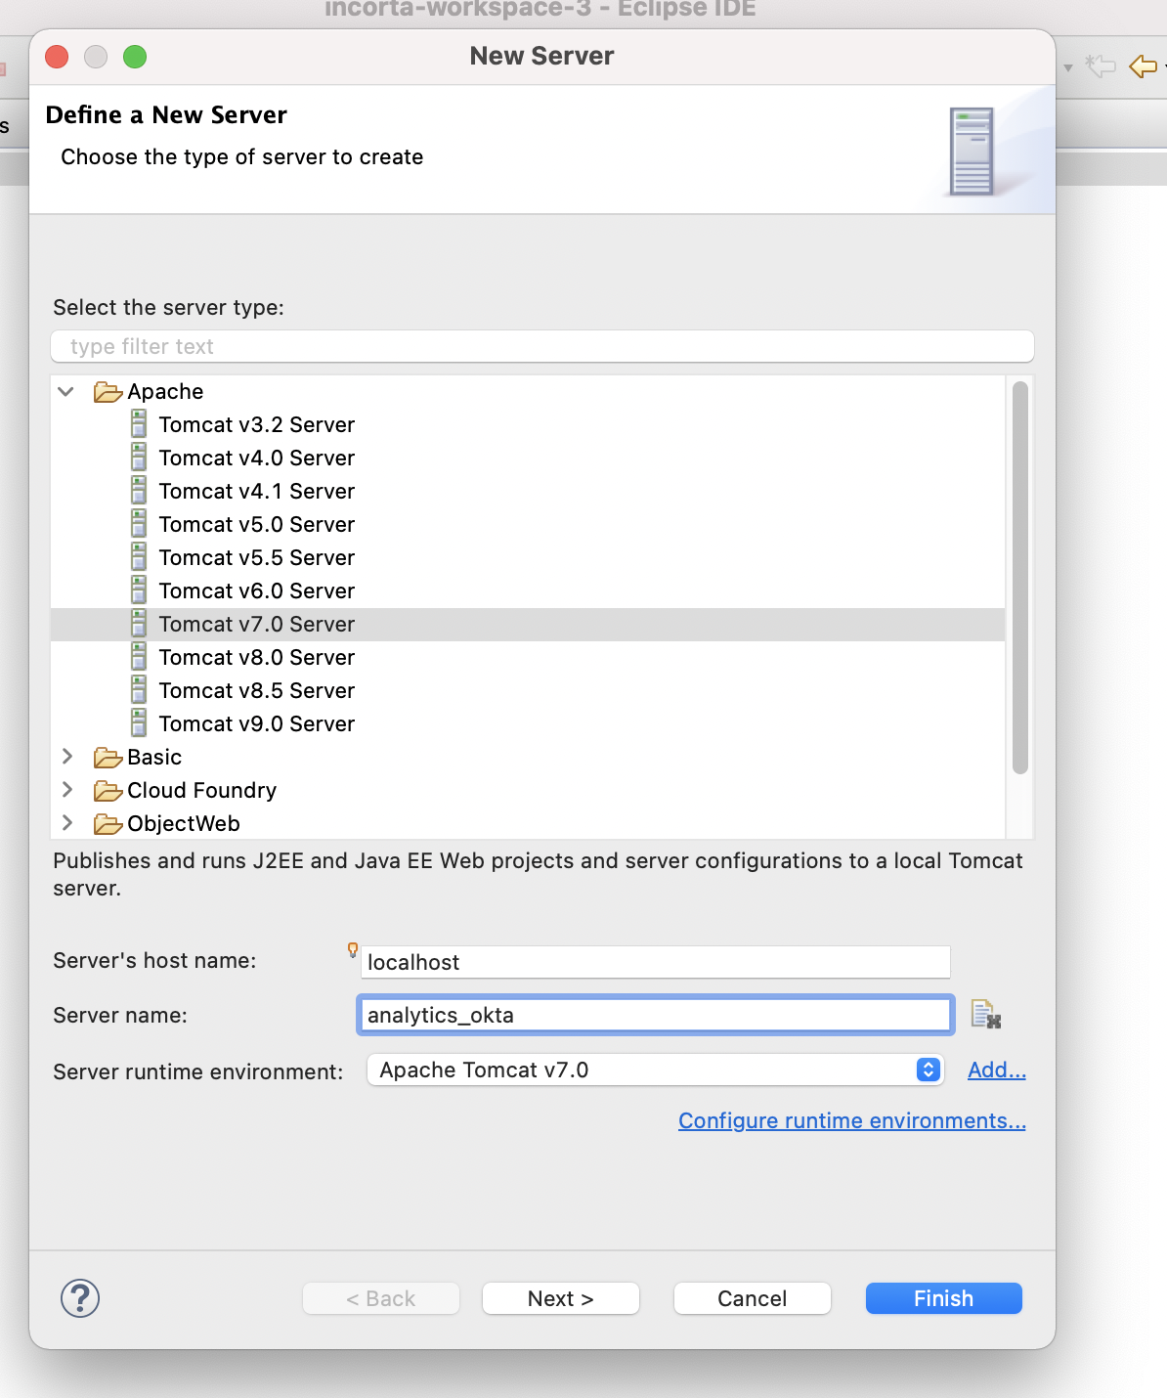
- choose incorta.server and click add, then click Finish
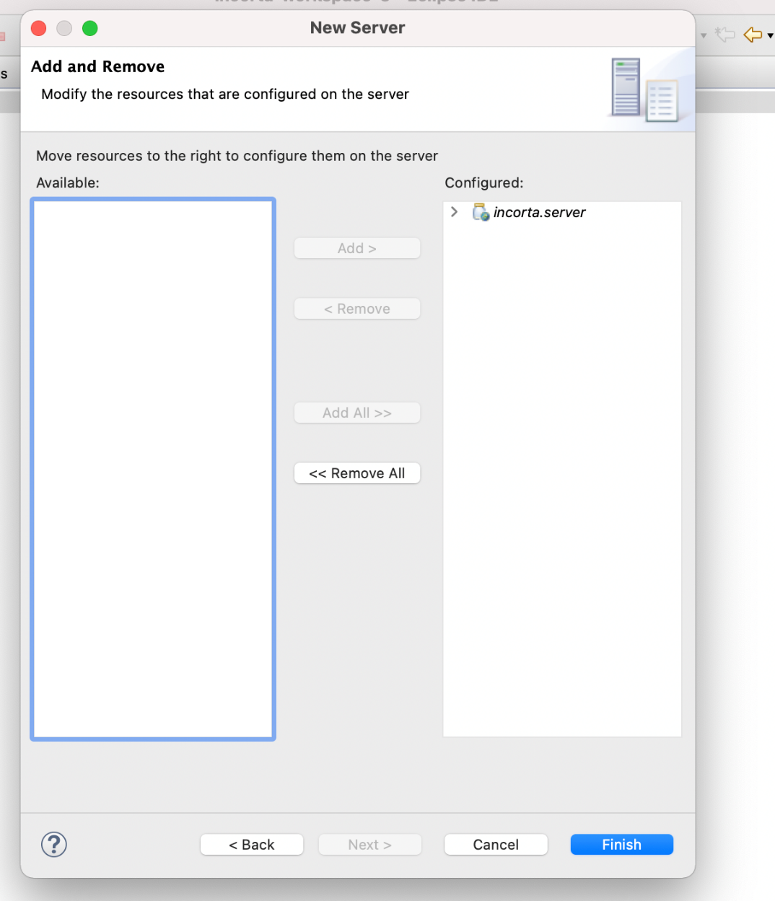
- double click on the server you created
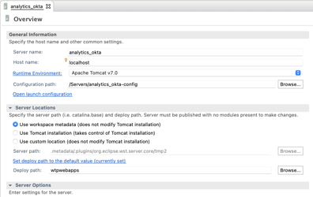
- change the configuration path to the path of the server’s configuration
- click on Use custom location in server locations and change the server path.
- save the changes
- click on Open launch configuration
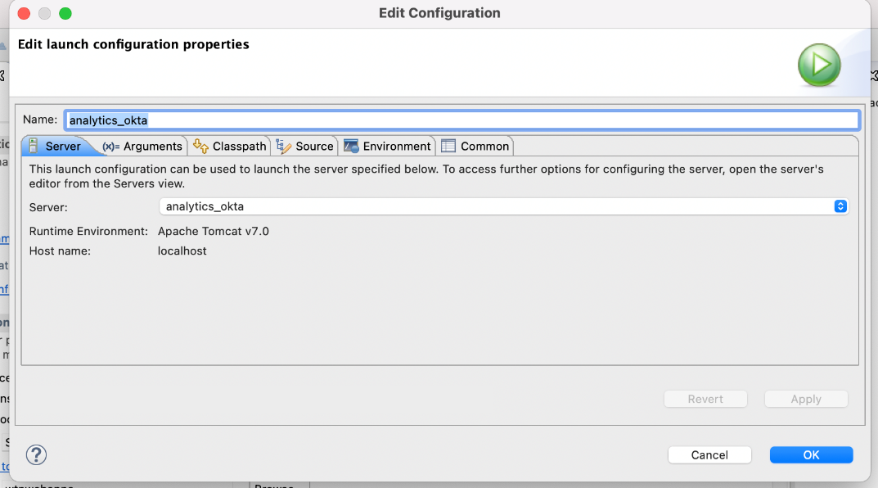
- go to Classpath and add the following two jars
  - mysql-connector-java (in case of using mysql)
  - commons-codec
- go to Arguments then add the following lines in VM arguments% -Djava.util.logging.manager=org.apache.juli.ClassLoaderLogManager -Dmax.off.heap.memory=100 -Dengine.offheap=true
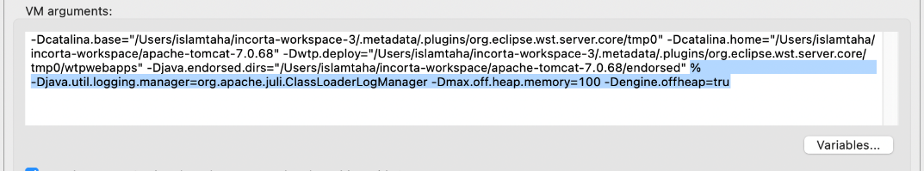
- you can also refer to the following document: /wiki/spaces/INC/pages/18448391
- click apply, then click ok
- open the server configuration folder then open server.xml
- add the following as Valve in the server.xml
<Valve className="com.incorta.sso.valves.OktaValve"
confFilesMap="TENANT_NAME=ABSOLUTE_PATH,TENANT_NAME2=ABSOLUTE_PATH2"
LoggingEnabled = "true"
/>
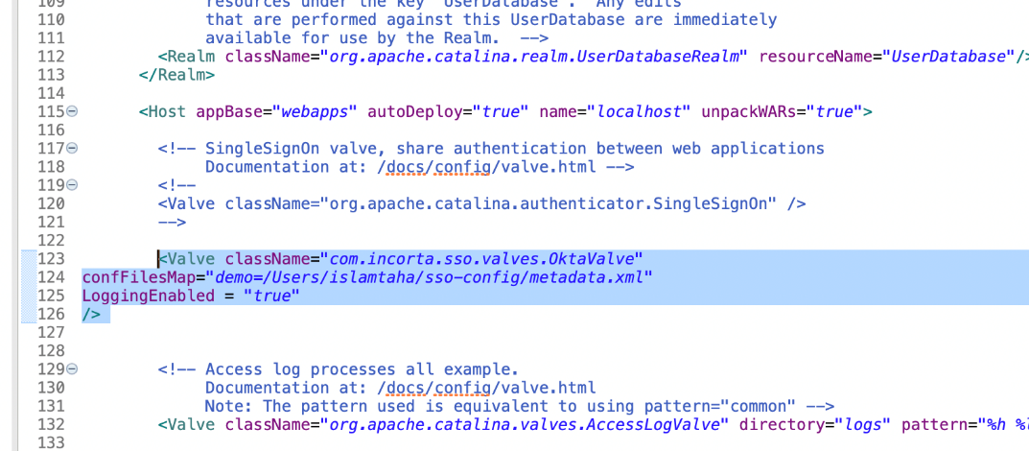
- open okta metadata xml file that we downloaded earlier and add the following tags between md:EntityDescriptor tag:
<configuration>
<default><http://www.okta.com/exk2dy7f8xbKMqTG05d6</default>>
<applications>
<application>
<md:EntityDescriptor>
</md:EntityDescriptor>
</application>
</applications>
</configuration>
also make sure that the URL in the default tag should be the same as the entityId in <md:EntityDescriptor>
So eventually your xml folder should look something like this:
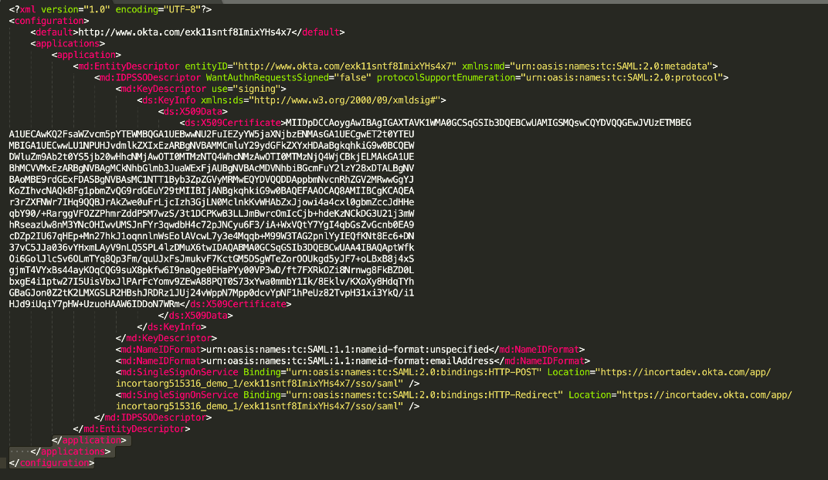
- now double click on the server and click on Open launch configuration, then choose the Classpath tab
, then click on Add external jars, navigate to Tomcat installation directory then include all the jars inside lib folder except tomcat7-websocket.jar and websocket-api.jar
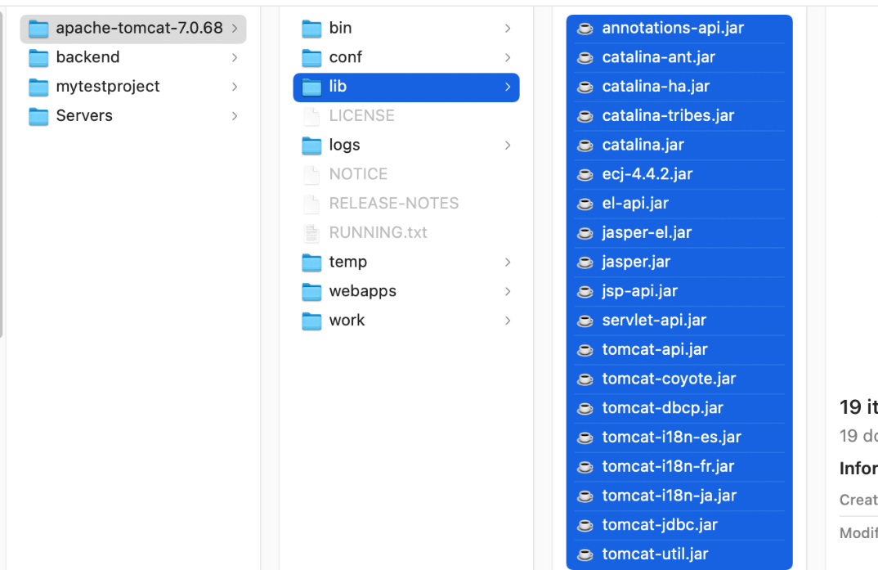
then click on add projects, and add incorta.addons in the classpath, then click ok
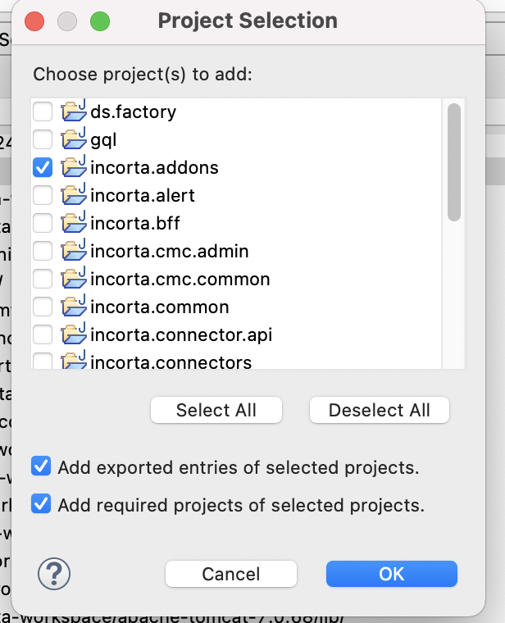
then click on add jars, then add the jars in the following image from lib/Okta
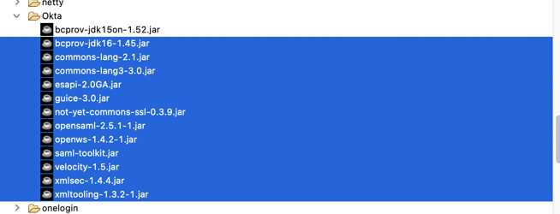
- add slf4j-api-1.7.25.jar from lib/slf4j and commons-logging-1.1.13.jar and commons-collections-3.2.1.jar from lib/apache and joda-time-2.1.jar from lib/joda
- make sure that the classpath contains the following dependencies in the same order
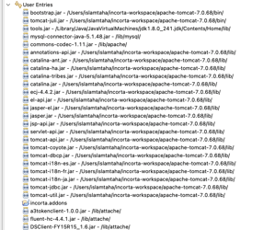
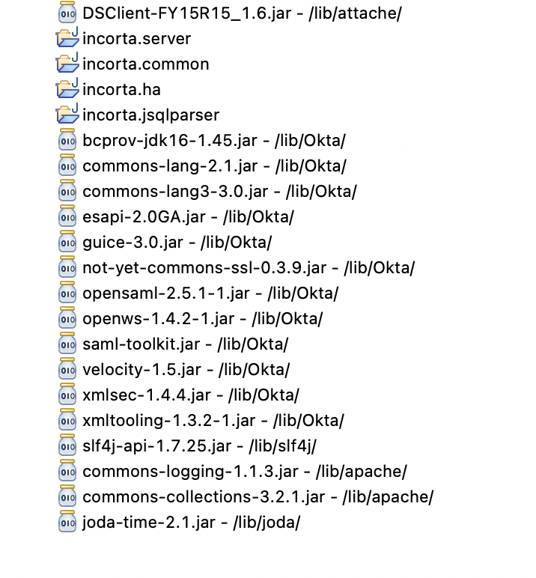
- start the server, then login into Incorta and create a new user with type SSO and the loginName is the same user email in okta
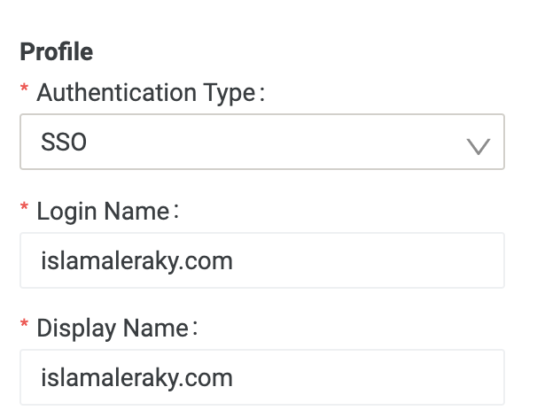
- sign out of the current user and then type the localhost:8080/incorta/!<tenantName> for example localhost:8080/incorta/!demo and should be redirected to okta login page
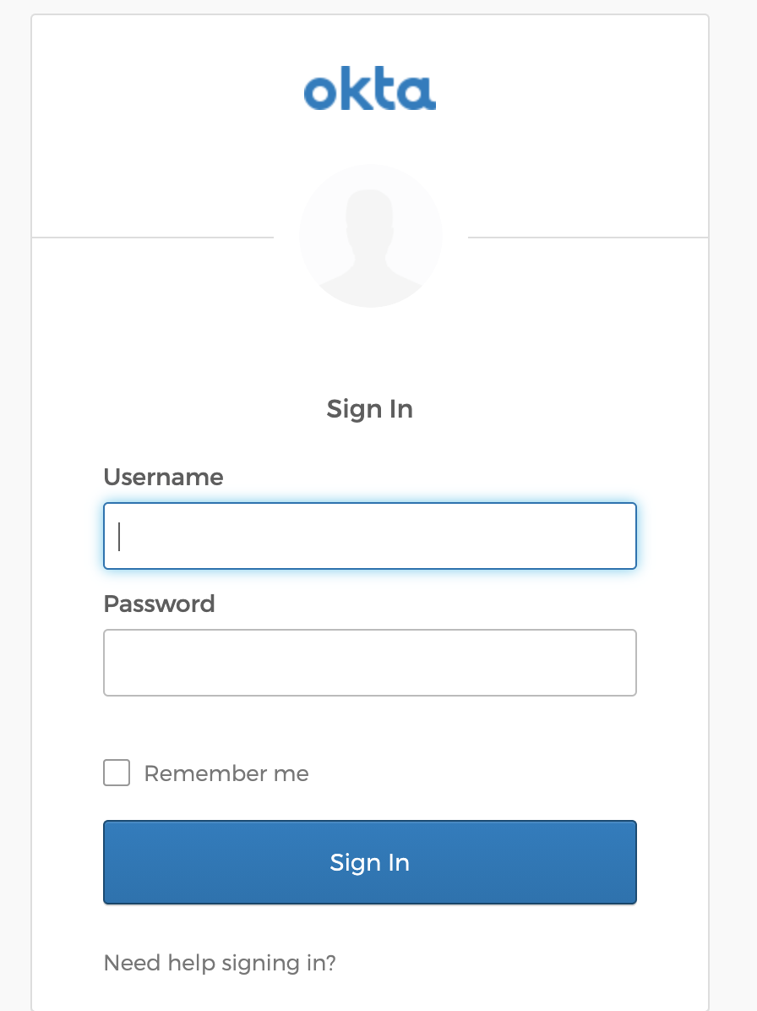
- enter the username which is okta email and password and you shall be redirected to Incorta

