# Auth0 SAML Provider

1- Login at [Auth0](https://auth0.com/)

2- Go to **Applications** → **Applications** → **Create Application** → **Regular Web App**

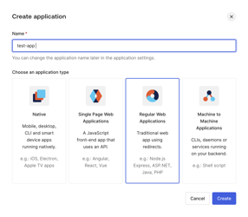

3- Scroll to the top and select the **Addons** tab.

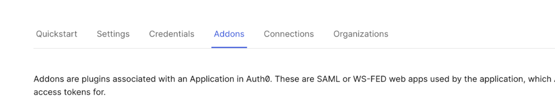

4- Enable the **SAML2 Web App** toggle.

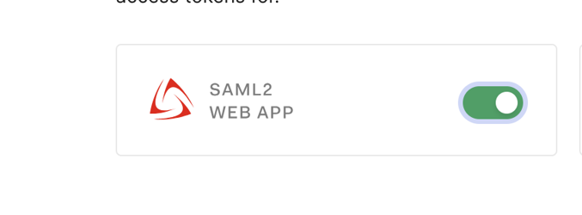

5- On the **Settings** tab, enter the **Application Callback URL** to your Incorta URLfollowed by !<tenant_name>  
**Example:** [**http://localhost:8080/incorta/!demo/**](http://localhost:8080/incorta/!demo/)  
Then click **Enable**

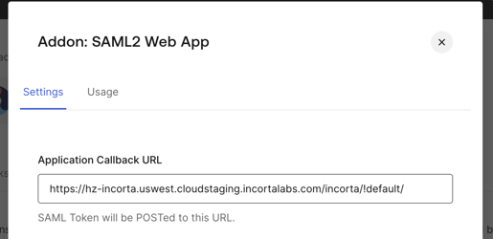

6- Go to **Action** → **Library** → **Create Action → Build from scratch**  
Trigger: Login / Post Login  
Runtime: Node 18 (as Recommended)

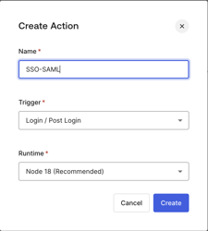

7- Set the following code and click → **Deploy**

exports.onExecutePostLogin = async (event, api) => {

api.samlResponse.setAttribute('loginName', event.user.email || null);

api.samlResponse.setMapUnknownClaimsAsIs(true);

};

8- Go to **Action** → **Flows** → **Login** → **Add Action** → **custom**   
and select your custom action, Drag and Drop it as follows

then click → **Apply**

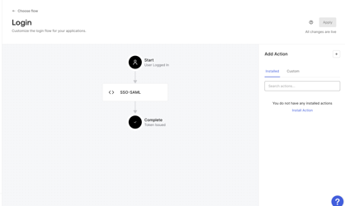

9- Go to **Applications** → **Applications** → select your app → **Settings** → Scroll down to Advanced Settings and select the **Endpoints** tab. Copy the **SAML Metadata URL** and Download the metadata from this URL.  
  
10- Map the metadata XML to our Incorta SAML2 configuration

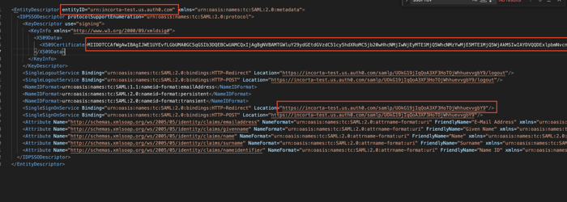

onelogin.saml2.strict= false

onelogin.saml2.sp.entityid=urn:incorta-test.us.auth0.com

onelogin.saml2.sp.assertion_consumer_service.url=https://hz-incorta.uswest.cloudstaging.incortalabs.com/incorta/!default/

onelogin.saml2.sp.single_logout_service.url= https://hz-incorta.uswest.cloudstaging.incortalabs.com/incorta/!default/

onelogin.saml2.idp.entityid=urn:incorta-test.us.auth0.com

onelogin.saml2.idp.single_sign_on_service.url=https://incorta-test.us.auth0.com/samlp/UOkG19jIqQoA3XF3HoTOjWhhuevvgbY9

onelogin.saml2.idp.single_logout_service.url=https://incorta-test.us.auth0.com/samlp/UOkG19jIqQoA3XF3HoTOjWhhuevvgbY9

onelogin.saml2.idp.x509cert=

11- Don’t forget to add users to your auth0 app from the **User Management** tab, and also to add SSO users to your Incorta instance.  
  
12- Login to Incorta with your instance URL followed by !<tenant_name> (Example: <http://localhost:8080/incorta/!demo/>)