# Enable API Key Generation and Create API Key

If you’re a user with super role or has access to incorta “Security” tab, Log in to Incorta and navigate to the “Security” tab.

You’ll find a new column “API Key Generation” with either Enabled/Disabled value indicating whether the user has the ability to create API Key or not.

**Note:** Any user with the super-user role will have API Key Generation always enabled as long as the super mode is enabled for the users’ tenant.

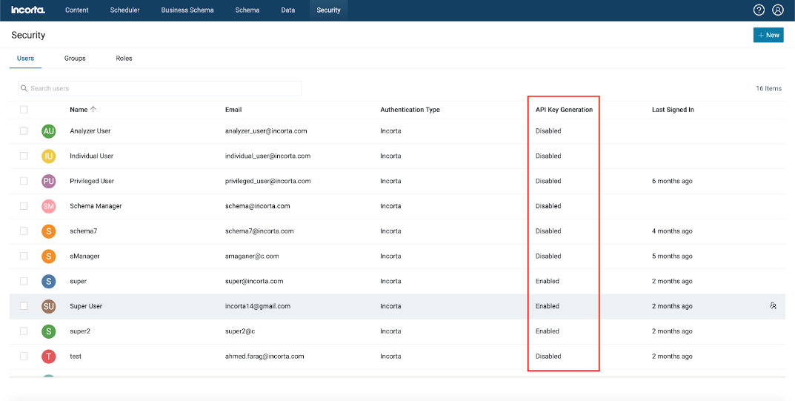

Enabled means user can create/renew API Key and use public apis.  
Disabled means user can’t have API key or use public apis.

## You enable/disable API Key generation for users in 3 ways:

1- Toggle the flag for multiple users at once

Select the users you want to enable/disable the API Key Generation for them and press on the kebab menu in the top right corner and choose the action to perform on the selected users.

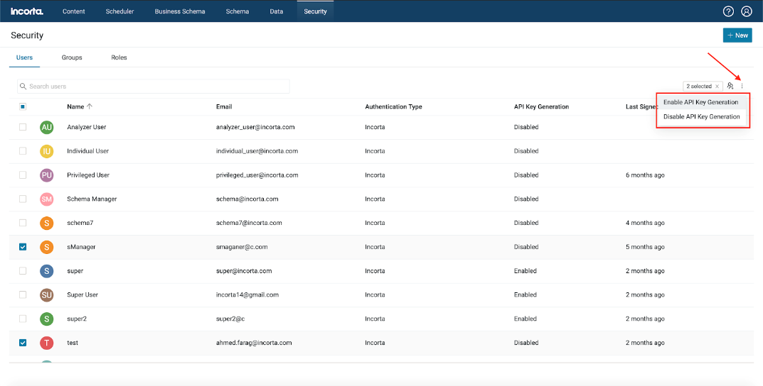

**Note:** Any user with the super-user role will have API Key Generation always enabled as long as the super mode is enabled in the users’ tenant and will fail to change its flag with the following message.

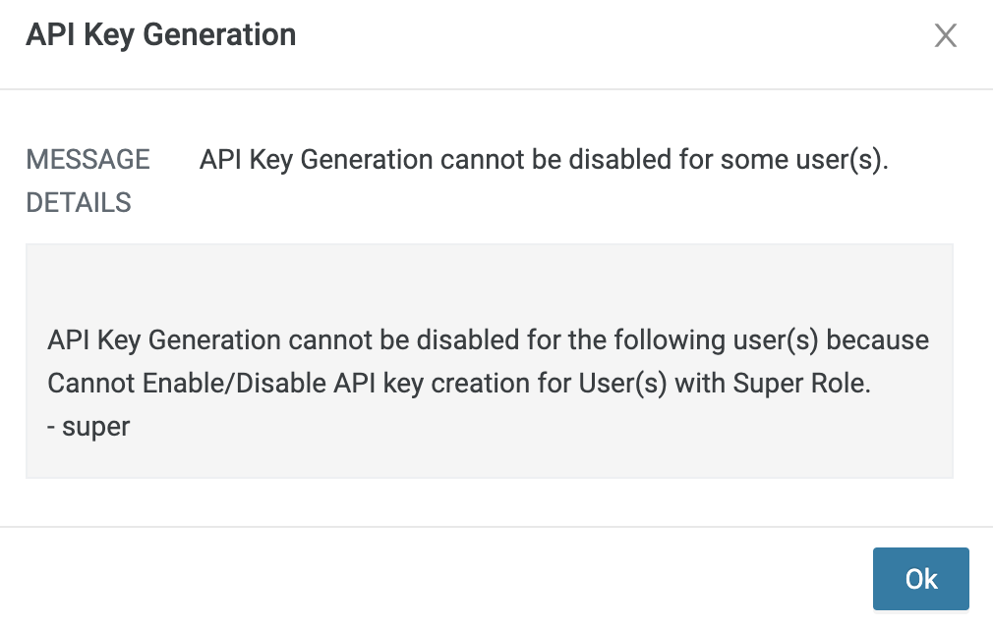

2- Toggle the flag for users inside multiple groups at once

Navigate to the “Groups” tab and select the groups you want to change the API Key Generation for their members and press on the kebab menu in the top right corner and choose the action to perform on the selected users.

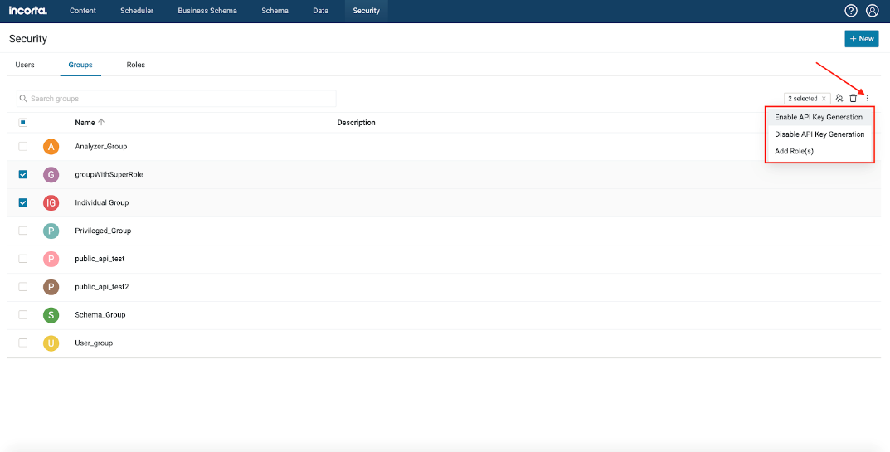

**Note:** Any group with the super-user role will have API Key Generation always enabled for its users as long as the super mode is enabled for the groups’ tenant and will fail to change its users’ flag with the following message.

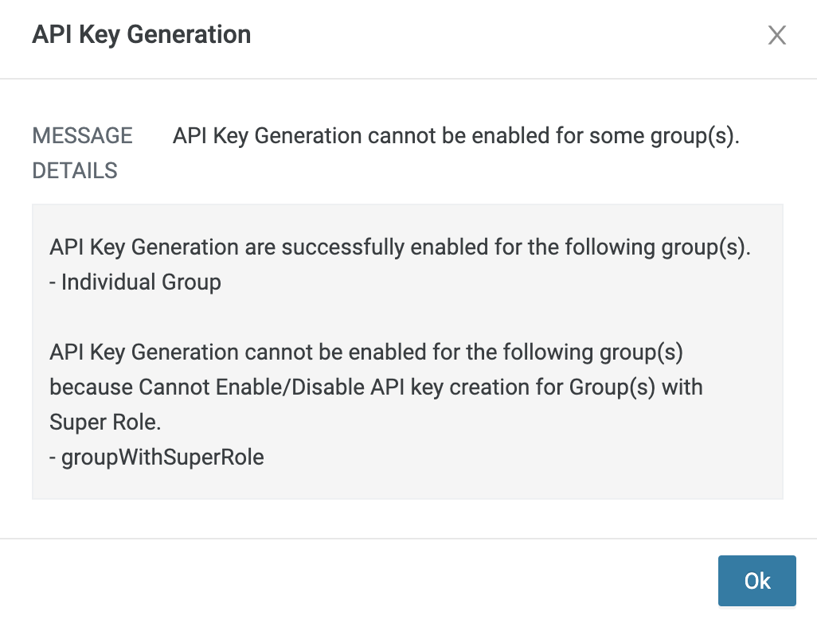

3- Toggle the flag for a single user from the user profile tab

Navigate to the security tab in the user profile, you will find a flag to enable/disable API Key Generation in the Developer Tool section.

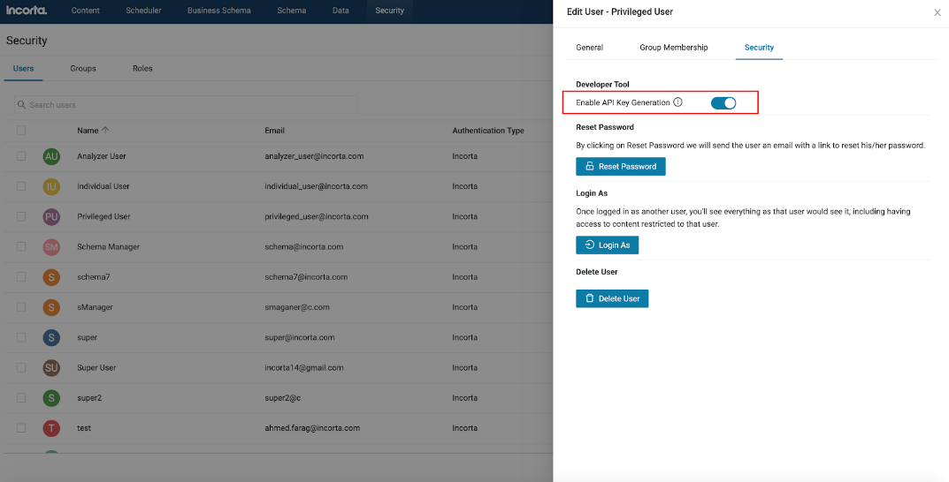

Any user will receive a notification mail whether he has the API Key Generation enabled or disabled for him.

**Note:** in order to receive a notification, the user needs to logon to Incorta at least once.

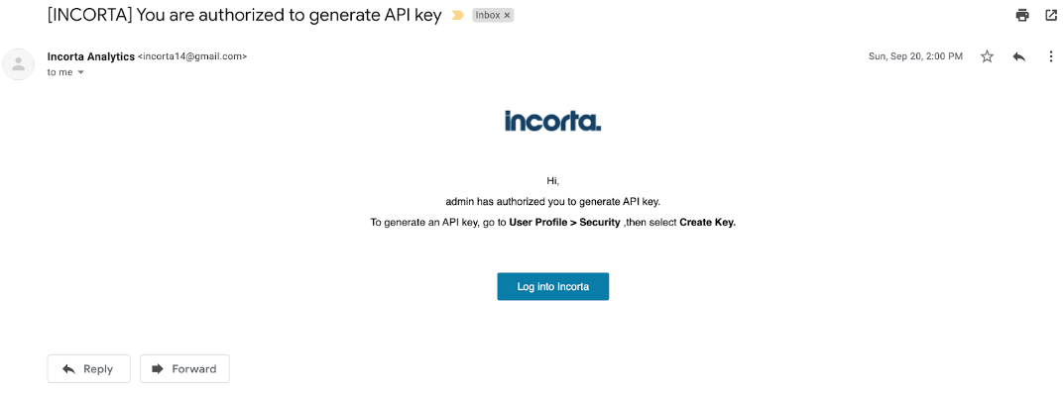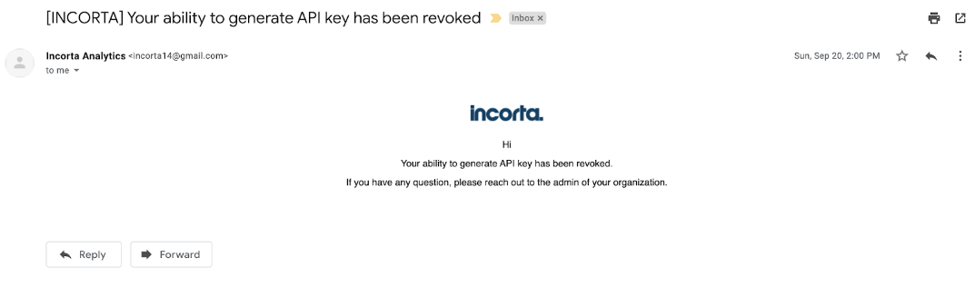

## Creating API Key

Any user with API Key Generation flag enabled for him can log in to Incorta, navigate to the security tab in his user profile and create API Key if it’s his first time or renew it if it exists.

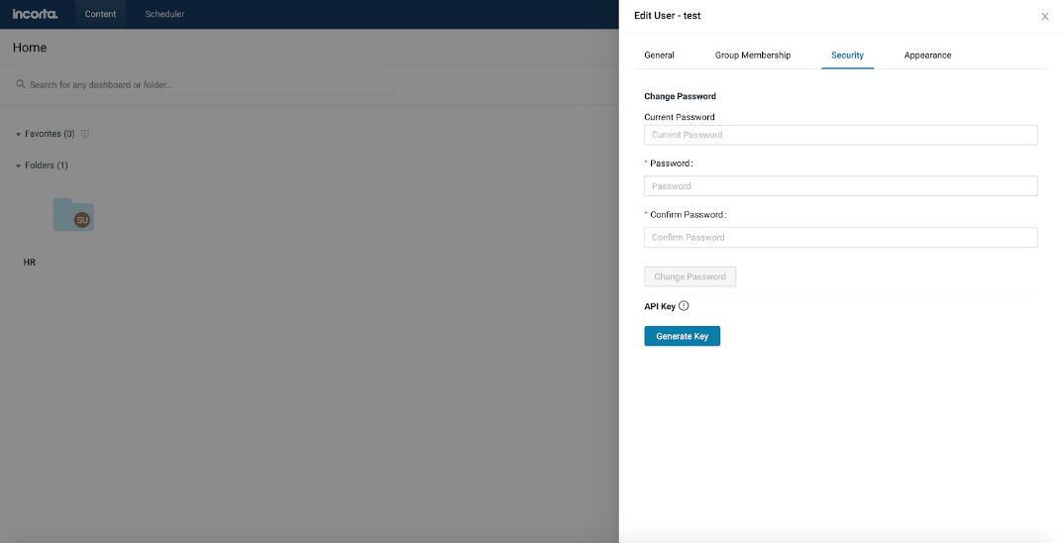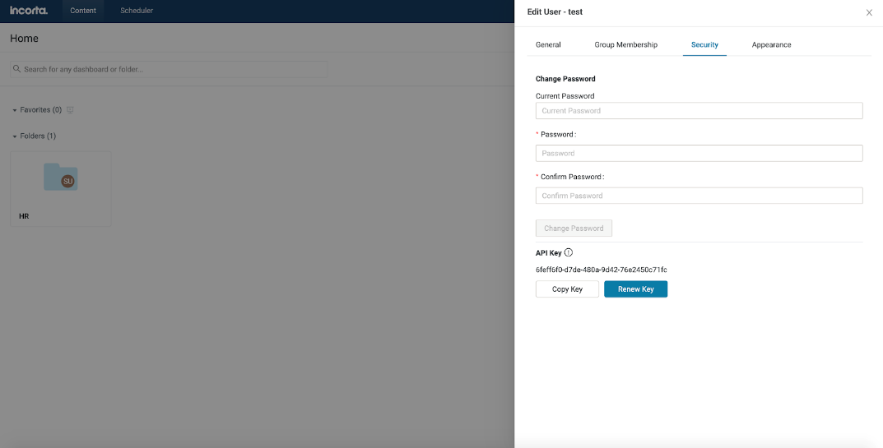

**Note:** User can have only one API Key.