**Grocery Management System**

**Team:**

01.

Name: Abdullah Mohammad Sayem

ID: C221070

02.

Name: Tanvir Younus

ID: C221067

03.

Name: Kazi Tafhimul Islam

ID: C221063

**Description:** In this project we made a simple command line application using c programming for grocery management. By using this system, an user can manage his daily products.

**Features:**

1. Insert product data
2. Show product list
   1. Show all at once
   2. Search with multiple fields (ID, Name, Price, Stock)
3. Sort product list
   1. Sort by ascending with multiple fields (ID, Name, Price, Stock)
   2. Sort by descending with multiple fields (ID, Name, Price, Stock)
4. Update a product
5. Delete a product

**Product Insert:**

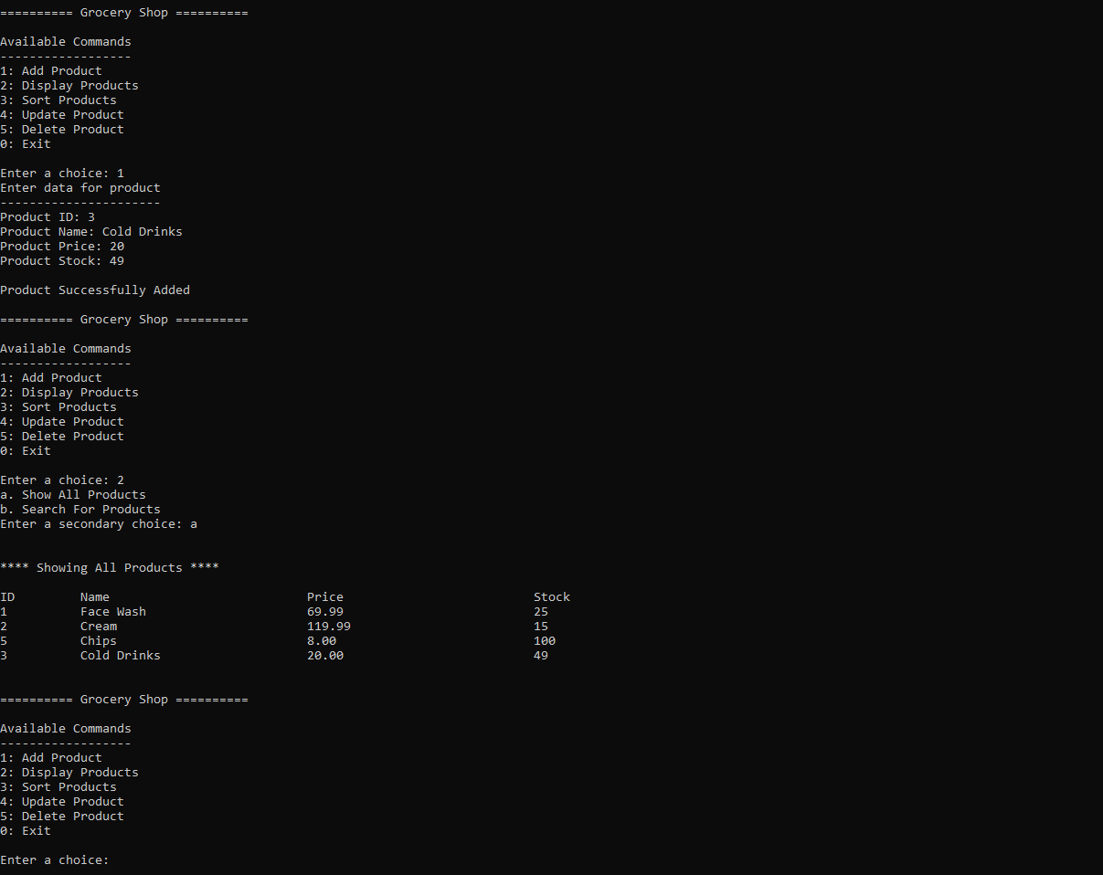

Figure .01: Inserting product

**Display Show:**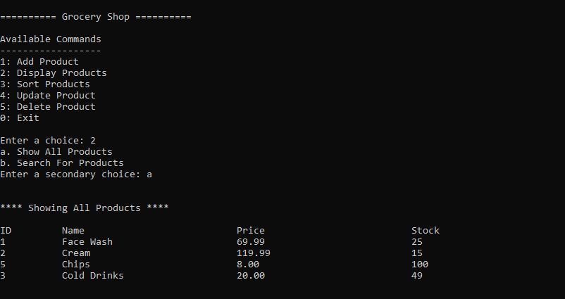

Figure .01: Showing all products

**Sort Product:**

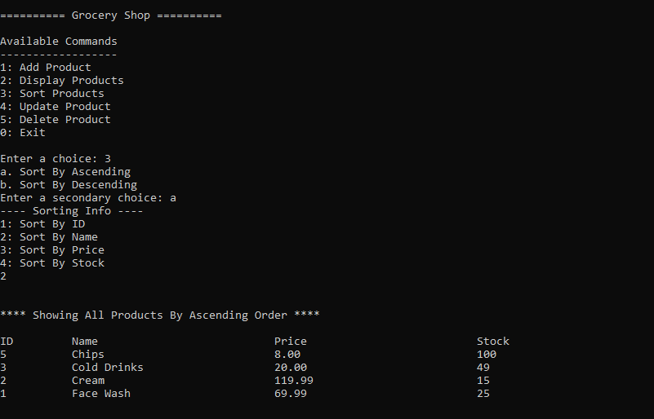

Figure .01: Sorting products

**Update Product:**

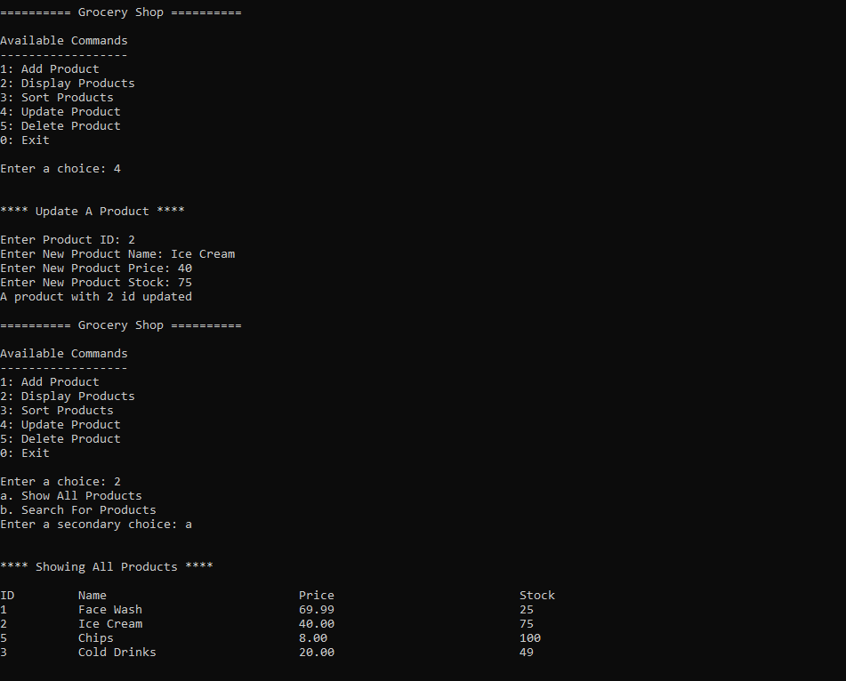

Figure .01: Updating a product by ID

**Delete Product:**

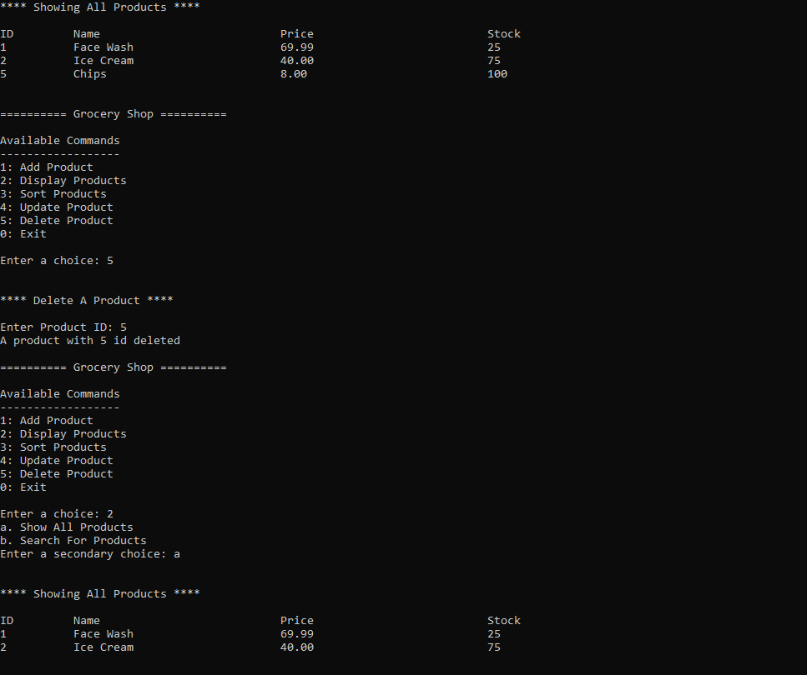

Figure .01: Deleting a product by ID