Text Analytics Assignment – Set D
Name: ____________________ Roll Number: ____________________
Topics: Word2Vec word embeddings (Gensim) and a text preprocessing pipeline (NLTK).
Files submitted: TextAnalytics_SetD.ipynb, data/word2vec_corpus.csv, data/dataset.csv, this document. An interactive Streamlit app (app.py) is also included in the GitHub repo to explore the results.

Question 1 – Word2Vec on Health & Fitness Sentences

Approach
- Loaded the 20 given sentences into a Python list (also saved as word2vec_corpus.csv).
- Cleaned each sentence: lowercase, replaced hyphens with spaces (so 'low-impact' → 'low impact'), removed punctuation.
- Tokenized with NLTK word_tokenize.
- Removed English stopwords (optional step). Vocabulary went from 122 to 102 unique words, and words like 'a', 'is', 'the' stopped showing up as 'similar' to everything.
- Trained Gensim Word2Vec with vector_size=50, window=3, min_count=1, sg=1 (skip-gram), epochs=500, seed=42, workers=1.
- Printed vocabulary, the vector for 'diet', and the top-5 most similar words for 'diet' and 'workout'.
Why these settings: the dataset is tiny, so small vectors (50) are enough, min_count=1 keeps every word (almost every word appears only once), skip-gram works better than CBOW on small data, and many epochs are needed because there are very few training examples. With only 200 epochs every pair of words came out ~0.99 similar, i.e. the vectors had not separated yet.

Key Outputs
Metric | Value
Total sentences | 20
Vocabulary size | 102
Word vector shape | (50,)

Full vocabulary (most frequent first):
diet, workout, improve, workouts, strength, muscle, balanced, important, training, health, protein, high, enough, body, schedule, part, days, rest, sufficient, provide, still, vegetarian, intense, prepare, exercises, warm, goals, individual, based, plan, design, often, nutritionists, levels, fitness, term, long, routines, consistent, problems, several, linked, sugar, quickly, calories, burn, interval, diseases, lifestyle, prevent, recommend, doctors, flexibility, improves, impact, low, yoga, discomfort, digestive, cause, change, sudden, recovery, sleep, getting, density, bone, build, grains, whole, vegetables, fruits, include, injury, risk, reduces, stretching, time, metabolism, slow, meals, skipping, lung, heart, help, cardio, athletes, among, common, digestion, good, supports, daily, water, drinking, overall, sessions, regular, weight, healthy, maintain, helps
First 10 values of the 'diet' vector:
[-0.2806 -0.1459 0.0633 0.1014 -0.078 0.1492 0.0044 0.3786 -0.1828
-0.2185]
Top-5 similar words:
Rank | Similar to 'diet' | Score | Similar to 'workout' | Score
1 | digestive | 0.9166 | consistent | 0.9308
2 | balanced | 0.9096 | stretching | 0.9253
3 | sudden | 0.9077 | levels | 0.9179
4 | cause | 0.9071 | injury | 0.9157
5 | change | 0.9069 | reduces | 0.9146

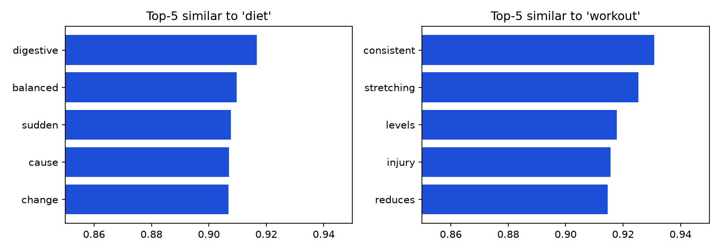
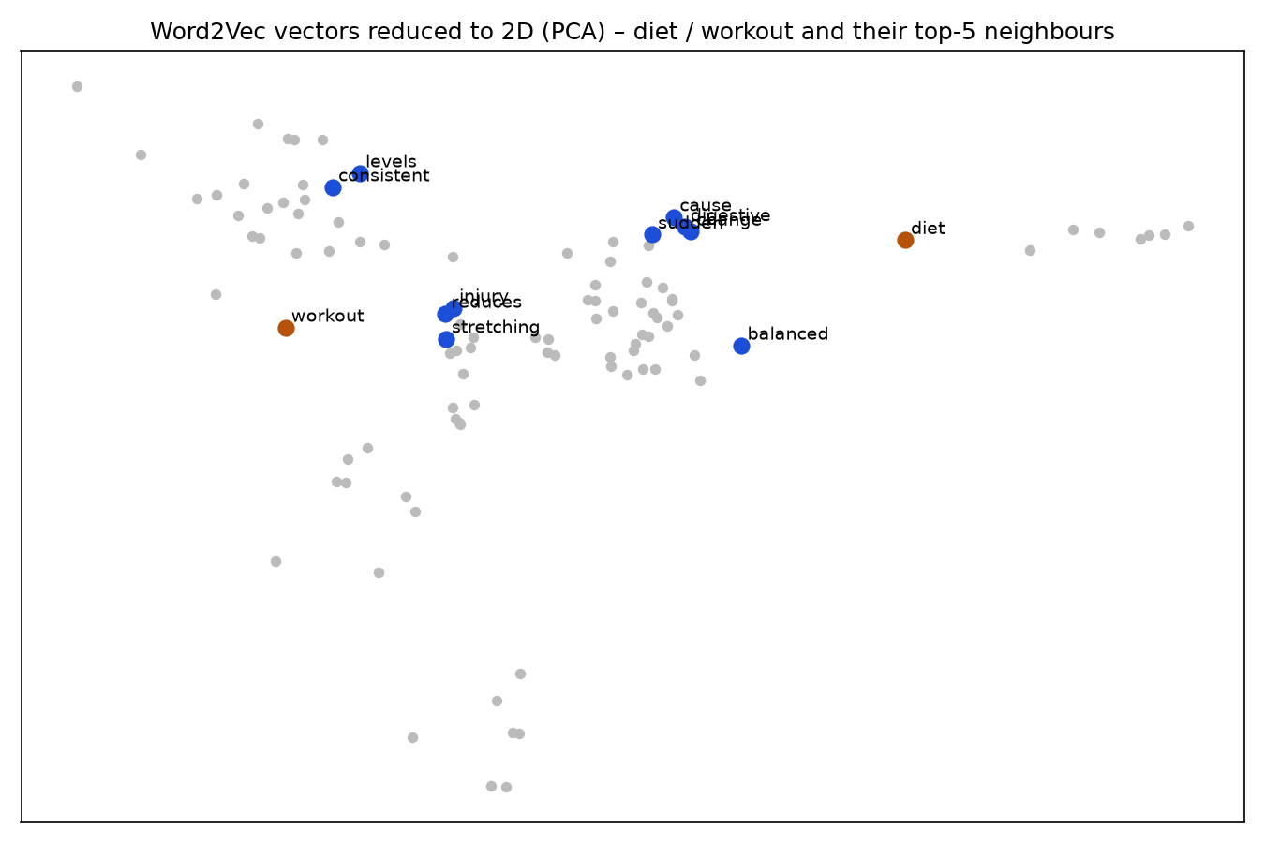

Interpretation
Partly. For 'diet', 'balanced' makes real sense because "balanced diet" appears three times. The other neighbours (digestive, sudden, cause, change) all come from a single sentence – "a sudden change in diet can cause digestive discomfort". Similarly, 'workout' is close to consistent, stretching, levels, injury and reduces, which are just words that shared a sentence with it. So the model is mostly remembering which words appeared together rather than learning true meaning. With only 20 short sentences most words appear once, so one accidental co-occurrence decides the vector; a large corpus averages these accidents out.

Interpretation Questions
Why is min_count needed, and what if we increase it? min_count drops words that appear fewer times than the threshold. On real data it removes typos and rare words that cannot get a good vector anyway, and it makes training faster. On this dataset nearly every word appears once, so raising it shrinks the vocabulary drastically: min_count=1 → 102 words, 2 → 14 words, 3 → 7 words. Most of the useful words would be lost.
What does increasing the window size change? The window decides how many neighbouring words count as context. A small window captures close, almost grammatical relationships (words right next to each other). A larger window captures broader topic relationships – words that appear anywhere in the same sentence become similar. In our short sentences a big window basically means 'same sentence'.
Why might results differ if we re-train? Word2Vec starts from random vectors, uses random negative sampling and processes data in a random order (and in parallel threads). Each run therefore ends in a slightly different place. On a small dataset this randomness has a big effect – in the notebook, seeds 1, 7 and 99 gave three different top-5 lists for 'diet'. Fixing seed and using workers=1 makes results repeatable.

Question 2 – Text Preprocessing Pipeline

Approach
- Saved the 12 raw sentences as dataset.csv (single column 'text') and loaded them with pandas.
- Cleaning function: lowercase → regex removes everything that is not a letter or space (punctuation, numbers, symbols) → collapse extra spaces.
- Tokenized with both NLTK word_tokenize and RegexpTokenizer(r'[a-zA-Z]+').
- Removed NLTK English stopwords and recorded token counts before/after.
- Applied PorterStemmer, SnowballStemmer('english') and WordNetLemmatizer (with POS tags from nltk.pos_tag).
- Built a comparison table and counted vocabulary size at each stage.

Raw vs Cleaned
# | Raw text | Cleaned text
1 | A balanced DIET helps maintain healthy body weight!! | a balanced diet helps maintain healthy body weight
2 | regular workout sessions improve muscle strength... love it :) | regular workout sessions improve muscle strength love it
3 | drinking 8 glasses of water daily supports digestion!! | drinking glasses of water daily supports digestion
4 | skipping meals can SLOW down your metabolism... | skipping meals can slow down your metabolism
5 | stretching before a workout reduces injury risk!! important | stretching before a workout reduces injury risk important
6 | strength training builds muscle & improves bone density | strength training builds muscle improves bone density
7 | getting 7-8 hrs of sleep is important for recovery :) | getting hrs of sleep is important for recovery
8 | yoga is a LOW-impact workout, improves flexibility!! | yoga is a low impact workout improves flexibility
9 | a high-sugar diet is linked to health problems... | a high sugar diet is linked to health problems
10 | interval training burns calories QUICKLY!! great results | interval training burns calories quickly great results
11 | nutritionists design diet plans based on individual goals | nutritionists design diet plans based on individual goals
12 | rest days are an important part of any workout schedule!! | rest days are an important part of any workout schedule

Tokenization comparison (first 3 sentences)
Sentence 1
word_tokenize (raw) : ['A', 'balanced', 'DIET', 'helps', 'maintain', 'healthy', 'body', 'weight', '!', '!']
RegexpTokenizer (raw) : ['A', 'balanced', 'DIET', 'helps', 'maintain', 'healthy', 'body', 'weight']
Both on cleaned text : ['a', 'balanced', 'diet', 'helps', 'maintain', 'healthy', 'body', 'weight']
Sentence 2
word_tokenize (raw) : ['regular', 'workout', 'sessions', 'improve', 'muscle', 'strength', '...', 'love', 'it', ':', ')']
RegexpTokenizer (raw) : ['regular', 'workout', 'sessions', 'improve', 'muscle', 'strength', 'love', 'it']
Both on cleaned text : ['regular', 'workout', 'sessions', 'improve', 'muscle', 'strength', 'love', 'it']
Sentence 3
word_tokenize (raw) : ['drinking', '8', 'glasses', 'of', 'water', 'daily', 'supports', 'digestion', '!', '!']
RegexpTokenizer (raw) : ['drinking', 'glasses', 'of', 'water', 'daily', 'supports', 'digestion']
Both on cleaned text : ['drinking', 'glasses', 'of', 'water', 'daily', 'supports', 'digestion']
On cleaned text both tokenizers give identical output since no punctuation is left. On raw text, word_tokenize keeps '!', '...', ':' and ')' as separate tokens while RegexpTokenizer keeps only alphabetic words.

Stopword removal – token counts
# | Before | After | Tokens after removal
1 | 8 | 7 | balanced diet helps maintain healthy body weight
2 | 8 | 7 | regular workout sessions improve muscle strength love
3 | 7 | 6 | drinking glasses water daily supports digestion
4 | 7 | 4 | skipping meals slow metabolism
5 | 8 | 6 | stretching workout reduces injury risk important
6 | 7 | 7 | strength training builds muscle improves bone density
7 | 8 | 5 | getting hrs sleep important recovery
8 | 8 | 6 | yoga low impact workout improves flexibility
9 | 9 | 6 | high sugar diet linked health problems
10 | 7 | 7 | interval training burns calories quickly great results
11 | 8 | 7 | nutritionists design diet plans based individual goals
12 | 10 | 6 | rest days important part workout schedule

Total: 95 tokens → 74 tokens.

Stemming and lemmatization output
# | Porter | Snowball | Lemma (POS-aware)
1 | balanc diet help maintain healthi bodi weight | balanc diet help maintain healthi bodi weight | balance diet help maintain healthy body weight
2 | regular workout session improv muscl strength love | regular workout session improv muscl strength love | regular workout session improve muscle strength love
3 | drink glass water daili support digest | drink glass water daili support digest | drinking glass water daily support digestion
4 | skip meal slow metabol | skip meal slow metabol | skip meal slow metabolism
5 | stretch workout reduc injuri risk import | stretch workout reduc injuri risk import | stretch workout reduces injury risk important
6 | strength train build muscl improv bone densiti | strength train build muscl improv bone densiti | strength training build muscle improve bone density
7 | get hr sleep import recoveri | get hrs sleep import recoveri | get hrs sleep important recovery
8 | yoga low impact workout improv flexibl | yoga low impact workout improv flexibl | yoga low impact workout improve flexibility
9 | high sugar diet link health problem | high sugar diet link health problem | high sugar diet link health problem
10 | interv train burn calori quickli great result | interv train burn calori quick great result | interval training burn calorie quickly great result
11 | nutritionist design diet plan base individu goal | nutritionist design diet plan base individu goal | nutritionist design diet plan base individual goal
12 | rest day import part workout schedul | rest day import part workout schedul | rest day important part workout schedule

Comparison table (rows where Porter ≠ Snowball are highlighted)
Original Word | Porter Stem | Snowball Stem | Lemma
balanced | balanc | balanc | balance
sessions | session | session | session
improves | improv | improv | improve
drinking | drink | drink | drinking
glasses | glass | glass | glass
supports | support | support | support
digestion | digest | digest | digestion
skipping | skip | skip | skip
metabolism | metabol | metabol | metabolism
stretching | stretch | stretch | stretch
builds | build | build | build
density | densiti | densiti | density
calories | calori | calori | calorie
quickly | quickli | quick | quickly
hrs | hr | hrs | hrs
nutritionists | nutritionist | nutritionist | nutritionist
plans | plan | plan | plan
days | day | day | day

Vocabulary size at each stage
Stage | Vocabulary size
Raw tokens | 77
After stopword removal | 63
After Porter stemming | 62
After Snowball stemming | 62
After lemmatization | 62

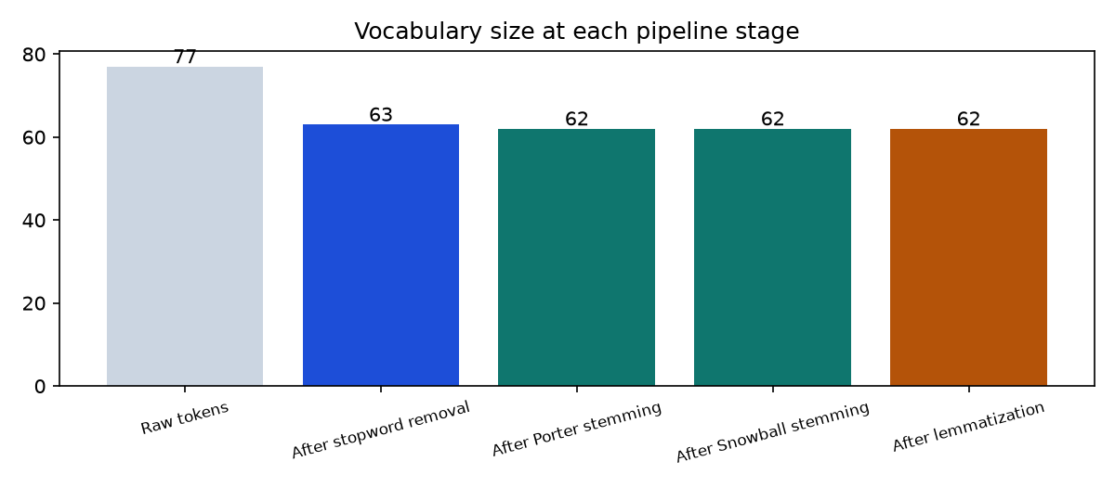

Interpretation
Both techniques shrink the vocabulary by merging forms of the same word (workout/workouts, improve/improves). Stemming just cuts suffixes by rules, so it is fast but creates non-words like 'balanc', 'calori', 'densiti' and 'metabol'. Lemmatization uses the WordNet dictionary plus POS tags and returns real words like 'improve', 'build' and 'burn', but it is slower and depends on correct POS tags. For a search engine I would use stemming because speed and grouping more variants together (better recall) matter more than readability. For classification or anything a person will read (topic labels, word clouds, explanations), I would prefer lemmatization because the tokens stay meaningful.

Interpretation Questions
Why can stemming produce non-dictionary words while lemmatization returns a valid word? A stemmer is a fixed list of suffix-stripping rules (e.g. remove '-ing', turn '-ies' into '-i') and never checks whether the result is a real word, so 'calories' → 'calori' and 'density' → 'densiti'. A lemmatizer looks the word up in a dictionary (WordNet) and returns its base form, so the output is always a valid word.
RegexpTokenizer vs word_tokenize – practical difference? word_tokenize is NLTK's trained English tokenizer: it splits punctuation into its own tokens and handles contractions ("don't" → 'do', "n't"). RegexpTokenizer simply returns whatever matches the pattern, so with [a-zA-Z]+ it keeps only letters. I'd use word_tokenize when punctuation carries meaning (sentiment – '!!' and ':)' – or POS tagging/parsing), and RegexpTokenizer when I only want clean words and full control over what counts as a token.
A word where Porter and Snowball disagree, and why. 'quickly' → Porter: 'quickli', Snowball: 'quick'. Also 'hrs' → Porter: 'hr', Snowball: 'hrs'. Snowball (also called Porter2) is Martin Porter's improved version of his original algorithm. It has an extra rule for '-ly' adverb endings and changes how the final 'y' and short words are handled, so the two stemmers can give different stems for the same word. Outside the dataset the same pattern appears for 'generously' (gener vs generous) and 'fairly' (fairli vs fair).

Conclusion
Q1 showed that Word2Vec can be trained in a few lines with Gensim, but on 20 sentences it mostly learns sentence co-occurrence instead of real meaning. Q2 built a full cleaning → tokenizing → stopword → stemming / lemmatization pipeline; stopword removal gave the biggest reduction in tokens, and lemmatization kept readable words while stemming was faster but produced non-words.

