Part 1: Architecture Design- PayLink Africa
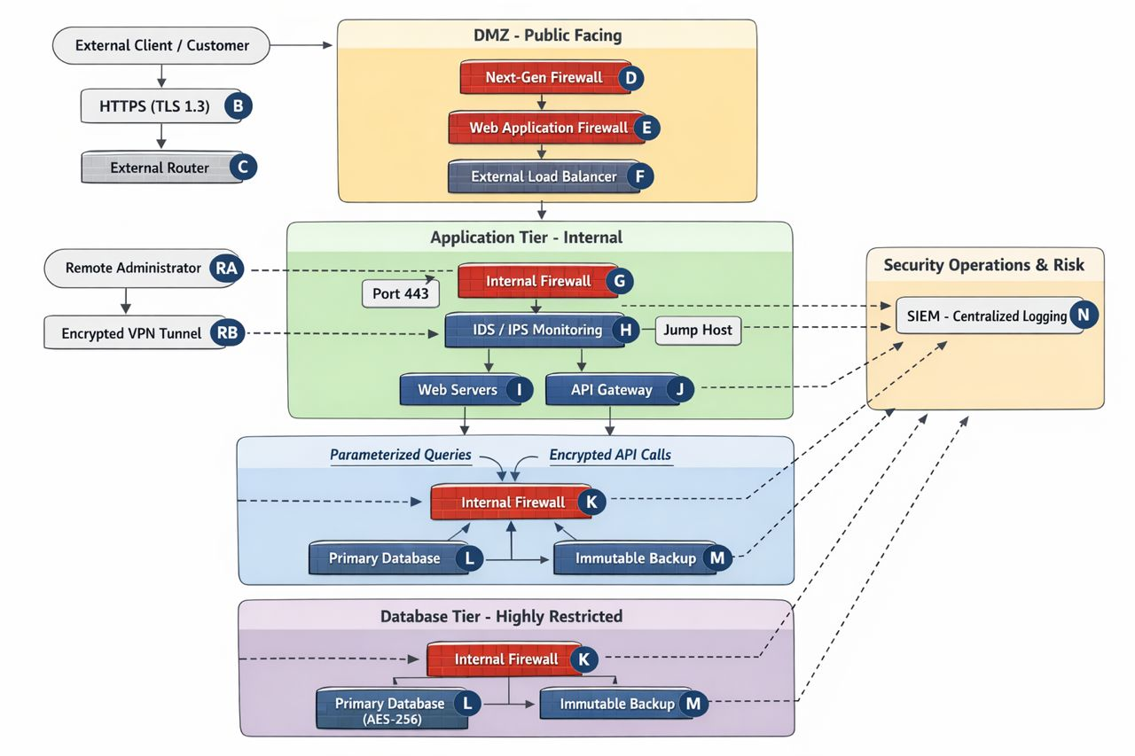

Part 2: Explanation and Justification

Introduction

PayLink Africa is a high-growth fintech dedicated to providing secure digital wallet services and payment solutions. Processing massive volumes of Personally Identifiable Information (PII) and financial transaction data makes the platform a prime target for sophisticated cyberattacks like SQL injection and DDoS. This three-tier architectural design prioritizes data integrity and asset protection, guided by the security controls recommended in NIST SP 800-53 and PCI-DSS requirements to ensure secure credit card processing and maintain stakeholder trust.

Enforcement of the CIA Triad

The architecture meticulously enforces the CIA Triad across the DMZ, application, and database tiers to protect sensitive financial flows.

Confidentiality: Unauthorized access is prevented through three primary layers. All client-to-system communication is secured via an HTTPS (TLS 1.3) tunnel (B) to stop "Man-in-the-Middle" attacks. At rest, financial records are secured with AES-256 encryption (L), ensuring data remains unreadable even if physical storage is compromised. Additionally, VPC segmentation isolates the database behind Internal Firewalls (K), preventing direct internet exposure.

Integrity: To ensure records remain unaltered, the system uses SHA-256 cryptographic hashes for all bank API transactions (J); any mismatch triggers an automatic rejection. A Web Application Firewall (E) and the use of Parameterized Queries block SQL injection attempts. Finally, WORM logs and Centralized SIEM Logging (N) create an immutable audit trail.

Availability: Services remain online 24/7 through an External Load Balancer (F) that distributes requests across redundant Web Servers (I). Cloud-based DDoS scrubbing blocks volumetric threats at the network edge. Disaster recovery is guaranteed by the 3-2-1 backup rule using Immutable Backups (M), allowing for rapid restoration following ransomware or hardware failure.

Defense in Depth and Least Privilege

The architecture adopts a proactive "Castle Approach" to maximize resilience through layered defenses. Protection begins at the perimeter with a Next-Generation Firewall (D) and WAF (E). Internal threats are monitored by an IDS/IPS (H) for lateral movement, while Endpoint Detection and Response (EDR) on each host identifies malicious processes in real-time. Data encryption serves as the final fail-safe if network layers are breached.

Complementing these layers, the Principle of Least Privilege (PoLP) restricts access via Role-Based Access Control (RBAC). For instance, Web Servers (I) are granted only "Read-Only" access and are blocked by Internal Firewalls (G) from direct database communication. High-level changes require Just-In-Time (JIT) Access via a secure Jump Host, requiring admins to use an Encrypted VPN Tunnel (RB) for temporary, audited maintenance.

Threat Mitigation and Framework Alignment

This design specifically neutralizes critical fintech threats. SQL Injection is blocked by the WAF (E) and backend Parameterized Queries. DDoS attacks are mitigated by the Load Balancer (F) and scrubbing services. To address Ransomware, Immutable Backups (M) provide cryptographically locked copies that cannot be encrypted or deleted, ensuring service restoration without ransom payments. The strategic logic is heavily influenced by the NIST Cybersecurity Framework (CSF) and the SABSA model.

In addition, the architecture aligns with security management principles from ISO/IEC 27001 by implementing structured access control, risk management, and monitoring processes. The system also addresses common web application threats identified in the OWASP Top 10, particularly SQL injection and API-related vulnerabilities. By aligning with NIST "Protect" and "Detect" functions through SIEM (N) and IDS/IPS (H) visibility, PayLink Africa ensures regulatory compliance and builds international institutional trust

Part 3: Reflection
- What was the hardest part of designing your architecture?
The most challenging aspect was balancing high-security requirements with system performance (latency). In a fintech environment like PayLink Africa, customers expect instant payment confirmations. However, every security layer added—such as the WAF inspection, deep packet inspection at the Internal Firewall, and multiple rounds of encryption—introduces a small amount of "latency" or delay. The hardest part was strategically placing these controls (like using a Load Balancer to offset the processing load) so that the system remains "Fort Knox" secure without frustrating the user with slow transaction speeds.

- How would your design differ if the company operated entirely in the cloud (AWS, Azure, or GCP)?
If PayLink Africa were entirely cloud-native, the physical hardware components (routers and physical firewalls) would be replaced by software-defined networking (SDN). I would utilize Security Groups and Network Access Control Lists (NACLs) to manage traffic between tiers. Instead of managing a physical IDS/IPS, I would use cloud-native services like AWS GuardDuty or Azure Sentinel. The core logic would remain the same, but the "Shared Responsibility Model" would apply: the cloud provider would handle the physical security of the data center, while I would focus exclusively on the configuration and identity management.

- What lessons did you learn about balancing security, cost, and usability?
I learned that security is a "diminishing return" game where you must find a practical middle ground. You could theoretically make a system 100% secure by disconnecting it from the internet, but then it has zero usability. Similarly, high-end "Next-Gen" tools carry significant licensing costs. I learned that the most effective architecture doesn't just buy every tool available; it applies the Principle of Least Privilege and Defense in Depth to protect the most sensitive "crown jewels" (the database) while keeping the public-facing "lobby" (the web app) fast and accessible.

