Forensic Investigation Report: AWS SecurityMonitoring and Automated Response
1. Executive Summary
This project involved the design and implementation of a real-time AWS securitymonitoring and alerting system to detect unauthorized access to sensitive secrets. Thesystem monitored access to a protected database credential stored in AWS Secrets Manager and generated immediate alerts when the secret was accessed. Two detectionapproaches were implemented and evaluated: a metric-based approach using CloudWatch (Flow 1) and an event-driven approach using EventBridge (Flow2).
In addition to detection, an automated active-defense mechanism was implementedtoimmediately revoke access from a compromised user. The simulation successfullydemonstrated detection, alerting, and automated response to a security breach, meeting the objectives of continuous monitoring and rapid incident containment.
2. Lab Architecture
The security monitoring system followed two parallel detection paths built on a shared logging foundation.
Conceptual Flow
Sensitive Access → CloudTrail → Detection Logic → Alerting →Automated Response
Detection Flows
Flow 1: CloudTrail → CloudWatch Logs → Metric Filter →Alarm →SNS Email Flow 2: CloudTrail → EventBridge Rule → SNS Email + Automated Kill-Switch
3. Phase 1 – Infrastructure & Logging 3.1 CloudTrail Configuration
A multi-region AWS CloudTrail was created to ensure all management events were captured across regions. The trail was configured to log both read and write management events and was integrated with CloudWatch Logs to allowreal-time detection and filtering.
3.2 Secrets Manager – Honeytoken Creation
A secret named Database_Credentials was created in AWS Secrets Manager. This secret acted as a monitored honeytoken designed to trigger alerts if accessed.
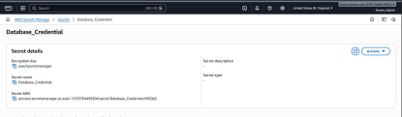
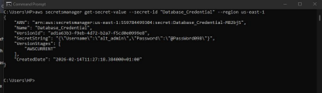Figure 1 Secrets Manager showing the secret name and configuration
3.3 S3 Data Residency and Logging
An S3 bucket was created to store CloudTrail logs. Server Access Logging was enabled on the bucket to provide additional auditability and meet data residency requirements.
4. Phase 2 – Detection Logic (Flow 1: CloudWatch) 4.1 Metric Filter Creation
A CloudWatch Logs metric filter was created to detect the GetSecretValue API call targeting the Database_Credentials secret. The filter matched CloudTrail log entries containing the specific event name and secret identifier.
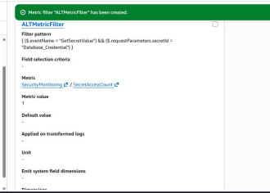
Figure 2 CloudWatch Logs metric filter configuration
4.2 Alarm Configuration
A CloudWatch Alarm was created based on the metric filter. The alarmwas configured to trigger when the metric value was greater than or equal to one withinaone-minute period, ensuring any single access attempt would raise an alert.
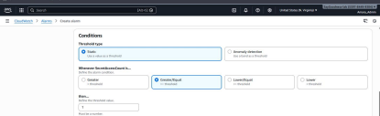Figure 3 CloudWatch Alarm configuration showing threshold ≥ 1 in 1 minute
4.3 SNS Notification (Flow 1)
The CloudWatch Alarm was linked to an SNS topic configured for email notifications. The email subscription was confirmed to ensure alert delivery.
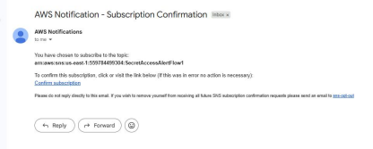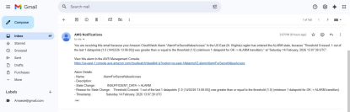Figure 4 SNS topic with confirmed email subscription linked to CloudWatch Alarm
5. Phase 3 – Detection Logic (Flow 2: EventBridge) 5.1 EventBridge Rule Configuration
An EventBridge rule was created to detect sensitive data access events fromCloudTrail. The rule matched management API calls related to secret retrieval. The rule was configured to process all CloudTrail management events.
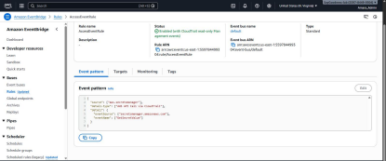Figure 5 EventBridge rule showing event pattern configuration
5.2 SNS Alerting (Flow 2)
A separate SNS topic was configured for Flow 2 alerts to allow independent evaluation of detection speed and alert context.
5.3 Breach Simulation
The breach was simulated using the AWS CLI to retrieve the secret: aws secretsmanager get-secret-value --secret-id Database_Credential
This action generated CloudTrail logs and triggered both detection flows.
6. Phase 4 – Active Defense Kill-Switch 6.1 Kill-Switch Implementation
An automated response mechanism was implemented using EventBridge as the trigger. Upon detecting sensitive secret access, the rule invoked an automated remediation process that disabled the IAM access key of the offending user, effectively stripping all permissions.
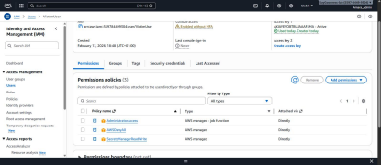Figure 6 Kill-Switch Implementation
6.2 Trigger Integration
The EventBridge rule from Flow 2 was configured with a second target pointing tothe automated remediation action. This ensured that detection and response occurredwithin seconds of the breach.
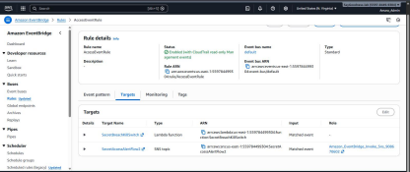Figure 7 EventBridge rule showing SNS and Kill-Switch as dual targets
6.3 Trap Test (Victim User)
A “Victim” IAM user was created with read-only Secrets Manager permissions. Theuser accessed the secret via the AWS CLI, triggering detection. Immediately afterward, any subsequent AWS CLI command failed due to revoked access.
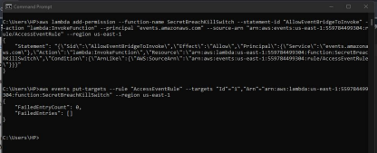Figure 8 IAM console showing Victim user with no active permissions or disabled access key
7. Forensic Evidence
7.1 CloudTrail Log Evidence
A CloudTrail log entry confirmed the breach, showing:
eventTime - "2026-02-14T13:25:03Z"
userIdentity - "VictimUser"
sourceIpAddress - "102.89.84.110"
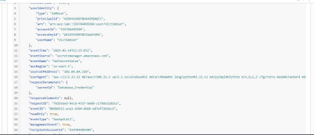Figure 9 CloudTrail JSON log snippet showing GetSecretValue event
7.2 Access Denied Confirmation
A subsequent CloudTrail log showed the remediation outcome with an AccessDenied error when the Victim user attempted another command.
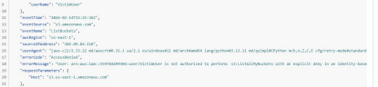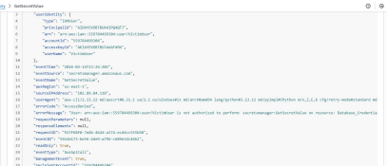Figure 10 CloudTrail JSON showing errorCode: AccessDenied
8. Security Analysis
Speed
Flow 2 (EventBridge) provided faster notification than Flow 1. EventBridge
processed the event almost immediately, while CloudWatch metric evaluation introduced a short delay.
Context
EventBridge alerts provided richer contextual data, including event structure and identity details. To automatically block users after detection, EventBridge combinedwith Lambda or SSM Automation was the most effective service.
Compliance
This lab satisfied the Continuous Monitoring requirement of frameworks such as NIST by ensuring ongoing visibility into sensitive access events, automated detection, and timely response.
9. Lessons Learned
For a banking environment, EventBridge (Flow 2) would be preferred for triggeringthe Kill-Switch due to its lower latency, richer context, and native integration withautomated remediation workflows. While CloudWatch metric filters are effective for monitoring, EventBridge provides superior control for real-time security response.

