为什么要用ConcurrentHashMap
HashMap -> 非线程安全的
HashTable synchronized（偏向锁、轻量级锁(CAS)）
性能 -> 安全性之间做好平衡

ConcurrentHashMap的使用
java - 8 lambda（一种简化,语法糖）
computeIfAbsent computeIfPresent
compute（computeIfAbsent和computeIfPresent两者的结合）
merge（合并数据）

ConcurrentHashMap它的存储结构和实现.
JDK1.8
JDK1.7 segment 分段锁。锁的粒度较大。红黑树的引入， 时间复杂度O(n) -> O(logn)

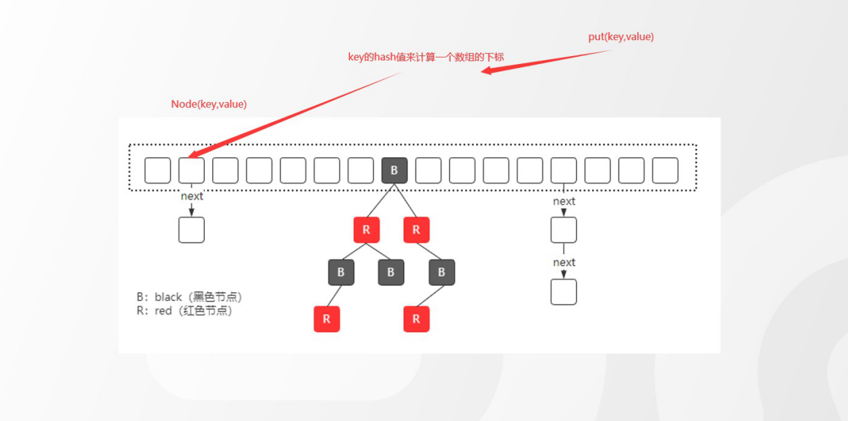

CHM的源码
transient volatile Node<K,V>[] table;

final V putVal(K key, V value, boolean onlyIfAbsent) {
if (key == null || value == null) throw new NullPointerException(); int hash = spread(key.hashCode());
int binCount = 0;

//自旋（;;） {cas}
for (Node<K,V>[] tab = table;;) { Node<K,V> f; int n, i, fh;
//如果tab为空，说明还没有初始化.
if (tab == null || (n = tab.length) == 0)
tab = initTable(); //初始化完成后，进入到下一次循环
//(n - 1) & hash) -> 0-15 ->计算数组下标位置.
else if ((f = tabAt(tab, i = (n - 1) & hash)) == null) {
//如果当前的node的位置为空，直接存储到该位置.
//通过cas来保证原子性.
if (casTabAt(tab, i, null,
new Node<K,V>(hash, key, value, null)))
break; // no lock when adding to empty bin
}

else if ((fh = f.hash) == MOVED) tab = helpTransfer(tab, f);
else {
V oldVal = null;
synchronized (f) { //锁住当前的node节点，避免线程安全问题if (tabAt(tab, i) == f) { //重新判断（）
//针对链表来处理if (fh >= 0) {
binCount = 1; //统计了链表的长度
for (Node<K,V> e = f;; ++binCount) { K ek;
//是否存在相同的key，如果存在，则覆盖
if (e.hash == hash &&
((ek = e.key) == key ||
(ek != null && key.equals(ek)))) { oldVal = e.val;
if (!onlyIfAbsent) e.val = value;
break;
}
//如果不存在，则把当前的key/value添加到链表中. Node<K,V> pred = e;
//说明到了最后一个节点，直接添加到尾部if ((e = e.next) == null) {
pred.next = new Node<K,V>(hash, key,
value, null);
break;
}
}
}
//针对红黑树的处理
else if (f instanceof TreeBin) { Node<K,V> p;
binCount = 2;
if ((p = ((TreeBin<K,V>)f).putTreeVal(hash, key,
value)) != null) {
oldVal = p.val;
if (!onlyIfAbsent) p.val = value;
}
}
}
}
//
if (binCount != 0) {
//如果链表长度大于等于8，则会调用treeifyBin方法if (binCount >= TREEIFY_THRESHOLD)
treeifyBin(tab, i); if (oldVal != null)
return oldVal; break;
}
}
}
addCount(1L, binCount); return null;
}

initTable();

private final Node<K,V>[] initTable() { Node<K,V>[] tab; int sc;
//只要tab没有初始化，就不断循环直到初始完成
while ((tab = table) == null || tab.length == 0) { if ((sc = sizeCtl) < 0)
Thread.yield(); // lost initialization race; just spin
//通过cas自旋（通过CAS来占用一个锁的标记）
else if (U.compareAndSwapInt(this, SIZECTL, sc, -1)) {
//说明当前线程抢到了锁
try {
if ((tab = table) == null || tab.length == 0) { int n = (sc > 0) ? sc : DEFAULT_CAPACITY;
@SuppressWarnings("unchecked")
Node<K,V>[] nt = (Node<K,V>[])new Node<?,?>[n]; table = tab = nt;
sc = n - (n >>> 2); //扩容的阈值.
}
} finally {
sizeCtl = sc;
}
break;
}
}
return tab;
}

treeifyBin
会根据阈值来判断，是转化为红黑树还是扩容
private final void treeifyBin(Node<K,V>[] tab, int index) { Node<K,V> b; int n, sc;
if (tab != null) {
//如果table长度小于64.
if ((n = tab.length) < MIN_TREEIFY_CAPACITY) tryPresize(n << 1); //扩容
else if ((b = tabAt(tab, index)) != null && b.hash >= 0) { synchronized (b) {
//红黑树转化.
if (tabAt(tab, index) == b) { TreeNode<K,V> hd = null, tl = null;
for (Node<K,V> e = b; e != null; e = e.next) { TreeNode<K,V> p =
new TreeNode<K,V>(e.hash, e.key, e.val,
null, null); if ((p.prev = tl) == null)
hd = p;
else
tl.next = p; tl = p;
}
setTabAt(tab, index, new TreeBin<K,V>(hd));
}
}
}
}
}

tryPresize
该方法用来实现扩容，
多线程并发扩容（允许多个线程来协助扩容）
扩容的本质
创建一个新的数组（16-32，32-64）。然后把老的数据迁移到新的数组。

private final void tryPresize(int size) {
//用来判断扩容的目标大小.
int c = (size >= (MAXIMUM_CAPACITY >>> 1)) ? MAXIMUM_CAPACITY :
tableSizeFor(size + (size >>> 1) + 1); int sc;
while ((sc = sizeCtl) >= 0) { //说明要做数组的初始化.
Node<K,V>[] tab = table; int n;
// 初始化.
if (tab == null || (n = tab.length) == 0) {
n = (sc > c) ? sc : c; //如果初始容量|扩容的目标容量，谁最大选谁. if (U.compareAndSwapInt(this, SIZECTL, sc, -1)) {
try {
if (table == tab) { @SuppressWarnings("unchecked")
Node<K,V>[] nt = (Node<K,V>[])new Node<?,?>[n]; table = nt;
sc = n - (n >>> 2);
}
} finally {
sizeCtl = sc;
}
}
}

//已经是最大容量了，不能扩容了。直接返回
else if (c <= sc || n >= MAXIMUM_CAPACITY) break;
else if (tab == table) {

int rs = resizeStamp(n); //扩容戳. 保证当前扩容范围的唯一性.
//第一次扩容的时候，不会走这段逻辑if (sc < 0) {
Node<K,V>[] nt;
//表示扩容结束
if ((sc >>> RESIZE_STAMP_SHIFT) != rs || sc == rs + 1 || sc == rs + MAX_RESIZERS || (nt = nextTable) == null || transferIndex <= 0)
break;
//表示没有结束，每增加一个扩容线程，则在低位+1.
if (U.compareAndSwapInt(this, SIZECTL, sc, sc + 1)) transfer(tab, nt);
}
//第一次扩容走这段逻辑
else if (U.compareAndSwapInt(this, SIZECTL, sc,
(rs << RESIZE_STAMP_SHIFT) + 2))
transfer(tab, null);
}
}
}

必须要有一个地方去记录，在当前扩容范围内，有多少个线程参与数据的迁移工作. 必须要保证所有的线程完成了迁移的动作，才能够表示扩容完成。
resizeStamp

static final int resizeStamp(int n) {
return Integer.numberOfLeadingZeros(n) | (1 << (RESIZE_STAMP_BITS - 1));
}

0000 0000 0000 0000 0000 0000 0001 0000 -> 27位
0000 0000 0000 0000 1000 0000 0001 1011
resizeStamp返回的数: 1000 0000 0001 1011 0000 0000 0000 0000 rs << RESIZE_STAMP_SHIFT) + 2 ,二进制左移16位+2
1000 0000 0001 1011 0000 0000 0000 0010 ->表示当前有一个线程来扩容。
高位16表示当前的扩容标记， 保证唯一性. 低16位表示当前扩容的线程数量.

transfer
如何实现多个线程对同一个容器做数据迁移. 实现数据转移。
数据的迁移
需要计算当前线程的数据迁移空间。（任务拆分） 创建一个新的数组（容量为扩容后的大小）
实现数据的转移。
如果是红黑树
数据迁移后，不满足红黑树的条件，则红黑树转链表如果是链表
高低位迁移

private final void transfer(Node<K,V>[] tab, Node<K,V>[] nextTab) { int n = tab.length, stride;
if ((stride = (NCPU > 1) ? (n >>> 3) / NCPU : n) < MIN_TRANSFER_STRIDE)
stride = MIN_TRANSFER_STRIDE; // subdivide range if (nextTab == null) { // initiating
try {
@SuppressWarnings("unchecked")
Node<K,V>[] nt = (Node<K,V>[])new Node<?,?>[n << 1]; nextTab = nt;
} catch (Throwable ex) { // try to cope with OOME sizeCtl = Integer.MAX_VALUE;
return;
}
nextTable = nextTab; transferIndex = n;
}
int nextn = nextTab.length;
ForwardingNode<K,V> fwd = new ForwardingNode<K,V>(nextTab); boolean advance = true;
boolean finishing = false; // to ensure sweep before committing nextTab for (int i = 0, bound = 0;;) {
Node<K,V> f; int fh; while (advance) {
int nextIndex, nextBound;
if (--i >= bound || finishing) advance = false;
else if ((nextIndex = transferIndex) <= 0) { i = -1;
advance = false;
}
else if (U.compareAndSwapInt
(this, TRANSFERINDEX, nextIndex, nextBound = (nextIndex > stride ?
nextIndex - stride : 0))) {
bound = nextBound; i = nextIndex - 1; advance = false;
}
}
if (i < 0 || i >= n || i + n >= nextn) { int sc;
if (finishing) { nextTable = null; table = nextTab;
sizeCtl = (n << 1) - (n >>> 1); return;
}
if (U.compareAndSwapInt(this, SIZECTL, sc = sizeCtl, sc - 1)) { if ((sc - 2) != resizeStamp(n) << RESIZE_STAMP_SHIFT)
return;
finishing = advance = true;
i = n; // recheck before commit
}
}
else if ((f = tabAt(tab, i)) == null) advance = casTabAt(tab, i, null, fwd);
else if ((fh = f.hash) == MOVED)
advance = true; // already processed else {
synchronized (f) {
if (tabAt(tab, i) == f) { Node<K,V> ln, hn;
if (fh >= 0) {
int runBit = fh & n; Node<K,V> lastRun = f;
for (Node<K,V> p = f.next; p != null; p = p.next) { int b = p.hash & n;
if (b != runBit) { runBit = b; lastRun = p;
}
}
if (runBit == 0) { ln = lastRun; hn = null;
}
else {
hn = lastRun; ln = null;
}
for (Node<K,V> p = f; p != lastRun; p = p.next) {
int ph = p.hash; K pk = p.key; V pv = p.val; if ((ph & n) == 0)
ln = new Node<K,V>(ph, pk, pv, ln); else
hn = new Node<K,V>(ph, pk, pv, hn);
}
setTabAt(nextTab, i, ln); setTabAt(nextTab, i + n, hn); setTabAt(tab, i, fwd); advance = true;
}
else if (f instanceof TreeBin) { TreeBin<K,V> t = (TreeBin<K,V>)f; TreeNode<K,V> lo = null, loTail = null; TreeNode<K,V> hi = null, hiTail = null; int lc = 0, hc = 0;
for (Node<K,V> e = t.first; e != null; e = e.next) { int h = e.hash;
TreeNode<K,V> p = new TreeNode<K,V> (h, e.key, e.val, null, null);
if ((h & n) == 0) {
if ((p.prev = loTail) == null) lo = p;
else
loTail.next = p;
loTail = p;
++lc;
}
else {
if ((p.prev = hiTail) == null) hi = p;
else
hiTail.next = p;
hiTail = p;
++hc;
}
}
ln = (lc <= UNTREEIFY_THRESHOLD) ? untreeify(lo) : (hc != 0) ? new TreeBin<K,V>(lo) : t;
hn = (hc <= UNTREEIFY_THRESHOLD) ? untreeify(hi) : (lc != 0) ? new TreeBin<K,V>(hi) : t; setTabAt(nextTab, i, ln);
setTabAt(nextTab, i + n, hn); setTabAt(tab, i, fwd); advance = true;
}
}
}
}
}
}

