# R2 Documentation:

**Proposal ID: NITK_PALS21_037**

**Experiment Name: Delta Modulation**

**Story Outline:**

The goal of this experiment is to understand the principle of Delta modulation (DM) and demodulation and how the sampled signals are quantized by a 1 bit quantizer to reduce the transmission bandwidth and transmitted. The baseband signal is retrieved back from the error signal at the receiver section by using a reconstruction filter. This experiment also illustrates the different noises encountered for improper selection of amplitude values of baseband signal such as slope overload distortion (fast varying baseband signal) and granular noise (slow varying baseband signal).

**Story:**

The simulator workspace is made up of blocks that the end user can drag and drop into the place as per the prescribed procedure. The user can begin the simulation by doing the block connections and be able to generate a sinusoidal signal which is to be modulated. The user can input their desired amplitude (V) and frequency (Hz) settings in the respective fields when selecting the sine wave generator block (Amplitude and Frequency). By clicking on the necessary blocks during the simulation, the user may find the desired conditions to be set for modulating the signal to avoid distortions. The demodulation blocks are made available to the user and can be dragged and dropped into the workspace, and the connections are made in order to extract the message signal from the delta modulated signal. For the proposed DM circuit, the user can view and analyze the modulated signal and the reconstructed message signal.

**Set User Objectives & Goals:**

1) Understand the principle of Delta modulation (DM) and demodulation.

2) Choose the amplitude and frequency for the baseband signal which is to be modulated.

3) Recall the conditions for perfect sampling and choose appropriate sampling rate.

4) Choose the step size and sampling rate appropriately for making DM, an efficient technique.

5) The amplitude and sampling rate of baseband signal is to be chosen such that the samples are encoded one bit per sample without any distortions.

6) Perform DM demodulation to reconstruct the modulating signal from the Delta modulated signal.

7) Calculate the total power consumption and bandwidth requirement for the proposed DM circuit.

**Pathway activities:**

1) Students will navigate to the theory icon and click on it to browse through the theory and procedure, which will direct them through the process of simulating Delta modulation and demodulation.

2) The students should next choose an appropriate frequency and amplitude for the Baseband signal for the DM simulation.

3) The students would then compute the amplitude condition favourable to avoid distortion and compare the same with the simulated result.

4) The students would build a modulator and demodulator circuit in the workspace as per the procedure to record and analyze the encoded sequence at transmitter and reconstructed signal at the receiver.

5)The students should then calculate the power and bandwidth for the proposed circuit and compare the same with the simulation generated values.

**Set Challenges and Questions/Complexity/variation:**

### **PreTestSection:**

#### Note:

##### *These questions are asked to examine the Theoretical knowledge absorbed by the user during the theory class.*

##### *Please do answer all the questions below within the allocated time to avoid any errors.*

##### Number of Questions:10

##### Question Pattern: MCQ

#### Quick Quiz

1. **In Delta modulation,**  
     
   a) One bit per sample is transmitted  
   b) All the coded bits used for sampling are transmitted  
   c) The step size is fixed  
   d) Both a) and c) are correct

**Answer: d**

1. **In digital transmission, the modulation technique that requires minimum bandwidth is**  
     
   a) Delta modulation  
   b) PCM  
   c) DPCM  
   d) PAM

**Answer: a**

1. **In Delta Modulation, the bit rate is**  
     
   a) N times the sampling frequency  
   b) N times the modulating frequency  
   c) N times the nyquist criteria  
   d) None of the above

**Answer: a**

1. **Delta modulation is ______ conversion.**

a) Analog to digital  
b) Digital to analog  
c) Analog to digital and digital to analog  
d) None of the mentioned

**Answer: c**

1. **To achieve high signal to noise ratio, delta modulation must use**

a) Under sampling  
b) Over sampling  
c) Aliasing  
d) None of the mentioned

**Answer: b**

1. **The demodulator in delta modulation technique is**

a) Differentiator  
b) Integrator  
c) Quantizer  
d) None of the mentioned

**Answer: b**

1. **Source of noise in delta modulation is**

a) Granularity  
b) Slope overload  
c) Granularity & Slope overload  
d) None of the mentioned

**Answer: c**

1. **Compared to PCM, delta modulation:**

a) Transmits fewer bits per sample

b) Requires a much higher sampling rate

c) Can suffer slope overload

d) all of the above

**Answer: d**

1. **In delta modulation, “granular noise” is produced when:**

a) The signal changes too rapidly

b) The signal does not change

c) The bit rate is too high

d) The sample is too large

**Answer: b**

1. The number of bits per sample transmitted in delta modulation is ____________________.

**Answer: 1**

### **Post Test Section:**

#### Note:

##### *These questions are asked to examine the knowledge absorbed by the user after performing the experiment via simulator.*

##### *Please do answer all the questions below within the allocated time to avoid any errors.*

##### Number of Questions:10

##### Question Pattern: MCQ

#### Quick Quiz

* + - 1. In a single integration DM scheme the voice signal is sampled at a rate of 64kHz. The maximum signal amplitude is 2V, and the voice signal bandwidth is 3.5 kHz. Determine the minimum value of the step size required to avoid slope overload distortion.

1. 0.687 V
2. 0.894 V
3. 0.586 V
4. 0.274 V

Answer: 0.687 V

* + - 1. In a single integration DM scheme the voice signal is sampled at a rate of 64kHz. The maximum signal amplitude is 2V, and the voice signal bandwidth is 3.5 kHz. Calculate the granular noise power.

1. 4.8 mW
2. 8.6 mW
3. 5.2 mW
4. 2.4 mW

Answer: 8.6 mW

* + - 1. A DM system is designed to operate at sampling frequency of 6 kHz and a step size of 350 mV. Determine the maximum amplitude of 1kHz input sinusoidal signal for which the DM does not show slope overload distortion.

A.0.274 V

B. 0.584 V

C. 0.687 V

D. 0.167 V

Answer: 0.167 V

* + - 1. A DM system is designed to operate at sampling frequency of 6 kHz and a step size of 350 mV. The maximum amplitude of input sinusoidal signal is 1kHz. Determine the output SNR.

A. 4.37 dB

B. 4.37

C. 5.38 dB

D. 2.46 dB

Answer: 4.37 dB

* + - 1. Consider an analog signal $x\left(t\right)=0.1*sin⁡(2*π*{10}^{4}*t)$ for a DM, the signal is sampled at a rate of $2*{10}^{4}Hz.$ Find whether the slope overload distortion occurs for the step size of 4 mV.

1. Slope overload occurs
2. Slope overload does not occur

Answer: Slope overload occurs

* + - 1. Consider an analog signal $x\left(t\right)=0.1*sin⁡(2*π*{10}^{4}*t)$ for a DM, the signal is sampled at a rate of $2*{10}^{4}Hz.$ Find whether the slope overload distortion occurs for the step size of 60 mV

1. Slope overload occurs
2. Slope overload does not occur

Answer: Slope overload occurs

* + - 1. Find the total number of bits transmitted per sample in DM.

1. 1
2. 2
3. 3
4. 4

Answer: 1

* + - 1. In digital transmission, the modulation technique that requires minimum bandwidth is

A. Delta modulation  
B. PCM  
C. DPCM  
D. PAM

Answer: Delta modulation

* + - 1. The filter used in reconstruction of original signal at the receiver is

A. LPF

B. HPF

C. BPF

D. BRF

Answer: LPF

* + - 1. Which of the following is an example of analog to digital converter?

1. sampler
2. quantizer
3. encoder

Answer: quantizer.

**Allow pitfalls: NA**

**Conclusion:**

By doing the above experiment the user would get familiarized with the below points

1. Display of modulating signal, and delta modulated and demodulated waveforms in time domain.

2. Calculation of power, bandwidth and SQNR of the designed DM circuit.

3. Differentiate the types of noise in DM.

4. Identify the impact of reduction of transmission bandwidth.

**Time required to perform the virtual experiment.**

The approximate time required to understand the procedure to perform the experiment would take about 5 min. To connect the circuit for DM modulation & demodulation will take another 5 min. Analyzing the practical output with theory calculations (Power estimation) will take 5 min. Answering the assessment questions will take about 5 min. Thus, the total time required to perform the experiment will require around 20 min.

#### **Equations/formulas:**

| Theory | Formulae | Description |
| --- | --- | --- |
| Sampling rate | $f_{s}>2f_{m}$ | $f_{s}→sampling rate$ $f_{m}→modulating frequency$ |
| Bandwidth | $B=\frac{mf_{s}}{2}$ | m $→$ number of bits $f_{s}→sampling rate$ |
| Power (Pmax) | $P_{max}=\frac{∆^{2}}{8*π^{2}*{f_{m}}^{2}*{T_{s}}^{2}}$ | $∆→step size$ $T_{s}→sampling time period$ |
| Condition to avoid slope overload distortion | $A_{m}≤\frac{∆}{2*π*f_{m}*T_{s}}$ | $A_{m}→Amplitude of the message signal$ |
| Signal to Quantization Noise ratio, SQNR | $SQNR=\frac{3*{f_{s}}^{3}}{8*π^{2}*{f_{m}}^{2}*W}$ | $W→\frac{f_{s}}{2}$ $→maximum frequency of$ $message signal$ |

Flowchart: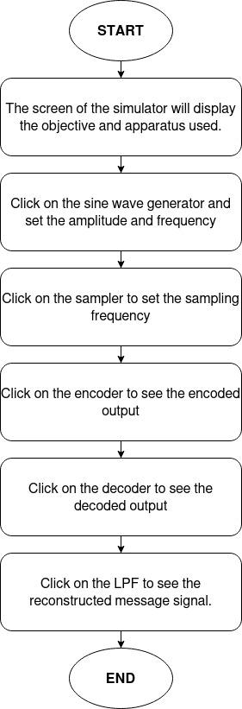

Mind map

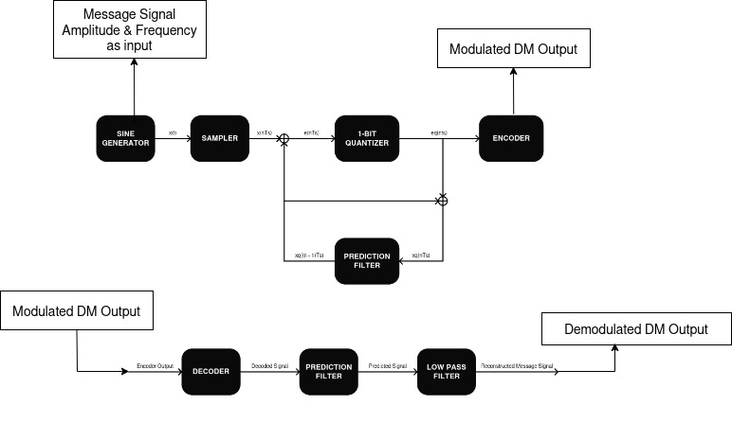

Storyboard:

**Aim:**

To study and understand the process of Quadrature phase shift keying Modulation/Demodulation scheme and calculate the bit error rate for the same using the **Virtual Labs Assessment Tool(V.L.A.T)**

**Equipment’s/Components Required:**

| **Name of equipment/component** | **Quantity required/used** |
| --- | --- |
| 1)Sine wave Generator block | 1 |
| 2) Sampler | 1 |
| 3) 1 Bit Quantizer | 1 |
| 4) Prediction filter | 2 |
| 5) Encoder | 1 |
| 6) Decoder | 1 |
| 7) Low pass filter | 1 |

**Step by Step Procedure to perform the experiment.**

1. **DM Modulation**

**Step1:** The user should Click on the theory under which the concept behind the working of the experiment would be displayed followed by the procedure which would be displayed on the screen, so that the user could perform the DM modulation and demodulation experiment based on the guidelines listed under the procedure.

**Step2:** The blocks required for the experiment are pre-connected . So , the user gets to have a view at the block diagram after reading the procedure.

**Step3:** Once the user performs Step 2, then the user could very well click on the input graph button . So that the user could adjust the amplitude , frequency , horizontal and vertical scales to get the required graph.

**Step4:** Once the user performs Step 3,**then the user has successfully performed the DM Modulation** and the **Figure-1** depicts the workspace to perform the experiment of **DM Modulation.**

**Workspace**

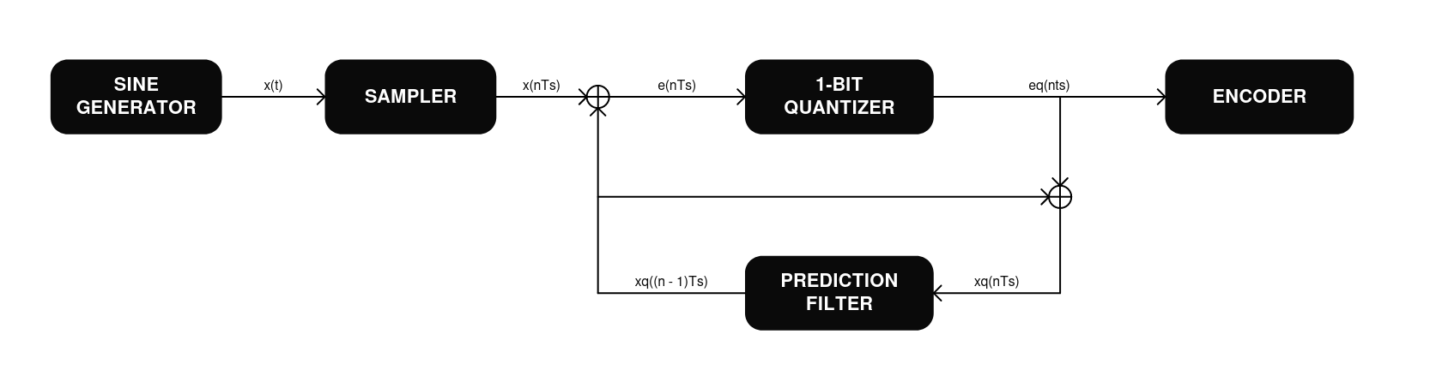

**Figure 1**

**B) DM Demodulation**

**Step1:**Once the user performs the **DM Modulation,** then the user would be redirected to a new page where the user would see the DM Demodulation / Receiver.

**Step2:** Once the user performs Step 1, then the user can then see the demodulation part of the DM experiment to carry out the demodulation whose blocks are pre-connected .

**Step3:** Once the user performs Step 2, then the user could simulate the DM demodulation i.e. click on the demodulated graph button ,once the Compilation of the design model is completed then the output process i.e., the extraction of the modulated signal from the modulating signal. Would be performed and the output which is the modulated signal (a.k.a message signal)

**Step4:** Once the user performs Step 3, **then the user has successfully performed the DM Demodulation. Figure-10** depicts the workspace to perform the experiment of **DM Demodulation.**

**Workspace  
Figure 2**