Northern Bukidnon State

College



**Design and Implementation of a Web**

**-**

**Based Office Decision Support**

**System for Public Employment Services Offices (PESO) In LGU of**

**Manolo Fortich**

A Capstone Project

Presented to the

Faculty of the College of Computer Studies

Northern Bukidnon State Coll

ege

In Partial Fulfillment

of the Requirements for the Degree

Bachelor of Science in Information Technology

By

Jhaisrhie P.

Emata

Joshua Rey G.

Sayagnon

Francis Xavier P.

Talipan

Sharlene L.

Zulita

November

2023

**CRISTINE JOY SAGAOSAO**

Northern Bukidnon State College

ii

**APPROVAL SHEET**

This Capstone Propo

sal entitled:

**“**

**Design and Implementation of a Web**

**-**

**Based Office Decision Support System for Public Employment Services**

**Offices (PESO) In LGU of Manolo Fortic**

**h**

**”**

is prepared and submitted by

**Jhaisrhie P. Emata, Francis Xavier P. Talipan, Sharlene L. Zulita**

an

d

**Joshua Rey G. Sayagnon**

in partial fulfillment of the requirements for the

degree of

**Bachelor of Science in Information Technology**

has been examined

and is

recommended for acceptance and approval.

Adviser

**PANEL OF EXAMINERS**

Appro

ved by the Committee on Final

Defense with a

grade of ____

__________ on

Novembe

r

_____, 2023.

**SHIE**

**LA MAE OROZCO**

**, MIT**

Chairman

**CHARLENE B. UNDAG**

Member

**ROLAND JUSTINE**

**M.**

**PARTOS**

Member

Approved and accepted in partial fulfillment of the requirements

for the degree

Bache

lor of Science in Information Technology.

**SH**

**IE**

**LA MAE OROZCO, MIT**

Program Head

|  |  |  |
| --- | --- | --- |
|  |  |  |
|  | Northern Bukidnon State College | iii |
|  | **ACKNOWLEDGMENT**    The researchers of this study would like to extend their immeasurable appreciation and deepest gratitude to the following persons who in one way or another have contributed in making this study possible.  First and foremost to **God Almighty**, for his immeasurable blessings and guidance throughout the study and for the wisdom ha have bestowed upon the researchers to complete the research successfully.  To the research adviser **Ms. Cristine Joy Sagaosao** for the unwavering support, guidance and word of encouragement. Her expertise and patience have been truly invaluable to the researchers and have played a crucial role in the success of this study.  To the **researcher’s parents** who have given their utmost sincerity and support financially and emotionally. This research paper stands as a tribute to their unwavering commitment to our education and personal growth. We are profoundly grateful for their love, guidance, and the values they instill in us, which continue to shape our academic and personal pursuits.  Lastly, the researcher would also like to extend their deepest gratitude to the **research participants** and **Manolo Fortich Public Employment Service**  **Office (PESO)** for without them this study wouldn’t be made possible.                  **The Reseachers** |  |
|  | |  |

|  |  |  |
| --- | --- | --- |
|  |  |  |
|  | Northern Bukidnon State College | iv |
|  | **ABSTRACT**  This project aims to develop the Management Information System with decision support system through Chrome based Local Network to assist the PESO OFFICE staff in managing and access available jobs for the Job-seekers in the Municipality of Manolo Fortich. The system is developed using PHP as programming language with Bootstrap5, CSS, HTML and JavaScript while the VScode as tool to develop the System. Through this system it can help to the office staff smooth process to provide services to the job-seekers. In fulfilling to refer the Job-seekers to have employment, livelihood and technical course offered.          **KEYWORDS:** Management Information System, Decision Support, Data Mining, Classification learning, Decision Tree algorithm. |  |
|  | |  |

|  |  |  |  |  |  |
| --- | --- | --- | --- | --- | --- |
|  |  |  | | |  |
|  |  | Northern Bukidnon State College | | | v |
|  |  | **TABLE OF CONTENTS** | **Page** | |  |
|  |  | **TITLE PAGE** | **i** | |  |
|  |  | **APPROVAL SHEET** | **ii** | |  |
|  |  | **ACKNOWLEDGMENT** | **iii** | |  |
|  |  | **ABSTRACT** |  | **iv** |  |
|  |  | **TABLE OF CONTENTS** |  | **v** |  |
|  |  | **LIST OF FIGURES** |  | **viii** |  |
|  |  | **LIST OF TABLES** |  | **ix** |  |
|  |  | **CHAPTER**   1. **THE RATIONALE**   **1**  1.1 Introduction |  | 1 |  |
|  |  | 1.2 Statement of the Problem |  | 3 |  |
|  |  | 1.3 Objectives of the Study 4  1.4 Scope and Limitations of the Study 5  1.5 Significance of the Study 6  1.6 Definition of Terms 7   1. **REVIEW OF RELATED LITERATURE AND STUDIES9**    1. Related Literature and Studies 9    2. Synthesis of the Reviewed Related Literature and Studies 16 | | |  |
|  | | | | |  |

|  |  |  |  |  |  |
| --- | --- | --- | --- | --- | --- |
|  |  | | |  |  |
|  |  | Northern Bukidnon State College | |  | vi |
|  |  | 1. **METHODOLOGY**    1. Research Design       1. Type of Research    2. Research Design Approach    3. Hardware and Software Specification       1. Hardware Development Specification       2. Software Development Specification       3. Hardware Deployment Specification    4. System Architecture    5. System Diagram    6. System Evaluation 2. **RESULTS AND DISCUSSIONS**     1. ISO Results    2. Overall Results 3. **SUMMARY OF FINDINGS,**   **RECOMMENDATION**   * 1. Summary of Findings   2. Conclusion   3. Recommendation   **APPENDICES**  **REFERENCES** | **17**  17  17  18  24  24  25  26  **CONCLUSION** | **AND** |  |
|  | | | |  |  |

|  |  |  |
| --- | --- | --- |
|  |  |  |
|  | Northern Bukidnon State College | vii |
|  | **LIST OF FIGURES**  Figures Title   1. Agile Development 2. System Design Architecture 3. Use Case Diagram 4. Entity-Relationship Diagram 5. Training and Briefing 6. Presentation Pictorials 7. Gathering of Feedback through Evaluation 8 Overall Quality Testing Graph |  |
|  | |  |

Northern Bukidnon State College



CHAPTER 1

**THE RATIONALE**

**1.1**

**Introduction**

The challenges for duty seekers to find employment that best

match their interests and skills. Ha

ving inaccurate information about the

organization's mission, workplace culture, and open positions is

challenging. Finding the right candidat

es with the required qualifications

to fill their existing job openings is also a crucial role for recruiters in

e

very company.

Based in

the Republic Act No. 8759, known as the PESO Act

of 1999. The Public Employment Services Office (PESO)

serves as

referral and information center for the various services and programs of

the Department of labor and Em

ployment (DOLE) and other government

agencies. The PESO is a non

-

free charging multi

-

employment service

facility or entity established or auth

orized. It accords to the Statistics, the

percentage of unemployed in the Philippines has dropped to 4.5 % in

Apri

l 2023, from 5.7 % in the same month last year. From the number of

unemployed persons in April 2023 composed of 2.26 million, it was down

by

506.20

thousand from the 2.76 million unemployed persons in April

2022

. At the same time, the employed person was

increased to 95.5 % in

April 2023, this was 94.3% in April 2022. In number of employed about

48.06

million from 45.63 million in the same peri

od of 2022.

In an era characterized by dynamic economic shifts and labor market

fluctuations, the role of public e

mployment services offices is more critical than

|  |  |  |
| --- | --- | --- |
|  |  |  |
|  | Northern Bukidnon State College |  |
|  | ever before. These organizations are tasked with the responsibility of facilitating employment opportunities for job seekers while assisting employers in their search for qualified talent. To meet these demands effectively, public employment services offices require innovative tools and systems that enhance their operational efficiency, improve decision-making processes, and streamline their interactions with job seekers and employers.  The proposed study is a Management Information System with decision Support System for PESO Manolo Fortich. Through the help of decision tree, the process or collection data based on the completion skills and experience result can determine and predict the job recommendation of the job seeker. In this paper, the proponents developed a Management  Information System with Decision Support System that aims to a user-friendly system to the public employment service office staff. This system has the capability to archive files, generate reports, and retrieve files, print documents and saved information to the job seekers and trainee.  **1.1 Statement of the Problem**  The study aims to create a management information system with a decision support system due to a major concern where the management of information in the PESO office that has impact the local government services.  Moreover, the study sought to answer the following:   * What are the effective features of the management information system? * How effective and functional is this web-based office decision support system? |  |
|  | |  |

|  |  |  |
| --- | --- | --- |
|  |  |  |
|  | Northern Bukidnon State College |  |
|  | **1.3 Objectives of the Study**  **General Objectives**  The general objective of the study is to create a management information system in the PESO office of Manolo Fortich with decision support system and adaptable and efficient system.  **Specific Objectives**   * Data gathering * Analyze data gathering * To design features of the system as to coit: DSS * To develop a fully functional management system. * Evaluate the performance of the system using ISO 25010 * Implement the management system in PESO LGU Manolo Fortich.   **1.4 Scope and Limitations of the Study**  This study mainly focuses on creating a system using the Google Chrome web browser, which is connected to a local server and uses the same network. Specifically, the system focuses on organizing files, and saving information on PESO and TESDA applicants. The study was conducted during the year 2023 starting on the month of June within the vicinity of  Tankulan, Manolo Fortich. The respondents are from Manolo Fortich Public Service Office (PESO) staff and applicants. The respondents are based only upon the criteria, given that must be qualified to atleast one of the following; (1) an applicant who have made transactions in PESO (2) a client who have utilized services offered by the PESO office (3) and client who voluntarily agreed to participate in the research. |  |
|  | |  |

|  |  |  |  |
| --- | --- | --- | --- |
|  |  |  |  |
|  |  | Northern Bukidnon State College |  |
|  |  | **1.5 Significance of the Study**  The study aims to develop a web-based office management system more specifically to be conducted at the Public Employment Service Office (PESO) Manolo Fortich Bukidnon. The results of this study will be beneficial to the following entities and institutions: (1) the Northern Bukidnon State College; (2) Publice Employment Service Office (3) the users; (4) to the researchers; (5) and to the future researchers.   * **To Northern Bukidnon State College (NBSC).**The study is beneficial to NBSC as this gives recognition to the institution for its influential findings. This will contribute to the instituition’s academic reputation and   supports further research initiatives.   * **To Public Employment Service Office (PESO)*.*** The result of this study has a significant contribution to organizing important activities within the office. Having a centralized platform for managing administrative tasks it increases and enhances efficiency and productivity. Moreover, it reduces manual effort and streamlines processes. This research is beneficial for better organization, accessibility of data, seamless communication, and eradicating data loss by ensuring data integrity. Overall, this research helps PESO staff improve organizational effectiveness. * **To the users**.The study’s results will be a great benefit to users, as they will experience satisfactory experience and hassle-free transactions due to its accessibility feature that enables them to have easy transactions. An office management system helps internal processes that enable employees to immediately respond to client queries more efficiently. It facilitates faster access to information and enables prompt, accurate responses, enhancing the overall customer service experience. |  |
|  | | |  |

|  |  |  |
| --- | --- | --- |
|  |  |  |
|  | Northern Bukidnon State College |  |
|  | * **To the researchers***.* This study is beneficial to the researcher by providing wider knowledge in developing beneficial programs for storing, sorting, and organizing data. This will enhance knowledge and skills to develop more efficient and sustainable advancement. * **Future researchers***.* The study’s result will serve as a crucial baseline for future researchers, offering them valuable data to delve deeper into developing a web-based office management system. Building upon these findings, future researchers can conduct more comprehensive, varied, and wide features of management systems, by providing a broader   understanding of the subject matter. Moreover, this will contribute to the advancement of knowledge in the field and promote an improvement to office tasks.    **1.6 Definition of Terms**  **Classification learning:** a learning scheme is presented with a set  of classified examples from which it is expected to learn a way of classifying unseen examples. In association learning, any association among features is sought, not just ones that predict a particular class value.  **Data mining*:*** the process of searching and analyzing a large batch  of raw data in order to identify patterns and extract useful information.  **Decision support system (DSS):** differentiated into active and passive  models. In which passive models collects the information and organize those in an effective manner and it do not provide any suggestions or decisions from the collected information. In case of active decision support system, it collects and process the information to produce solutions and strategies. On the other, |  |
|  | |  |

|  |  |  |
| --- | --- | --- |
|  |  |  |
|  | Northern Bukidnon State College |  |
|  | cooperative decision support collects and analyze the data and along with human interaction it refines the solutions to obtain best strategies.  **Decision tree algorithm*:*** a machine learning algorithm that uses a  decision tree to make predictions. It follows a tree-like model of decisions and their possible consequences. The algorithm works by recursively splitting the data into subsets based on the most significant feature at each node of the tree.  **E-office:** was a term coined to cover the increasing use of computer-based  information technology for office work.  **Management information system (MIS):** a computer system consisting  of hardware and software that serves as the backbone of an organization's operations. An MIS gathers data from multiple online systems, analyzes the information, and reports data to aid in management decision-making.  **Public Employment Service Office (PESO):** According to the Republic Act No. 8759, popularly known as the PESO Act of 1999. The PESO aims to ensure prompt and efficient delivery of employment facilitation services as well as to provide timely information on labor market and DOLE Programs. A non-fee charging multi-service facility that is established to provide employment information and assistance to the Department of Labor and Employment (DOLE) clients and constituents of Local Government Units (LGU).  **User authentication:** provides access control for systems by checking  to see if a user's credentials match the credentials in a database of authorized users or in a data authentication server. In doing this, authentication assures secure systems, secure processes and enterprise information security. |  |
|  | |  |

|  |  |  |
| --- | --- | --- |
|  |  |  |
|  | Northern Bukidnon State College |  |
|  | CHAPTER 2  **REVIEW OF RELATED LITERATURE AND STUDIES**  **2.1 Related Literature and Studies**  For a more comprehensive comprehension of the study, the researchers utilized relevant published literature that is indispensable in expanding the understanding of the proponents. These materials will also function as a compass in attaining their desired goals by consulting other related research and enhancing them as feasible.  Based on study of IOP Conference Series: Materials Science and Engineering the effectiveness of the E-office system aims to create a paperless office environment, improving data processing efficiency and search capabilities. The development process involved analyzing software requirements, maturing concepts, system development with PHP and MySQL, and conducting alpha and beta testing. The system was found to be feasible and can be used effectively by the Vocational school of Diponegoro University. Technology and Vocational Education, Univeristas  Negeri Padang Developed E-Office Information System in Administration Faculty of Engineering. The web-based information system Minimized of errors and difficulties in data management. Convenient to operate, low cost, high efficiency Improves office information management system efficiency  Technology and Vocational Education, Univeristas Negeri Padang  Developed E-Office Information System in Administration Faculty of Engineering. The web-based information system Minimized of errors and difficulties in data management. Convenient to operate, low cost, high |  |
|  | |  |

|  |  |  |
| --- | --- | --- |
|  |  |  |
|  | Northern Bukidnon State College |  |
|  | efficiency Improves office information management system efficiency (Sabrina et al. 2022).  On the other hand, in the office administration technology skills are crucial in the 21st century, especially in vocational schools. These skills include the use of information technology, media, and applications for office or administrative activities. Vocational schools are expected to provide education and training in electronic archiving, digitalization of offices, and the use of office machines and equipment. The acquisition of both hard and soft skills is necessary for effective performance in modern offices (Lestari and Aulia 2018).  In addition, office management in educational institutions involves the planning, organizing, directing, and controlling of various functions and processes within the institution. It aims to support employees in carrying out their work effectively and efficiently. The implementation of project management offices (PMOs) can greatly improve the methodology and management tools used in educational institutions. Automation of office management functions can simplify complex duties and improve the quality of services delivered by educational institutions. Best practices in office automation, such as record keeping, filing systems, and the use of network and computer technology, contribute to the efficiency and image of an institution (Arif Prastiawan et al. 2019).  In the University of Raharja, Management Information Systems on Integrated Student and Lecturer Data is developed. This said systems aim to provide accurate, transparent, and accountable information to |  |
|  | |  |

|  |  |  |
| --- | --- | --- |
|  |  |  |
|  | Northern Bukidnon State College |  |
|  | support academic affairs in universities. They enable the design and implementation of data management information systems, allowing for the improvement or replacement of outdated systems. The student information management system is a web-based self-service environment that facilitates the management of student data and provides services for students, faculty, staff, and administration. It allows for the entry of student test scores, scheduling, attendance tracking, and other student-related data needs. The implementation of student information systems has been successful in improving student discipline and achieving target participation in student activities. These systems also fulfill the desired database model, including student profiles, lecturer profiles, schedules, and academic and nonacademic achievements. The use of student information management systems ensures the accuracy, efficiency, and security of student data (Hendriyati et al. 2022).  Moreover, management Information Sytem and Decision was the subject of a study by University Of Mumbai, Mumbai, Maharashtra, India. The Management information system refers to a system that offers information assistance for decision-making in an organization. In accordance with the Management Information Systems Institute's definition, a management information system (MIS) is a computer-based system that integrates human and machine intelligence in order to deliver information to support an organization's operations, management, and decision-making activities. The successes in the other field, which is DSS, the virtual office, and knowledge-based systems, are facilitated by the |  |
|  | |  |

|  |  |  |
| --- | --- | --- |
|  |  |  |
|  | Northern Bukidnon State College |  |
|  | achievements in MIS. The fundamental concept underlying management information systems (MIS) is to ensure that management has a constant supply of information. Following that, choices are made based on the facts and information collected from the MIS. the importance of information in decision-making. Effective decision-making requires the availability of reliable, timely, and relevant information (Thorat 2019).  Another study from Computer Science and Engineering  Department, Amrita School of Engineering, Coimbatore, TamilNadu, India.  The Data Mining Based Marketing Decision Support System Using Hybrid Machine Learning Algorithm defind the Decision support system in educational institutions helps to obtain details about student details. Based on prediction it could define the students count for the upcoming year. Depends upon the results, institutions plan and process the student enrolment (Dr. T. Senthil Kumar 2020).  Based on the study of Kushagra Institute of Information and Management Science, BPUT, India. the effectiveness of web-based decision support systems using thin-client in business companies. The results of the study show that web-based DSS processes provide essential information and help managers make effective decisions for the companies. However, the lack of effective skills among the employees is one of the biggest reasons for the failure of using web-based DSS processes. The study Suggests that business companies should arrange training programs for the employees to enhance their technological and computer skills. and provides |  |
|  | |  |

|  |  |  |
| --- | --- | --- |
|  |  |  |
|  | Northern Bukidnon State College |  |
|  | insights into the importance of web-based decision support systems using thin-client in business companies (Das 2022).  According to Roza Dastres (2021), Decision making in today's complex world has become a challenge for managers and organizations. Therefore, decision-making processes to choose the right alternatives from the available options are an integral part of rational processes in human daily life. Moreover, today, with the explosive development of communication technologies and, consequently, the increasing growth of access to information, and as a result, faced with various options and selection criteria, decision making processes have become more complex. When choosing an option from multiple options, decision makers often consider several criteria at the same time. Criteria are sometimes aligned and sometimes reciprocal. Classic models of operations research such as linear programming, integer programming, nonlinear programming, and the like are decision models that perform optimization based on only one criterion (Dastres et al. 2021).  Another study from IT Department, Technical College of Informatics Akre, Duhok Polytechnic University, Duhok, Kurdistan Region, Iraq. Nowadays, technology has developed a lot, especially in the field of Machine Learning (ML), which is useful for reducing human work. In the field of artificial intelligence, ML integrates statistics and computer science to build algorithms that get more efficient when they are subject to relevant data rather than being given specific instructions. Besides speech recognition, image detection, text localization, etc. In this paper, a |  |
|  | |  |

|  |  |  |
| --- | --- | --- |
|  |  |  |
|  | Northern Bukidnon State College |  |
|  | comprehensive review is performed for the latest and most efficient approaches that have been performed by researchers in the past three years about decision trees in different areas of machine learning. Also, the details of this method, such as using algorithms/approaches, datasets, and the findings achieved are summarized. In addition, this study highlighted the most commonly used approaches and the highest accuracy methods achieved. Decision tree classification algorithms consist of several types that are used to generate DT. This is by the control of both the continuous and periodic attributes of the missing values. DT is generated by a form that is typically represented as a statistical classifier and can be used for clustering. Nodes and branches are included in the DT. Each node requires problems that are based on one or more properties, i.e. comparing an attribute value with a constant or using other functions to compare more than one property (Charbuty and Abdulazeez 2021).  Another study from Malaysia-Japan International Institute of Technology. Machine learning techniques have been used to develop multi class prediction models for student grade prediction. These models aim to improve the accuracy and performance of predicting student grades in educational institutions. Various machine learning algorithms such as  Decision Tree, Support Vector Machine, Naive Bayes, K-Nearest Neighbor, Logistic Regression, and Random Forest have been compared to determine their accuracy in predicting student grades. Additionally, the importance of building interpret able models for educational data mining tasks has been highlighted, with a proposed framework based on optimal |  |
|  | |  |

|  |  |  |
| --- | --- | --- |
|  |  |  |
|  | Northern Bukidnon State College |  |
|  | rule-list mining algorithm showing higher prediction and interpret ability values compared to black-box models. Hybrid algorithms, such as the weighted voting classifier in conjunction with other machine learning algorithms, have also been used to predict student grades with high accuracy and identify students' performance levels (Bujang et al. 2021).  Another study through machine leaning techniques the idea underlying machine learning is that we give a computer program access to lots of data and let it learn about relationships between variables and make predictions. Some of the techniques of machine learning date back to the 1950s but improvements in computer speeds and data storage costs have now made machine learning a practical too. New terminology: features, labels, activation functions, target, bias, supervised/unsupervised learning and Develop different models using the training set and compare them using the validation set (Hull 2018).  **2.2 Synthesis of the Reviewed Related Literature and Studies**  The above connected literature demonstrated that the present investigation, despite its similarities with other systems, prioritized the identification of research gaps to generate inventive concepts. Consequently, the suggested system possesses an advantage over previous studies concerning Management Information System and Decision Support System.  The above studies had a significant impact on the development of the essential features of the management information system, including the decision support system. There are supporting studies that stated the E-office |  |
|  | |  |

|  |  |  |
| --- | --- | --- |
|  |  |  |
|  | Northern Bukidnon State College |  |
|  | systems aim to create a paperless office environment, improve data processing efficiency, and enhance administrative activities. Vocational schools should provide education and training in electronic archiving, digitization, and office automation. Several studies with the used Web-based information systems minimize errors and difficulties in data management, making them convenient, low-cost, and high-efficiency. From different perspective by recommending Decision support systems specifically decision tree it help to obtain prediction and determined from data information where used to classify and process. |  |
|  | |  |

|  |  |  |
| --- | --- | --- |
|  |  |  |
|  | Northern Bukidnon State College |  |
|  | CHAPTER 3  **METHODOLOGY**    **3.1 Research Design**  3.1.1 Type of Research  This research study used a developmental research design. Developmental research is described as “the systematic study of designing, developing and evaluating instructional programs, processes, and product that must meet the criteria of internal consistency and effectiveness” (Seels and Richey 1994). This approach utilized the proponents made use of developmental type due to its main objective wherein to develop a Management information system with decision support system for Manolo Fortich.  **3.2 Research Design Approach**  In this study, the researcher used Agile Methodology to enable the researchers for functional collaboration and continuous improvement.  This method follows six fundamental phases, namely: planning, requirements analysis, design, coding, unit testing and acceptance from the client (Anon 2023). |  |
|  | |  |

Source:

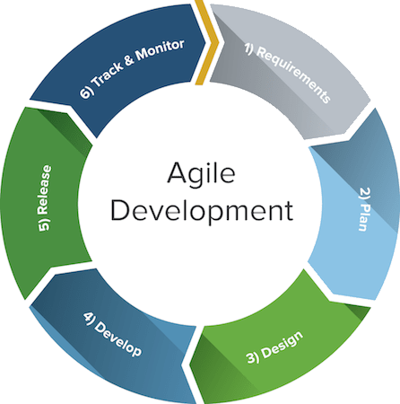

Figure 1. Agile Development

**Requirement Analysis**

Before the proponents began creating the proposed project, they made sure to create all the necessary documentation, which make sure understood exactly what the project needed. This meant carefully reviewed and analyzed all the requirements, including the most important variables for the study. Software development initiated from gathering the necessary requirements needed to meet the set objective. Interview was one of the most important means in data gathering for the system requirements.

|  |  |
| --- | --- |
| **Components** | **Recommended Specifications** |
| Hard disk Drive / SSD | 20GB |
| Memory (RAM) | 2GB |
| Monitor | Directx9, 10 24x768 res. or higher |
| Processor | 1.6GHZ |
| Database | phpMyAdmin version 5.1 or higher as handler of MySQL |
| Operating System | Windows 7 or Higher |
| Programming Lauguage | PHP with HTML, CSS, and  JavaScript |

Consultation to programming experts was also done for programming language suggestion that can be used. Table 1 shows the hardware ans software requirements or more recommended specifications.

**Table 1.** Hardware and Software Requirements

*.*

# Planning

The Gantt chart is so helpful because it clearly shows all the important steps to took during the development of the study. The proponents started with gathering information, which is super important because it helps us understand the purpose and benefits of the project.

Figure 3. Gantt chart

**Design**

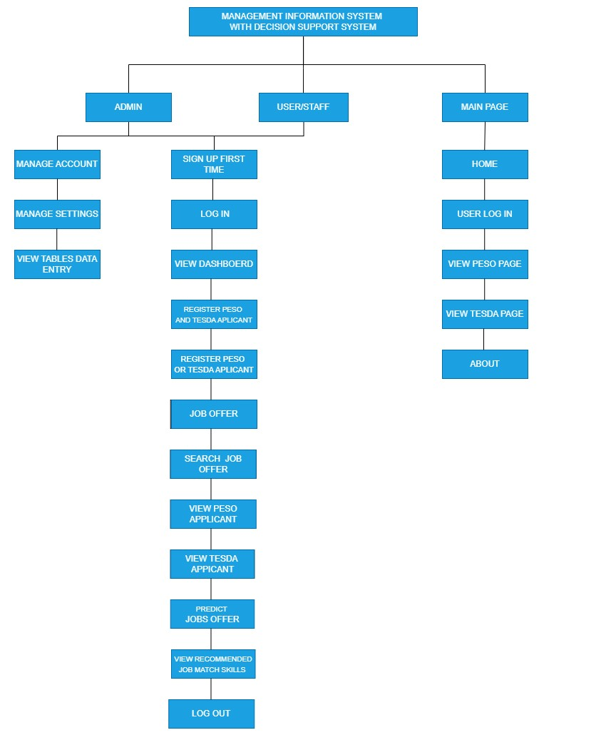

In this phase, the researcher specified the languages used such as PHP, CCS, HTML, JavaScript and VScode. Also, this phase integrates the following

System architecture diagram, activity diagram and flow chart.

Figure 4 shows the interface of the system perspective.

Figure 4. System Design Architecture

Figure 5.

Design Arc

hitecture (local network

)

Figure 5. It shows the walk in applicant to the user or staff and the network process,

where in it

how interconnected to the local network storage.

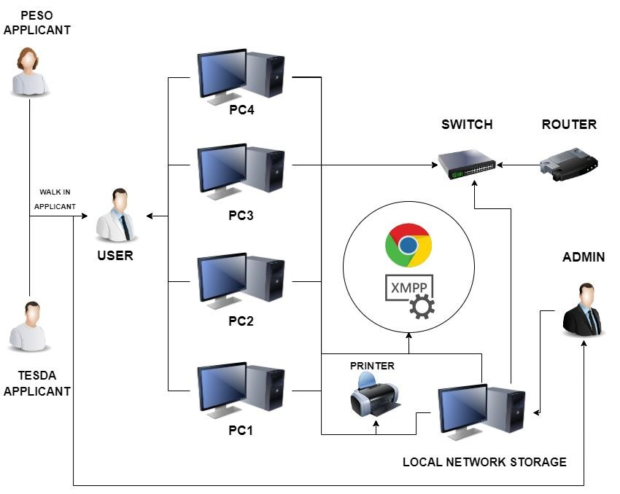

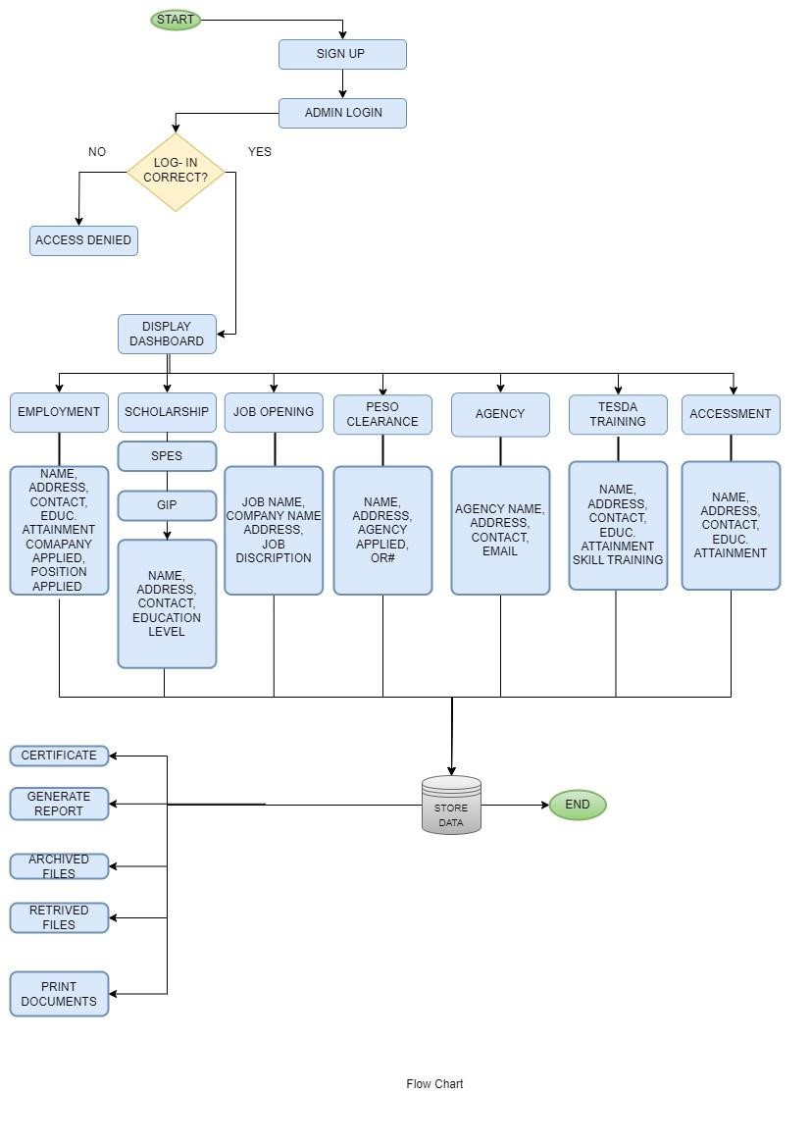

Figure 6. Flow Chart Diagram

It shows the whole process of the applicant/job-seekers and user or staff.

Figure 6. Flow Chart Diagram

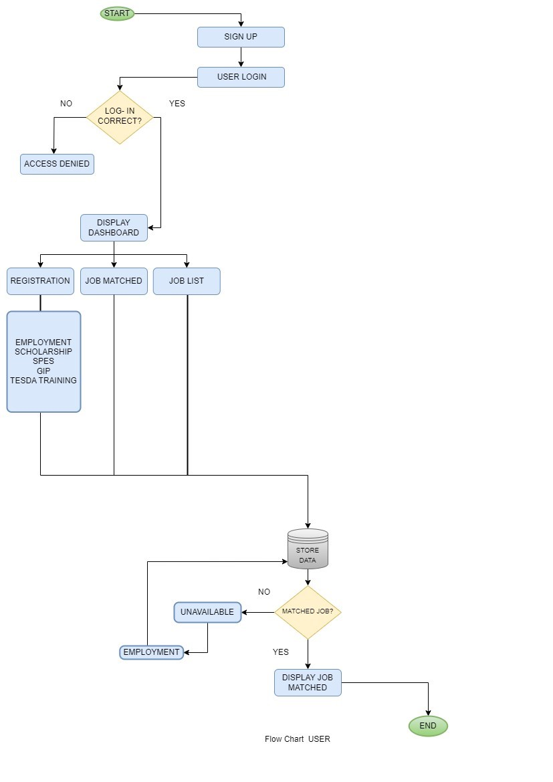

It shows the whole process of the applicant/job-seekers and user or staff.

Figure 7. Usecase Diagram

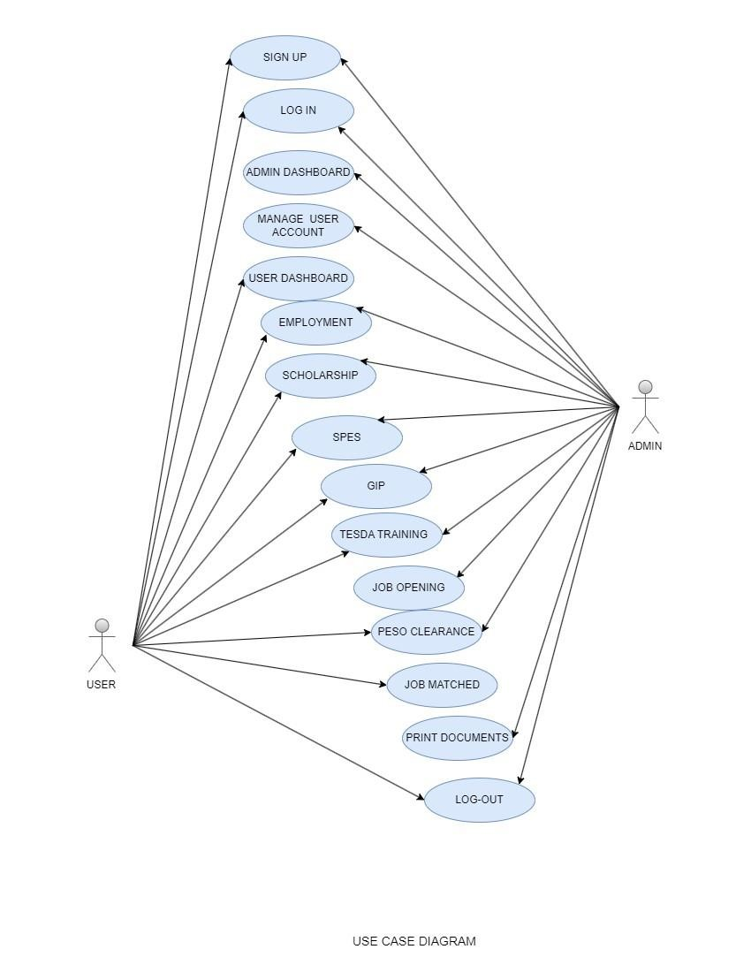

It shows the behavior and visualize the different role of the system.

**Source: (**Hull, John C. 2018)

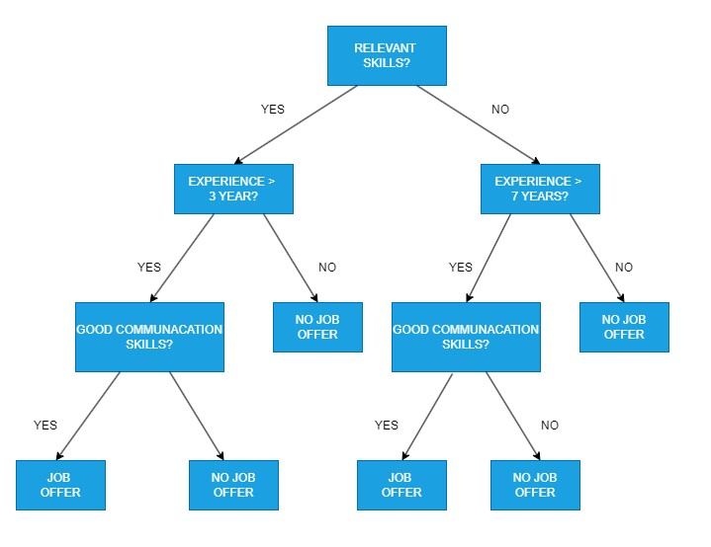

Figure 8. Propose Decision Tree

It shows how to predict a job offer or recommendation determine through the use of

decision tree.

**Development Phase**

This phase includes the actual develop

ment of the project proposed. The

proponents used the programming languages such as PHP, CSS, HTML, JavaScript

and VScode which is the development environment. Also, XAMMP is used

as a

local server of the said System proposed.

Figure 9. It shows the graphical representation and relationship with in the system.

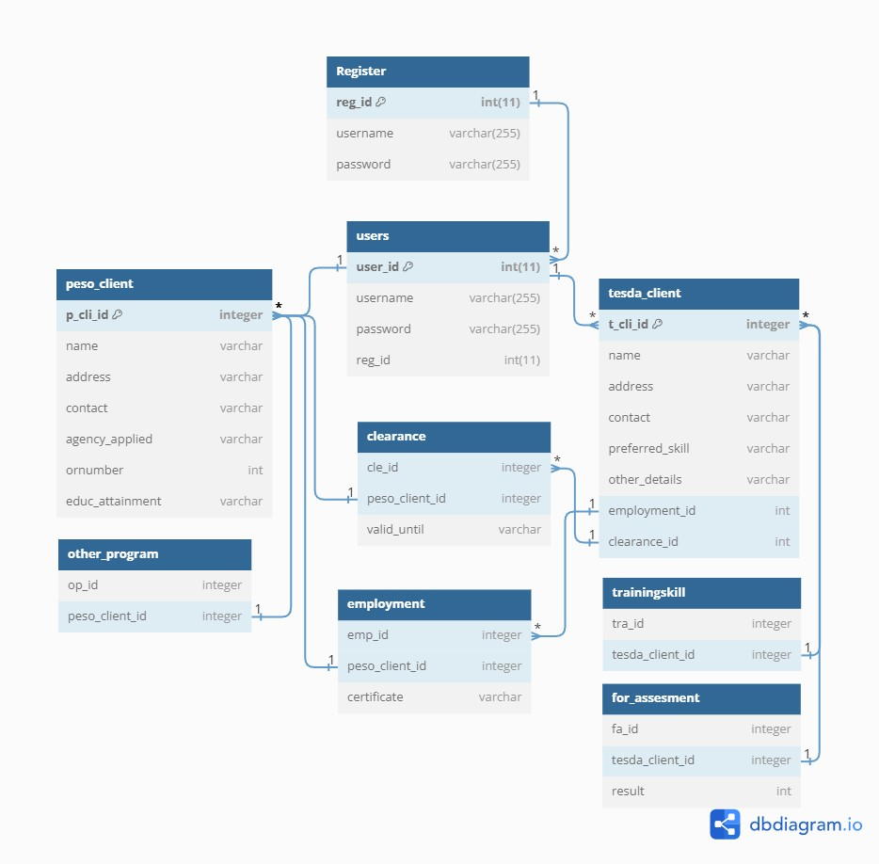

|  |  |  |
| --- | --- | --- |
|  |  |  |
|  | Northern Bukidnon State College |  |
|  | **Testing Phase**  After the development of the software, project testing is done to evaluate its functionality. During this phase, the researchers examine its performance, noting any bugs or defects that need to be tracked, fixed, and later tested. This step assesses the system’s usability and readiness for deployment at the PESO office.  **Deployment**  After testing, finally, the researchers present the overall project output to the mentioned organization for approval through a presentation and actual system demonstration. The software is available to launch and available to end-users and trained the user.  **3.3 Hardware and Software Specification**  The following are the hardware and software specifications of the project. These were requirements for the implementation and design of the application.  3.3.1 Hardware Specification for Development  The table shown below reflects the hardware components of the project during the development phase of the researchers. |  |
|  | |  |

|  |  |
| --- | --- |
| **SOFTWARE** | **SPECIFICATION** |
| Visual Studio code Version: 1.79.2 | a streamlined code editor with  support for development  operations like debugging, task running, and version control. It aims to provide just the tools a developer needs for a quick code-build-debug cycle and leaves more complex workflows to fuller featured IDEs, such as  Visual Studio IDE. |
| XAMPP version x64-8.1.6-0-vs16 | stands for Cross-Platform, Apache, MySQL, PHP, and  Perl, with the Ps standing for PHP and Perl, respectively. It's an open-source web-solutions kit that provides Apache  delivery for a variety of servers and command-line executable, as well as Apache api, MariaDB, PHP, and Perl  modules |

**Hardware Development Specification**

|  |  |  |  |  |  |  |  |  |  |  |  |  |  |  |  |  |  |  |  |
| --- | --- | --- | --- | --- | --- | --- | --- | --- | --- | --- | --- | --- | --- | --- | --- | --- | --- | --- | --- |
|  | |  |  | | --- | --- | | **HARDWARE** | **SPECIFICATION** | | Motherboard | A320M PRO-VH (MS-7C52)  (AM4) | | Powersupply | 700 watts | | CPU | AMD Ryzen 3 3200G | | RAM | 16.0GB Dual-Channel DDR4  (20-19-19-43) | | Storage | 223GB BR 240G (SATA  (SSD)  465GB Hitachi  HCS5C1050CLA382 (SATA) | | Dual Monitor | 18” 1440 x 900  16” 1366 x 768 | | Keyboard | Wired keyboard | | Mouse | Wired mouse | |

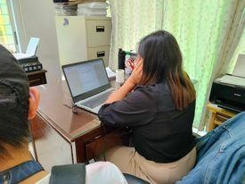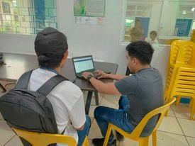

**3.6**

**System**

**Evaluation**

**Deployment**

The developers implemented the following procedures once

the applica

tion was prepared for deployment.

**Training and Briefing**

During the presentation, developers initiat

ed a training and

briefing process for the user. The developers showcased the website to the

client to ensure their underst

anding of its functions

and on how they will

used

as it presented to Figure 8.

# Pictorials

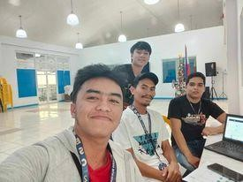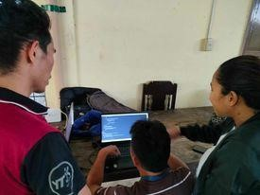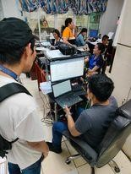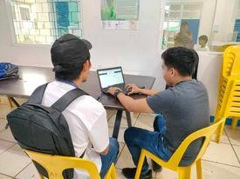

# Evaluation

After the presentation, the developers engaged in visual documentation on consulting the system to the PESO Office as illustrated in figure 9.

|  |  |  |  |  |  |
| --- | --- | --- | --- | --- | --- |
|  |  | | | |  |
|  | Northern Bukidnon State College | | | |  |
|  | Figure 10. **Gathering of Feedback through Evaluation**    The Evaluation phase aim to assess user feedback and ensure the quality of the final output. To conduct the system evaluation, ISO/IEC 25010 standards were applied to assess the system`s performance. The developer`s gathered 10 respondents to test the website and collect their feedback through a research instrument designed for this purpose. The data gathered was analyzed using likert scale.    **3.6.1 Evaluation Tool**  The system performance is evaluated to determine is compliance with ISO/IEC 25010 standards.    Table 6. **Likert Scale Table** | | | |  |
| **SCALE** | **PARAMETERS** | **VERBAL INTERPRETATION** |  |
| 5 | 5 | Excellent |
| 4 | 4 | Very Good |
| 3 | 3 | Good |
| 2 | 2 | Fair |
| 1 | 1 | Poor |
| A likert scale is widely used method for collecting data on people`s attitudes, opinions, or perceptions. It consist of a series of statements or questions to which respondents indicate their responses to evaluate questions. The developers used the likert scale to interpret the result and overall average of the ISO/IEC 25010 evaluation.    **Formula:**    Total Average = Overall Averag number of questioned item | | |
|  | | | | |  |

|  |  |  |  |  |  |  |  |
| --- | --- | --- | --- | --- | --- | --- | --- |
| CHARACTERISTICS | SUB-  CHARACTERISTICS | QUESTION | POOR | FAIR | GOOD | VERY GOOD | EXCELLENT |
| FUNCTIONALITY | Completeness | Does the system has complete features? |  |  |  |  |  |
|  | Correctness | Does the system provide correct information and function appropriately when use? |  |  |  |  |  |
|  | Appropriateness | Are the systems functionally and features  appropriate to use? |  |  |  |  |  |
| RELIABILITY | Maturity | Does the system meet the needs for  reliability under normal operation? |  |  |  |  |  |
|  | Availability | Is the system reliable and convenient to use when needed? |  |  |  |  |  |
|  | Fault Tolerance | Does the system still function despite encountering some errors when used? |  |  |  |  |  |
|  | Recoverability | Can the system recover data in the event of a failure? |  |  |  |  |  |
| USABILITY | Appropriateness recognizability | Is the system appropriate  for your needs? |  |  |  |  |  |
|  | Learnability | Is the system easy to learn? |  |  |  |  |  |
|  | Operability | Is the system easy to use? |  |  |  |  |  |
|  | Use error protection | Does the system prevent users from making errors? |  |  |  |  |  |
|  | User Interface aesthetic | Is the system design appropriate and user friendly? |  |  |  |  |  |
|  | Accessibility | Is it possible for people with a diverse set of |  |  |  |  |  |

# Table 7. ISO/IEC 25010 Survey Test

Name: __________________________________________

ISO IEC 25010 SURVEY

|  |  |  |  |  |  |  |  |
| --- | --- | --- | --- | --- | --- | --- | --- |
|  |  | characteristics and abilities to use the system? |  |  |  |  |  |
| EFFICIENCY | Time behavior | Does the system perform the task in a timely manner? |  |  |  |  |  |
|  | Capability | Does the system meet the expected requirements? |  |  |  |  |  |
|  | Resource utilization | Does the.  amount and type of resources of the system when performing functions meet requirements? |  |  |  |  |  |
| MAINTAINABILITY | Modularity | Does the changes in the system  component  not affect other components? |  |  |  |  |  |
|  | Reusability | Can the system be used by  different department and agencies? |  |  |  |  |  |
|  | Analyzability | Does the system provide analytical reports such as errors and records? |  |  |  |  |  |
|  | Modifiability | Can the system be easily modified without affecting other components? |  |  |  |  |  |

|  |  |  |  |  |  |  |  |
| --- | --- | --- | --- | --- | --- | --- | --- |
|  | Testability | Does the system effectively efficiently meet the test criteria? |  |  |  |  |  |
| PORTABILITY | Adaptability | Does the system have the capacity to adapt to changes? |  |  |  |  |  |
|  | Install ability | Can the system be easily installed and uninstalled? |  |  |  |  |  |

|  |  |  |  |  |  |  |  |  |  |  |  |  |  |  |  |  |  |  |  |  |  |  |  |  |  |  |  |  |  |  |  |  |  |  |  |  |  |  |  |  |  |  |  |  |  |  |  |  |  |  |  |  |  |  |  |  |  |
| --- | --- | --- | --- | --- | --- | --- | --- | --- | --- | --- | --- | --- | --- | --- | --- | --- | --- | --- | --- | --- | --- | --- | --- | --- | --- | --- | --- | --- | --- | --- | --- | --- | --- | --- | --- | --- | --- | --- | --- | --- | --- | --- | --- | --- | --- | --- | --- | --- | --- | --- | --- | --- | --- | --- | --- | --- | --- |
|  | |  |  |  |  |  |  |  |  | | --- | --- | --- | --- | --- | --- | --- | --- | |  | Replaceability | Can the system be easily replaced by a new system in the same environment? |  |  |  |  |  | | COMPATIBILITY | Co- existence | Does the system perform functions without affecting other records and components? |  |  |  |  |  | |  | Interoperability | Does the system allow one to exchange information from one device to another and use that information? |  |  |  |  |  | | SECURITY | Confidentiality | Does the system protect user information and only allow authorized  people to use it? |  |  |  |  |  | |  | Integrity | Does the system prevent unauthorized access? |  |  |  |  |  | |  | Non- repudiation | Does the system provide information that an action  has taken place? |  |  |  |  |  | |  | Accountability | Can the system track entity actions? |  |  |  |  |  | |

|  |  |  |  |
| --- | --- | --- | --- |
| **Characteristics** | **Sub- Characteristics** | **Mean** | **Verbal Interpretation** |
| Functionality | Functional  Completeness | 3.8 | Very Good |
| Functional  Correctness | 3.6 | Very Good |
| Functional  Appropriateness | 3.6 | Very Good |
| Weighted Mean | | 3.6 | Very Good |

# RESULTS AND DISCUSSION

The Design and Implementation of a Web-Based Office Decision Support

System for Public Employment Services Offices (PESO) In LGU of Manolo Fortich produced data in this chapter that was organized and easily accessible. The Results will be discussed in detail to support the stated objective's outcome.

**4.1 ISO RESULTS**

# Table 5: Functional Suitability

The table 5 displays the results of the system's functional suitability. Based on the verbal interpretation of the PESO, the result received a weighted mean of 3.6, indicating that the user satisfied with the application's functioning.

|  |  |  |  |
| --- | --- | --- | --- |
| **Characteristics** | **Sub- Characteristics** | **Mean** | **Verbal Interpretation** |
| Efficiency | Time Behavior | 3.6 | Very Good |
| Capacity | 3.5 | Good |
| Resource Utilization | 3.4 | Good |
| Weighted Mean | | 3.5 | Good |

|  |  |  |  |
| --- | --- | --- | --- |
| **Characteristics** | **Sub- Characteristics** | **Mean** | **Verbal Interpretation** |
| Compatibility | Co-existence | 3.5 | Good |
| Interoperability | 3.4 | Good |
| Weighted Mean | | 3.4 | Good |

# Table 6: Performance Efficiency

The table 6 displays the results of the system's Performance Efficiency. Based on the verbal interpretation of the Likert Scale, the result received a weighted mean of 3.5, indicating that the user satisfied with the application's functioning.

# Table 7: Compatibility

|  |  |  |  |
| --- | --- | --- | --- |
| **Characteristics** | **Sub- Characteristics** | **Mean** | **Verbal Interpretation** |
| Usability | 1. Appropriateness  Recognisability | 3.7 | Very Good |
| 2. Learnability | 3.7 | Very Good |
| 3. Operability | 3.7 | Very Good |
| 4. User Error  Protection | 3.6 | Very Good |
| 5. User Interface  Aesthetics | 3.4 | Good |
| 6. Accessibility | 3.3 | Good |
| Weighted Mean | | 3.5 | Good |

The table 7 shows the results on the Functional Compatibility of the system. The result got the weighted mean of 3.4 which means that the user considered it is a satisfied to the functionality of the application based on the Likert Scale verbal interpretation.

Table 8: **Usability**

|  |  |  |  |
| --- | --- | --- | --- |
| **Characteristics** | **Sub- Characteristics** | **Mean** | **Verbal Interpretation** |
| Relialibity | Maturity | 3.6 | Very Good |
| Availability | 3.6 | Very Good |
| Fault  Tolerance | 3.6 | Very Good |
| Recoverability | 3.3 | Good |
| Weighted Mean | | 3.5 | Good |

|  |  |  |  |
| --- | --- | --- | --- |
| **Characteristics** | **Sub- Characteristics** | **Mean** | **Verbal Interpretation** |
| Security | Confidentiality | 3.7 | Very Good |
| Integrity | 3.4 | Good |
| Non-  repudiation | 3.3 | Good |
| Accountability | 3.4 | Good |
|  |  |  |

# Table 9: Reliability

The table 9 shows the result on the Reliability of the system. The result of the study showed a weighted mean of 3.5, showing that the users considered the Web-based verbal interpretation was reliable.

Table 10: **Security**

|  |  |  |
| --- | --- | --- |
| Weighted Mean | 3.4 | Good |

|  |  |  |  |
| --- | --- | --- | --- |
| **Characteristics** | **Sub- Characteristics** | **Mean** | **Verbal Interpretation** |
| Maintainability | 1. Modularity | 3.5 | Good |
| 2. Reusability | 3.6 | Very Good |
| 3. Analysability | 3.4 | Good |
| 4. Modifiability | 3.7 | Very Good |
| 5. Testability | 3.6 | Very Good |
| Weighted Mean | | 3.5 | Good |

The table 10 shows the result of the Security of the system. The result of the study had a weighted mean of 3.4, indicating that the users are Strongly Agreed with theWeb-based security based on verbal interpretation of the likert scale

# Table 11: Maintainability

The table 11 shows the Maintainability of the system. The result got the weighted mean of 3.5 which means that the users considered it as strongly agreed to the maintainability of the Web-based on Likert Scale verbal interpretation.

|  |  |  |  |
| --- | --- | --- | --- |
| **Characteristics** | **Sub- Characteristics** | **Mean** | **Verbal Interpretation** |
| Portability | Adaptibility | 3.5 | Good |
| Installability | 3.7 | Very Good |
| Replaceability | 3.5 | Good |
| Weighted Mean | | 3.5 | Good |

# Table 12: Portability

The table 12 shows the result on the Portability of the system. The result achieved a weighted mean of 3.5, reflecting that the users agreed on the Webbased accessibility based on Likert Scale verbal description.

|  |  |  |
| --- | --- | --- |
|  |  |  |
|  | Northern Bukidnon State College |  |
|  | Figure 6: **Overall Quality Testing Graph**    The graph of the Overall Quality Testing presented on the ISO/ISE 25010 evaluation is shown in Figure 6, which concludes that the feedback received during the actual presentation was positive. As a result, the respondents found that the Design and Implementation of a Web-Based Office Decision Support System for Public Employment Services Offices (PESO) In LGU of Manolo Fortich met the expectations, as evidenced by the overall average satisfaction rating of 3.9 or evaluation to "Very Good." |  |
|  | |  |



CHAPTER 5

**SUMMAR**

**Y OF FINDINGS,**

**CONCLUSIONS AND RECOMMENDATIO**

**NS**

This Chapter summarizes the findings of the study and provides conclusions

and recommendation on the

Design and Implementation of a Web

-

Based Office

Decision Support System for Public Employment Services

Offices (PESO) In

LGU of Manolo Fortich

.

**5.**

**1**

**Summary of Findings**

The study designed and developed the Public Employment Service Office

(

PESO). The respondents of the study were 10 workers from PESO. The

developers designed the necessary for the develo

pment through the Entity

-

Relationship Diagram

that provided functional view of the system to easily see

or to find the names or the employers in PESO because their main problem is

they cannot easily find their records. The developed system was commended by

the employers of the PESO using ISO/IEC 2501

0

. The result of the survey or

the performance efficiency is 3.9 which the system is Good to them.

Northern Bukidnon State College

**5.2**

**Conclusion**

The design and development of Public Employment Service

Office (PESO) has

effectively gathered the necessary software reso

urces

and it can be used in their office especially the printing of clearance and

adding data in the system. The feedback is indicative of its acceptance

among the user aligning well with the ISO/IEC 25010.

The information from the user is not only to

input data but also

to input if there is an opening or hiring job and if there is a company contact

them that there is a slot for job

Implement advanced job

-

matching

algorithms that consider job seekers' ski

lls, qualifications, and preferences

to increase

the likelihood of successful placements.

|  |  |  |
| --- | --- | --- |
|  |  |  |
|  | Northern Bukidnon State College |  |
|  | **5.3 Recommendation**  Based on the findings and conclusions, it is recommended to the future developer develop the assigned job matched so that they can easily find the best job for the jobseeker. But the client can use it using mobile phone if they are not in their office they can access it to just typing the ip address in the google and they want to enter an employee that finding a job. The Design and Implementation of a Web-Based Office Decision Support System for Public Employment Services Offices (PESO) In LGU of Manolo Fortich, not only for promoting it but also make it easier to fill up or manage the employee and the scholars. But also, the PESO Implement advanced job-matching algorithms that consider job seekers' skills, qualifications, and preferences to increase the likelihood of successful placements. |  |
|  | |  |

Northern Bukidnon State College



**Appendices**

Figure

__

Request Letter

|  |  |  |
| --- | --- | --- |
|  |  |  |
|  | Northern Bukidnon State College |  |
|  | **References:**  Anon. 2023. “Agile One-stop Project Management Resource | Smartsheet”.. Retrieved July 16, 2023 (https://www.smartsheet.com/everything-you-needto-know-about-agile-project-management).  Arif Prastiawan, Arif, Arif Prastiawan, Imam Gunawan, Arda Purnama Putra, Ence Surahman, Dimas Arif Dewantoro, Puri Selfi Cholifah, and Ni Luh Sakinah  Nuraini. 2019. “Office Management of Educational Institutions: Theories and Applications.” 382(Icet):758–62. doi: 10.2991/icet-19.2019.181.  Bujang, Siti Dianah Abdul, Ali Selamat, Roliana Ibrahim, Ondrej Krejcar, Enrique  Herrera-Viedma, Hamido Fujita, and Nor Azura Md Ghani. 2021. “Multiclass  Prediction Model for Student Grade Prediction Using Machine Learning.” *IEEE Access* 9:95608–21. doi: 10.1109/ACCESS.2021.3093563.  Charbuty, Bahzad, and Adnan Abdulazeez. 2021. “Classification Based on Decision  Tree Algorithm for Machine Learning.” *Journal of Applied Science and Technology Trends* 2(01):20–28. doi: 10.38094/jastt20165.  Das, Abinash. 2022. “Effectiveness of Web-Based Decision Making to Deliver  Decision-Support Information to Business Analyst Using a ’Thin-Client.” *Technoarete Transactions on Advances in Data Science and Analytics* 1(1). doi: 10.36647/ttadsa/01.01.a001.  Dastres, Roza, Mohsen Soori, Web-based Decision Support, and Systems  International. 2021. “Advances in Web-Based Decision Support Systems To Cite This Version : HAL Id : Hal-03367778 Advances in Web-Based Decision  Support Systems.”  Dr. T. Senthil Kumar. 2020. “Data Mining Based Marketing Decision Support  System Using Hybrid Machine Learning Algorithm.” *Journal of Artificial*  *Intelligence and Capsule Networks* 2(3):185–93. doi: |  |
|  | |  |

|  |  |  |
| --- | --- | --- |
|  |  |  |
|  | Northern Bukidnon State College |  |
|  | 10.36548//jaicn.2020.3.006.  Hendriyati, Penny, Farida Agustin, Untung Rahardja, and Tarisya Ramadhan. 2022.  “Management Information Systems on Integrated Student and Lecturer Data.”  *APTISI Transactions on Management (ATM)* 6(1):1–9. doi:  10.33050/atm.v6i1.1527.  Hull, John C. 2018. “05. Machine Learning in Business.” *Rotmanmagazine.Ca* 1–6.  Lestari, Hanisa Sismaya, and Mia Aulia. 2018. “Office Administration Technology Skill of Vocational School on the 21st Century.” *IJIE (Indonesian Journal of Informatics Education)* 2(1):7. doi: 10.20961/ijie.v2i1.21640.  Sabrina, Elsa, Dedy Irfan, and Asrul Huda. 2022. “Development of E-Office  Information System in Administration Faculty of Engineering, State  University of Padang.” *Jurnal Paedagogy* 9(3):364. doi:  10.33394/jp.v9i3.5313.  Subari, A., S. Manan, and E. Ariyanto. 2020. “Design of E-Office System in Vocational School Diponegoro University Using Code Igniter Framework.” *IOP Conference Series: Materials Science and Engineering* 801(1). doi: 10.1088/1757-899X/801/1/012141.  Technology, Information. 2018. “Web Based Office Management System for PABX Division Sri Lanka Telecom PLC A Dissertation Submitted for the Degree of  Master of Information Technology.”  Thorat, Pritam. 2019. “Management Information Systems and Corporate Decision– Making.” *International Journal of Innovative Technology and Exploring Engineering* 9(2S4):205–7. doi: 10.35940/ijitee.b1117.1292s419. |  |
|  | |  |

|  |  |  |
| --- | --- | --- |
|  |  |  |
|  | Northern Bukidnon State College |  |
|  |  |  |
|  | |  |