Jal Rakshak: AI-Powered Smart Irrigation System
(13 size) A Project Based Learning Report Submitted in partial fulfilment of the requirements for the award of the degree

of

Bachelor of Technology
in The Department of Electronics and Communication Engineering
Project Based Learning (PBL)

Submitted by
Roll.no: SAYAK DARA 2510040014
Roll.no: MANAS KUMAR 2510040121

Under the guidance of
Faculty Guide: Dr A Bhuvaneshwari Sudhakar/ Dr Sanjay / Mrs Madhavi



Department of Electronics and Communication Engineering
Koneru Lakshmaiah Education Foundation, Aziz Nagar
Aziz Nagar – 500075
OCTOBER - 2026.

ABSTRACT
Water is an essential but limited resource in agriculture. Conventional irrigation practices often depend on fixed schedules or manual observation, which can lead to unnecessary watering, delayed irrigation, and inefficient use of available water. Jal Rakshak is a proposed AI-assisted smart irrigation system that combines soil-moisture information, water availability, and weather forecasts to provide clear irrigation recommendations through a web dashboard. The system architecture uses an ESP32 and soil-moisture sensor for field data acquisition, a Python FastAPI backend for communication and validation, a rule-based irrigation engine for decisions and safety checks, Ollama with a local language model to explain recommendations, Open-Meteo for forecast information, SQLite for storing readings and recommendations, and a React + Vite interface for monitoring. A key design principle is that deterministic rules—not the language model—make the irrigation decision; the AI agent explains the decision in natural language. The project presentation demonstrates the dashboard using simulated values, including an example soil-moisture reading of 22% and water availability of 80%, with rain expected. These values are illustrative rather than field measurements. Initial test scenarios cover dry soil, wet soil, expected rainfall, and insufficient water. The modular design is intended to support later integration of physical sensors and automated irrigation control. Actual water savings, crop yield improvements, and field performance must be measured during future physical testing.

LIST OF FIGURES
Figure 1. Proposed Jal Rakshak system architecture.
Figure 2. Irrigation recommendation workflow.
Figure 3. Example dashboard inputs and decision scenario (simulated values).

LIST OF TABLES
Table 1. Technology stack and component responsibilities.
Table 2. Initial irrigation test scenarios and expected behaviour.
Table 3. Staged implementation and validation plan.

TABLE OF CONTENTS
Abstract
List of Figures
List of Tables
1. Introduction
2. Methodology
3. Experiments and Test Scenarios
4. Results and Discussion
5. Conclusion and Future Work
References

JAL RAKSHAK: AI-POWERED SMART IRRIGATION SYSTEM

1. INTRODUCTION
Agriculture depends on reliable water management, yet irrigation decisions are frequently made using fixed schedules or visual inspection. Such approaches may apply water when the soil is already sufficiently moist or fail to provide water when crops need it. Unnecessary irrigation can waste water and energy, while delayed irrigation can place crops under water stress. Smart irrigation aims to make watering decisions more responsive to field conditions by combining sensor measurements, weather information, and suitable decision logic.
Internet of Things (IoT) technology enables field sensors and embedded devices to send environmental information to a monitoring application. Soil-moisture sensors provide an indication of water present in the root-zone soil. Weather forecasts add context because expected rainfall may make immediate irrigation unnecessary. Water-availability information is also important: a system should not recommend operating a pump when the available supply is inadequate. Research reviews describe IoT sensing, weather data, and data-driven methods as important directions for improving irrigation management [1]–[4]. However, sensor calibration, connectivity, crop-specific thresholds, and local soil conditions remain important practical considerations.
The project, Jal Rakshak, is designed as an AI-assisted irrigation advisory system. Its objective is to combine soil moisture, water availability, and forecast conditions and present an understandable recommendation on a web dashboard. The planned hardware path uses an ESP32 development board and a soil-moisture sensor. The software path uses a FastAPI backend, a Python rule-based irrigation engine, an Ollama-hosted local language model, a React + Vite dashboard, the Open-Meteo weather service, and SQLite storage. The system is modular so that simulated values can be replaced by sensor readings as hardware integration is completed.
A central design decision is to separate decision-making from explanation. The irrigation engine applies explicit rules and safety checks; the language model does not independently calculate the required irrigation. The AI agent coordinates the information and explains the rule-based result in natural language. This separation is intended to make the recommendation easier to inspect and test. The current project presentation identifies the React dashboard with clearly labelled simulated readings as the demonstration component and describes backend, AI, weather, and ESP32 integration as planned or not yet complete at the review stage. Therefore, this report does not claim that field trials or quantified water savings have already been achieved.
The main objectives are: (i) to monitor and display soil-moisture and water-availability values; (ii) to consider weather forecasts when generating an irrigation recommendation; (iii) to apply consistent rules and safety checks; (iv) to explain recommendations in accessible language; (v) to record readings and recommendations for later review; and (vi) to provide a staged path from simulated demonstration to physical sensor integration and, subject to further development, automated control.
The scope of the present design is an irrigation decision-support prototype. Final thresholds must be selected according to crop type, soil type, growth stage, local climate, sensor calibration, and field conditions. Recommendations from the prototype should be validated before they are used to control real irrigation equipment.

2. METHODOLOGY

2.1 System Overview
Jal Rakshak follows a modular data flow. Soil-moisture and water-availability values are collected from sensors or supplied as clearly labelled simulated inputs. The ESP32 is the planned edge device for sensor acquisition. A FastAPI backend receives and validates the data and coordinates the irrigation engine and external weather source. The rule-based engine evaluates the input conditions and produces a recommendation. Ollama with a local language model then generates a natural-language explanation based on the rule result and supporting inputs. Readings and recommendations are intended to be stored in SQLite and displayed through the React + Vite dashboard.
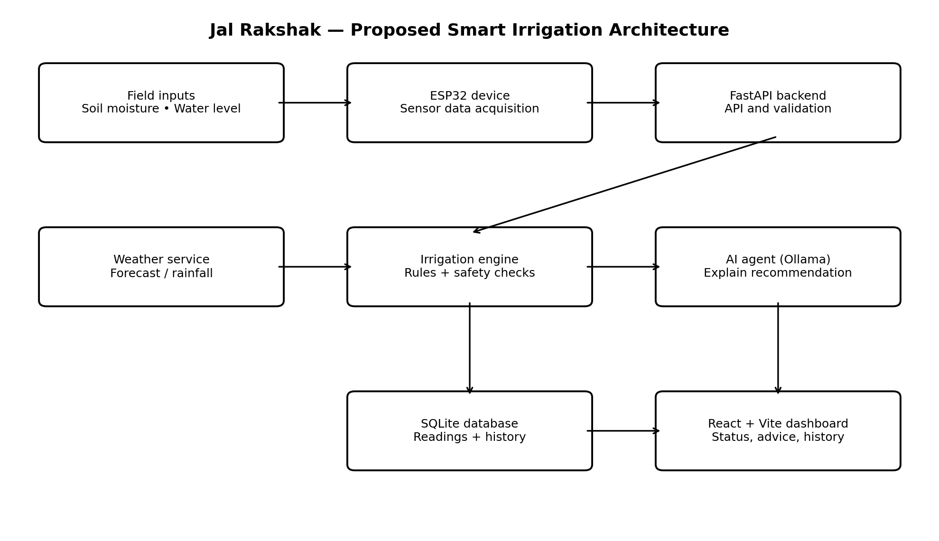
Figure 1. Proposed Jal Rakshak system architecture. Components marked as planned require integration and testing.

2.2 Hardware Components
The planned hardware consists of an ESP32 development board and a soil-moisture sensor. The ESP32 provides a Wi-Fi-capable controller for reading sensor values and communicating with the backend. A sensor output must be calibrated against the soil and installation conditions before its raw reading is treated as a meaningful moisture percentage. Water-level or water-availability input can be represented by a suitable sensor or entered as a test value in the prototype. Sensor wiring, voltage compatibility, grounding, and safe power arrangements must be checked before physical deployment.

2.3 Software Components
Component | Technology | Purpose / status
Frontend | React + Vite | Interactive dashboard; the presentation identifies a dashboard demo with simulated readings.
Backend | Python + FastAPI | Planned API and application logic for transferring and validating data.
Decision engine | Python rule-based logic | Applies irrigation conditions and safety checks; intended to determine the recommendation.
AI explanation | Ollama + local LLM | Planned natural-language explanation of the rule-based result.
Weather | Open-Meteo | Planned forecast integration to consider expected rainfall.
Database | SQLite | Planned storage of sensor readings and recommendations.
Hardware | ESP32 + soil-moisture sensor | Planned physical sensor integration to replace simulated inputs.

Table 1. Technology stack and component responsibilities.

2.4 Irrigation Decision Logic
The decision engine evaluates soil moisture, water availability, and forecast conditions. The initial design follows these principles: (i) when soil moisture is low and water is sufficient, irrigation may be recommended if significant rain is not expected; (ii) when soil moisture is low but heavy rain is expected, irrigation may be delayed and the reason displayed; (iii) when soil moisture is already high, unnecessary irrigation should be avoided; and (iv) when water availability is insufficient, the system should warn the user rather than recommend irrigation. These are initial rules for testing, not universal agricultural thresholds. Crop- and location-specific settings must be introduced before real-world use.
The language model is used to explain the engine's output, not to override the rules. For example, if the rule engine identifies low soil moisture but the weather service indicates expected rainfall, the dashboard may display a recommendation to delay irrigation and explain that rain is forecast. The example values in the presentation—22% soil moisture and 80% water availability—are simulated values and are used only to illustrate the interface and reasoning flow.

2.5 Data Storage and Dashboard
The dashboard is intended to show current soil moisture, water availability, forecast information, the irrigation recommendation, and a history of previous readings and recommendations. SQLite is selected as a lightweight database for prototype history. Data records should include a timestamp, input values, forecast context, decision outcome, and explanation so that recommendations can be traced and reviewed. Simulated readings should be visibly labelled to prevent them from being mistaken for live field data.

2.6 Implementation Plan
Stage | Task | Validation focus
1 | Build React dashboard | Display moisture and water availability with clear simulated-data labels.
2 | Develop FastAPI backend | Check data transfer, input validation, and API responses.
3 | Implement irrigation rules | Verify repeatable decisions for dry soil, wet soil, rain, and low water.
4 | Integrate Ollama | Ensure explanations match the rule engine's decision.
5 | Integrate Open-Meteo | Handle forecast data, missing responses, and expected rainfall.
6 | Add SQLite history | Confirm readings and recommendations can be stored and retrieved.
7 | Integrate ESP32 and sensor | Calibrate and compare sensor readings with reference observations.
8 | Test combined system | Check end-to-end behaviour and document failures or limitations.

Table 3. Staged implementation and validation plan.

3. EXPERIMENTS AND TEST SCENARIOS
The experiments are designed to verify that the decision rules respond consistently to different input combinations. The project presentation provides initial scenarios rather than completed field-test results. The expected behaviours below define how the prototype should respond when the corresponding inputs are supplied. Tests should first be run with simulated data and then repeated with calibrated hardware readings once integration is complete.
Test | Soil moisture | Water availability | Weather | Expected behaviour
1 | Low | Sufficient | No rain expected | Consider recommending irrigation, subject to crop-specific thresholds.
2 | Low | Sufficient | Heavy rain expected | Consider delaying irrigation and explain the forecast-based reason.
3 | High | Sufficient | No rain expected | Avoid unnecessary irrigation.
4 | Low | Insufficient | No rain expected | Show a warning that available water is inadequate.

Table 2. Initial irrigation test scenarios and expected behaviour.

3.1 Example Scenario
In the illustrative scenario shown in the project presentation, soil moisture is 22%, water availability is 80%, and rain is forecast. The expected advisory is to consider delaying irrigation because rainfall is expected. The displayed percentages are simulated demonstration values; they are not measurements collected from an agricultural field and should not be interpreted as validated thresholds.
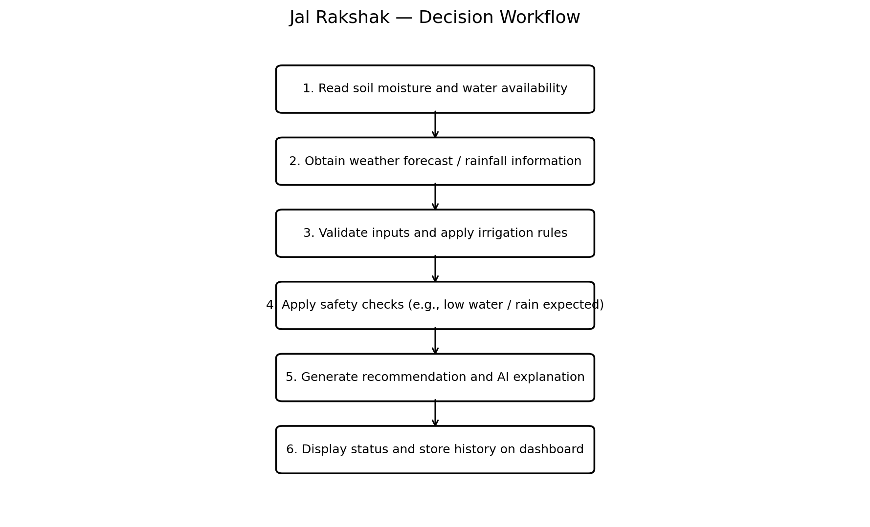
Figure 2. Irrigation recommendation workflow.

3.2 Evaluation Procedure
Set the input values for one test case and label them as simulated if they do not come from physical sensors.
Confirm that the backend receives valid values and handles missing or invalid inputs safely.
Run the rule-based engine and record the recommendation it returns.
Check that the AI-generated explanation agrees with the engine's result and does not invent sensor readings.
Confirm that the dashboard shows the inputs, weather context, recommendation, and appropriate warning.
Verify that the reading and recommendation are stored in the history database when that integration is enabled.
Repeat all four test scenarios and record pass/fail observations before reporting performance.

4. RESULTS AND DISCUSSION
The project presentation describes a staged prototype and explicitly distinguishes the current dashboard demonstration from components planned for later integration. The demonstrated dashboard uses clearly labelled simulated readings. Its example interface shows soil moisture of 22%, water availability of 80%, a rain forecast, and an advisory to delay irrigation because rain is expected. This example illustrates the intended user experience and the role of weather context; it is not evidence of live sensor operation or measured water savings.
The proposed architecture provides a clear separation between data acquisition, decision rules, AI explanation, storage, and presentation. This modular structure should make it possible to test the irrigation engine independently from the user interface and to replace simulated data with ESP32 sensor readings without redesigning the entire application. The rule-first approach also provides a way to audit why a recommendation was made. The language model can improve readability, but its explanation should remain grounded in the engine's output and validated inputs.
The initial test matrix covers four important cases: dry soil with adequate water and no expected rain; dry soil with rain expected; already-wet soil; and inadequate water availability. These cases represent expected behaviour to be verified, not completed experimental findings. Quantitative metrics such as decision accuracy, sensor error, response time, water consumed, and water saved have not been established in the supplied presentation. They should be measured during subsequent testing against a defined baseline, using calibrated sensors and repeated trials.
Important limitations include the use of simulated inputs in the current demonstration, the need for sensor calibration, dependence on weather-service availability, the need to determine local crop-specific thresholds, and the absence of reported field-trial measurements. Before connecting a pump or valve, the implementation should include fail-safe behaviour, manual override, electrical protection, and tests for sensor disconnection, low water, network failure, and stale weather data.

4.1 Suggested Performance Measures
Measure | How it should be evaluated
Sensor reliability | Compare sensor readings with reference measurements over multiple soil conditions.
Decision consistency | Run the same test case repeatedly and check whether the rule engine returns the same outcome.
Forecast handling | Test expected rain, no rain, unavailable forecast, and stale forecast responses.
System response time | Measure time from valid input submission to dashboard recommendation.
Water-use comparison | In a controlled trial, compare water used by the prototype strategy against a defined conventional schedule.
Safety behaviour | Verify that insufficient water, invalid readings, or disconnected sensors do not trigger unsafe control.

5. CONCLUSION AND FUTURE WORK
Jal Rakshak proposes a smart irrigation advisory system that combines soil moisture, water availability, and weather information to support more informed watering decisions. Its architecture integrates an ESP32-based sensing path, a FastAPI backend, a rule-based irrigation engine, Ollama for natural-language explanations, Open-Meteo for forecast data, SQLite for history, and a React + Vite dashboard. The key design principle is that explicit rules and safety checks determine the recommendation, while the AI agent explains it. The supplied presentation demonstrates the dashboard with simulated readings and defines initial test scenarios; it does not establish field performance or quantified water savings.
Future work includes completing the backend and API, integrating the local language model and weather service, implementing database history, and replacing simulated readings with calibrated ESP32 sensor data. The next phase should add crop-specific and soil-specific thresholds, validate moisture measurements, and test the system across varied weather and water-availability conditions. After software-only testing, a controlled physical trial can measure decision consistency, response time, sensor reliability, and water use. Automated pump or valve control should be added only after safety checks, manual override, electrical protection, and fail-safe behaviour are validated. Longer-term improvements may include multiple sensor nodes, crop growth-stage information, historical trend analysis, and carefully evaluated predictive models.
In conclusion, Jal Rakshak is intended to turn sensor and weather information into transparent irrigation advice through a user-friendly interface. Its effectiveness must be demonstrated through implementation, calibration, and controlled field evaluation before claims about resource savings or agricultural outcomes can be made.
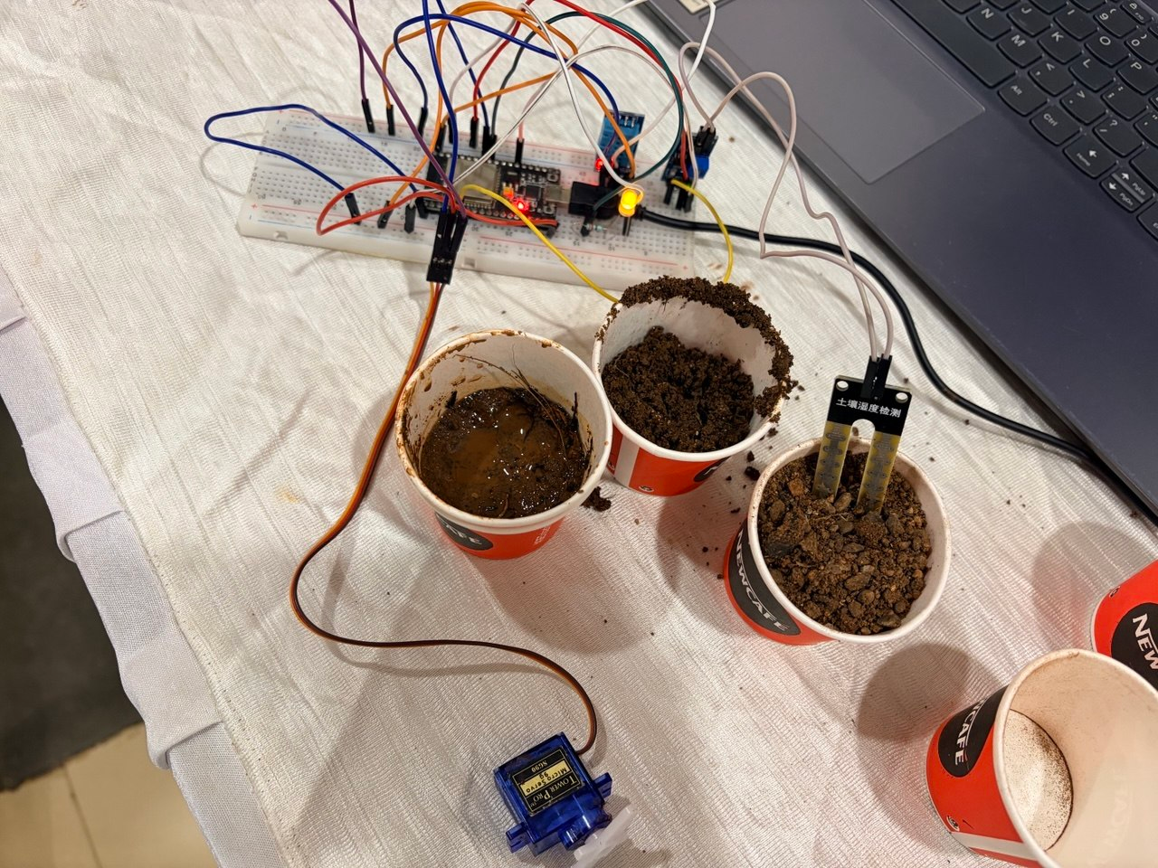

REFERENCES
- [1] “IoT and ML-based automatic irrigation system for smart agriculture system,” Agronomy Journal, vol. 116, no. 3, pp. 1187–1203, first published 25 March 2023. doi: 10.1002/agj2.21344.
- [2] “Smart Irrigation System Using Internet of Things,” IEEE conference publication, 2019. doi: 10.1109/ICSEngT.2019.8906497.
- [3] “A Systematic Review and Meta-Analysis of Intelligent Irrigation Systems,” IEEE Access, vol. 12, pp. 128285–128304, 2024. doi: 10.1109/ACCESS.2024.3421322.
- [4] “Development of a Wireless Sensor Network and IoT-based Smart Irrigation System,” Applied and Environmental Soil Science, 2022. doi: 10.1155/2022/7678570.
- [5] “Study and Development of IOT based Smart Irrigation System using Soil Moisture and Weather Prediction,” International Journal for Research in Applied Science and Engineering Technology, 2023. doi: 10.22214/ijraset.2023.50948.
- [6] Open-Meteo, “Weather Forecast API,” documentation. Available: https://open-meteo.com/. Accessed 23 October 2026.
- [7] Ollama, “Get up and running with large language models locally,” documentation. Available: https://ollama.com/. Accessed 23 October 2026.
- [8] FastAPI, “FastAPI documentation.” Available: https://fastapi.tiangolo.com/. Accessed 23 October 2026.
- [9] React, “React documentation.” Available: https://react.dev/. Accessed 23 October 2026.
- [10] SQLite, “SQLite documentation.” Available: https://www.sqlite.org/docs.html. Accessed 23 October 2026.

