CHAPTER 1 - INTRODUCTION
1.1 Background
Modern universities require reliable, scalable, and secure communication networks to support academic, administrative, and research activities. A campus network connects multiple departments, laboratories, faculty offices, libraries, and administrative blocks while enabling efficient sharing of information and network resources. As educational institutions continue to adopt digital learning platforms, centralized servers, and cloud-based services, a well-designed network infrastructure becomes essential for ensuring seamless communication and uninterrupted access to services.
This project presents the design and simulation of a University Campus Networking System using Cisco Packet Tracer. The proposed network integrates multiple campus buildings, a remote branch campus, and a cloud network into a unified enterprise-style architecture. The design emphasizes scalability, efficient traffic management, and reliable communication through the implementation of industry-standard networking technologies.

1.2 Problem Statement
Educational institutions often consist of multiple departments that generate significant network traffic while requiring secure and organized communication. A flat network architecture can lead to excessive broadcast traffic, poor performance, limited scalability, and difficulty in network management.
The challenge addressed in this project is to design a structured campus network capable of:
- Connecting multiple departments through logical network segmentation.
- Enabling communication between the Main Campus, Branch Campus, and Cloud Network.
- Providing centralized network services such as DHCP, DNS, FTP, HTTP, and Email.
- Supporting efficient routing between different network segments.
- Ensuring reliable communication while maintaining a scalable architecture.

1.3 Project Objectives
The primary objectives of this project are:
- Design an enterprise-style university campus network using Cisco Packet Tracer.
- Implement VLAN-based network segmentation for different university departments.
- Configure Router-on-a-Stick architecture for inter-VLAN communication.
- Establish communication between the Main Campus, Branch Campus, and Cloud Network using RIP Version 2 dynamic routing.
- Deploy centralized network services including DHCP, DNS, Web Server, FTP Server, and Email Server.
- Verify end-to-end connectivity through network testing and service validation.
- Develop a scalable network design that can be extended to accommodate future requirements.

1.4 Project Scope
The scope of this project includes the design, implementation, and simulation of an enterprise campus network that supports both academic and administrative activities. The implemented network consists of:
- A Main Campus containing multiple departmental VLANs.
- A Branch Campus connected through a WAN link.
- A Cloud Network hosting centralized services.
- Three Cisco 2911 routers for inter-network communication.
- Layer-3 switches and access switches for VLAN implementation.
- Dynamic routing using RIP Version 2.
- Network services including DHCP, DNS, FTP, HTTP, and Email.
- End-to-end communication between all network devices and users.
The project is implemented entirely within the Cisco Packet Tracer simulation environment and focuses on demonstrating practical networking concepts commonly used in enterprise networks.

1.5 Key Features
The proposed University Campus Networking System incorporates several enterprise networking technologies:
- VLAN-based segmentation of university departments.
- Router-on-a-Stick architecture for inter-VLAN routing.
- Dynamic routing using RIP Version 2.
- Automatic IP address allocation using DHCP.
- Internal DNS-based hostname resolution.
- Centralized Web, FTP, and Email servers.
- WAN connectivity between Main Campus, Branch Campus, and Cloud Network.
- Network verification through connectivity and application-level testing.

1.6 Software and Hardware Requirements
Software
Component | Version
Cisco Packet Tracer | 8.2.2
Operating System | Windows 10/11
GitHub | Repository Hosting
Hardware (Simulated)
Device | Quantity
Cisco 2911 Routers | 3
Layer-3 Switches | 2
Access Switches | 10
Servers (DNS, Web, FTP, Email) | 4
End Devices (PCs, Printers, Laptops) | Multiple

1.7 Document Organization
This document is organized into the following chapters:
- Chapter 1: Introduction
- Chapter 2: Network Overview and Architecture
- Chapter 3: Network Design and Implementation
- Chapter 4: Routing and Switching Configuration
- Chapter 5: Network Services
- Chapter 6: Testing and Validation
- Chapter 7: Results and Discussion
- Chapter 8: Future Enhancements
- Chapter 9: Conclusion

CHAPTER 2 - NETWORK OVERVIEW AND ARCHITECTURE
2.1 Network Overview
The University Campus Networking System is designed as a multi-site enterprise network that connects the Main Campus, Branch Campus, and Cloud Network into a single communication infrastructure. The network supports various academic and administrative departments through logical segmentation using Virtual Local Area Networks (VLANs), enabling efficient communication, improved network performance, and simplified management.
The architecture provides secure and reliable connectivity between users, servers, and network devices while supporting essential services such as dynamic IP address allocation, domain name resolution, web hosting, file transfer, and email communication.
The entire network is simulated using Cisco Packet Tracer 8.2.2, allowing the implementation and validation of real-world networking concepts within a virtual environment.

2.2 Network Architecture
The network follows a hierarchical architecture consisting of three major sections:
Main Campus
The Main Campus serves as the central communication hub of the university network. It accommodates multiple academic and administrative departments, each assigned to a dedicated VLAN for logical network segmentation. The Main Campus Router performs inter-VLAN routing using the Router-on-a-Stick architecture and maintains communication with both the Cloud Router and the Branch Campus Router.
The departments connected within the Main Campus include:
- Administration
- Human Resources
- Finance
- Business
- Electronics & Communication Engineering
- Academic Department
- Student Department
- Information Technology Department

Branch Campus
The Branch Campus represents a remote university facility connected to the Main Campus through a Wide Area Network (WAN) serial link. It provides network connectivity for staff offices and student laboratories while maintaining full communication with resources located in the Main Campus.
The Branch Campus includes:
- Staff Department
- Student Laboratory
The Branch Campus Router exchanges routing information with the Main Campus Router using RIP Version 2, enabling transparent communication between both campuses.

Cloud Network
The Cloud Network represents the external service infrastructure connected to the university network. It acts as an intermediary network that hosts centralized services and enables communication between the university network and external resources.
The Cloud Router establishes WAN connectivity with the Main Campus Router and provides access to centralized network services.

2.3 Network Components
The network infrastructure consists of the following major devices:
Component | Description
Cisco 2911 Routers | Provide inter-network routing between campuses and cloud network.
Layer-3 Switches | Support VLAN implementation and trunk connectivity.
Access Switches | Connect end-user devices within individual departments.
Servers | Provide DHCP, DNS, HTTP, FTP, and Email services.
End Devices | Desktop computers, laptops, and printers used by university users.

2.4 Logical Network Design
The university network is logically divided into multiple VLANs, with each department assigned to an independent broadcast domain. This approach reduces unnecessary broadcast traffic, improves network performance, enhances security, and simplifies network administration.
Communication between different VLANs is achieved through Router-on-a-Stick inter-VLAN routing implemented on the Main Campus Router and Branch Campus Router.
Dynamic routing between different campuses is achieved using Routing Information Protocol Version 2 (RIP v2), allowing routers to automatically exchange routing information and maintain updated routing tables.

2.5 Network Topology
The implemented topology consists of three interconnected network segments:
- Main Campus Network
- Branch Campus Network
- Cloud Network
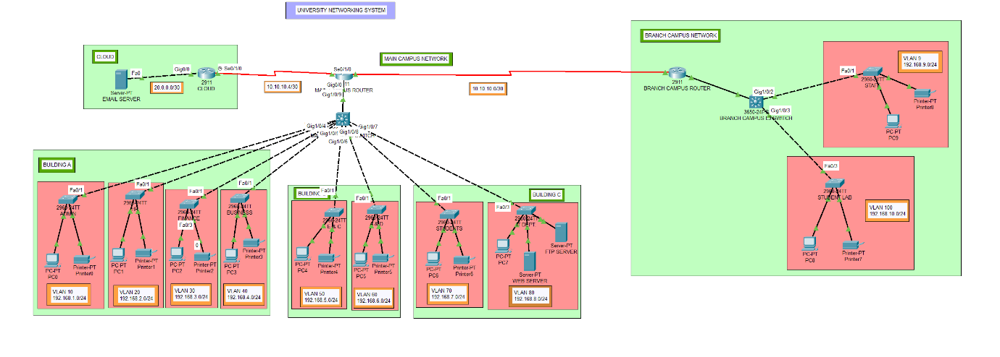
The Main Campus functions as the central network where most academic departments and network services are deployed. The Branch Campus communicates with the Main Campus through a dedicated WAN connection, while the Cloud Network provides centralized services and external connectivity.
Fig. 2.1 Overall architecture of the University Campus Networking System illustrating the Main Campus, Branch Campus, Cloud Network, departmental VLANs, routers, switches, servers, and end devices

2.6 Communication Flow
The network supports communication between users and services through the following workflow:
- A client device obtains an IP address automatically using the DHCP service.
- The client communicates with devices within the same VLAN through the local switch.
- For communication across VLANs, traffic is forwarded to the Router-on-a-Stick gateway.
- The router determines the optimal path using the RIP Version 2 routing table.
- If the destination is located in another campus, packets are forwarded through the WAN serial connection.
- DNS translates domain names into IP addresses whenever users access internal services using hostnames.
- Application servers such as HTTP, FTP, and Email respond to client requests after successful routing and name resolution.
This workflow enables seamless communication across all campuses while ensuring efficient utilization of network resources.

2.7 Design Advantages
The proposed architecture offers several advantages:
- Modular network design suitable for future expansion.
- Reduced broadcast traffic through VLAN segmentation.
- Centralized management of network services.
- Automatic route learning using RIP Version 2.
- Simplified IP address management through DHCP.
- User-friendly access to services using DNS-based hostname resolution.
- Reliable communication between geographically separated campuses.
- Scalable architecture capable of accommodating additional departments and network services.
CHAPTER 3 - NETWORK DESIGN AND IMPLEMENTATION
3.1 Network Design Methodology
The University Campus Networking System was designed using a modular and hierarchical approach to ensure scalability, efficient resource utilization, and simplified network management. The network architecture separates different university departments into independent VLANs while maintaining seamless communication through inter-VLAN routing and dynamic routing protocols.
The design process consisted of the following stages:
- Requirement analysis and departmental segregation.
- IP addressing and subnet planning.
- VLAN creation for logical network segmentation.
- Router-on-a-Stick implementation for inter-VLAN routing.
- WAN connectivity between campuses.
- Deployment of centralized network services.
- Testing and validation of network functionality.
This structured methodology ensures that the network remains organized, scalable, and suitable for future expansion.

3.2 VLAN Design
To improve network performance and security, each department was assigned a dedicated VLAN. VLAN segmentation reduces unnecessary broadcast traffic, improves traffic management, and simplifies administration by logically separating users based on departmental requirements.
The VLAN allocation used in this project is shown below.
VLAN ID | Department | Network Address | Default Gateway
10 | Administration | 192.168.1.0/24 | 192.168.1.1
20 | Human Resources | 192.168.2.0/24 | 192.168.2.1
30 | Finance | 192.168.3.0/24 | 192.168.3.1
40 | Business | 192.168.4.0/24 | 192.168.4.1
50 | Electronics & Communication | 192.168.5.0/24 | 192.168.5.1
60 | Academic Department | 192.168.6.0/24 | 192.168.6.1
70 | Student Department | 192.168.7.0/24 | 192.168.7.1
80 | Information Technology | 192.168.8.0/24 | 192.168.8.1
90 | Staff (Branch Campus) | 192.168.9.0/24 | 192.168.9.1
100 | Student Laboratory | 192.168.10.0/24 | 192.168.10.1
Each VLAN represents an independent broadcast domain while maintaining communication with other VLANs through the campus routers.

3.3 IP Addressing Scheme
A structured private IPv4 addressing scheme was adopted to simplify network management and troubleshooting. Each VLAN was allocated a unique Class C subnet with a /24 prefix, providing sufficient address space for end-user devices, printers, and servers.
The WAN links between routers utilize dedicated /30 point-to-point subnets to minimize address wastage while ensuring efficient router-to-router communication.
WAN Addressing
Connection | Network
Main Campus ↔ Branch Campus | 10.10.10.0/30
Main Campus ↔ Cloud Router | 10.10.10.4/30
Server Network
Server | IP Address
Email & DNS Server | 20.0.0.2
Cloud Router Gateway | 20.0.0.1
Web Server | 192.168.8.2
FTP Server | 192.168.8.3
This addressing plan ensures logical organization while simplifying routing and service deployment.

3.4 Inter-VLAN Routing
Since each department belongs to a different VLAN, direct communication between VLANs is not possible at Layer 2. To overcome this limitation, Router-on-a-Stick architecture was implemented.
The Main Campus Router and Branch Campus Router use IEEE 802.1Q encapsulation to create multiple logical sub interfaces over a single physical interface. Each sub interface acts as the default gateway for its corresponding VLAN.
This approach enables:
- Communication between departments.
- Centralized routing.
- Efficient utilization of router interfaces.
- Reduced hardware requirements.

3.5 Dynamic Routing
Communication between the Main Campus, Branch Campus, and Cloud Network is achieved using Routing Information Protocol Version 2 (RIP v2).
RIP Version 2 was selected because:
- It supports classless routing.
- It automatically exchanges routing information.
- It is simple to configure.
- It is suitable for small to medium-sized enterprise networks.
The routing protocol enables automatic learning of remote networks, eliminating the need for extensive static route configuration.

3.6 DHCP Design
Dynamic Host Configuration Protocol (DHCP) was implemented to automate IP address allocation for client devices.
The DHCP configuration provides:
- Automatic IP assignment.
- Default gateway configuration.
- DNS server configuration.
- Reduced manual configuration errors.
Each departmental VLAN has an independent DHCP address pool, ensuring organized address allocation and simplified network administration.

3.7 DNS Design
The Domain Name System (DNS) was configured to provide hostname resolution for internal services.
Instead of accessing services through IP addresses, users can connect using meaningful domain names such as:
- www.university.local
- ftp.university.local
- mail.university.local
This improves usability and reflects the behavior of real-world enterprise networks.

3.8 Server Infrastructure
The network includes multiple centralized servers providing essential services.
Server | Function
DNS Server | Hostname resolution
DHCP Server | Dynamic IP allocation
Web Server | University website hosting
FTP Server | File transfer services
Email Server | Internal email communication
Centralizing these services simplifies management and allows all campuses to access shared resources.

3.9 Network Scalability
The modular design allows future expansion with minimal configuration changes.
Potential enhancements include:
- Additional departments and VLANs.
- More branch campuses.
- Wireless network integration.
- Redundant routing paths.
- Advanced routing protocols such as OSPF.
- Firewall and Access Control List (ACL) implementation.
- Network monitoring using SNMP and Syslog.

3.10 Summary
The network design successfully combines VLAN segmentation, structured IP addressing, Router-on-a-Stick inter-VLAN routing, RIP Version 2 dynamic routing, and centralized server deployment into a unified enterprise campus network. The implementation provides reliable communication between multiple departments and campuses while supporting essential network services such as DHCP, DNS, Web, FTP, and Email.
CHAPTER 4 - ROUTING AND SWITCHING CONFIGURATION
4.1 Overview
The University Campus Networking System was designed using Cisco routing and switching technologies to provide efficient communication between multiple departments, campuses, and centralized servers. The network combines VLAN segmentation, Layer-2 switching, Router-on-a-Stick inter-VLAN routing, and RIP Version 2 dynamic routing to ensure reliable connectivity throughout the campus infrastructure.
The routing and switching configuration follows standard enterprise networking practices by separating the responsibilities of routers and switches. Switches manage local communication within individual VLANs, while routers enable communication between different VLANs and geographically separated campuses.

4.2 Router Configuration
Three Cisco 2911 routers were deployed in the network, each performing a specific role.
Main Campus Router
The Main Campus Router acts as the core routing device of the university network. It performs inter-VLAN routing for the Main Campus and connects both the Branch Campus and the Cloud Network.
The primary responsibilities of the Main Campus Router include:
- Router-on-a-Stick implementation using IEEE 802.1Q encapsulation.
- Gateway configuration for VLANs 10-80.
- Dynamic routing using RIP Version 2.
- WAN connectivity to the Branch Campus and Cloud Router.
- DHCP relay for client VLANs.
- Forwarding traffic between departments and centralized servers.

Branch Campus Router
The Branch Campus Router provides routing services for the remote campus and maintains communication with the Main Campus.
Its responsibilities include:
- Gateway configuration for VLANs 90 and 100.
- WAN connectivity to the Main Campus Router.
- RIP Version 2 route exchange.
- Routing traffic between the Branch Campus and centralized services.

Cloud Router
The Cloud Router represents the external service network connected to the university infrastructure.
Its primary responsibilities include:
- Providing connectivity between the university network and centralized servers.
- Participating in RIP Version 2 routing.
- Forwarding traffic to cloud-based resources.

4.3 Router-on-a-Stick Implementation
Inter-VLAN communication was achieved using the Router-on-a-Stick architecture.
In this implementation:
- A single physical Gigabit Ethernet interface on each router was divided into multiple logical subinterfaces.
- Each subinterface was configured with IEEE 802.1Q encapsulation corresponding to a specific VLAN.
- Every VLAN was assigned a unique gateway IP address through its respective router subinterface.
This approach minimizes hardware requirements while enabling communication between all departmental VLANs.
Advantages of Router-on-a-Stick implementation:
- Efficient utilization of router interfaces.
- Simplified network expansion.
- Reduced infrastructure cost.
- Centralized routing management.

4.4 Layer-3 Switch Configuration
Two Layer-3 switches were used to provide VLAN connectivity within the Main Campus and Branch Campus.
Main Campus Layer-3 Switch
The Main Campus Layer-3 Switch performs the following functions:
- Creation of VLANs 10-80.
- Assignment of access ports to departmental VLANs.
- Trunk link configuration towards the Main Campus Router.
- Forwarding Ethernet frames within the campus.
Branch Campus Layer-3 Switch
The Branch Campus Layer-3 Switch supports:
- VLAN 90 (Staff)
- VLAN 100 (Student Laboratory)
- Trunk connection to the Branch Campus Router.
- Layer-2 switching between connected end devices.

4.5 Access Switch Configuration
Each department is connected through an access switch configured with access ports belonging to the corresponding VLAN.
Examples include:
- Administration Switch → VLAN 10
- HR Switch → VLAN 20
- Finance Switch → VLAN 30
- Business Switch → VLAN 40
- ECE Switch → VLAN 50
- Academic Switch → VLAN 60
- Student Switch → VLAN 70
- IT Switch → VLAN 80
Access switches isolate broadcast domains while providing reliable connectivity to end-user devices.

4.6 Trunk Link Configuration
Trunk links were established between routers and Layer-3 switches using IEEE 802.1Q encapsulation.
The trunk links allow multiple VLANs to share a single physical connection while preserving VLAN information through frame tagging.
Benefits include:
- Reduced cabling requirements.
- Efficient bandwidth utilization.
- Simplified VLAN management.
- Scalability for future VLAN additions.

4.7 Dynamic Routing Configuration
The Routing Information Protocol Version 2 (RIP v2) was selected as the dynamic routing protocol for the network.
The protocol performs the following tasks:
- Advertises connected networks.
- Learns routes from neighboring routers.
- Updates routing tables automatically.
- Supports classless subnetting.
The routers periodically exchange routing information, ensuring that all campuses maintain up-to-date knowledge of reachable networks.

4.8 Network Verification
Following configuration, the network was verified using Cisco IOS diagnostic commands.
The primary verification commands included:
- show ip interface brief
- show running-config
- show ip route
- show vlan brief
These commands were used to verify:
- Interface status.
- IP address assignments.
- VLAN configuration.
- Routing table entries.
- Dynamic route propagation.
The successful output of these commands confirmed proper operation of routing and switching components.

4.9 Configuration Validation
The routing and switching infrastructure was validated through practical testing.
The following tests were performed successfully:
- Inter-VLAN communication between departments.
- Main Campus to Branch Campus connectivity.
- Main Campus to Cloud Network communication.
- Dynamic route learning through RIP Version 2.
- Successful forwarding of traffic to DNS, Web, FTP, and Email servers.
The verification process confirmed that all routers and switches were operating according to the intended network design.

4.10 Summary
The routing and switching configuration form the backbone of the University Campus Networking System. Through the combined use of VLAN segmentation, Router-on-a-Stick inter-VLAN routing, trunk links, Layer-3 switching, and RIP Version 2 dynamic routing, the network achieves reliable communication between departments, campuses, and centralized services. The implemented design follows enterprise networking principles while maintaining scalability, efficient resource utilization, and ease of administration.
CHAPTER 5 - NETWORK SERVICES
5.1 Overview
Modern enterprise networks rely on a variety of network services to provide efficient communication, centralized resource management, and seamless user experience. In addition to routing and switching, the proposed University Campus Networking System integrates several essential services that enable users to communicate, access resources, and utilize network applications effectively.
The following services have been successfully implemented within the simulated network:
- Dynamic Host Configuration Protocol (DHCP)
- Domain Name System (DNS)
- Hypertext Transfer Protocol (HTTP)
- File Transfer Protocol (FTP)
- Electronic Mail (SMTP & POP3)
The integration of these services transforms the network from a basic connectivity solution into a functional enterprise-style infrastructure.

5.2 Dynamic Host Configuration Protocol (DHCP)
Purpose
DHCP was implemented to automate the allocation of IP addresses and network configuration parameters to client devices. This eliminates the need for manual IP configuration and reduces the possibility of addressing errors.
Implementation
Separate DHCP address pools were configured for each departmental VLAN, allowing client devices to automatically receive:
- IP Address
- Subnet Mask
- Default Gateway
- DNS Server Address
Each VLAN obtains network parameters according to its assigned subnet, ensuring structured IP address management throughout the university.
Advantages
- Automatic client configuration
- Reduced administrative effort
- Prevention of duplicate IP addresses
- Simplified network expansion
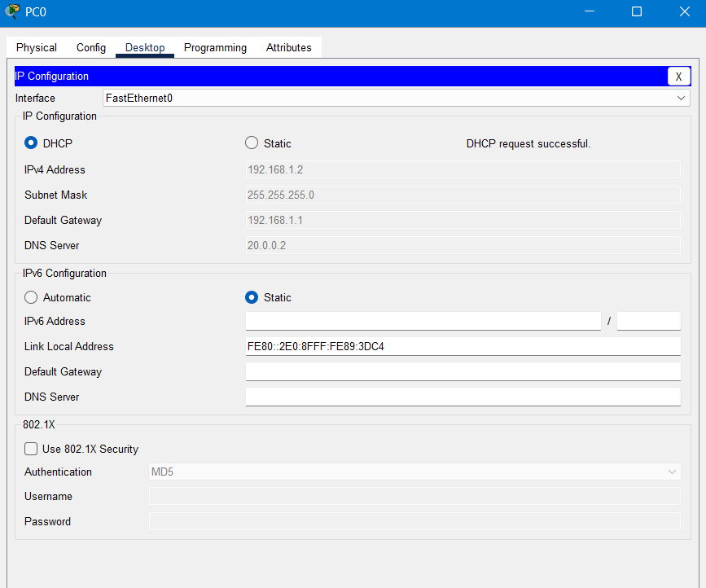
- Faster deployment of new devices
Fig. 5.1 DHCP configuration successfully assigning IP address to a client device.

5.3 Domain Name System (DNS)
Purpose
The DNS service provides hostname resolution, allowing users to access network resources using meaningful domain names instead of numerical IP addresses.
Implementation
The DNS server was configured with records for the university's internal services, including:
- Web Server
- FTP Server
- Email Server
Users can therefore access services using domain names such as:
- www.university.local
- ftp.university.local
- mail.university.local
instead of remembering their corresponding IP addresses.
Advantages
- Improved user convenience
- Simplified resource access
- Easier network administration
- Better scalability for future services
5.4 Web Server (HTTP)
Purpose
The Web Server hosts the university's internal website, providing users with access to campus-related information through a standard web browser.
Implementation
The HTTP service was configured on a dedicated server within the Information Technology VLAN. A customized homepage was developed to simulate a real university website, featuring:
- University title and branding
- Navigation menu
- University logo
- Image gallery
- Footer information
The website is accessible through both the server's IP address and the configured DNS hostname.
Advantages
- Centralized information sharing
- Realistic simulation of institutional web services
- Demonstration of HTTP service deployment
- DNS-integrated access to web resources
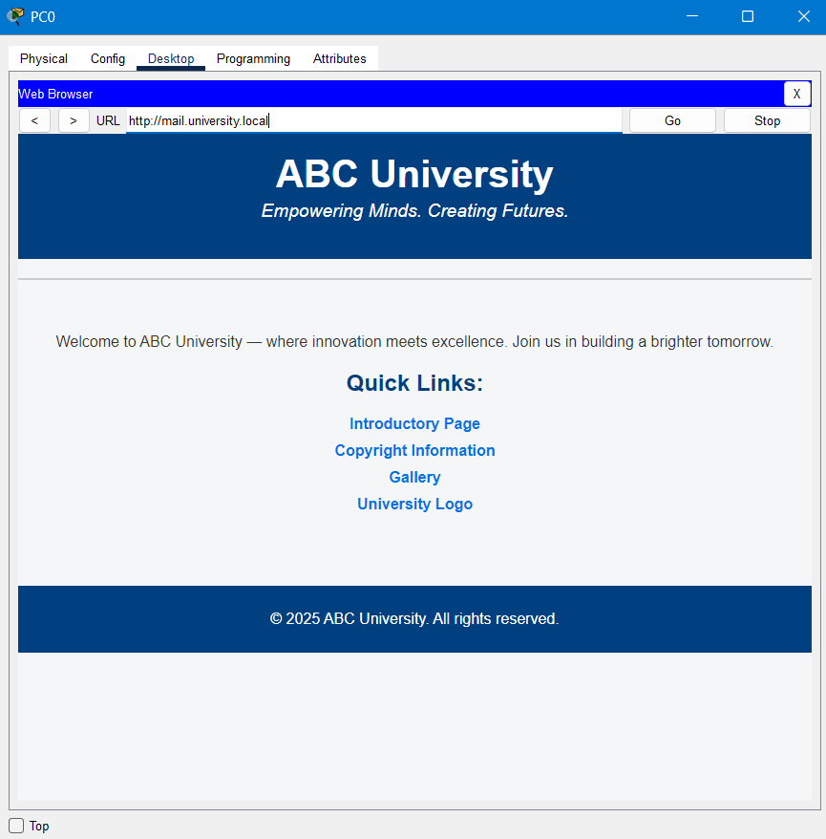
Fig. 5.3 University homepage hosted on the internal Web Server.

5.5 File Transfer Protocol (FTP)
Purpose
The FTP service enables centralized storage and transfer of files across the university network.
Implementation
A dedicated FTP server was configured with authenticated user access. Clients successfully connected to the server using valid credentials and verified connectivity by listing available directories.
The implemented FTP service demonstrates secure client-server communication and centralized file management within the campus network.
Advantages
- Centralized file storage
- User authentication
- Reliable file transfer
- Resource sharing among departments
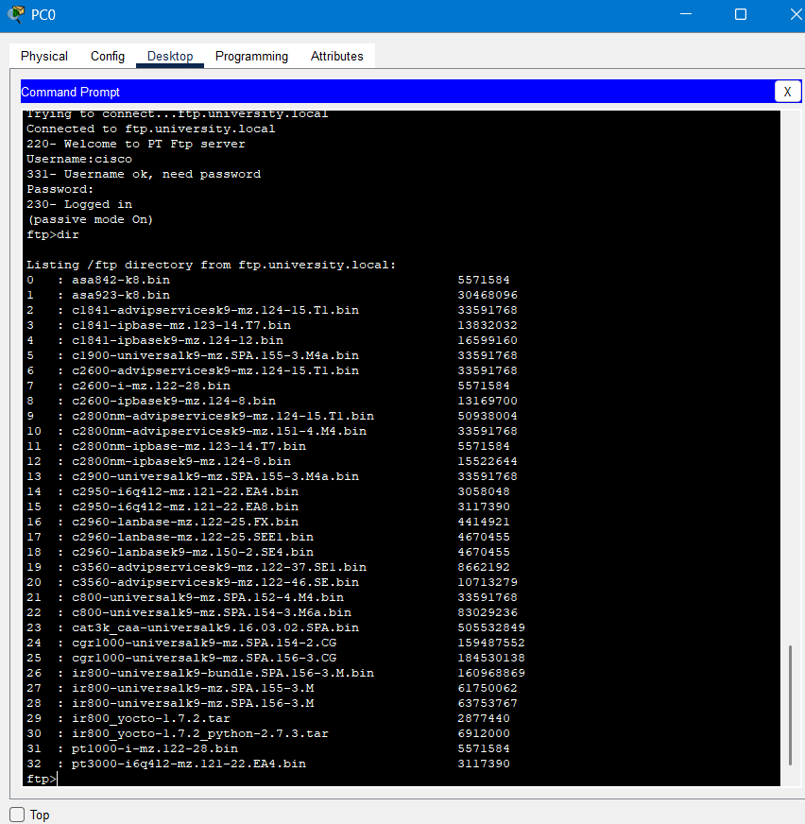
Fig. 5.4 Successful FTP login and directory listing.

5.6 Email Service (SMTP & POP3)
Purpose
An internal email service was deployed to facilitate communication between university users.
Implementation
The Email Server was configured with:
- SMTP service for sending emails
- POP3 service for receiving emails
- User accounts for different clients
- Internal university domain
Client systems were configured with appropriate email credentials and successfully exchanged messages through the internal mail server.
Advantages
- Secure internal communication
- Centralized mail management
- Practical implementation of enterprise email services
- Integration with DNS-based hostname resolution
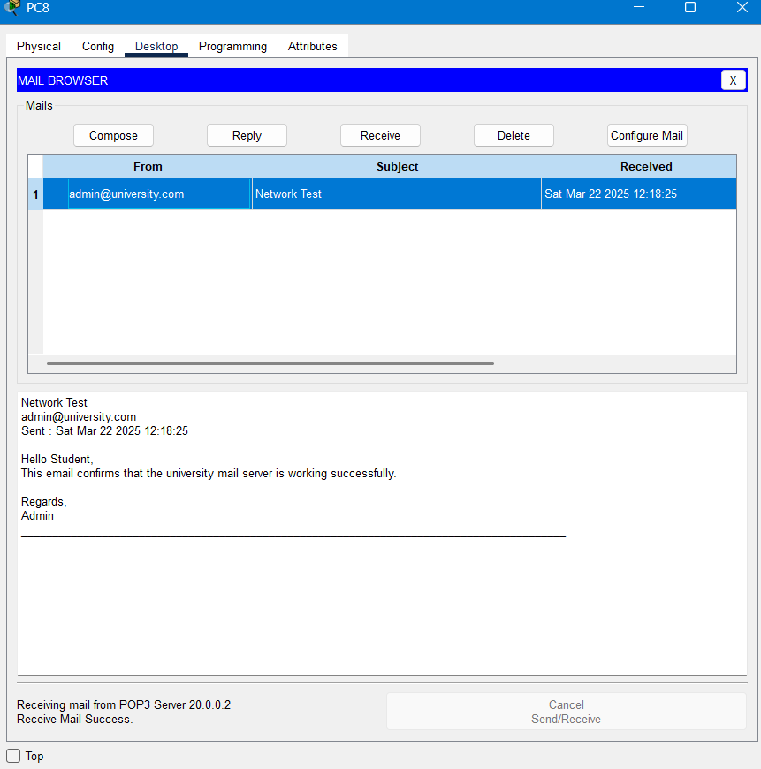
Fig. 5.5 Successful email communication between users.

5.7 Integration of Network Services
All implemented services operate together to provide a complete enterprise networking environment.
The interaction between services is summarized below:
- A client device receives an IP address through DHCP.
- DNS resolves the requested hostname into an IP address.
- The router forwards packets based on the routing table.
- The destination server processes the request.
- The requested service (HTTP, FTP, or Email) responds to the client.
This coordinated workflow demonstrates the integration of multiple networking technologies within a single infrastructure.

5.8 Service Validation
Each implemented service was tested to verify correct functionality.
Service | Validation Performed | Status
DHCP | Automatic IP allocation | Successful
DNS | Hostname resolution | Successful
HTTP | University website accessible | Successful
FTP | User authentication and directory listing | Successful
Email | Email transmission and reception | Successful
The successful completion of these tests confirms that all configured network services are functioning as intended.

5.9 Benefits of Service Integration
The deployment of multiple network services provides several operational benefits:
- Centralized management of network resources.
- Reduced manual configuration through DHCP.
- Simplified access to resources using DNS.
- Efficient internal communication through Email services.
- Centralized information sharing via the Web Server.
- Secure file transfer using FTP.
- Improved realism by simulating enterprise network infrastructure.

5.10 Summary
The implementation of DHCP, DNS, HTTP, FTP, and Email services significantly enhance the functionality of the University Campus Networking System. These services demonstrate how routing, switching, and application-layer protocols work together to create a reliable and user-friendly enterprise network. Successful validation of each service confirms that the proposed network supports both infrastructure-level communication and practical end-user applications.

CHAPTER 6 - NETWORK TESTING AND VALIDATION
6.1 Overview
After the implementation of the University Campus Networking System, a series of functional tests were conducted to verify network connectivity, routing performance, VLAN communication, and the operation of configured network services. These tests ensured that the network met the intended design objectives and that all critical components functioned correctly.

6.2 Connectivity Testing
End-to-end connectivity was verified using ICMP ping tests between devices located in different VLANs and campuses.
The following communication paths were successfully validated:
- Main Campus to Branch Campus
- Branch Campus to Main Campus
- Main Campus to Cloud Network
- Inter-VLAN communication between departments
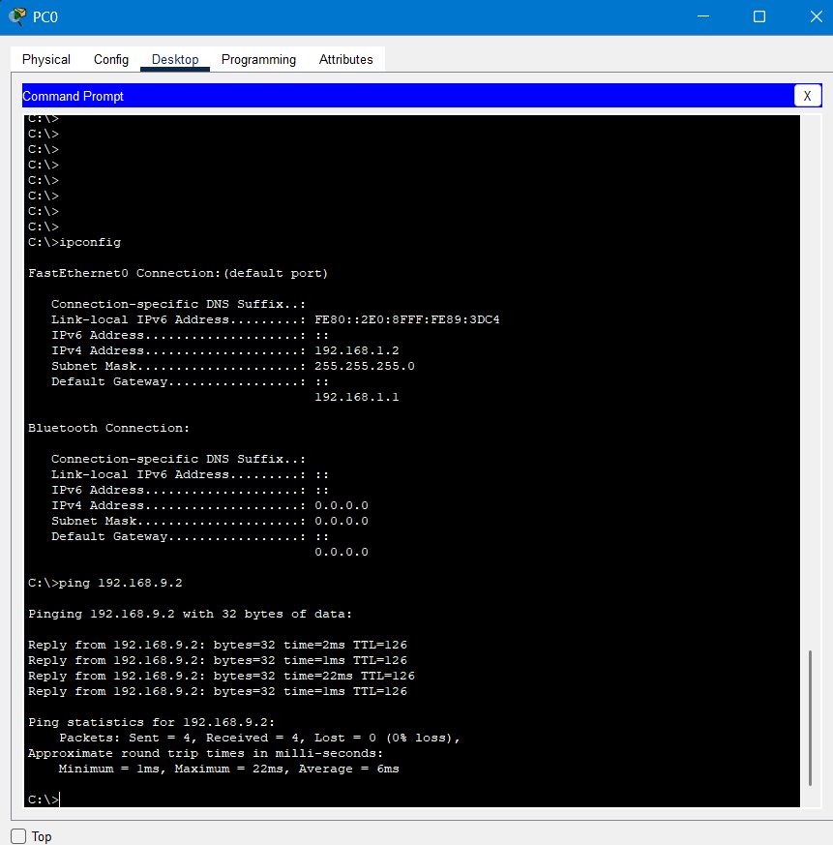
Successful ping responses confirmed that Router-on-a-Stick inter-VLAN routing and RIP Version 2 dynamic routing were functioning correctly.
Fig. 6.1 Successful ping test between the Main Campus and Branch Campus.

6.3 Service Validation
All configured network services were tested to ensure proper functionality.
Service | Validation Method | Result
DHCP | Automatic IP assignment | Successful
DNS | Hostname resolution | Successful
HTTP | University website access | Successful
FTP | Login and directory listing | Successful
Email | Email transmission and reception | Successful
The successful completion of these tests demonstrates that the implemented network supports both infrastructure-level communication and application-layer services.

6.4 Performance Summary
The implemented network successfully achieved the following objectives:
- Reliable communication between all VLANs.
- Dynamic route exchange between campuses.
- Automatic IP address allocation.
- Centralized network service availability.
- Successful access to internal Web, FTP, DNS, and Email services.
- Stable communication between the Main Campus, Branch Campus, and Cloud Network.
The overall testing confirms that the proposed network design is reliable, scalable, and suitable for a medium-sized university campus environment.

CHAPTER 7 - CONCLUSION AND FUTURE ENHANCEMENTS
7.1 Conclusion
This project successfully demonstrates the design and simulation of an enterprise-style University Campus Networking System using Cisco Packet Tracer. The implemented network integrates routing, switching, VLAN segmentation, dynamic routing, and centralized network services into a unified infrastructure capable of supporting academic and administrative activities.
The adoption of VLANs improved network organization by separating departmental traffic, while Router-on-a-Stick enabled efficient inter-VLAN communication. RIP Version 2 provided dynamic route exchange between the Main Campus, Branch Campus, and Cloud Network, ensuring seamless connectivity across geographically distributed locations.
In addition to network infrastructure, essential enterprise services including DHCP, DNS, HTTP, FTP, and Email were successfully deployed and validated through practical testing. The results demonstrate the effectiveness of the proposed design in providing reliable communication, centralized resource management, and scalable network operation.
Overall, the project reflects the application of fundamental enterprise networking concepts and provides a strong foundation for understanding the design and implementation of modern campus networks.

7.2 Future Enhancements
Although the implemented network meets the current project requirements, several improvements can be incorporated to further enhance its functionality and security:
- Replace RIP Version 2 with OSPF to improve scalability and routing efficiency.
- Implement Access Control Lists (ACLs) to control inter-department network access.
- Configure Network Address Translation (NAT) for secure Internet connectivity.
- Integrate wireless access points to support Wi-Fi-enabled devices.
- Deploy redundancy mechanisms such as HSRP and Spanning Tree Protocol (STP) for high availability.
- Implement Quality of Service (QoS) to prioritize delay-sensitive applications.
- Enable SNMP and Syslog for centralized network monitoring and troubleshooting.
- Expand the network by adding additional campuses, departments, and servers without major architectural changes.
These enhancements would transform the simulated campus network into an even more robust and production-ready enterprise infrastructure.

