Cell nucleus visualization with phenotypic characteristics

Sayaka Nagai* Naohisa Sakamoto Koji Kyoda Shuichi Onami

Graduate School of System Informatics, Kobe University Laboratory for Developmental Dynamics, RIKEN Quantitative Biology Center

Abstract

For elucidating the developmental mechanism of multicellular organisms, it is important to analyze the spatiotemporal features (phenotypic characteristics) of cells appearing during cell division and their correlation. Furthermore, in order to analyze how phenotypic characteristics correlate, it is necessary to observe cell nucleus shapes. We proposed a system that visualizes phenotypic characteristics and three-dimensional cell nucleus shapes before, but there were problems that cell nucleus shapes cannot be observed individually and information such as cell nuclear position or movement distance was insufficient. In order to solve such problems, we have improved visualization methods of cell nuclei and phenotypic characteristics. This improvement enabled us to analyze cell nucleus shapes and a nuclear position accurately.

**Keywords**: Phenotypic characteristics, Cell nucleus shape, Semi-transparent rendering.

**Index Terms**: K.6.1 [Management of Computing and Information Systems]: Project and People Management—Life Cycle; K.7.m [The Computing Profession]: Miscellaneous—Ethics

# Introduction

In the field of life sciences, research for elucidating the developmental mechanism of multicellular organism using nematode (*C.elegans*), which is one of representative model organisms, is actively carried out. To elucidate it, which phenotypic characteristics affect other ones have been studied. We previously developed a system that narrows down pairs with high correlation between phenotypic characteristics up to the 8 cell stage and visualizes the three dimensional shape of cell nuclei having the selected characteristic. [1]

　When phenotypic characteristics expressed over multiple time steps are chosen, an average shape was visualized so that the outline of cell nuclei could be observed at a glance. However, since the average shape is not an actual cell nucleus shape, it is necessary to observe an individual shape. In addition, in the case of phenotypic characteristics of position and distance, it is difficult to grasp them only from a cell nucleus shape, so it is necessary to visualize them.

In this study, we propose methods to visualize cell nuclei having a phenotypic characteristic appearing over multiple time steps and to show information of position and distance.

# METHOD

We proposed two visualization methods of cell nucleus having a phenotypic characteristic.

## Visualization of 3D cell nuclei

We describe a method to visualize both the approximate form of cell nuclei and an individual cell nucleus when a phenotypic characteristic exists over multiple time steps. Figure 1(a) shows how shapes of several cell nuclei with a phenotypic characteristic change over time. First, in order to display an overview of them, all the cell nuclei are overlapped and displayed as shown in Figure 1(b). When you want to observe a specific cell nucleus shape, it is changed opaque and the other ones are translucently drawn. When rendering semitransparent cell nuclei simultaneously, polygon sort processing is necessary, so we performed the stochastic rendering technique[2].

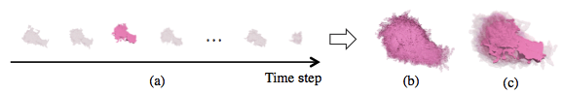

1. (a) A time change of the cell nucleus shape. (b) The result of overlapping all of them. (c) The result of highlighting a specific cell nucleus shape.

## Visualization of phenotypic characteristic

We describe how to visualize the phenotypic characteristics, a cell nuclear position, a distance between a cell nucleus center and an embryo center, and a movement distance of a cell nucleus.

* 177x216x@stu.kobe-u.ac.jp

2.2.1 Nuclear position

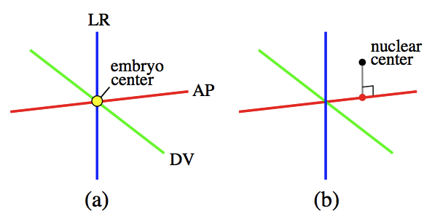

1. (a) The anterior-posterior axis (AP), dorso-ventral axis (DV), left-right axis (LR) of a *C.elegans* embryo and the embryo center (b) The result of subtracting a vertical line from the cell nuclear center to the AP axis

In order to show the cell nuclear position relative to the AP, DV, LR axis, we visualized these axes and the cell nuclear position. In the *C.elegans* embryo, anterior-posterior(AP) axis, dorso-ventral(DV) axis and left-right(LR) axis[3] are defined, and they are orthogonal each other. As shown in Figure 2(a), red line is AP axis, green one is DV axis, blue one is LR axis and the yellow sphere is the embryo center. We drew the cell nuclear center with the black sphere and the foot of the perpendicular on the axis where the feature value was measured (ex. AP axis in Fig. 2(b)) using a sphere of the same color as the axis.

2.2.2 Distance between nuclear center and embryo center

To show the distance between an embryo center and a cell nuclear center, we connected them by a black line as shown in Figure 3.

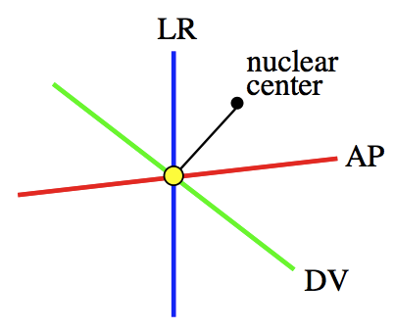

1. Connection between a nuclear center and a embryo one

2.2.3 Movement distance of a cell nucleus

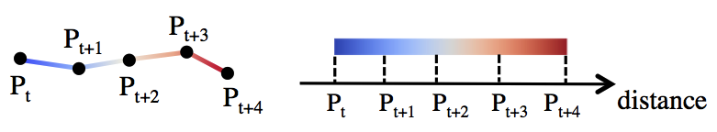

1. A movement distance of a cell nucleus. The colors of the line segments refer from the diverging color map.

In order to show the movement distance of a cell nucleus, we visualized cell nuclear centers and connected them with a line. Pt is the position of a cell nucleus at the time step t and we drew the line with the color of the divergent color map [4] according to the distance from the starting point (Pt). It means that the cell nucleus moves in the direction from blue to red as time goes on.

# Experimental result

In order to show the usefulness of the proposed methods, we describe the results using the proposed methods and the evaluation of two domain experts. We used the BDML data [5] (cell nucleus shape data) and expression period data of phenotypic characteristics in Section 3.1. And we used these two data, nucleus center data, embryo center data and AP, DV, LR axis data in Section 3.2.

## Visualization of several 3D cell nucleus shapes

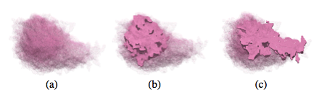

1. (a) The overview of AB nuclei. Highlighted cell nuclei at the 3rd (b) and the 23rd (c) time steps.

When selecting the phenotype characteristic "Movement distance of AB nucleus", it is expressed over 27 time steps. Figure 5(a) shows the result of visualizing 27 AB cells simultaneously. Figure 5 (b) shows the AB nucleus at the 3rd time step, and Figure 5(c) shows the AB nucleus at the 23rd time step, showing that the cell nucleus at the selected time step changed opaque and highlighted. We got the opinion that previously only the overlapped nucleus could be visualized, but they could observe an individual nucleus.

## Visualization of a phenotypic characteristic

Figure 6(a) shows the phenotypic characteristic "distance between EMS nucleus and the embryonic center at the midpoint of interphase". The center of EMS nucleus, AP, DV, LR axes and the embryo center are visualized, and we can confirm that EMS center and the embryo center are connected. Figure 6 (b) shows the phenotypic characteristic "DV position of ABp nucleus at the first time point of interphase". The perpendicular is drawn from the ABp center to DV axis, and the foot of the perpendicular is plotted. Up to now, information of the position was not visualized, but they could grasp the exact position. In Figure 6 (b) we drew

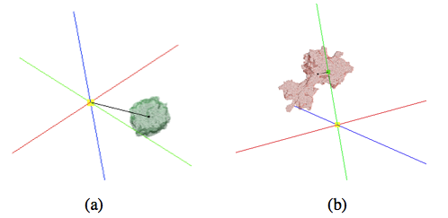

1. (a) Distance between nuclear center and EMS embryo center. (b) DV position of ABp nucleus.

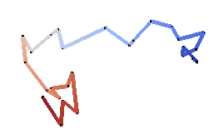

1. Movement distance of AB nucleus.

the perpendicular, but the information they wanted was the foot of the perpendicular, so it should be emphasized.

Figure 7 shows the phenotypic characteristic "Movement distance of AB cell". 27 centers and their time trajectory are displayed, and we can understand that the cell nucleus moves from blue to red. We gave the opinion that it may be good to draw not only a trajectory but a straight line which represents length of the movement distance.

# Conclusion

In this study, we have improved the visualization methods of cell nuclei having a phenotypic characteristic and information of phenotypic characteristics. We could draw cell nucleus shapes at selected time step individually and display position and distance.

The feature values of 33 *C.elegans* embryos have been measured for calculating correlation coefficients of pairs of phenotypic characteristics. But when we select a phenotypic characteristic, we can visualize only cell nuclei and information of one embryo. In the future, we would like to show how feature values increase or decrease by using 33 *C.elegans* embryo data.

# Acknowledgement

This work was supported in part of JSPS KAKENHI Grant Number JP17K00169 and JST CREST Grant Number JPMJCR1511, Japan.

References

1. Sayaka Nagai, Naohisa Sakamoto, Development of a visual analytics system for cell division dynamics in early C.elegans embryos, SIGGRAPH ASIA Symposium on Visualization (SA17), 19:1-19:8, 2017.11
2. Naohisa Sakamoto, Koji Koyamada, “A Stochastic Approach for Rendering Multiple Irregular Volumes”, In Proc. of IEEE Pacific Visualization 2014 (VisNotes), pp.272-276, 2014.
3. Scott F. Gilbert. (2013) *Developmental Biology. Tenth Edition.* Sinauer Associates, Incorporated.
4. Moreland, Kenneth. "Diverging color maps for scientific visualization." *Advances in Visual Computing* (2009): 92-103.
5. Koji Kyoda, Yukako Tohsato, Kenneth HL Ho, and Shuichi Onami. “Biological Dynamics Markup Language (BDML): an open format for representing quantitative biological dynamics data”. Bioinformatics, p. btu767, 2014.