Laboratory work 4

**1. a) What are the main phases in the database design? What is done on each**

**development phase?**

**b) What is the entity-relationship (ER) data model?**

a) 1. Initial phase – characterize fully the data needs of the user

2. Choosing a data model – apply the concept, translating these requirement into conceptual schema

3. Logical – deciding on the db schema

4. Physical – deciding on the physical layout of db

b) Entity Relationship Model is a graphical approach to database design. It is a high-level data model that defines data elements and their relationship for a specified software system

2. a)

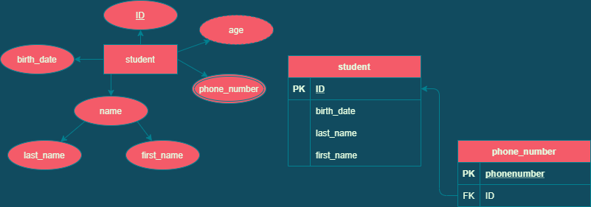

b)

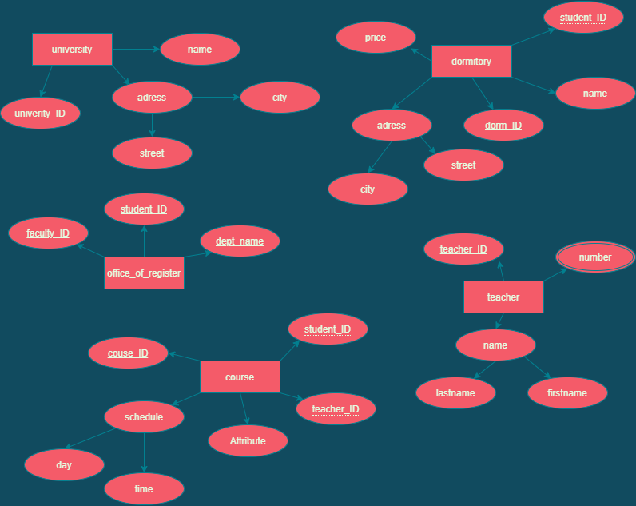

3.

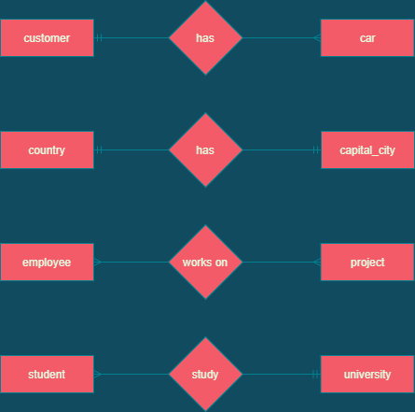

One-to-many

One customer can have many cars. While cars have one cutomer.

One-to-one

One country can have only one capital_city as well as one capital_city can be for one country

Many-to-many

One employee can work on many projects while one project can have many employee working on it

Many-to-one

Student can study in one university while university can have many student

4.

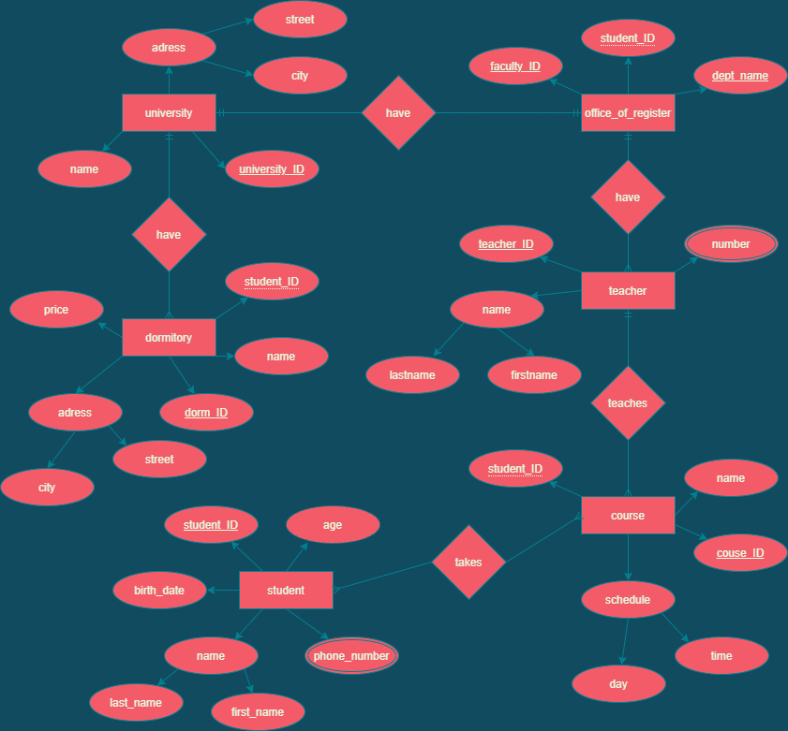

5.

