CIRRASPEC Application Configuration & Setup

Quick Start Guide

System Version: 2.0

Revision History

|  |  |  |  |
| --- | --- | --- | --- |
| **Document Version** | **Date** | **Name** | **Description** |
| 1.1 | 02/09/2012 | Robin Petros | Initial publication for 1.1 Release. |
| 1.2 | 02/21/2012 | Robin Petros | Incorporated minor edits received from Ben Koomson. |
| 1.3 | 05/01/2012 | Robin Petros | Revised for 1.1.3 Release. Added five IAMS Import Data uploads to System Administration. Added limitation to Create Kit Templates re: special characters not allowed for Kit Template Name of Code. |
| 1.4 | 07/02/2015 | Siddhi Jadhav | Revised for 1.1.8 Release. Added PHI authorization feature. |
| 2.0 | 05/30/2016 | Siddhi Jadhav | Revised for CIRRASPEC (version 2.0). |
| 3.0 | 31/01/2018 | Sayali Dev | Revised for Current CIRRASPEC version. |

This document and any documents referenced within are for the sole use of TGen employees (including employees of its subsidiaries and affiliates). This document contains confidential, proprietary, legally privileged information protected by law from disclosure. Any unauthorized review, use, copying, disclosure or distribution to other parties is prohibited.

**Table of Contents**

Revision History 2

Overview 4

Software Engineering Team 4

System Administration 4

System Administration 8

Add Sites 8

Add Couriers 9

Add Users 9

Create Kit Templates 10

Create Forms 11

Upload Sample Processing Templates 12

Project Management 13

Create a Project 13

Create a Collection 13

Create Collection Events 16

Publish the Collection 17



# Overview

The purpose of this document is to provide Quick Start steps and tips for configuring and setting up the CIRRASPEC application prior to implementation.

This document is intended for use by the System Administrator.

The tables below summarize the tasks required to set up the application prior to going “live”.

More detailed Quick Start steps are provided in the **System Administration** and **Project Management** sections of this document.

### Software Engineering Team

The CIRRASPEC Software Engineering Team is responsible for the following database configurations:

* Reports (based on business requirements)
* Barcode Label Codes (based on business requirements)
* General Question Library
* Import Process Data Templates
* System Administrator Login and Password

### System Administration

Before any projects can be set up in CIRRASPEC, the System Administrator must perform the following set-up tasks:

| **Task** | **Description** | **Application Module** |
| --- | --- | --- |
| **Add Collection Site(s)** | Hospitals and subjects’ sample collection sites participating in the research study must be added and activated in the application’s address book. | IAMS > Address Book |
| **Add Processing Site(s)** | Sample processing labs participating in the research study must be added and activated in the application’s address book. | IAMS > Address Book |
| **Add Storage Site(s)** | Biobank and sample storage locations participating in the research study must be added and activated in the application’s address book. | IAMS > Address Book |
| **Add Courier(s):** | Shipping couriers used for shipping collection kits and samples to and from the collection site, Biobank and processing sites must be added to and activated in the application’s address book. | IAMS > Address Book |
| **Add User(s)** | Biobank and collection site users must be added and activated in the application’s address book. This process includes defining the following:   * Login ID and Password * Authentication Source * Sites for which the user is authorized to access information * User’s Role * Whether the user needs to be PHI authorized or not   *Note:*   * Only the System Administrator can add users. * Activated users in the address book do not have access to CIRRASPEC until they are assigned to a Published Collection in the Project Management setup on **RPMS**. * It is currently not recommended to add **Project Manager** Users to collections. | IAMS > Address Book |
| **Create Questions** | Questions must be created first in the system.   * If a new question is needed, you must add the question to the database library using the **IAMS>Question Designer** module prior to creating the form. * All questions created are stored in a database question library and questions to be added on the form are supplied by this database question library. * Questions can be marked as PHI questions and Non-PHI questions. | IAMS > Questions Designer |
| **Create Forms** | Following forms must be created and activated in the application:   * Consent Form, which is used by collection site personnel in the **CIMS>Subject Centric View** module to record the subject’s consent for participating in the research study. * Specimen Collection Form, which is used by collection site personnel in the **CIMS>Subject Centric View** module to record information related to the subjects’ sample collection. * Sample Processing Form, which is used by processing site personnel in the **LIMS>Workflow** module to record information related to lab processing of the subjects’ sample.   *Note:*   * Form naming convention and content are defined by business requirements. * Forms are assigned to a Collection in the Project Management setup on **RPMS**. * Forms can have PHI and/or Non-PHI questions. | IAMS > Forms Designer |
| **Create Kit Templates** | Kit templates must be created and activated in the application.  *Note:*   * Kit template naming convention and kit contents are defined by business requirements. * Kit templates are assigned to a Collection in the Project Management setup on **RPMS**. | IAMS > Kits Designer |
| **Upload Sample Processing Templates**  **(Optional)** | Based on business requirements, any or all of the following sample processing workflow templates can be uploaded to the application:   * Aliquot * Derivative * Pooling * Generic Experiment   *Note:*   * Process templates are used in the **LIMS>Workflow** module to pre-populate the input and output sample processing fields with standardized template values. * Process template content is defined by business requirements. * Processing templates will be assigned to a Collection in the Project Management setup on **RPMS.** | IAMS > Import Data > Upload Process Templates |

**Project Management**

Once the System Administration setup is completed, the System Administrator must perform the following set-up tasks to create the project hierarchy:

*Note:* Prior to setting up the project hierarchy in this section, the applicable users, sites, kit templates, forms and process templates must be created/activated as outlined in the previous System Administration section.

| **Task** | **Description** | **Application Module** |
| --- | --- | --- |
| **Create Project** | A Project must be added as the first level. | RPMS > Configuration |
| **Create Collection(s)** | Collection is added as the second level.  *Note:* Multiple Collections can be added under a Project. The creation process requires:   * Assigning one or more authorized collection, processing and storage sites to the Collection on the Sites tab. * Assigning an Anonymous or Nominative **Subject Type** to each collection site on the Sites tab. * Assigning users to each of the **Bio Repository Technician**, and **Clinical Research Nurse** roles on the Personnel tab.   **Note**: It is currently not recommended to add **Project Manager** users to collections.   * Assigning one or more kit templates to each collection site on the Kit Templates tab. * Setting the following on the Kit Templates tab: 1) a unique barcode template default value for each assigned kit template, and 2) unique barcode and label codes for all items of the kit component groups. * Assigning one or more **Specimen Collection Forms** to the kit component groups on the Kit Templates tab. * Assigning a **Consent Form** to each collection site on the Form templates tab. * If applicable, assigning one or more Clinical Forms to each collection site on the Form Templates tab. * Assigning one or more sample **Processing Workflow Templates** to each processing site on the Process Workflow Templates tab. * Assigning one or more **Sample Processing Forms** to the processes on the Process Workflow Templates tab. * Assigning one or more **Couriers** to the Collection on the Courier tab. | RPMS > Configuration |
| **Create Collection Event(s)** | At least one Collection Event must be added to a Collection.  *Note:* Multiple Events can be added for each Collection Site.  The creation process requires:   * Selecting the **Collection Site** where the Event will occur. * Selecting a **Collection Event Type** for the event (Initial, Follow-up, Final or Visit). * Scheduling the appointment, if applicable. | RPMS > Configuration |
| **Publish Collection** | Once all of the above tasks are completed, the Collection must be published. | RPMS > Configuration |
| **Add Storage Device(s)** | Once the collection is published, storage devices to be used for samples associated with that Collection must be created. | IAMS > Storage Designer |

# 

# System Administration

To perform the system administration setup tasks:

1. Log on to CIRRASPEC with the System Administrator login ID and password.
2. Perform each of the tasks outlined in this section.

General tips:

* Required fields are marked with a red asterisk *.
* Place the cursor on the blue **question mark icon** 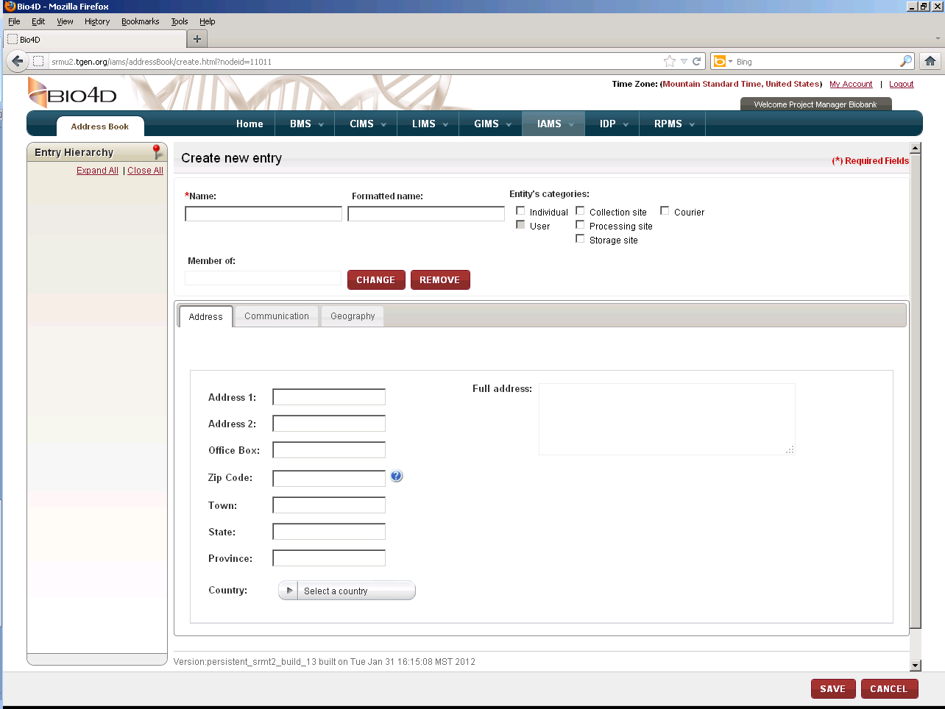next to a field to display format requirements for that field.
* Address Book entries must be added one at a time, clicking **Save** after completing required fields.
* Once created and saved, a new Address Book entry must be activated by clicking **Activate.** *Note:* Only activated entries can be assigned to a new Project in the **Project Management** section.
* After activating an entry, you can use the **Copy** button and change field values as needed to create the next new entry,   
  OR  
  You can click **Close** and then **Create Entry** link to start with a blank create screen.

## Add Sites

1. Access **IAMS>Address Book** and click the **Create Entry** link.
2. Create, **Save** and **Activate** each collection, processing, storage and Biobank site associated with the new Project you will be setting up in CIRRASPEC.

* The **Select a user** pop-up displayed when you click **ADD** in the Attached Users tab will only list existing users. Use the pop-up to attach *existing* users to the new site, if applicable. New users are assigned to the new site when you add users below.
* The contact information on the Address and Communication tabs are not required fields. However, the information is used by the system to pre-populate the Contact Details fields for shipments on the Create Shipment screen.
* For collection sites, select the **Collection site** checkbox under **Entity’s categories**.
* For lab processing sites, select the **Processing site** and **Storage site** checkboxes under **Entity’s categories**.
* For Biobank sites, select the **Processing site** and **Storage site** checkboxes under **Entity’s categories**.

## Add Couriers

1. Create, **Save** and **Activate** each courier associated with the new Project you will be setting up in CIRRASPEC.

* Select the **Courier** checkbox under **Entity’s categories**.

## Add Users

1. Create, **Save** and **Activate** each user associated with the new Project you will be setting up in CIRRASPEC.

*Note:* Only the System Administrator can add users.

* **Entity’s categories**: Select the **Individual** checkbox**,** and then select the **User** checkbox.  
  *Note:* The **User** checkbox will be disabled until the Individual checkbox is checked.
* **Login:** Input the login ID you want to assign to the new user.
* On the User tab:
* The **Account Enabled** checkbox must be selected for an entry to be activated.
* **Password**: Click **CHANGE** and complete the **Change Password** pop-up to set a temporary password.
* **Authorized Sites**: Click **ADD** and complete the **Select a site** pop-up to specify the site(s) for which the new user is authorized.  
  *Note:* You may specify multiple sites, but you must select and add them one at a time.
* Select the preferred default site on the list of authorized sites and click **MAKE DEFAULT**.
* **Role:** Click **ADD** and complete the **Select a role** pop-up to specify the role for which the new user is authorized.
* **PHI authorized:** Select the checkbox if you want the user to be a PHI authorized user. By default, the checkbox will not be selected implying that the user will be a Non-PHI authorized user.

*Note:* An activated user cannot access CIRRASPEC until the user is assigned to a published Collection, which is done later in the Project Management section.

## Create Kit Templates

1. Access **IAMS>Kits Designer** and click the **Create New Kit Template** link.
2. Based on business requirements for the new Project; create, **Save** and **Activate** each of theKit Templates needed for the Collections and the Collection Sites.

* The same kit template can be used for multiple Collection Sites. However, barcode labels must be defined with label codes that will make each kit template barcode label unique.
* To define barcode label format for kits and kit contents:

1. Connect to the database and perform below queries:

**Barcode template:**

Make entries into the RPM_BARCODE table.

The IDENTIFIER_TYPE_ID column determines which barcode is for what entity

(See BIO_IDENTIFIER_TYPE table).

For ease of use, make a copy the current entry for IDENTIFIER_TYPE_ID = 2 and use the below text for the label format:

[identifierMasterDomain.identifierLabel]{TAB}[TemplateContentDomain.labelCode][COPY_TO_IDENTIFIER]

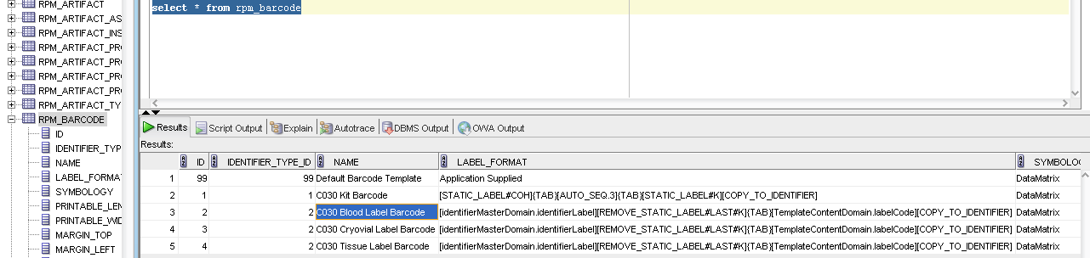

**Label Code**

This is sourced from the RPM_LABEL_CODE table.

You will need to make another entry in that table.

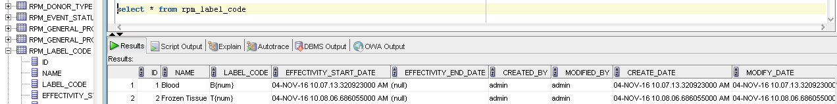

* Multiple kit templates can be created. The same set of kit templates can be used for multiple sites.   
    
  **Example:** You can create a kit template for the Initial collection event, then a second kit template for a Follow-up event, and a third kit template for a Final event. The same kit templates can be used for multiple sites with the same events.
* An existing **Kit Template Name** can be used when creating a new kit. However, the **Kit Template Code** must be unique for each template.   
    
  *Example*: To create three kits with the same name: **Kit Template Name** for each can be Lung Cancer Study, and the **Kit Template Codes** could be Initial1, Initial2 and Initial3.  
    
  *Note:* The **Kit Template Name** and **Kit Template Code** cannot contain special characters.
* **Component Group Name**: You must select a **Component Group Name** for each different component of the kit (blood, tissue, packing items, etc.) before adding a component or spare item to the template.  
    
  *Note:* If the appropriate group name is not listed, you can add a new group by inputting the name in the **Component Group Name** textbox on the right and clicking **ADD**.
* **Add New Component:** Specify the kit contents for each Component Group by clicking this link, completing the required fields and then clicking **ADD**.
* **Add New Spare item:** If applicable, specify any spare items (zip-lock bags, gauze, swabs, packing list, etc.) that should be included in the kit for each Component Group by clicking this link, completing the required fields and then clicking **ADD**.

## Create Forms

1. Access **IAMS>Forms Designer** and use the **Create New Data Collection Form** link.   
   General tips for Create Form screen:

* **Search Questions** link: Click link to access **Search Question** pop-up. Search and select questions to add to the form. Then click **ADD**.
* You can perform wildcard searches using partial words with an asterisk (*) at the end or the beginning.
* You can add PHI as well as Non-PHI questions to the Data Collection Forms.
* **Order**: Once questions are added to the form, place the cursor on a question and use the “drag and drop” feature to change the order of the questions on the form.
* **Delete:** To delete a question that has been added, click on the **trash can icon** 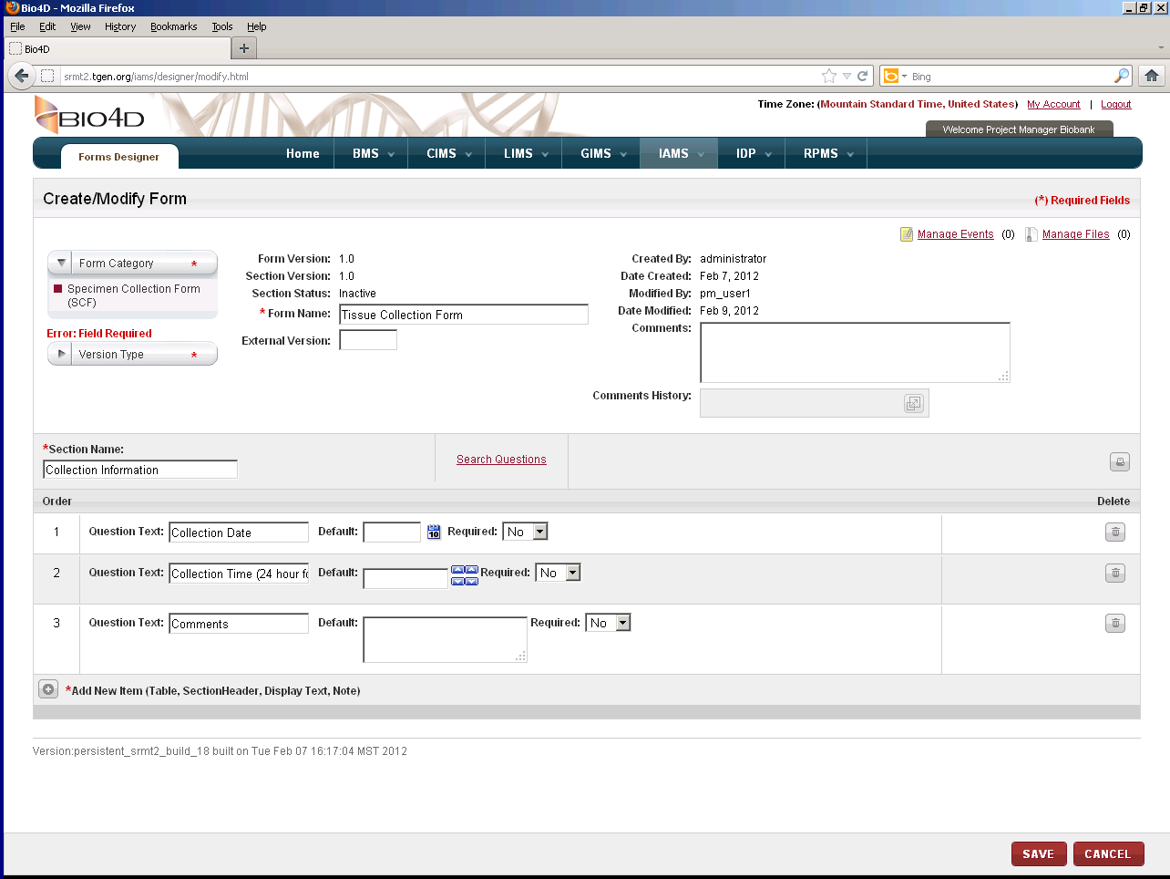(last column on the right).
* **Print Form:** Click the **print icon ** above the Delete column to preview and/or print the new form.
* **Add New Item:** Click the **+ icon** and complete required fields to add a Table, Section Header or Note to the form.

1. Based on business requirements for the new Project; create, **Save** and **Activate** a Consent Form.
2. Based on business requirements for the new Project; create, **Save** and **Activate** a Sample Processing Form for each applicable LIMS workflow: Aliquot, Derivative, Pooling and Generic Experiment.
3. Based on business requirements for the new Project; create, **Save** and **Activate** aSpecimen Collection Form for each kit template component group.

## Upload Sample Processing Templates

**Note:**

* Only the administrator user can upload the Process Template.
* Any other users cannot upload the Process templates.
* Uploading Sample Processing Templates are optional.

If a template is not uploaded for a LIMS workflow, the system will use a default template.

1. Based on business requirements for the Project; create a Sample Processing Template spreadsheet for each applicable LIMS workflow: Aliquot, Derivative, Pooling and Generic Experiment.
2. Access **IAMS>Import Data** and select **Process Template** as the **Upload Type**.
3. **Browse**, select and **Upload** each of the applicable templates (one at a time).

# Project Management

To perform the project management setup tasks:

1. Log in to CIRRASPEC with the System Administrator’s login ID and password, and access **RPMS > Configuration**.
2. Perform each of the tasks outlined in this section.   
   General tips:

* Required fields are marked with a red asterisk *.
* Place the cursor on the blue question mark icon next to a field to display format requirements for that field.

## Create a Project

1. Click **Create Project** link. Complete the required fields to add the Project and click **CREATE.** Complete additional fields, as needed
2. Click on Personnel tab, Add the users for the roles. (Optional step, to be done if all collections under this project have the same users and their roles )
3. Click **SAVE**

## Create a Collection

1. Click **CREATE COLLECTION.** Complete the required fields to add the Collection and click **CREATE.** Complete additional fields on the Properties tab, as needed and click **SAVE**.  
     
   *Note:* If you want to allow unplanned events to be scheduled by a collection site user for a subject in the **CIMS>Subject Centric View** module, click the **Allow Unscheduled Collection Events** checkbox.  
     
   General tips:

* To assign items on any of the various tabs:   
  Select the appropriate item on the list on the right side and “drag and drop” it to the appropriate item on the left side.  
  OR  
  Select the appropriate item on both lists and click the applicable **ASSIGN** button.
* You can assign multiple items to a site, role, kit, etc. However, you must select and assign the items one at a time.
* When assigning items using “drag and drop”, the red X indicates that you are trying to assign the item to an invalid level or location.
* If you click on **SAVE** before completing all of the tabs, you must click on **MODIFY COLLECTION** to return to “create” mode and continue with the setup tasks.
* To unassign an item on any of the various tabs: Select the item on the left that you want to unassign, and click the **UNASSIGN** button.

1. Sites tab:

* Assign the appropriate **Available Sites** on the right side to the applicable sites (**Collection, Processing and Storage)** on the left.   
    
  *Note:* The **Available Sites** list displays all sites created and activated in **IAMS>Address Book**. If you don’t see an item you want to assign, verify that it is activated in the IAMS module.
* Assign the appropriate **Subject Types** item on the right side to the applicable collection site location on the left side.

1. Personnel tab:

* Assign the appropriate **Users** on right side to the applicable roles (**Bio Repository Technician** and **Clinical Research Nurse)** on the left.

**Note**: It is currently not recommended to assign **Project Manager** users to collections.  
  
*Note:* The Users list displays all users assigned to the sites selected in the **Sites** tab. If you don’t see an item you want assigned, verify that it has been assigned to one of the selected sites and has been activated in the **IAMS>Address Book** module

1. Kit Templates tab:

* Assign the appropriate **Available Kits** on the right side to the applicable collection site(s) on the left.   
    
  *Note:* The **Available Kits** list displays all kits created and activated in **IAMS>Kits Designer** that are available for this Project. If you don’t see an item you want to assign, verify that it is activated in the IAMS module.
* Expand the **Selected Kits** hierarchy tree. Assign the appropriate **Specimen Collection Forms** on the right to the applicable kit component group(s) on the left.  
    
  *Note:* The **Available Specimen Collection Forms** list displays all forms created and activated in **IAMS>Forms Designer** with the Category Type = Specimen Collection Form. If you don’t see an item you want to assign, verify that it is activated in the IAMS module.
* Assign the default barcode template values for *each* kit template and *each* kit component:
* Select the kit template name on the **Selected Kits** hierarchy tree, and then click **DEFAULT VALUES**.
* In the **Default Values** pop-up, click **CHANGE.**
* Input the number of **Copies**, select the appropriate value on the **Available Barcode Templates** list and click **SAVE**.
* Select the kit component on the **Selected Kits** hierarchy tree, and then click **DEFAULT VALUES**.
* In the **Default Values** pop-up, click **CHANGE.**
* Input the number of **Copies** and select the appropriate value on the **Available Barcode Templates** list.
* Select the appropriate value on the **Label Code** list.  
  **Note:** The selected Label Code values must be unique for each kit component.
* **Quantity** is optional. However, if input, the system assigns this quantity as the initial quantity for all samples collected for this kit template component.
* **Code Scheme** is optional. However, if a code scheme is selected, the system assigns this code for all samples collected for this kit template component.
* Click **SAVE.***Note***:** Kit templates and kit components that have the default barcode values assigned are displayed on the **Selected Kits** hierarchy tree with a green check mark.

1. Form Templates tab:

* Assign the appropriate Consent Form from the **Available Consent Forms** list on the right side to the applicable collection site (s) on the left.   
    
  *Note:* The **Available Consent Forms** list displays all forms created and activated in **IAMS>Forms Designer** with the Category Type = Consent Form. If you don’t see an item you want to assign, verify that it is activated in the IAMS module.
* If applicable, assign the appropriate Clinical Form(s) from the **Available Clinical Forms** list on the right side to the applicable collection site on the left.  
    
  *Note:* The **Available Clinical Forms** list displays all forms created and activated in **IAMS>Forms Designer** with the Category Type = Clinical Form. If you don’t see an item you want to assign, verify that it is activated in the IAMS module.

1. Process Workflow Templates tab:

* Assign the appropriate Process Template(s) from the **Available Process Workflows** list on the right side to the applicable processing site(s) on the left.   
    
  *Note:* The **Available Process Workflows** list displays all sample processing templates uploaded in **IAMS>Import Data**. If you don’t see an item you want to assign, create and upload the appropriate template(s) in the IAMS module.
* Expand the list under **Available Process Workflow Forms** on the right side. Assign the appropriate Sample Processing Form from the list on the right to each of the applicable processing template(s) on the left.  
    
  *Note:* The **Available Process Workflow Forms** list displays all forms created and activated in **IAMS>Forms Designer** with the Category Type = Sample Processing Form. If you don’t see an item you want to assign, verify that it is activated in the IAMS module.

1. Couriers tab:

* Assign the appropriate **Available Couriers** item(s) on the right side to the applicable Collection on the left.   
  *Note:* The **Available Couriers** list displays all couriers created and activated in **IAMS>Address Book**. If you don’t see an item you want to assign, verify that it is activated in the IAMS module.
* Click **SAVE**.

## Create Collection Events

1. Click **CREATE COLLECTION EVENT.**  Complete the required fields to add the Collection Event and click **CREATE.**   
     
   General tips:

* You can create the same Collection Events for multiple collection sites. However, you must create events for each site one at a time.
* If you click **SAVE** before completing all tabs, you must click on **MODIFY COLLECTION EVENT** to return to “create” mode and continue with the setup tasks.

1. Appointments tab:

* For Initial collection events, the **Mandatory** checkbox is automatically checked and the **Scheduled** checkbox is disabled.
* For all other event types, you can specify **Mandatory** or **Scheduled**.
* If you specify **Scheduled**, you must complete the scheduling fields. The **days +/-** box allows a variance in the scheduling. For example: If you input 10 in the first field and input 2 in this field, this event is scheduled for 8 to 12 days.

## Publish the Collection

*Before Publishing the Collection please check below:*

* At least one user as BRT, CRT must be assigned.
* Atleast one collection event, kit template, processing site and courier must be assigned.
* All assigned sites, couriers, users, forms, kit templates and workflow process templates must be activated.
* Each collection site must have a subject type assigned.
* Each kit template must have a barcode.
* Each kit template content or spare item must have a barcode if ‘Barcode Needed’ indicator is checked in the template in IAMS>Kits Designer.
* Each kit template content item must also have a unique label code within that kit template.
* At least one Initial collection event must be added to the Collection.

1. Click **PUBLISH.**

Note: If you receive a publication failed message, click the **expand icon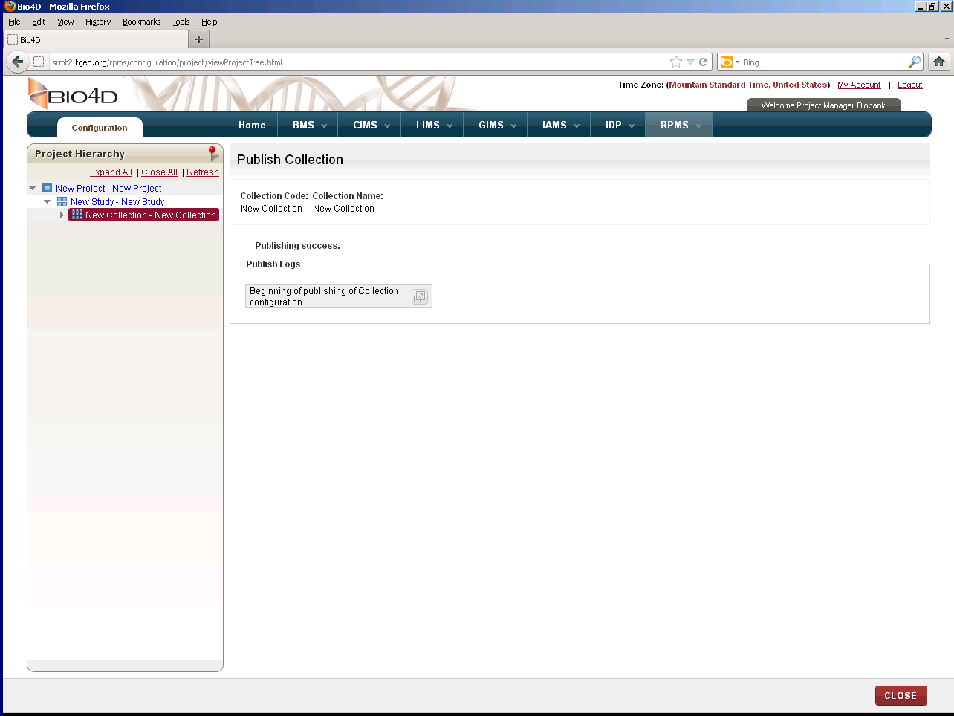.**

* Scroll downand make note of the validation errors, which appear in red.
* Click **close**.
* Click **Modify COLLECTION** and make the necessary corrections.
  + Click **Publish**.  
    Confirmation message will appear.

1. Click **CONFIRM.**  
   Below screen will be seen.

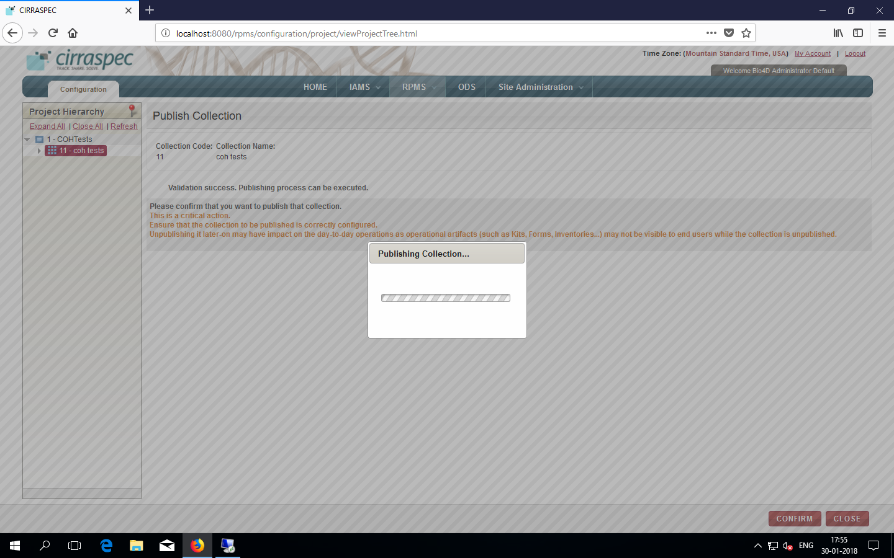

“Publishing Success” will be displayed on screen once collection publishing is a success.

Please see below screen:

