1. What is Synchronization?
Definition: A strict, one-at-a-time execution model. Task B cannot start until Task A is completely finished. It is "blocking," meaning the program stops and waits for a task to end before moving to the next line of code.

In Python (Synchronous)
Python handles this by default. It uses a single thread and executes line-by-line. If a line takes 10 seconds (like a download), the entire program freezes for 10 seconds.
- How it works: It uses the standard def keyword.
- Example: time.sleep(5) literally stops the Python interpreter from doing anything else.
- Syntax:
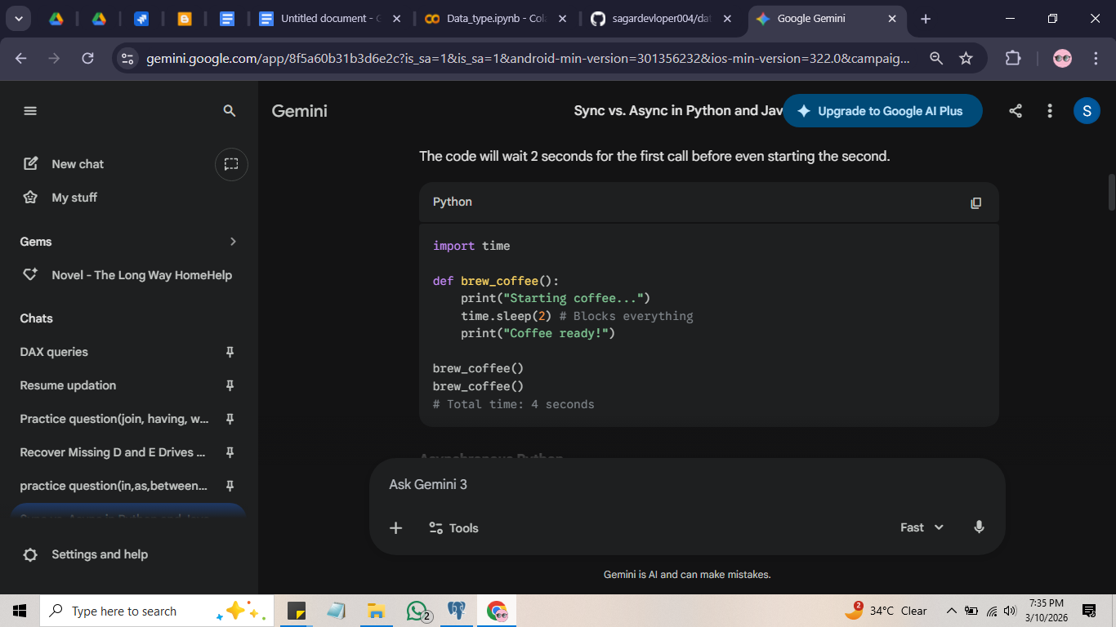

In Java (Synchronous)
Java is naturally multi-threaded, but "Synchronized" usually refers to Thread Safety. It means only one thread can access a piece of code or an object at a time to prevent data corruption.
- How it works: Uses the synchronized keyword.
- Example: If two people try to withdraw money from the same bank account at the same millisecond, Java "locks" the account so the first person finishes before the second starts.
- Syntax:
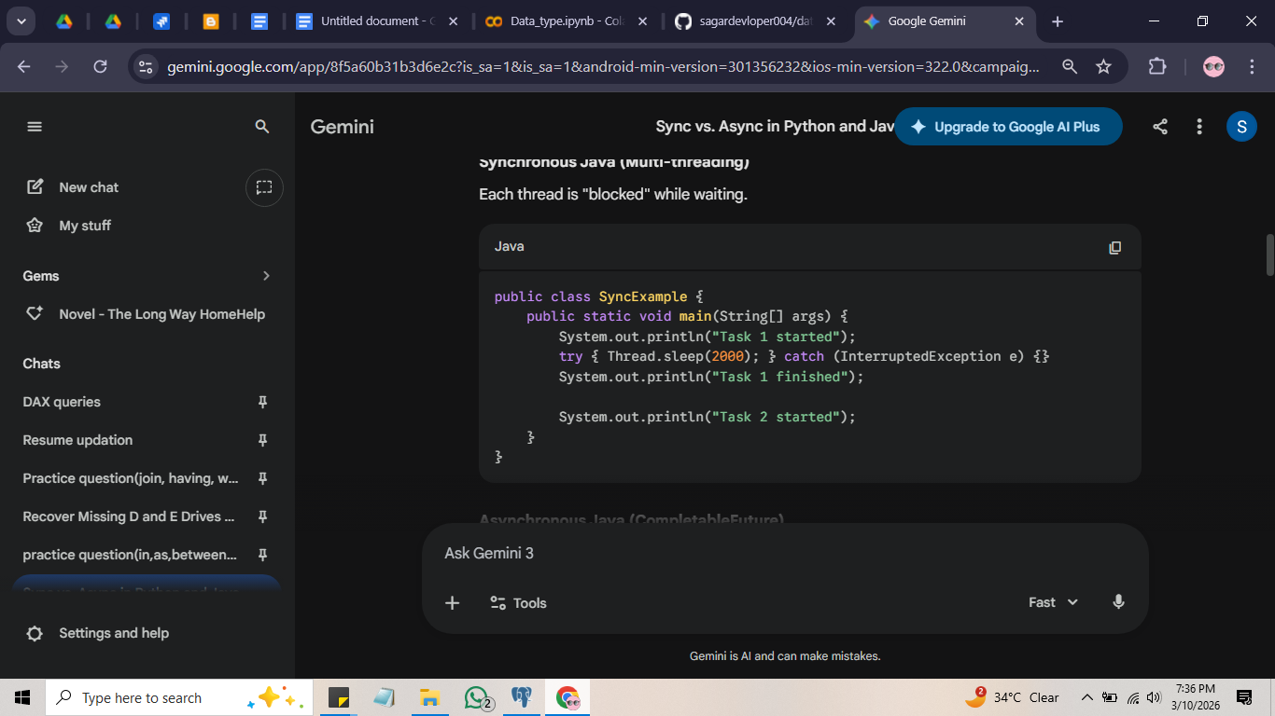

2. What is Asynchronization?
Definition: A "start now, finish later" execution model. It allows a program to start a long-running task and immediately move on to other tasks without waiting. When the long task finishes, the program is notified.

In Python (Asynchronous)
Python uses an Event Loop. Think of it as a single manager juggling many tasks. When one task hits a "wait" point (like an API call), the manager puts it aside and picks up another task.
- How it works: Uses async def to define a function and await to pause only that function while waiting.
- Key Tool: The asyncio library.
- Syntax:
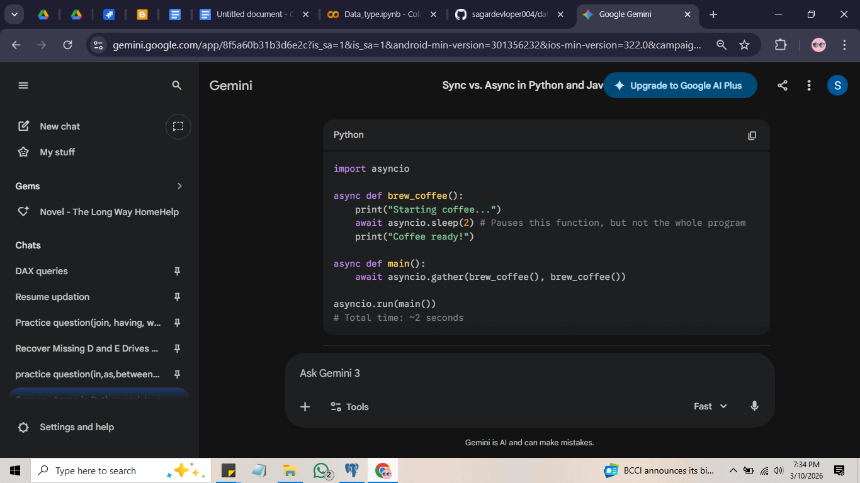

In Java (Asynchronous)
Java handles this by offloading tasks to Background Threads. The main thread says, "Hey, go do this calculation on another desk and call me when you have the result." This keeps the main application (like a user interface) responsive.
- How it works: Uses "Futures" or "Promises."
- Key Tool: CompletableFuture.
- Syntax:
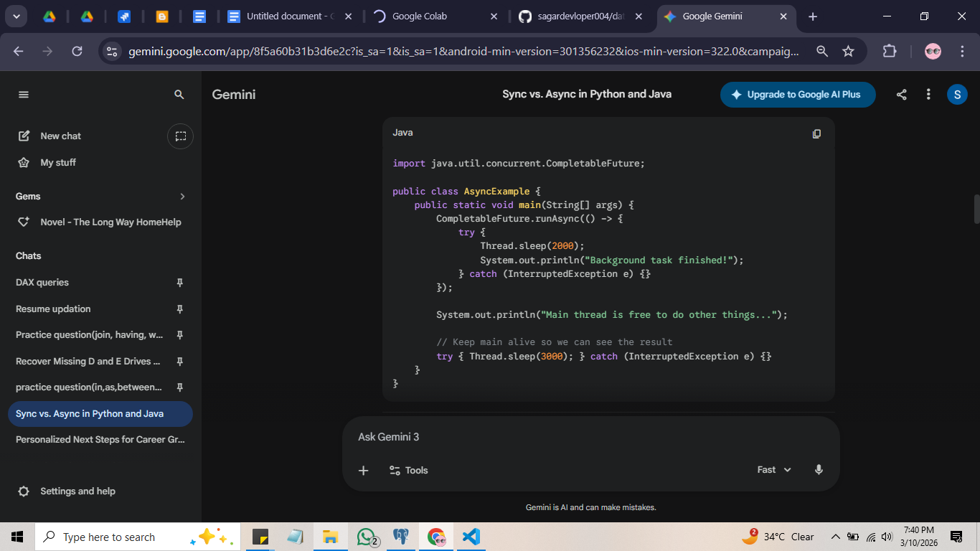

Comparison Summary
Feature | Synchronous (Python/Java) | Asynchronous (Python/Java)
Wait Time | Program stops and waits. | Program stays busy with other things.
Execution | Sequential (1, 2, 3). | Concurrent (1 & 2 & 3 start together).
Analogy | A single-lane road. | A multi-lane highway.

Quick Code Comparison

Python
- Sync: result = get_data() (Wait here until data arrives).
- Async: result = await get_data() (Pause this task, do other things, come back when data is here).

Java
- Sync: public synchronized void update() (Only one thread can enter this method at a time).
- Async: CompletableFuture.runAsync(() -> doWork()) (Run doWork in the background immediately).

Concept | Behavior | Best Used For
Synchronous | Tasks are executed one after another. Each task must finish before the next begins. | Simple logic, CPU-heavy tasks.
Asynchronous | Tasks can start, run, and complete in overlapping time periods. The program doesn't "block" while waiting for a response. | I/O tasks (API calls, database queries, reading files).

