System to Reduce Fake Votes during Elections.

Kailash Kendre, Sayali Kulkarni

***Abstract****: An****election****is a way people can choose their candidate or their preferences in a representative democracy or other form of government. The nature of democracy is that elected officials are accountable to the people, and they must return to the voters at prescribed intervals to seek their mandate to continue in office. For that reason most democratic constitutions provide that elections are held at fixed regular intervals. Voting the right candidate is right of every person, but there have been many cases in India about double voting and multiple voter Ids. To reduce the bogus voting and paper work during elections we have thought of an idea to make it* ***mandatory*** *to link the Voter Id with Adhaar card. In our work we also propose that website should be used at the polling booth to check if the person has Voter Id linked with Adhaar card, and further to change the status of the voter as ‘Voted’ on the website instead of the traditional way of voter list and slips given on polling booth and the signature register.*

1. **INTRODUCTION**

India is a union of states with a parliamentary system governed under the Constitution of India, which defines the power distribution among the central government and the states.

Elections in the Republic of India include elections for :

Members of the Parliament in Lok Sabha,

Members of State Legislative Assemblies,

Members of the Parliament in Rajya Sabha,

Members of State Legislative Councils,

Members in village Panchayats or city corporation councils.

**Election Process**:

Candidates are required to file their nomination papers with the Electoral Commission. Then, a list of candidates is published.  Government employees are employed as poll officers at the polling stations. Electronic Voting Machines (EVM) are being used instead of ballot boxes. After the citizen votes his or her left index finger is marked with an indelible ink. This practice was instituted in 1962.

The Election Commission prepares, maintains and periodically updates the Electoral Rolls, which show who is entitled to vote, supervises the nomination of candidates, registers political parties, monitors the election campaign, including the funding and exponential by candidates. During actual conduct of elections, a vast number of additional staff are temporarily drafted for about two weeks. They function mainly as polling and counting officials.

1. **LITERARY STUDY**

According to the study and news every year, there have been several cases of election fraud. In 2019 it was found in Andhra Pradesh that about 59 lakh entries in the voters list are false. The allegation is significant as there are about 3.67 Cr. eligible voters in the state, which means the alleged ‘fake voters’ constitute about 16 per cent of the total electorate.

**Double Voting:**

One of the basic tenets of democracy is that each person has one vote. A person cannot be enrolled as a voter at more than one place in view of the provisions contained in Sections 17 and 18 of Representation of People Act, 1950. Likewise, no person can be enrolled as an elector more than once in any electoral roll. Even though there exists a law, there are many cases not only in India but in other countries too. For all the new concern about double voting, though, the odds of getting caught remain minuscule. Comparing voter databases county by county and state by state is a needle-in-haystack undertaking, even with the aid of computers. Hence, there should be sufficient safeguards to prevent double-voting. Our proposed system will help to reduce the voter fraud.

The following articles show the cases of double voting in India.

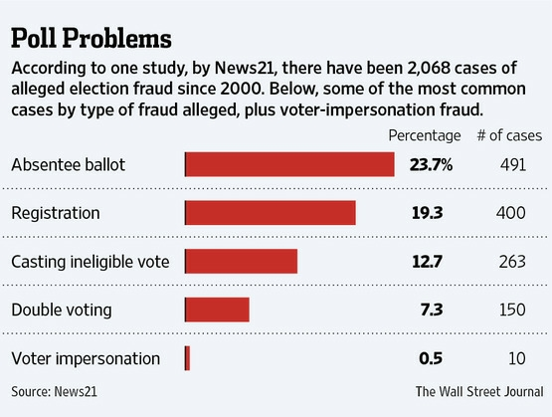

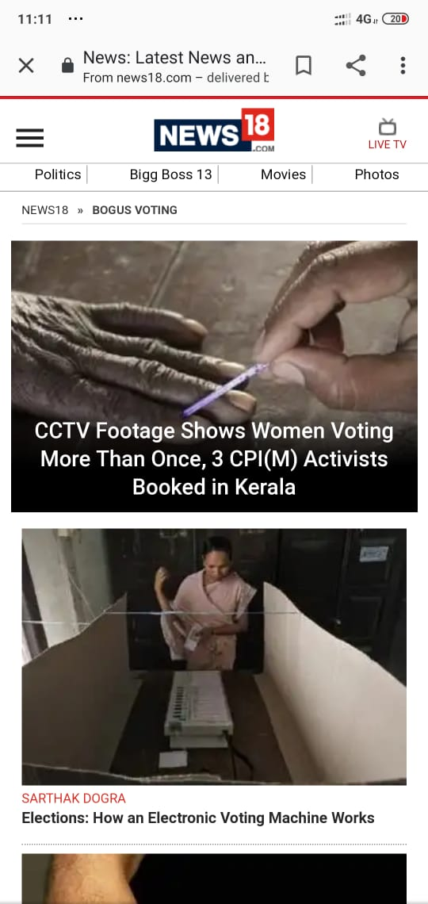

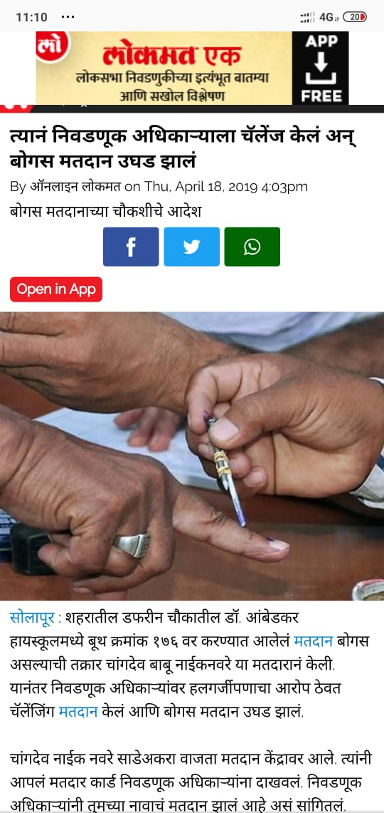

Hence, conduct of elections in a vast country like India must involve elaborate security management. It must include ensuring the security of polling personnel, security at the polling stations, security of polling materials and also the overall security of the election process. As online platform and technology in almost all fields, it must also be used in elections to reduce the frauds and make all the process more secure.

1. **PROPOSED**

**MODEL**

**3.1** **Proposed Methodology**:

1. It will be MANDATORY to link Adhaar card to voter Id.

2. A unique password will be given to all the polling officers before the day of elections.

2. The voter can either bring his/her Voter Id or Adhaar card at the polling booth.

3. At the day of voting, the election officer at the polling booth will check on the Voting Website if Adhaar card and voter card of the voter is linked by entering the voter’s Adhaar number or Voter id number .

4. The officer will mark the status of the voter as ‘VOTED’ on the site which will update in the database.

The Electoral Photo Identity Card (EPIC)/ Voter ID is an identity document issued by the electoral registration officer. The EPIC contains details of the elector like name, father’s/mother’s/husband’s name, date of birth/ age on the qualifying date, sex, address, and most importantly, the photograph of the elector. EPIC is a permanent document for an elector. It is to be used by the elector to establish one’s identity at the time of polls. It is compulsory for an elector who has been issued an EPIC to produce the EPIC at the time of polling to enable voting.

Aadhaar is a 12 digit individual identification number which serves as proof of identity and proof of address for residents of India. It establishes uniqueness of every individual on the basis of demographic and biometric information such as fingerprint and iris scans.

Hence, with the new feature of mandatorily linking of voter ID with Aadhar card, the Election Commission will be able to detect as well as eliminate the bogus/fake voter ID cards in a single individual’s name, and the chances of duplication are almost impossible.

An online platform i.e the website will be used to store the status of the voter instead of the signature on the register. This will help to reduce the paper work and save a lot of time. As the status of the voter is stored in central database, the person if tries to and vote at some other place will be detected due to the online platform.

**3.2 About the website:**

The website will consists of a central database which will have details of all the candidates all over India. The database handling will be similar to that of Adhaar database handling. The polling stations are divided according to districts and further the regions in that district with a unique region number. The interface will have the login screen where the polling officer will enter his details, the election area information, the region number, etc. This will provide the list of all the voters in that specific area on the screen. The polling officer can search either for the voter’s Adhaar number or Voting card number through the search page to get his/her faster. After entering the number, the details of that candidate will be seen along with this status like ‘VOTED/NOT VOTED’ in the respective elections. All these changes are reflected in central database.

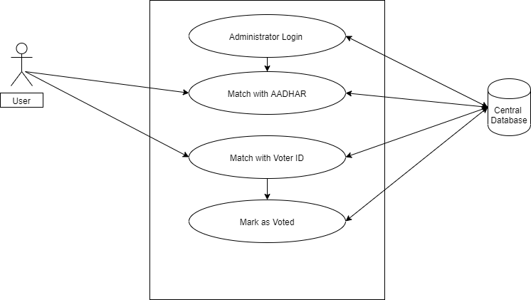

Technology Stack of the website:

Frontend: HTML, CSS, Javascript

Backend: Java, Spring MVC

Database: Mysql

India has the second highest number of internet users in the world. The BharatNet scheme aims to connect more than 600,000 villages in India with a minimum broadband speed of 100Mbps.

**India's broadband users**

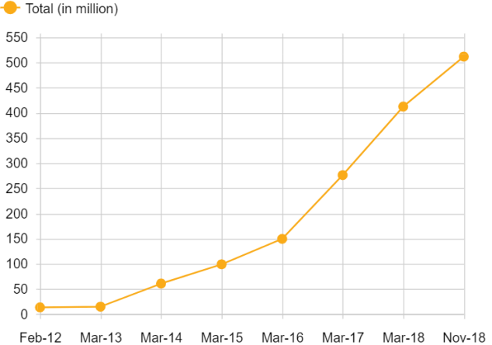

This shows that Internet access is now in urban as well as rural areas. In many polling stations the EVM machines are also connected to internet. So using website is flexible while elections.

1. **CONCLUSION**

Thus, in this proposed system the bogus voting can be reduced to a large extent. The system will be able to keep the record of all the voters in a secure way. This process will also lead to reduction of paper work and time required at the polling stations. The future scope of this proposed system will include detecting the Adhaar number by scanning the card as it consists of QR code. So it will be more easy for the polling officer to scan thus reducing time of entering the number manually on the website. Hence, the approach of online platform while election process than the trivial paper based process can be more beneficial.