**TEMPLATES**

**1. Home page and Navbar -**



Transparent navbar and carousal images with animation.

Link to the template - <https://bootstrapmade.com/demo/eBusiness/>

**2. Top Selling Brands**

If brands are less -

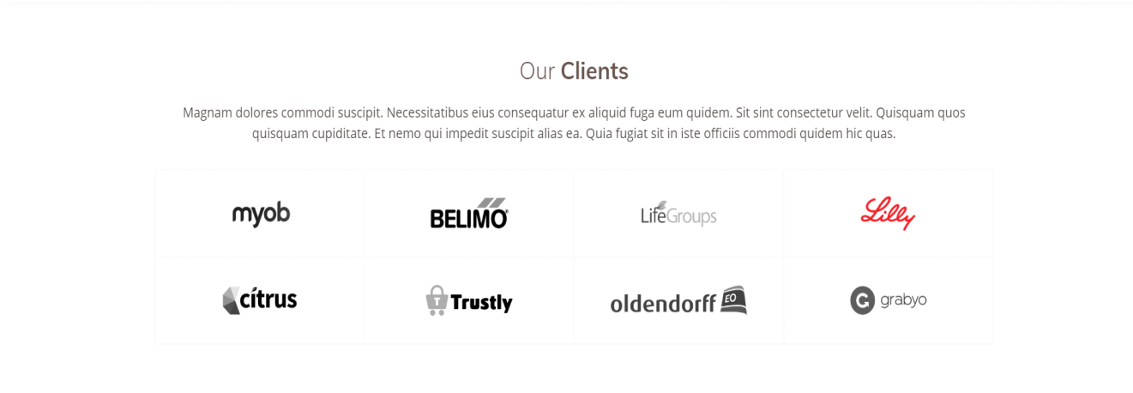

Link to the template - <https://bootstrapmade.com/demo/Flattern/>

If top brands are more, using carousal type -

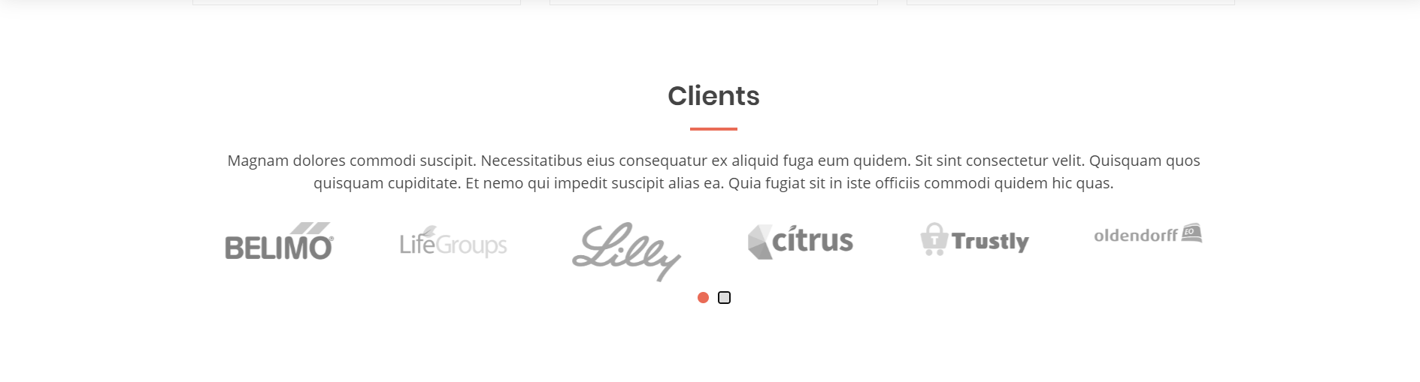

Link to the template - <https://bootstrapmade.com/demo/Eterna/>

3. Specially For Your Pet

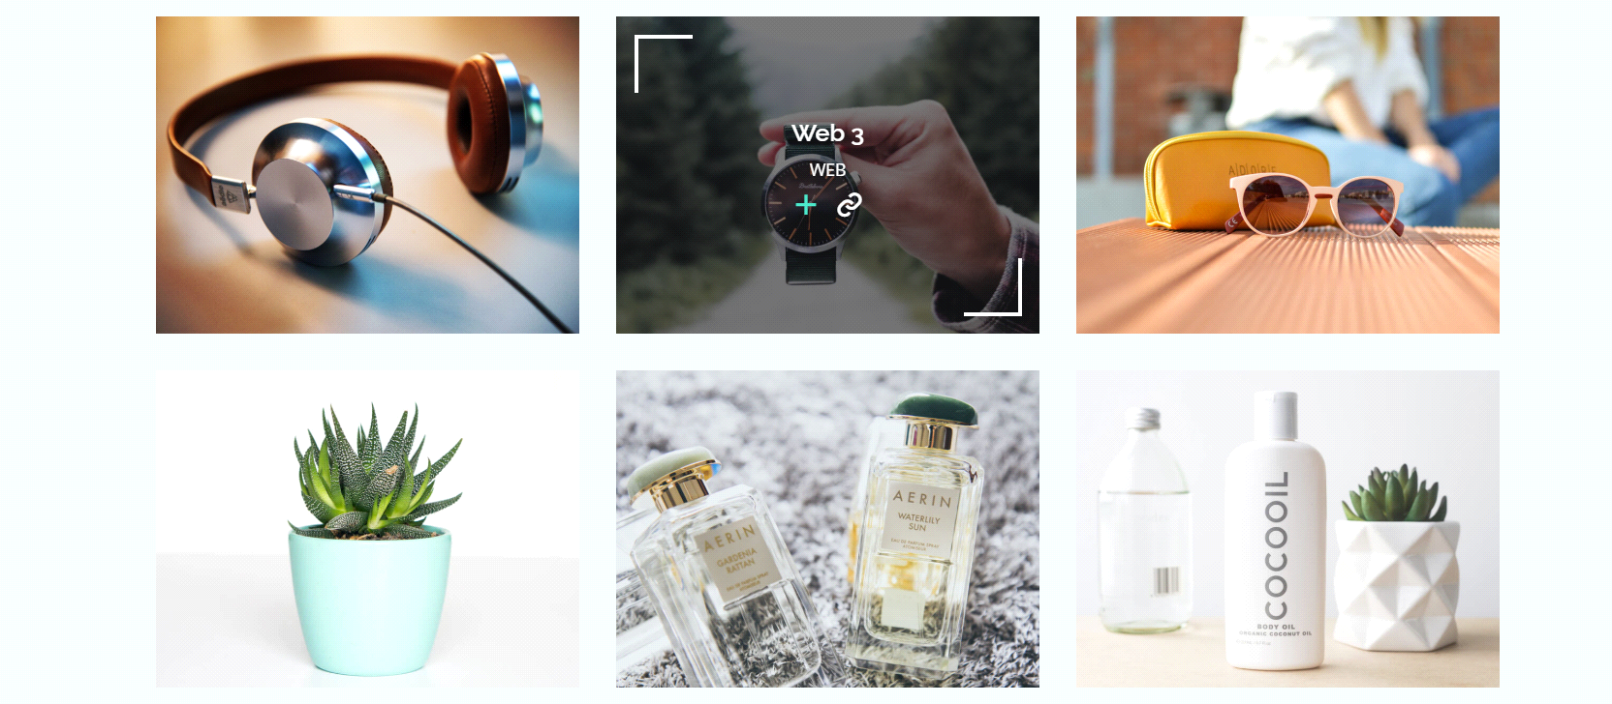

4 images in this pattern, 2 in one line, 2 below. When clicked on images (ex- dogs, cats, birds or small pets) it goes to respective category section to buy products.

Link to the template - <https://bootstrapmade.com/demo/Maxim/> (refer portfolio section of this template)

**4. Best Seller/ Top Featured -**

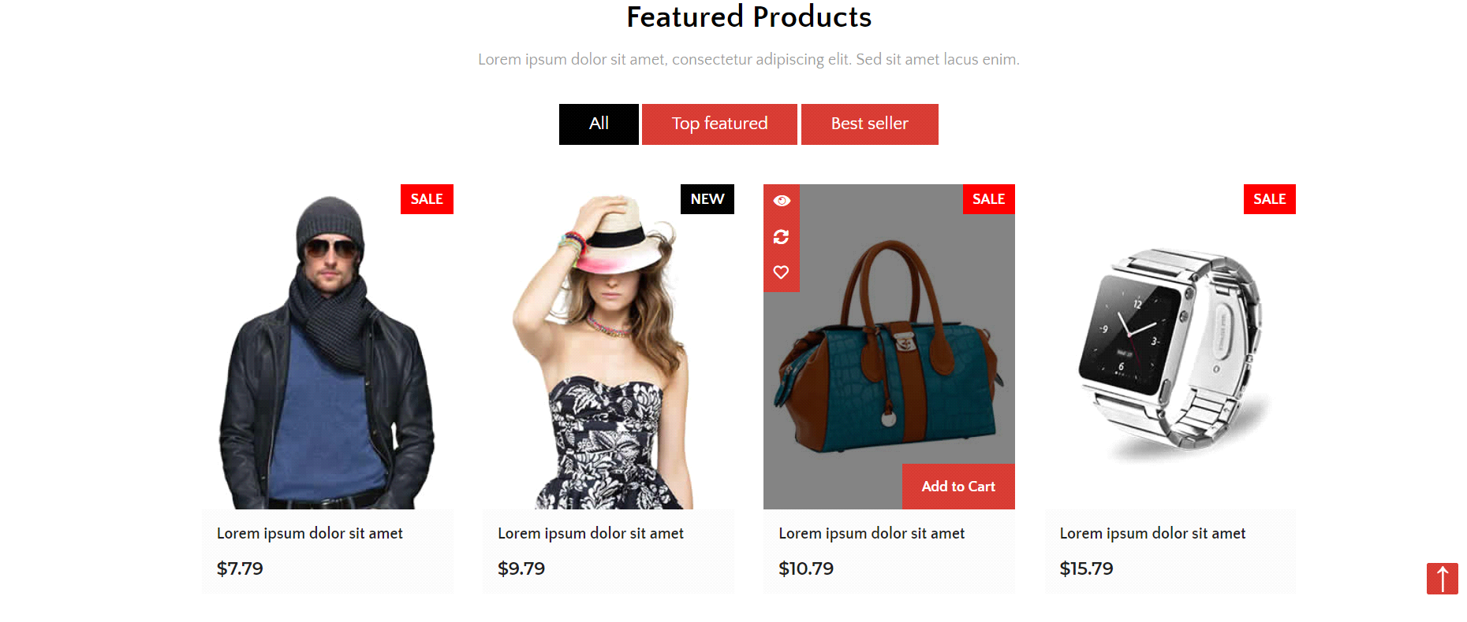

Link to the template - <https://www.free-css.com/free-css-templates/page246/thewayshop>

**5. Just Arrived -**

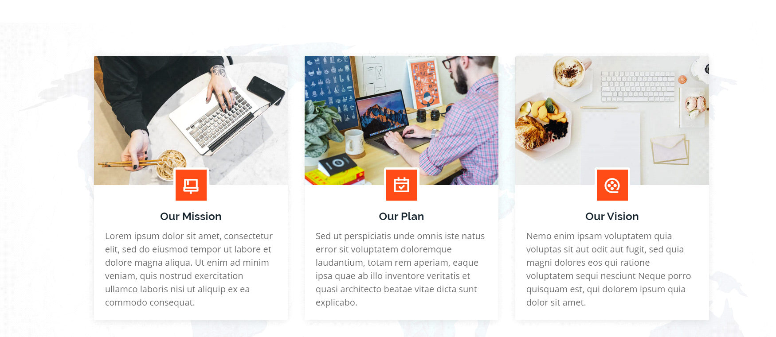

Just arrived images with add to cart option and details in the above format.

Link to the template - <https://bootstrapmade.com/demo/Dewi/>

**6. Special Offers -**

If offers are less -

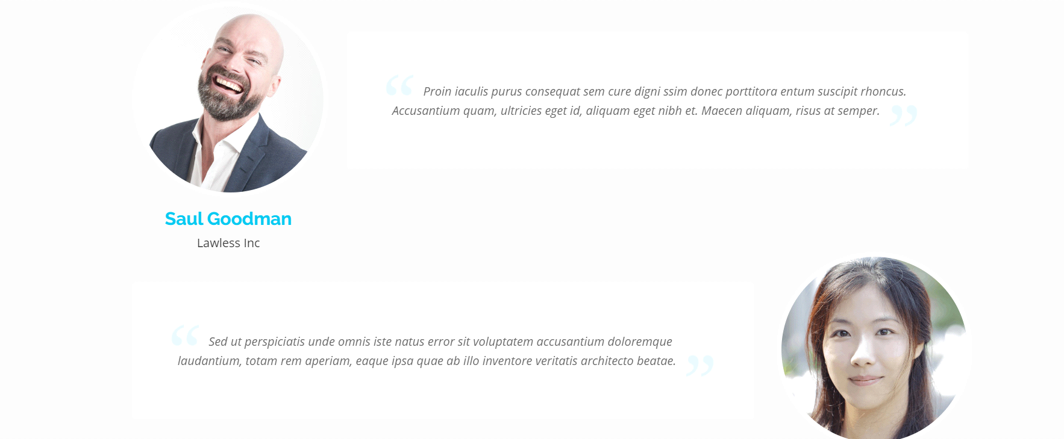

Offer image and details about the offers.

Link to the template - <https://bootstrapmade.com/demo/Imperial/>

If more offers -

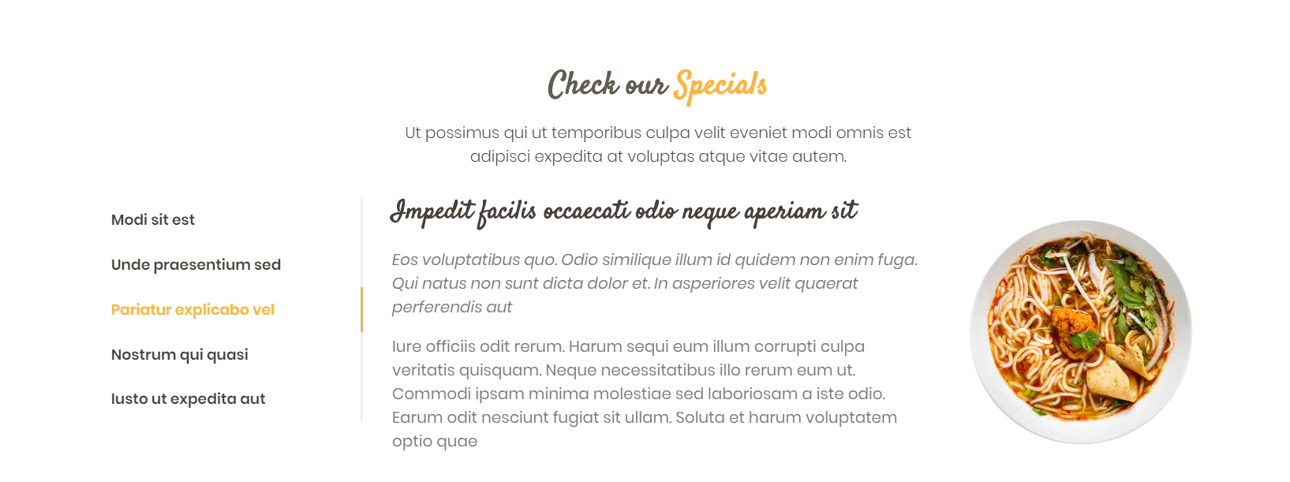

Offer names on left side. When clicked on specific names it shows details and image on right.

Link to the template - <https://bootstrapmade.com/demo/Delicious/>

**7. Contact Us and Footer -**

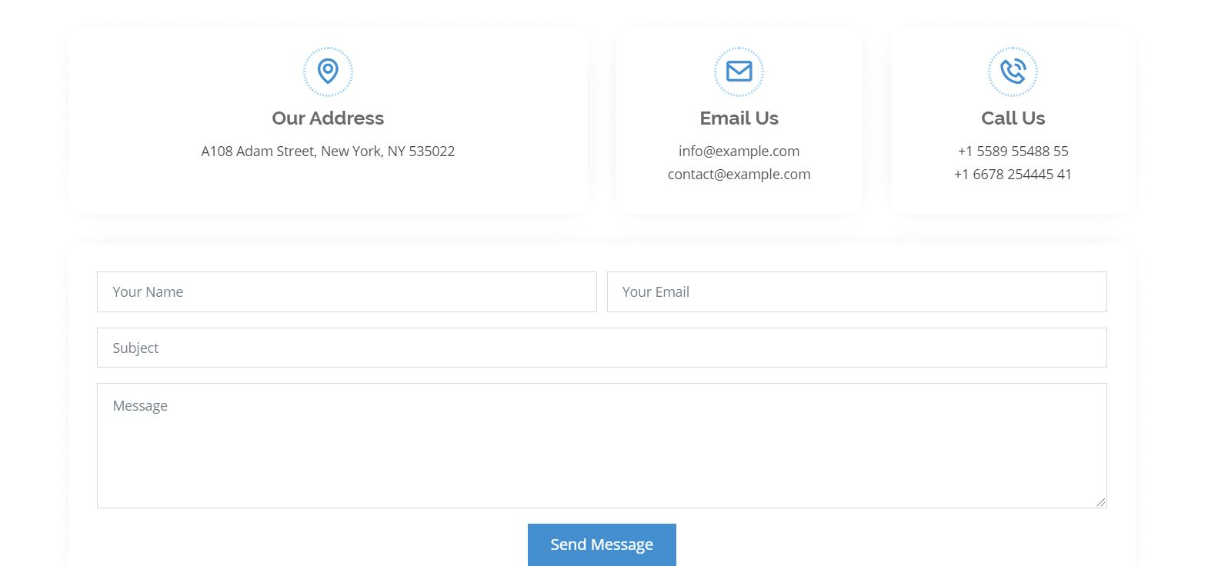

Footer -

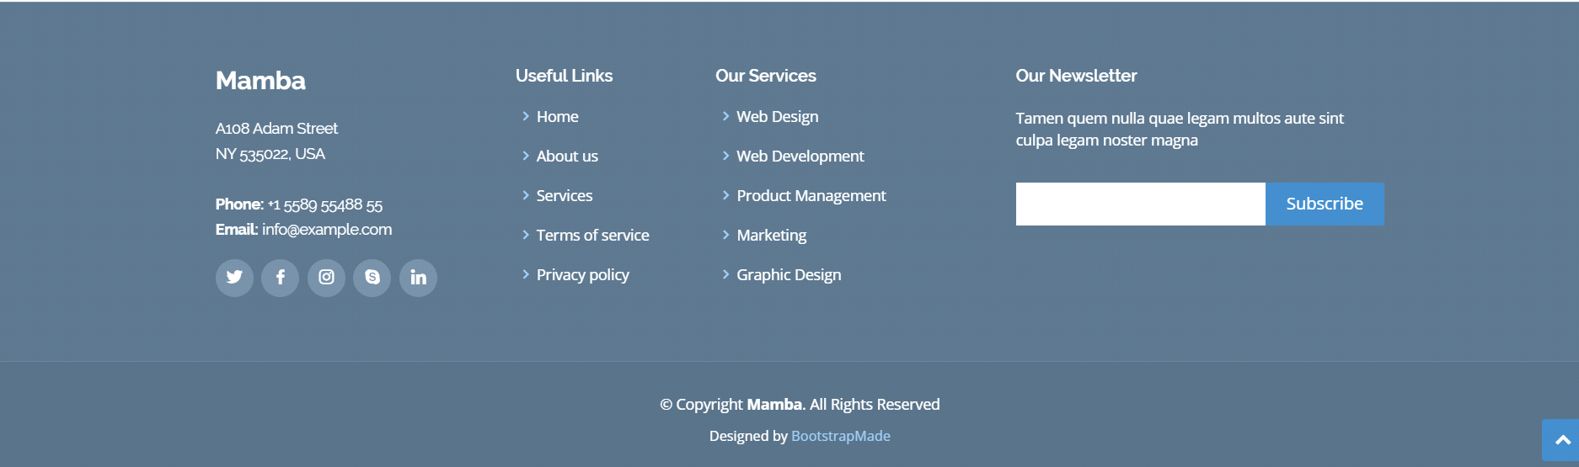

Link of contact us and footer - <https://bootstrapmade.com/demo/Mamba/>