2016/17 COP501 Advanced Programming – Coursework Specification
[This assessment is worth 70% of the total module assessment. It should be completed and submitted by 4 pm, on the specified date of re-sit coursework submission. More information about the coursework submission, including the date of submission will be published in the module website.]
Coursework Specification
This coursework aims to assess your ability to carry out the design, implementation and testing of a device/system that is widely used in image compression. The implementation is to be initially carried out using MATLAB.
During the lectures you will be introduced to the principles of JPEG baseline image coding, using G.K.Wallace’s seminal research paper titled, “JPEG Still Picture Compression Standard”, published in the IEEE Trans. on Consumer Electronics, 1991. You are required to model a JPEG baseline CODEC (an Encoder is illustrated in figure 1) and carry out computer simulations to illustrate and analyse the effects of data compression on the visual quality of still images.
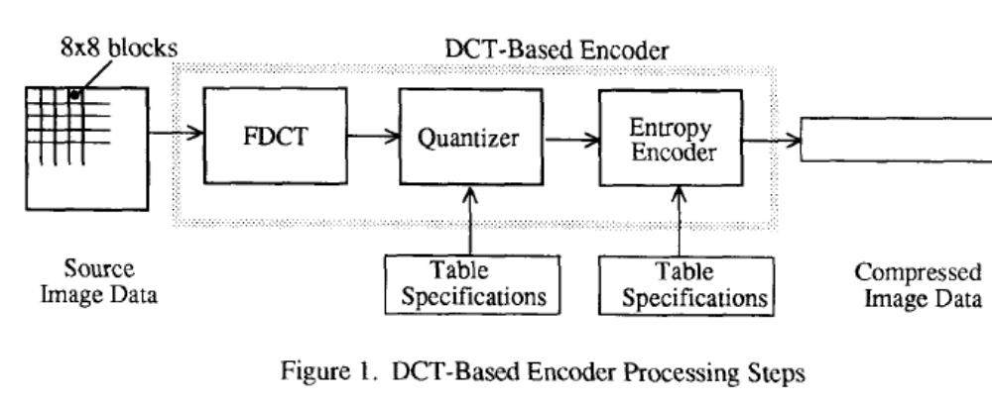
Implementation
Your implementation should be carried out entirely (including the GUI) using MATLAB.
The Encoder should meet the following specifications:
- You are required to model the block processing, forward-DCT and the quantization, modules of a JPEG Encoder and the inverse quantization and inverse-DCT modules of a JPEG decoder. The modules should be modeled and implemented independent of each other and finally integrated for simulations. The modeling and implementation of the entropy coding and decoding modules should be ignored.
- The quantization module should be modeled so the effects of using different quantization values (i.e. compression rates) can be simulated.
- Block processing should be applied to fixed, 8x8 size blocks.
The GUI: Design and implement a graphical user interface (GUI) in MATLAB that will enable the effective simulation of your model. In particular the user should be able to select an image (either from a list provided or via browsing) and different quantization parameters for simulation. The GUI should be able to display the original image and compare its visual quality as against the quality of the coded image. You may further consider any additional functionality that may enhance the usage of the above GUI.
The Report
Write a report (not exceeding 1500 words) that includes the assumptions made, reasons for any design decisions taken, program design & implementation details (for both implementations and the GUI), results and an analysis of the results obtained using your implementation.
Assessment Details
The breakdown of marks:
- Design & implementation of the MATLAB based CODEC – 30%
- GUI design and implementation – 30%
- Report (including results & analysis) – 40%
- Note that 10% of the above marks will be allocated for work conducted that exceeds the expectations of the coursework specification, as will be explained in the lecture on the coursework assignment and submission.

Note: Additional guidelines for writing the report will be provided in the module web site. These documents should be carefully read and understood before preparing for the module assessment.

Prepared: E.A.Edirisinghe, September 2016

